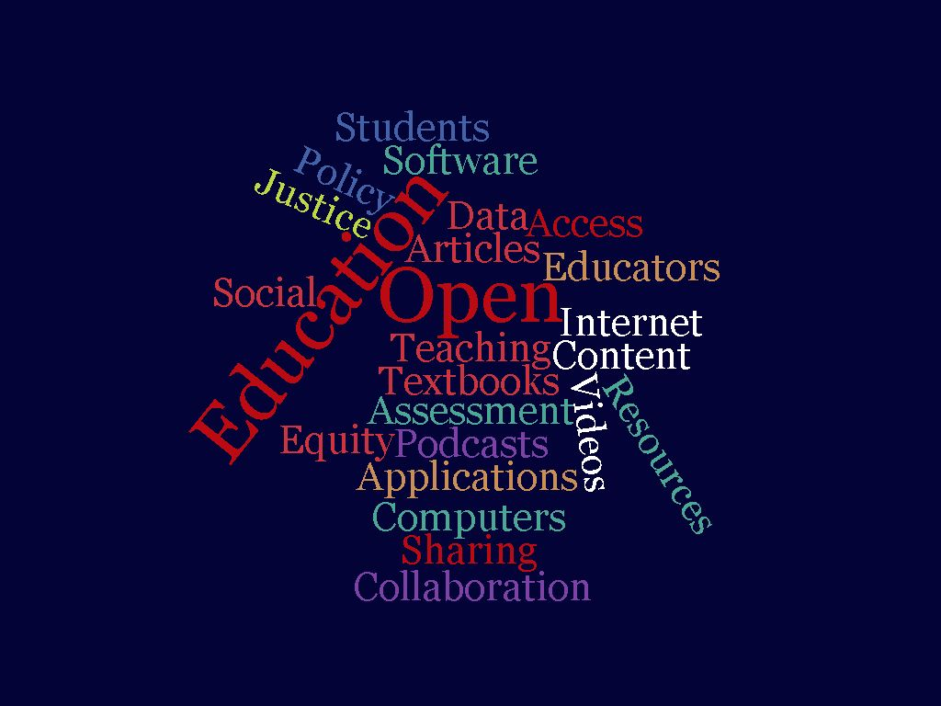

"Opening Up Education": An Interactive Discussion on Open Access and Open Education

"Opening Up Education": An Interactive Discussion on Open Access and Open Education

Jessica B. Srivastava

"Opening Up Education": An Interactive Discussion on Open Access and Open Education by Jessica B. Srivastava is licensed under a Creative Commons Attribution-ShareAlike 4.0 International License, except where otherwise noted.

Contents
- Introduction
- Overview Of Workshop
- Learning Objective
- Open Access
- Open Education
- Creative Commons
- Open Education Resources

Welcome to “Opening Up Education”. I created this Pressbook as part of my capstone project for the University of British Columbia Program for Open and Scholarly Education. The four-month course has been a real inspiration and is full of amazing information. The course models the open concept by providing the course materials for access at UBC POSE regardless of whether you are registered in the course. If you have a strong interest in this field, I strongly encourage you to look around the course content. I have also included ideas and materials from another excellent open access course, the Ontario Extend Empowered Educator Microcredential, specifically, the Curator module.
The goal of this Pressbook is to share my journey and understanding of the open approach in education to hopefully inspire and build collaborations. It will also be used as the base for an interactive workshop.
So why “open”?
This was a very new concept for when I attended a cohort run out of our college to help complete the Ontario Extend Curator Model. I was hooked! I never realized the amount of information that was available in such an organized manner under Creative Commons (CC) License. In fact, I did not have much know about CC. Moving onto the UBC POSE, the information was in depth and really challenged me to think about my teaching and drew me into thinking about open access and education from a social justice lens. I have much to learn but I am excited to share my “open” with you, the readers and workshop attendees.
Who am I?



I am a passionate educator, writer and entrepreneur.
With a diverse work background, today my focus is on teaching in higher education. My teaching brand is summarized best by my students: a teacher who kind is, patient, organized, effective, passionate, and fun. My teaching metaphor is a gardener tending and facilitating my students to help them on their learning journey, even the pesky ones that challenge us (the weeds).

Source: https://unsplash.com/photos/YlCDPIrcduI

The picture attached shows a wide variety of flowers to indicate the diversity in the classroom and if you look closely, you will see some weeds.
I teach undergraduate and post graduate communications mainly into business programs. While I have a diverse group of students, a large proportion is international, and I love this student population who bring unique challenges, insights, and experience that makes the classroom so enriched. Having travelled extensively and lived in three different countries, I am comfortable with being a global citizen and educator.
Also, an entrepreneur, I work online, with new immigrants, potential immigrants, and students around the world to pass the IELTS exam or improve their English and with business owners and employees to improve their communication skills. I develop articles and other written materials for companies and am an experienced grant and business plan writer.
When I am not teaching, I can be found in my kitchen trying out new recipes for my blog, 2MumsCook, writing articles for my Tales from the eTrenches blog. gardening, loudly watching Manchester United or just hanging out with my cats.
I can be reached at jsrivastava@conestogac.on.ca

Overview Of Workshop
This workshop will use the UBC POSE approach of Open Scholarship as an umbrella to discuss open practices. This approach includes integrating open practices in teaching and learning, research, and the scholarly environment.
I also think that Tom Woodward’s statement that “open is a purposeful path towards connection and community,” and the values of inclusion, social impact, and participation are integral to the practice of open” is especially important because education and education research should be open to everyone. The notion of social justice and equity is integral to my understanding and desire to participate in the open process. Also, Open Pedagogy lends itself to the use of Active Learning and Learner Centered teaching strategies which I think increases student engagement.
The workshop will briefly discuss the concept of Open Access and focus on Open Education, specifically Open Pedagogy and the create of Open Education Resources.

Overview of Open Concepts and Workshop
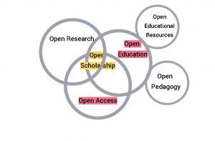

Learning Objective

Learning Objectives
- Highlight the basic rationale and context and issues related to Open Access.
- Explain the basic concept of Creative Commons licenses and provide examples of what one can/cannot do with resources that have different CC licenses (BY, NC, SA, ND)
- Illustrate how to find CC licensed content and how to curate the content.
- Explain what makes an educational resource open and discuss its’ value.
- Define each of the 5Rs, of OER and describe the associated permissions.
- Identify and evaluate sources of open educational resources.
- Model the use of open resources to develop and present the workshop using Pressbooks and H5p integration.

Chapter 1

Open Access

Open Access
Open access simply refers to “literature [which] is digital, online, free of charge, and free of most copyright and licensing restrictions” (Suber, 2015) .
The term was first used at the Budapest Open Access Initiative (2002) noted that “free availability on the public internet, permitting any users to read, download, copy, distribute, print, search, or link to the full texts of these articles, crawl them for indexing, pass them as data to software, or use them for any other lawful purpose, without financial, legal, or technical barriers other than those inseparable from gaining access to the internet itself” (Budapest Open Access Initiative, 2002). There was an emphasis on giving the author control and attribution for their work.
Clearly, the Open Access movement was heavily linked to the development of the internet but the growth in this field has been slow.
There are now many Open Access journals which include the traditional peer-review process and there are different levels of Open Access. Read more about current forms of Open Access at this resource from Cornell University – Open Access Publishing: What is Open Access?
To understand the issues around scholarly publishing and open access, watch Open Access Explained!
This interactive video was created using H5p and has questions embedded into the video which will pause to allow for discussion.
An interactive H5P element has been excluded from this version of the text. You can view it online here:
https://ecampusontario.pressbooks.pub/openingupeducationaninteractivediscussion/?p=5#h5p-1
OER, Open Access Explained by Piled Higher and Deeper (PHD Comics) under a Creative Commons Attribution license

Key Takeaways

- The current publication ecosystem has negative impacts on academic work.
- The development of the internet and Open Access were meant to change the academic publication system and give the researchers and authors more control, but this has not happened fully.
- Open Access is congruent with copyright, peer review academic standing and print.
- Even if Open Access could be realized fully, there would still be barriers to access, such as filtering and censorship from governments and companies, language, accessibility, and internet access.

Chapter 2

Open Education

Open Education
The term Open Education refers to educational practices and resources that can be used, shared, and adapted in the digital environment.
The 2007 Cape Town Open Education Declaration stated that open education and the use of open educational resources (OER) contribute “to making education more accessible, especially where money for learning materials is scarce. They also nourish the kind of participatory culture of learning, creating, sharing and cooperation that rapidly changing knowledge societies need.” The promotion of OER was further supported by the UNESCO Paris OER Declaration [pdf] as a way to promote lifelong learning.
The basis for Open Education is the use of OER which the OER Commons notes are. “teaching and learning materials that you may freely use and reuse, without charge”. These materials generally have a Creative Commons license which provides permission indicating how the materials can be used, reused, adapted, or shared. OERs can be as simple as an assignment to a textbook or full course.

Chapter 3

Creative Commons

Creative Commons
Creative Commons (CC) is a nonprofit organization which “enables sharing and reuse of creativity and knowledge through the provision of free legal tools. Our legal tools help those who want to encourage reuse of their works by offering them for use under generous, standardized terms” (Creative Commons, n.d.).
It was started in 2001 in the United States by Lawrence Lessig, a Stanford Law professor and Hal Abelson, a MIT Computer Science Professor and Eric Eldred, a publisher dedicated to publishing works that had passed into the public domain.
The organization states its’ vision is to “Help others realize the full potential of the internet.”(Creative Commons, n.d.)
CC commonly refers to a form of licensing which gives the creator a choice in how other people can use their work.
This video provides an overview of the purpose of Creative Commons and its; differences from Copyright.

A YouTube element has been excluded from this version of the text. You can view it online here: https://ecampusontario.pressbooks.pub/openingupeducationaninteractivediscussion/?p=63
OER, Wanna Work Together by Creative Commons under a Creative Commons Attribution license

Copyright v Creative Commons
Copyright refers to the “exclusive legal right to produce, reproduce, publish or perform an original literary, artistic, dramatic or musical work. The creator is usually the copyright owner”. (Canadian Intellectual Property Office).
Most intellectual property is covered by copyright on creation and it remains in place for the creator’s lifetime plus another 50 years after death when it returns to the public domain.
Creative Commons Licenses do not invalidate copyright but they build on the copyright by allowing the work to be used with an attribution. This means that the the intellectual property remain the property of the copyright holder. Creative Commons states, “CC licenses are copyright licenses, and depend on the existence of copyright to work. CC licenses are legal tools that creators and other rights holders can use to offer certain usage rights to the public, while reserving other rights.”

Attribution
Attribution is given to work using the following:
Title, Creator, Source, License.
Example:

- Title: “A rock with the word smile on it ”
- Creator: “Nick Fewings on —with a link to their profile page
- Source: “Unsplash“—with a link to the original photo on Unsplash
- License: “CC BY 4.0”—with a link to the license deed
For more information and best practices in using attributions, check out the CC Wiki.

Creative License Elements
Each Creative Commons license is made up of one or more of 4 license elements:
Attribution (BY)

“BY” refers to attribution. This means in order to use the work, you must attribute the author of the work. All of the Creative Commons licenses require this condition.

Share Alike (SA)



Share Alike means that if you create an adaptation of a work that has this license, the adaptation must be licensed under the same or a compatible license.

NonCommercial (NC)

NC means that the work may only be used for non-commercial purpose. In NC licenses, non-commercial is defined as “not primarily intended for or directed towards commercial advantage or monetary compensation” (see, e.g., CC BY-NC 4.0). What matters here is the use to which the work is being put, not the user: one has to consider whether the use is for a commercial purpose, not whether the user is a commercial entity.
No Derivatives (ND)

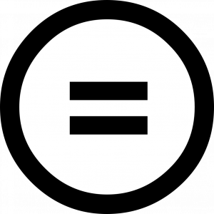
ND means that you cannot share an adaptation of the work, though you could use and share it in its original form. An example of an adaptation of an image would be changing its colour, blurring it, or adding another image on top of it. An example of an adaptation of a written work would be translating it to a different language
.For more information on these elements, check out the CC Wiki

Types of Creative Commons Licenses
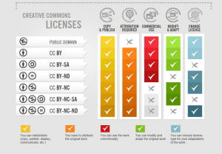

JoKalliauer; foter, CC BY-SA 3.0 <https://creativecommons.org/licenses/by-sa/3.0>, via Wikimedia Commons
Attribution
CC BY
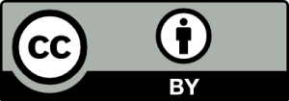
This license lets others distribute, remix, adapt, and build upon your work, even commercially, as long as they credit you for the original creation. This is the most accommodating of licenses offered. Recommended for maximum dissemination and use of licensed materials.
Attribution-ShareAlike
CC BY-SA

This license lets others remix, adapt, and build upon your work even for commercial purposes, as long as they credit you and license their new creations under the identical terms. This license is often compared to “copyleft” free and open source software licenses. All new works based on yours will carry the same license, so any derivatives will also allow commercial use. This is the license used by Wikipedia, and is recommended for materials that would benefit from incorporating content from Wikipedia and similarly licensed projects.
Attribution-NoDerivs
CC BY-ND

This license lets others reuse the work for any purpose, including commercially; however, it cannot be shared with others in adapted form, and credit must be provided to you.
Attribution-NonCommercial
CC BY-NC
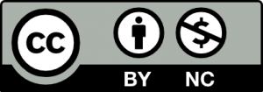
This license lets others remix, adapt, and build upon your work non-commercially, and although their new works must also acknowledge you and be non-commercial, they don’t have to license their derivative works on the same terms.
Attribution-NonCommercial-ShareAlike
CC BY-NC-SA

This license lets others remix, adapt, and build upon your work non-commercially, as long as they credit you and license their new creations under the identical terms.
Attribution-NonCommercial-NoDerivs
CC BY-NC-ND

This license is the most restrictive of our six main licenses, only allowing others to download your works and share them with others as long as they credit you, but they can’t change them in any way or use them commercially.
An interactive H5P element has been excluded from this version of the text. You can view it online here:
https://ecampusontario.pressbooks.pub/openingupeducationaninteractivediscussion/?p=63#h5p-4
An interactive H5P element has been excluded from this version of the text. You can view it online here:
https://ecampusontario.pressbooks.pub/openingupeducationaninteractivediscussion/?p=63#h5p-3
An interactive H5P element has been excluded from this version of the text. You can view it online here:
https://ecampusontario.pressbooks.pub/openingupeducationaninteractivediscussion/?p=63#h5p-2

Key Takeaways
- Creative Commons licenses are built on top of copyright and work within existing copyright laws. Due to this, creators are able to retain copyright while granting others permission to use their work.
- There are four elements to Creative Commons licenses – Attribution (BY), Share Alike (SA), NonCommercial (NC), and Non Derivatives (ND).
- The four elements are used to create 6 types of Creative Commons licensing.
- All licenses require attribution (title, attribution, source, license).
- NonCommercial (NC) is determined by whether the use of work is for commercial purpose, not whether the user is a commercial entity.

Chapter 4

Open Education Resources

Open Education Resources
Educational resources are available all over the internet, however, this does not mean they are “open” resources and free to use. Consider that OERs are defined as being “freely available, high-quality learning materials that can be downloaded, edited, and shared to better serve all students.” (Hewlett Foundation).

Why Use OERs
There are many reasons to use OERs including improving student engagement and retention, improve accessibility and equity for students and providing up to date materials. The BCOER infographic below highlights some of the benefits from different perspectives.
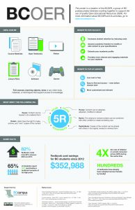

“5Rs of Open”.
For a resource to be open, it is recommended they have the “5Rs of Open”.
Retain
The right to make, own, and control copies of the content for example, download, and store. Copies can be kept for personal archives or reference.
Reuse
The right to use the content in a wide range of ways (e.g., in a class, in a study group, on a website, in a video); content can be reused in its unaltered original format.
Revise
The right to adapt, adjust, modify, or alter the content itself (e.g., translate the content into another language); content can be modified or altered to suit specific needs.
Remix
The right to combine the original or revised content with other open content to create something new (e.g., incorporate the content into a mashup)
Redistribute
The right to share copies of the original content, revisions or remixes with others (e.g., give a copy of the content to a friend)

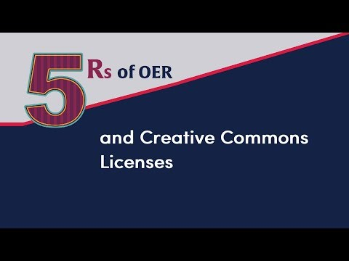
A YouTube element has been excluded from this version of the text. You can view it online here: https://ecampusontario.pressbooks.pub/openingupeducationaninteractivediscussion/?p=86
OER, The 5Rs of Open, and Creative Commons Licenses by Martha Greatrix under a Creative Commons Attribution license.

Finding OERs
There are several ways to search for OERs. Many people probably would start with a Google search but with all the resources available, this might be overwhelming.
A more effective strategy is to use OER repositories. There are effective because the resources have been assessed and are included in the repository based on their findability, ease of use and wide ranging disciplinary materials.
Here is a list of some of the OER Repositories currently available:

Photographs and Images
The Gender Spectrum Collection. Photo library featuring images of trans and non-binary models that go beyond the clichés.
Creative Commons Search
Flickr.comsupports Creative Commons. A filter on its site facilitates search results from creators who want to share their work.
Unsplash.comAll the photos on Unsplash can be used for for free whether they are for

General OER Repositories
Creative Commons Search – A repository of various types of media, including images, music, and videos.
OER Commons – A large collection of a variety of types of OER, including textbooks, courses, and ancillary materials.
MERLOT – “a curated collection of free and open online teaching, learning, and faculty development services contributed and used by an international education community.”
CORE– Based in the United Kingdom, CORE is committed to aggregating open access research from across the globe.
eCampusOntario H5P Studio:Ontario educators can create, share, and discover over 45 different types of interactive activities which can be embedded in your LMS. There is a database of created OERs which can be used or adapted.
eCampusOntario Open Library:Ontario’s home for open educational resources. The library has over 500 resources spanning from textbooks to syllabi. All the resources in the Open Library have an Open License.

Textbooks
OpenStax – Supported by Rice University, OpenStax has a huge collection of open, peer-reviewed textbooks on a large variety of subjects.
Project Gutenberg – A collection of tens of thousands of digitized books available for download; audiobooks are also available.
AU Press – Athabasca University’s AU Press publishes open access journals and books with a focus on Canada, the North American West, and the Circumpolar North.
Courses
Khan Academy – A collection of instructional videos and practice exercises on topics including math, science, programming, history, English, economics, and standardized test prep.
MIT OpenCourseWare– offers free access to almost all MIT course content
Saylor Academy – a non-profit organization committed to providing free and open online courses
Coursera – an educational platform partnered with dozens of prestigious universities and institutions (including MoMA, Stanford, Yale, the University of Toronto, and the University of London)

Discipline-Specific Repositories
Mathematics and Sciences – https://phet.colorado.edu/en/simulations/
University of Colorado at Boulder creates open source, research-based, interactive simulations for mathematics and the sciences.
Psychology – https://nobaproject.com/
NOBA is an open and free online platform that provides a high-quality, flexibly structured psychology resource for instructors and students. Noba has also curated the various modules into a number of “Ready-Made” textbooks that instructors can use as-is or edit to suit their needs.
Nursing – http://cms.montgomerycollege.edu/edu/department.aspx?id=8522
Montgomery College offers 10 video scenarios depicting difficult, real-world issues in nursing. Accompanying each scenario are documents to support learning and reflection.
Business – https://mitsloan.mit.edu/LearningEdge/simulations/
English as a Foreign Language – http://oedb.org/ilibrarian/50_essential_resources_for_esl_students/
This offering is a meta-OER. It aggregates comprehensive resources on EFL and divides its list into the specific topics of concern for learners.
Open Culture – http://www.openculture.com
Open Culture brings together high-quality cultural and educational media for the worldwide lifelong learning community. Its mission is to centralize this content, curate it, and provide access to this high-quality content whenever and wherever users want it.

Evaluating OERs
There are several resources that help in evaluating OERs. Much like evaluating any online resource, it is important to ensure the information is credible and in the case of OERs, has the correct licensing.
To assess online resource:
The CRAAP Test
To assess OERs:
Achieve Rubric for Evaluating OER
BC OER Faculty Guide for Evaluating Open Education Resources
Open Education Network Open Textbook Review Criteria

Adapting v Creating OERs
There is a vast array of OERs in every disciple and these can be be reused, revised, remixed, and redistributed. Before considering creating a new OER, search the repositories for material that might be reusable; content that you can update or improve on to keep the OER movement going.
Before starting on the process of creating new materials, think about the steps in this Decision tree.
Creating OER – Decision
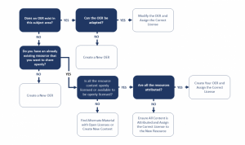
Creating OER – Decision Tree by E. Fields licensed under CC BY-SA 4.0

Steps For Developing an OER
This interactive developed using the H5p platform provides a short overview of the steps to consider when developing an OER.

An interactive H5P element has been excluded from this version of the text. You can view it online here: https://ecampusontario.pressbooks.pub/openingupeducationaninteractivediscussion/?p=86#h5p-5

Other considerations
Accessibility

Part of the benefit of developing and using OERs is to create inclusivity and accessibility.
OERs can increase accessibility by:
- Removing legal barriers to adapting and customizing the content to suit a learning environment by the use of Creative Commons Licenses.
- Provide the opportunity to curate content to meet the needs of students who have typically been marginalized, for example, students with disabilities, language barriers or other historical accessibility and inclusivity issues.
- OERs can be adapted to meet accessibility issues and through sharing can cut down duplication and workload across educational institutions.
- OERs reduce costs for both the educator and the student.
There are many excellent resources to support educators in developing accessible OERs:
BCcampus’s Open Education Accessibility Toolkit
Merlot Open and Accessibility

Open Pedagogy
It is important not just to use OERs, it is important to look at our approaches to teaching.
There is not clear definition of Open Pedagogy. One that I am personally drawn to is from Maja Bali “The potential of openness and sharing to improve learning, as well as a social justice orientation – caring about equity, with openness as one way to achieve this.
Some other aligning concepts include using a constructivist education approach, reflective practice, integration of technologies, use of OERs, engaging students as co-creators.
I think the concept of students as co-creators is particularly important. Mike Neary (2010) discussed this idea in the Student as Producer model where there was collaboration between educators and students in producing knowledge, This idea really forces an educator to think from a student centered focus when both developing OERs and in delivering the knowledge.
Part of having Students as Producers, includes students developing work to share not just with their instructor but also with a wider audience outside the classroom. It includes students working on authentic issues and having some level of autonomy in their work.
Another aspect is the concept of ‘renewable assignments’. This addresses the issue of what I call “make work” projects, assignments that are completed for a grade and then disposed.
There are many issues with having sharing students’ work, note least of which is privacy, which need to be considered.
The UBC Open Pedagogy Toolkit provides a comprehensive review of open pedagogy and provides ideas for its’ implementation.

Examples of OERs
The following OERs were created by me while participating in the Ontario Extend Empowered Educator Micro credential and UBC POSE
Both these programs, while having different focuses, are excellent and have inspired me as an educator.
Ontario Extend Curator Module – “Business Writing”
The focus of this OER was to address academic writing issues including APA referencing for out of country students. I wanted to find ways to make the content more engaging and to build on my portfolio of content that had the students developing their knowledge through activities instead of just doing presentations and ‘lecturing’ even in this online situation.
I searched through all the various databases just to have an understanding of what is available but I predominantly used https://openlibrary.ecampusontario.ca. and was able to use the materials contained there to develop the attached materials. As I did this in just a day, I now plan to turn this presentation into an H5P Studio interactive slide show. I also used Mentimeter ( see attached file) and Unsplash.com for my pictures. I also developed a graphic using Canva.com
Ontario Extend Experimenter Module: H5p – Preparing for an interview the Heineken Way
This interactive video is of an interview campaign run by Heineken and was designed to be a fun introduction to my interview techniques class. The students watched them in small breakout groups and then we debriefed as a class. They loved it!

Ontario Extend Experimenter Module: GIFs – Welcome to the course
As we are all online, and often the course shells are active at least a week in advance, I wanted to create a welcoming and fun atmosphere for my welcome the course announcement. I developed this Gif using pictures from Unsplash.com and created a PowerPoint which I then turned into a Gif using the ScreentoGIF software.
Ontario Extend Experimenter Module: Infographics – IELTS v TOEFL Inforgraphic
I used Canva.com to create an infographic to highlight the differences between the IELTS and TOEFL exams.
UBC POSE: Create a slide using a CC licensed image – Introduction to interview techniques
I used H5P Course Presentation and added videos, one of which is interactive as well as some images all which include the correct metadata and licensing information. I spent quite a bit of time reviewing the You Tube License agreement/information One of the videos (How to answer behavioural questions) has a CC license the others are licensed under the You Tube agreement. I have also included pictures from Unsplash and The Noun Project. I also found an academic journal article which turned out to be published under CC which is the first time I have seen or maybe just noticed this.

Key Takeaways
- The use of OERs is fundamental to the open education movement.
- OERs are cost effective for both students and faculty.
- It is recommended that the OER allow for the 5Rs: reuse, remix, retain, revise and redistribute.
- It important to ensure that accessibility and equity issues are addressed when developing OERs.
- When using existing OERs, it is important to evaluate them.
- Curriculum planning and teaching approaches, including open pedagogy should be a part of the OER development process.
- When sharing OER it is important to improve discoverability by selecting the appropriate OER repository.

