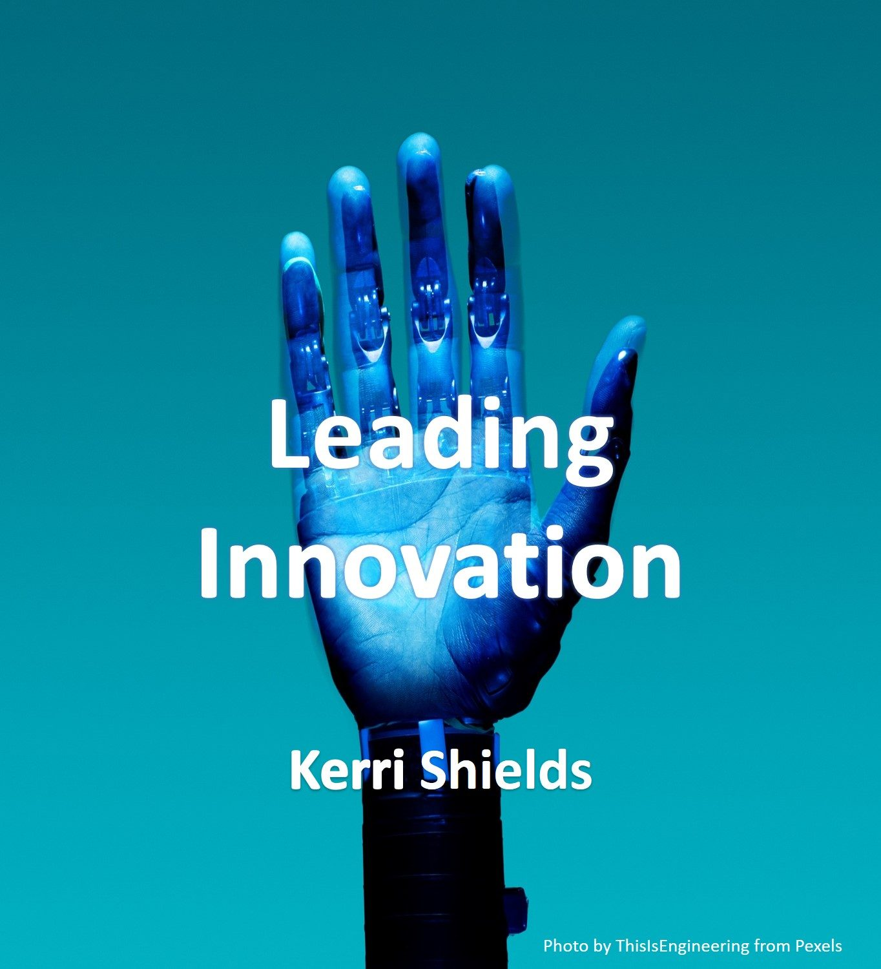

Leading Innovation, 1st Edition

Leading Innovation, 1st Edition

Kerri Shields
Kerri Shields
Toronto

Leading Innovation, 1st Edition Copyright © 2022 by Kerri Shields is licensed under a Creative Commons Attribution-NonCommercial-ShareAlike 4.0 International License, except where otherwise noted.

Contents
- Introduction
- Chapters
- Chapter 1: Business Innovation Foundations
- Chapter 2: Thinking Creatively
- Chapter 3: Service Innovation
- Chapter 4: Process Innovation
- Chapter 5: Sustainable Innovation
- Chapter 6: Growth Strategy
- Chapter 7: Design Thinking
- Chapter 8: Product Innovation
- Chapter 9: Innovation Risks
- Chapter 10: Leading Innovation
- Glossary of Terms

1

Introduction

Concept
Innovation today considers the economic, environmental, and/or social sustainability of an innovative initiative from its inception or idea generation through to its commercialization or implementation. This concept applies to many types of innovation such as products, processes, services, technologies, and business models. Companies use innovation as a means to gain competitive advantage and bring value to business stakeholders. This book introduces business innovation, from incremental innovation such as enhancing the performance of an existing product, service, or process, to radical or disruptive innovation such as one that has a significant impact on a market. Content examines how leaders foster a culture of innovation, how companies turn creativity into innovation, and how innovation transforms not only organizations, but economies as well.

Chapter Features and Bloom’s Taxonomy
- Chapter Learning Outcomes — The learning outcomes listed within each chapter align with the lower levels of Bloom’s Taxonomy of Educational Objectives for Knowledge-based goals (knowledge and comprehension) based on the activity of simply reading the chapter. Should readers complete the exercises within the chapters and at the end of the chapters, higher levels of Bloom’s Taxonomy can be reached (application, analysis, synthesis, evaluation).
- Example-rich narrative
- Embedded videos with PDF transcripts
- Graphic elements which illustrate and reinforce concepts
- Self-assessments (e.g., quiz, game, or other H5P content)
- Explore the Concept and End-of-Chapter Exercises
- Key Takeaways
- Additional resource links and Chapter references for additional reading
- Embedded navigation and image alt-text for screen readers
- Free online, PDF, and various other book formats
- PowerPoint slides to support the presentation of chapter concepts
- Glossary of Terms
- Open license, Creative Commons Attribution-NonCommercial-ShareAlike 4.0 International License permits adoption, adaptation (customization), and sharing

eCampus Ontario
eCampusOntario is a provincially-funded non-profit organization that leads a consortium of the province’s publicly-funded colleges, universities, and indigenous institutes to develop and test online learning tools to advance the use of education technology and digital learning environments.
This textbook is part of the eCampusOntario (and BCCampus) open textbook library, which provides free learning resources in a wide range of subject areas. These open textbooks can be assigned by instructors for their classes and can be downloaded by learners to electronic devices. These educational resources are customizable to meet a wide range of learning needs.
If you decide to adopt this book for a course or training program (or other) please report your adoption as eCampusOntario is keen to report students’ savings and connect with successful OER adopters.

Book Versions
Below is a record of edits and changes made to this book since its initial publication. Whenever edits or updates are made in the text, a record and description of those changes will be noted here. The edition number will only change when there is a major update to the book. The ancillary files (i.e., test bank, slides) that accompany this book always reflect the most recent version.
Table 0.1: Leading Innovation Book Versions
Date of Publication | Edition | Revisions
March 3, 2022 | Leading Innovation, 1st Edition
November 9, 2022 | Leading Innovation, 1st Edition, Version 2
July 21, 2023 | Leading Innovation, 2nd Edition
Accessibility
Every attempt has been made to make this OER accessible to all learners and compatible with assistive and adaptive technologies. The Pressbooks content management system was chosen for its commitment to built-in accessibility. The Web version of this resource has been designed to meet Web Content Accessibility Guidelines 2.0, level AA and follows all guidelines in Appendix A: Checklist for Accessibility of the Accessibility Toolkit – 2nd Edition. In addition to the web version, additional files are available in a number of file formats including PDF, EPUB (for eReaders), and Course Cartridge (for LMS).
If you are having problems accessing this resource, please contact kshields@centennialcollege.ca. Please include the following information: The location of the problem by providing a web address or page description. A description of the problem. The computer, software, browser, and any assistive technology you are using that can help us diagnose and solve your issue (e.g., Windows 10, Google Chrome (Version 65.0.3325.181), NVDA screen reader)
Each chapter has been evaluated using WAVE® and modified as needed to meet zero errors in accordance with WCAG AA. “WAVE® is a suite of evaluation tools that helps authors make their web content more accessible to individuals with disabilities. WAVE can identify many Web Content Accessibility Guideline (WCAG) errors, but also facilitates human evaluation of web content. Our philosophy is to focus on issues that we know impact end users, facilitate human evaluation, and to educate about web accessibility.”
- All images that convey information include alternative text (alt text) descriptions of the image’s content or function. Graphs and charts also include contextual or supporting details in the text surrounding the image. Images do not rely on colour to convey information.
- All colours meet WCAG contrast requirements.
- Content is organized under headings and subheadings. Headings and subheadings are used sequentially (e.g., Heading 1, Heading 2).
- Embedded videos are from YouTube and do have closed captioning available, although many YouTube videos have captions that are auto-generated and these do not always translate correctly. To combat this issue, PDF (English) transcripts have been posted for download with each chapter video.
- Tables are used to structure information and not for layout. Tables include row and column headers. Row and column headers have the correct scope assigned. Tables include a caption. Tables avoid merged or split cells. Tables have adequate cell padding.
- The Microsoft Accessibility checker was run on PowerPoint slides that accompany the book. ALT tags were added to images, PDF (English) transcripts are posted with embedded videos, colour contrast was checked.
- All Web links describe the destination of the link and do not use generic text such as “click here” or “read more”. If a link will open or download a file (e.g., PDF), a textual reference is included in the link information (e.g., [PDF–New Tab]).
- In-text citations are embedded using the Footnote feature of Pressbooks, therefore, footnotes appear as References at the end of each chapter with Web links to the original sources.
- Font size is 12 points or higher for body text in PDF documents. Font size can be enlarged to 200 percent in Webbook or Ebook formats without needing to scroll side to side.
- An H5P element is included with each chapter as a quick review of the chapter’s content. These are accessible based on the H5P type. The goal for the accessible content types is WCAG 2.1 AA support, so the content types have been tested against these criteria and more by the H5P.org developers. Refer to the accessible content types list for additional information.
- PowerPoint slides have been checked with the Microsoft Accessibility checker to ensure proper colour contrast. Images contain ALT text. Fonts are 24 points or larger. PDF Transcripts are linked with each embedded Video. PDF copies of each slide deck are also provided.

Author
As a college professor, I have developed many courses and used creativity and innovative skills to develop projects and engaging content for students. What I have learned about innovation, is that it takes a lot of hard work and a little creativity to be innovative. I have built skills in researching, developing partnerships, networking, solving problems, and spotting opportunities to make changes and improvements. Some of my successful innovative ideas include: embedding industry certifications in courses to enable students to gain industry credentials, using open educational resources (OER) to reduce student fees, partnering with software vendors to embed current business technologies within courses to enable students to practice with current systems and prepare for the work world.
Prior to my career as a college professor, I worked in the human resource solutions industry and used creativity and innovative thinking to design corporate training modules that fit the unique needs of each client. Clients would have a need but often did not have a solution. My job was to identify the problem/need and recommend solutions, then apply creativity and innovation to implement the clients’ vision. Win-win for everyone!
I hope you find the content in this book interesting and the lessons helpful. You may find some tips for improving your personal creative thinking skills as well as learn some of the important concepts pertaining to business innovation.
I will try my best to update the book content from time to time and check that videos or resources do not become obsolete or outdated.
Sincerely,
Kerri Shields

References
(Note: This list of sources used is NOT in APA citation style instead the auto-footnote and media citation features of Pressbooks were utilized to cite references throughout the chapter and generate a list at the end of the chapter.)

eCampus Ontario. (2021).

WAVE. (n.d.).

1

Chapter 1: Business Innovation Foundations

Chapter 1 Learning Outcomes
After reading this chapter, you should be able to do the following:
- Define business innovation.
- Explain why businesses innovate.
- Describe four (4) types of innovation.
- List characteristics of innovative products and services.
- Explain how the Systematic Inventive Thinking (SIT) methodology can be applied to help people think more creatively.

What is Business Innovation?
A century ago, Thomas Edison thought deeply about what drives invention or, as we call it today, innovation. One of his famous sayings, “Genius is 1 percent inspiration and 99 percent perspiration,” stresses that innovation involves more than just great ideas. Edison knew from his own experience that the systematic hard work of trial-and-error experimentation paid off. His inventions, like the lightbulb and the phonograph, emerged through thousands of attempts as he refined the process step by step.
There are many definitions for innovation and even the innovation experts in today’s business world cannot agree on the definition of innovation. Below are definitions from 15 innovation experts.

Explore the Concept – 15 Definitions of Innovation
Which do you think best defines the term “innovation”? Why?
- Turning an idea into a solution that adds value from a customer’s perspective. (Nick Skillicorn)
- The application of IDEAS that are novel and useful. (David Burkus)
- Staying relevant. (Stephen Shapiro)
- A great idea, executed brilliantly, and communicated in a way that is both intuitive and fully celebrates the magic of the initial concept. (Pete Foley)
- A feasible relevant offering such as a product, service, process, or experience with a viable business model that is perceived as new and is adopted by customers. (Gijs Van Wulfen)
- Introduction of new products and services that add value to the organization. (Kevin McFarthing)
- Any variation goes, as long as it includes “new” and it addresses customer needs and wants. (Robert Brands)
- The fundamental way the company brings constant value to their customer’s business or life, and consequently their shareholders and stakeholders. (Paul Hobcraft)
- Work that delivers new goodness to new customers in new markets, and does it in a way that radically improves the profitability equation. (Mike Shipulski)
- Creativity is thinking of something new. Innovation is the implementation of something new. (Paul Sloane)
- The implementation of creative ideas in order to generate value, usually through increased revenues, reduced costs, or both. (Jeffrey Baumgartner)
- I try not to define “innovation” as we should tone down our use of the work and term. (Stefan Lindegaard)
- Anything that is new, useful, and surprising. (Drew Boyd)
- New organic value creation by applying creativity, in-depth relationships with consumers and customers, and new thinking. (Michael Graber)
- The future delivered. (Jorge Barba)
We might give business innovation a more encompassing definition. Business Innovation is “Executing an idea that addresses a specific challenge or opportunity and achieves value for both the company and its stakeholders.” Of course, stakeholders include customers, government, partners, suppliers, shareholders/owners, lenders, society, employees (and their families), and the community.



When we think of innovation in the great big world, including the innovations of organizations, we might define Innovation in more broad terms, such as, “Creating something new that serves people’s needs or wants.”

Why Do We Innovate?
Innovative ideas are envisioned by individuals, businesses, and governments because of the following reasons.
- Remain competitive and relevant and avoid obsoletion
- Keep up with customer demands, preferences, and trends
- Adapt to take advantage of changes in modern technology
- Reduce expenses
- Increase revenues
- Improve efficiency and/or effectiveness
- Improve company and/or brand image
- Expand market share
- Improve the quality of life
- Improve the standard of living
- Attract investors, employees, and partners
- Solve a problem
- Take advantage of an opportunity
As commonly said in business, innovation is the only Imperative. In a world where everything changes rapidly, the field of business has been left no other option but to keep pace. Whether the innovation is about making a product more user-friendly or creating a more efficient finance model, Innovation is bound to happen.
What is the calculus of innovation? The calculus of innovation is quite simple: Knowledge drives Innovation, Innovation drives Productivity; Productivity drives Economic Growth. – William Brody

Where Do Good Ideas Come From?
Innovation is the process of taking an idea and putting it into practice. Creativity, on the other hand, is what you do in your head to generate the idea. An innovative idea must be new, original, or improved, and must create value.
Once a business has a creative idea it must determine if the idea is feasible to implement. Can it be done? Is it affordable? Are resources available or obtainable? Will it meet the needs of the target audience? Before spending time and money researching and developing a new product or changing a business model, feasibility and risk must be assessed.
Watch the YouTube video below, “Where Good Ideas Come From” to learn about where you can find or how you can develop good ideas. Transcript for “Where Good Ideas Come From” Video [PDF–New Tab]. Closed captioning is available on YouTube.
One or more interactive elements has been excluded from this version of the text. You can view them online here: https://ecampusontario.pressbooks.pub/leadinginnovation/?p=5#oembed-1

Why is Innovation Important?
Today, we need innovators more than at any time before. Every organization and business is feeling the impact of globalization, migration, technological and knowledge revolutions, and climate change issues. Innovation will bring added value and widen the employment base. Innovation is imperative if the quality of life in these trying circumstances is to improve. Innovation will make the world a better place for the younger generation.

What are the Types of Innovation?
We often see innovations in products and services being offered to customers, but there are many other types as well. Innovation can be classified based on the degree of innovation as well as the object of innovation.

Degree of Innovation
Incremental Innovation is the concept of growing or improving a company by making a succession of small-scale improvements to existing products, services, processes, and tools. Incremental innovation focuses on improving existing offerings to align with current consumer trends and is considered a relatively low-risk approach. This approach is the most common type of innovation and has helped many companies remain competitive for decades.
A few examples:
- Volkswagen (VW) releases a new Golf model every five years or so.
- Gillette uses incremental innovation each time it brings out the next generation of its razors.
- Microsoft innovates incrementally with each new Windows release (Win 3.1, Win XP, Win 7, Win 8, Windows 10).
Disruptive Innovation is the launch of a new business model, concept, product, or service that creates a new market segment and value drivers. Often, disruption comes from a new company, which eventually displaces established market leaders and products. This approach focuses on meeting consumer demands in ways that no other product or service has done before. Disruptive innovation often creates entirely new markets or a fundamental shift in how consumers interact with the current market after the disruptive product is introduced.
- There are quite a few examples of disruptive innovation, one of the more prominent being Apple’s iPhone disruption of the mobile phone market. Prior to the iPhone, most popular phones relied on buttons, keypads, or scroll wheels for user input.
- Apple’s iTunes and Spotify are streaming music platforms that made previous music formats obsolete. Do you know what a vinyl record is? How often do you see a physical music store? They used to exist. As each new technology became available it disrupted the music industry and made past formats obsolete. For example, we used to listen to music on vinyl records, then 8-track tapes and cassette tapes, then compact discs (CDs), then MP3 digital music (iPod craze), and more recently with iTunes and Spotify. Streaming music seems to be where it’s at, for now!
- Netflix’s business model is subscription-based. It is a streaming platform, which offers on-demand video. The evolution of movie formats–8mm film to videocassettes (VHS, Beta) to CD, DVDs, and Blu-rays took home entertainment to the next level, then Netflix brought us movie streaming. Movie streaming has revolutionized the home entertainment experience. When Netflix began streaming movies, video rental companies such as BlockBuster went out of business and cinemas also saw reduced revenues. While Blockbuster clung to its business model of being a video rental company, Netflix constantly disrupted itself. Netflix went from a business model of being a DVD subscription rental service to streaming movies and TV series to being a creator of content.

Object of Innovation
Products and services are the most common objects to innovate, but there are many types of innovation and they are categorized in many ways.

Business Model
Business Model Innovation is probably the most challenging of the innovation types as it will likely present an organization with major requirements for change. Often, the very capabilities or processes that have been optimized to make a company successful and profitable will become the targets for transformation. In some cases, these changes can threaten elements of the company’s identity and come into conflict with brand expectations or promises.
Whereas both product and process innovation can be incremental and moderate, business model innovation is almost always radical, risky, and transformative. When talking about business model innovation, without a doubt, names like AirBnB, Uber, or Spotify will come up. These are perfect examples of fast-moving companies that were able to disrupt age-old markets (hotel, taxi, music) by tweaking or inverting their industry’s traditional business model.

Social innovation
Social Innovation refers to a response to a social or environmental problem, which, once adopted, results in better solutions than existing approaches. Social innovations have a transformative impact and improve organizations, communities, regions, or systems.
Social innovation can include:
- new, more effective social programs
- the use of new technologies
- the growth of social enterprises
Social enterprises are businesses that pursue a social or environmental mission.
In Canada, activity at the governmental level includes the government’s launching of a Social Innovation and Social Finance Strategy to provide better support to community organizations working to tackle social challenges. The strategy includes a Co-Creation Steering Group made up of 16 leaders, practitioners, and experts from multiple fields, including the community, philanthropic, financial, and research sectors, and complemented with public consultation.

Product innovation
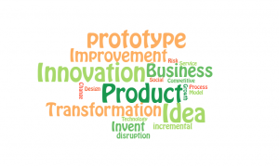
When people think of innovation, often, they’re thinking of product innovation. Product Innovation can come in three different forms. 1) The development of a new product, such as the Fitbit or Amazon’s Kindle. 2) An improvement of the performance of the existing product, such as an increase in the digital camera resolution of the iPhone 11. 3) A new feature to an existing product, such as power windows to a car.
Drivers of product innovation might be technological advancements, changes in customer requirements and demands, or outdated product design. Product innovation is generally visible to the customer and should result in a greater demand for a product.

Service innovation
With the growing economic importance of the services sector, service innovation is playing an ever more significant role in driving growth in today’s knowledge-intensive economy. Service Innovations ensure and enhance the utility, performance, and apparent value of an offering. Some offerings are purely service, such as getting a haircut, hiring someone to paint your house, or taking an Uber to your friend’s place. These are services you may utilize throughout your lifetime. Other service innovations may be combined with product offerings, such as purchasing groceries (products) and having them delivered to your home (service), or buying a new television (product), and purchasing the warranty (service).
Service innovations may make a product easier to enjoy, reduce the risk associated with buying a product or may make a product more compelling to buy. Service innovations may simply make your life more enjoyable. Who doesn’t enjoy a visit to the spa? According to SuperOffice, 86% of buyers will pay more for a great customer experience.

Explore the Concept – Product and Service Innovation
Consider a business that you have been buying from for several years and answer the following questions.
- Which services have you noticed they offer today that they may not have offered in previous years? When you went for a hair cut were there any new service offerings at the salon? When you ordered online were there any new services? New service innovations may add some small service that enhances the customer experience or be fully new and something you have not seen in the past. During COVID many companies added new services in order to abide by isolation guidelines. For example, many businesses offered customers an opportunity to order online and have their products shipped to their homes, or customers could drive to the store, park, and have their order delivered to their vehicle in the parking lot.
- What service offerings do you enjoy most? Playing a game of paintball? Going to the Cinema? Taking dance lessons? Dining at a restaurant? Whatever it is, consider whether it is a service offering or a combination of service and product offering?
- What products have you been talking about with your friends lately–new shoes, new cell phones, or new restaurants? Many new products are simply incremental innovations but many customers are eagerly awaiting the next release of the iPhone or an Xbox or Wii game. What are you eagerly waiting for?

Process innovation
Process is the combination of facilities, skills, and technologies used to produce, deliver, and support a product or provide a service. Within these broad categories, there are countless ways process can improve. While product innovation is often visible to customers, a change in process is typically only seen and valued internally. Generally, changes in process reduce costs of production more often than they drive an increase in revenue. Of the three types of innovation, process is typically the lowest-risk.



by
has been designated to the
Process Innovation can include changes in the equipment and technology used in manufacturing (including the software used in product design and development), improvement in the tools, techniques, and software solutions used to help in supply chain and delivery system, changes in the tools used to sell and maintain goods, as well as methods used for accounting and customer service.
One of the most famous and groundbreaking examples of process innovation is Henry Ford’s invention of the world’s first moving assembly line. This process change not only simplified vehicle assembly but shortened the time necessary to produce a single vehicle from 12 hours to 90 minutes.

Technological Innovation
Technological Innovation focuses specifically on technology and how to embody it successfully in many types of innovations such as products, services, processes, profit models, channels, and customer service engagement innovations. Regardless of the industry or products, technology is likely to be a pillar for businesses because many innovations stem from advances in technology. By embracing AI, machine learning, data science, and automation, businesses can innovate in each of these areas to improve internal processes and external communications. Ultimately, these advances will positively impact productivity, sales, marketing, and customer service.

Explore the Concept – Technology Innovation
Consider the following examples.
- Do you own an Internet of Things (IoT) device? These devices connect to the Internet. Have you heard of the refrigerator that automatically keeps track of what is put in and what is taken out? Samsung has a refrigerator with a feature called SmartThings Video. This feature lets people watch security cameras from the fridge.
- Many people are talking about artificial intelligence these days. And yes, in many cases, the topic is covered with exaggerations and hype. Fortunately, the overall AI progress and the pace of the underlying technological innovation easily justify this hype. Consider the progress achieved in fields like Deep Learning and areas such as Computer Vision and Natural Language Processing.
- Virtual reality (VR) technology is exploding. So are the opportunities for innovative experiences, use-cases, and products. Content creation for VR is a great opportunity with significant startup activity worldwide. VR startups are working across multiple domains and business scenarios, including E-commerce, gaming, social applications, learning and education, healthcare, online VR environments, and more. The next few years will bring impressive progress on all VR hardware, applications, and VR content.
- Blockchain is one of the most disruptive technologies out there. Its distributed, decentralized, and immutable properties make it the ideal way to store and track data across numerous domains. In the years to come, we shall see new applications and novel scenarios beyond crypto-currencies and fin-tech. Startups are already working on novel concepts that make sense to leverage blockchain. Some of these will disrupt the social, government, and even political aspects of our world.

Doblin’s Ten Types of Innovation®

Ten Types of Innovation® Framework
The Ten Types of Innovation® Framework is a great way to categorize innovation types. For many years, executives equated innovation with the development of new products. But creating new products is only one way to innovate, and on its own, it provides the lowest return on investment and the least competitive advantage. The Ten Types of Innovation® Framework (as shown below in Figure 1.1) provides a way to identify new opportunities beyond products and develop viable innovations.

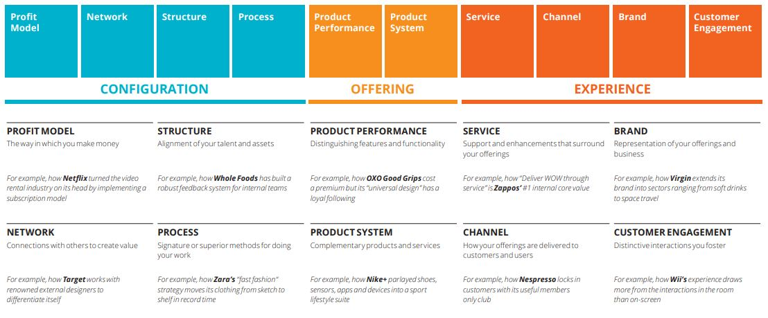

Figure 1.1
by
, all rights reserved. Used according to
.

What is Systematic Inventive Thinking (SIT)?
Systematic Inventive Thinking (SIT) is a thinking methodology where creativity takes center stage. It contains five thinking patterns that humans have used for thousands of years. It directly contradicts the principle of ‘thinking outside the box’ and uses ‘thinking inside the box’ as a guiding principle.
Studies have found that the majority of new, inventive, and successful products result from only five patterns or templates, which form the basis of the innovation method called Systematic Inventive Thinking (SIT)-or inside-the-box thinking.
Most innovators and creative people use patterns and structured thinking to innovate. Agatha Christie, for example, wrote over 60 novels and has sold more books than anyone. She did it by using a familiar template in each of her books. That template helped structure her thinking in a way that made her more creative. This is the essence of a method called Systematic Inventive Thinking (SIT). With SIT, innovation follows a set of patterns that can be reapplied to any product, service, or process.

Cognitive Fixedness
SIT helps you overcome cognitive fixedness. Cognitive Fixedness is a state of mind in which you think of an object or situation in one specific way, to the exclusion of any alternative. SIT promotes thinking of objects in various situations and uses.

Two Principles
According to Drew Boyd, a global leader in creativity and innovation, using the five SIT patterns correctly relies on two key principles.
The first is the Closed World Principle is the notion that the best and fastest way to innovate is to look at resources close at hand. The famous architect Frank Lloyd Wright followed this principle when he created the spectacularly beautiful and unique home in Pennsylvania called Fallingwater. He used existing rocks, streams, and elements around the home as part of the building, visualizing all of the environmental components as part of the Closed World.
With the second principle, Function Follows Form Principle, you begin with an abstract, conceptual solution and then work back to the problem that it solves. The Function Follows Form Principle is the opposite of the famous “form follows function” principle, which has been followed by many innovators throughout the past century. This principle helps overcome the drawbacks of traditional research-led or design-based innovation.
Conventionally, product innovation begins with consumer need identification that’s then translated into functions, therefore the form of the product is identified by the functions the product will be used for by consumers. Most consumers however struggle to articulate unmet needs and would have difficulty imagining a new product that never existed before. For example, people most probably would not have thought of needing a car when horses and buggies were being used for locomotion. There is a famous quote from Henry Ford, “If I had asked people what they wanted, they would have said faster horses.”

Five Thinking Patterns
SIT applies a backward approach to innovation. Rather than starting with needs in the market, SIT would have you start by applying the five thinking patterns to existing products and services in order to ideate new products and services. After some ideas were generated you would evaluate whether or not these new innovative ideas will fill a need or want of consumers. If they will then you determine if developing these new ideas is feasible for the company (e.g., resources) and if the company can mitigate the risks involved.
Surprisingly, the majority of innovative products and services can be explained by just five patterns as listed in table 1.1 below. Check out Drew Boyd’s Pinterest page for multiple examples of each pattern.
Table 1.1 Systematic Inventive Thinking (SIT) – Five Patterns
Subtraction | Remove an essential component from a product and find a new arrangement of the existing components. Examples: Discount airlines subtracted the frills. Removing ear covers from traditional headphones resulted in earbuds. Dyson fan without blades.
Task Unification | Assign a component of a product an additional job, one that it wasn’t designed to do. Examples: Some facial creams moisturize and block the sun. The Fitbit tells you the time, how many steps you walked, and so much more.
Multiplication | Take a component and copy it but change the component in some counterintuitive way. Examples: A bicycle may have training wheels added to the rear wheels for stability. Blenders with multiple-sized containers to blend different recipes.
Division | Take a component or the product itself and divide it along some physical or functional line and then rearrange it back into the product. Examples: Single-serve size foods such as Cup-O-Soup. Cargo pants that zip apart to make shorts.
Attribute Dependency | Two or more product attributes that previously seemed unrelated now correlate with one another. When one thing changes, something else changes. Examples: Windshield wipers that change speed as the amount of rain changes. The mood ring shows the mood of the user at any given time.

Creative Constraint
SIT uses thinking inside the box as a guiding principle, which means using constraints to help you be more creative in solving problems. Constraints can foster innovation when they represent a motivating challenge and focus efforts on a more narrowly defined path. Having some constraints may incite big thinking, while having too many constraints may limit outcomes. Constraints may include limited time, money, or requiring results to include very specific needs.
Watch “The Power of Creative Constraints” YouTube Video below to learn more about creative constraints. Transcript for “The Power of Creative Constraints” Video [PDF–New Tab]. Closed captioning is available on YouTube.
One or more interactive elements has been excluded from this version of the text. You can view them online here: https://ecampusontario.pressbooks.pub/leadinginnovation/?p=5#oembed-2

Key Takeaways
- Business Innovation is “Executing an idea that addresses a specific challenge or opportunity and achieves value for both the company and its stakeholders.” Of course, stakeholders include customers, government, partners, suppliers, shareholders/owners, lenders, society, employees (and their families), and the community.
- When we think of innovation in the great big world, including the innovations of organizations, we might define Innovation in more broad terms, such as, “Creating something new that serves people’s needs or wants.”
- Today, we need innovators more than at any time before. Every organization and business is feeling the impact of globalization, migration, technological and knowledge revolutions, and climate change issues. Innovation will bring added value and widen the employment base. Innovation is imperative if the quality of life in these trying circumstances is to improve. Innovation will make the world a better place for the younger generation.
- Incremental Innovation is the concept of growing or improving a company by making a succession of small-scale improvements to existing products, services, processes, and tools. Incremental innovation focuses on improving existing offerings to align with current consumer trends and is considered a relatively low-risk approach. This approach is the most common type of innovation and has helped many companies remain competitive for decades.
- Disruptive Innovation is the launch of a new business model, concept, product, or service that creates a new market segment and value drivers. Often, disruption comes from a new company, which eventually displaces established market leaders and products.
- Social Innovation refers to a response to a social or environmental problem, which, once adopted, results in better solutions than existing approaches. Social innovations have a transformative impact and improve organizations, communities, regions, or systems.
- Product Innovation can come in three different forms. 1) The development of a new product, such as the Fitbit or Amazon’s Kindle. 2) An improvement of the performance of the existing product, such as an increase in the digital camera resolution of the iPhone 11. 3) A new feature to an existing product, such as power windows to a car.
- Service Innovations ensure and enhance the utility, performance, and apparent value of an offering. Some offerings are purely service, such as getting a haircut, hiring someone to paint your house, or taking an Uber to your friend’s place. These are services you may utilize throughout your lifetime. Other service innovations may be combined with product offerings, such as purchasing groceries (products) and having them delivered to your home (service), or buying a new television (product), and purchasing the warranty (service).
- Process Innovation can include changes in the equipment and technology used in manufacturing (including the software used in product design and development), improvement in the tools, techniques, and software solutions used to help in supply chain and delivery system, changes in the tools used to sell and maintain goods, as well as methods used for accounting and customer service.
- Business Model Innovation is probably the most challenging of the innovation types as it will likely present an organization with major requirements for change.
- Technological Innovation focuses specifically on technology and how to embody it successfully in many types of innovations such as products, services, processes, profit models, channels, and customer service engagement innovations.
- The Ten Types of Innovation is a great way to categorize innovation types.
- Systematic Inventive Thinking (SIT) is a thinking methodology where creativity takes center stage. It contains five thinking patterns that humans have used for thousands of years.
- Cognitive Fixedness is a state of mind in which you think of an object or situation in one specific way, to the exclusion of any alternative.
- With the Function Follows Form Principle you begin with an abstract, conceptual solution and then work back to the problem that it solves. The Function Follows Form Principle is the opposite of the famous “form follows function” principle, which has been followed by most innovators over the past century.
- Constraints can foster innovation when they represent a motivating challenge and focus efforts on a more narrowly defined path. Having some constraints may incite big thinking, while having too many constraints may limit outcomes. Constraints may include limited time, money, or requiring results to include very specific needs.

End-of-Chapter Exercises

- New Innovation Development. Research one of these companies – Walmart, Lego, Coca Cola, Ikea, Google – and find out what they are working on in the way of innovation then share your findings with the class and professor.
- Innovation Lab. Enterprise companies across all industries, including Walmart, H&M, and Starbucks have opened innovation labs to help them fast-track new products, understand market trends, and develop solutions for customers. Find a company that has an Innovation Lab, research what it is all about and how it is used. Share your findings with the class and your professor.
- Technology Innovation. Find a new Technology Innovation other than those mentioned within the chapter. Research it. How will this technological innovation be used? Who will it help? What value does it bring? Provide an example of where it is used now (if it is already in production or prototype). Share your findings with your class and professor.
- Cognitive Fixedness. Practice overcoming cognitive fixedness (thinking a product can only be used in a very specific way). Pick up a coffee mug. What would most people say it is used for? Apply SIT by applying each of the five patterns to this coffee mug. What did you invent by applying each pattern? Who would use your new innovations? What value would they bring? Compare your innovative ideas with a partner (another student). Did you derive similar results or were they very different? Discuss with your class and professor. This exercise can be done with just about any item you wish to start with.
- Cognitive Fixedness. Try it again, practice overcoming cognitive fixedness (thinking a product can only be used in a very specific way), but this time grab a plastic shopping bag. Many of these bags are thrown into the garbage after one use. Apply SIT by applying each of the five patterns to this plastic bag. What did you invent by applying each pattern? Who would use your new innovations? What value would they bring? Compare your innovative ideas with a partner (another student). Did you derive similar results or were they very different? Discuss with your class and professor. This exercise can be done with just about any item you wish to start with.
- Non-polluting car. Wouldn’t it be great to have flying cars that ran on sunshine? Let’s try an exercise in innovative thinking within the box (applying constraints). Discuss with a partner (another student) how you might create a car that would not pollute the environment, that would not make noise (or very little), that would not be too expensive for consumers, and that would be a car disabled people (e.g., sight impaired, physical impairment, hearing impaired – you may wish to work with one constraint at a time then try combining them) could drive. Apply SIT by applying each of the five patterns to this innovative problem. What ideas did you come up with? Are they feasible? Can they be developed in today’s world or will they have to wait until some technological advancement is made in society? Discuss with your class and professor.

Self-Check Exercise – Matching Game – Ten Types of Innovation®

To complete this exercise you may need to do a little research on Doblin’s Ten Types of Innovation® first. Have fun testing your memory by matching image cards with text cards to pair each type of innovation.
Note: Cards have audio (please adjust audio settings on your device as desired).

An interactive H5P element has been excluded from this version of the text. You can view it online here:
https://ecampusontario.pressbooks.pub/leadinginnovation/?p=5#h5p-1

Additional Resources
- Innovation that Change The World
- Top 10 Latest Technological Innovations
- Think Inside the Box: The Power of Constraint. YouTube Video.
- Ten Types of Innovation, Deloitte

References
(Note: This list of sources used is NOT in APA citation style instead the auto-footnote and media citation features of Pressbooks were utilized to cite references throughout the chapter and generate a list at the end of the chapter.)

Media Attributions
- Person wearing a prosthetic leg © Photo by ShotPot from Pexels is licensed under a CC0 (Creative Commons Zero) license
- Innovation Wordle © Kerri Shields is licensed under a CC0 (Creative Commons Zero) license
- Vehicle Assembly Line © Image by Clker-Free-Vector-Images from Pixabay is licensed under a CC0 (Creative Commons Zero) license
- Fan without blades © Pinterest is licensed under a All Rights Reserved license
- Fitbit © Drew Boyd Pinterest Collection is licensed under a All Rights Reserved license
- Blender with multiple tops © Pinterest is licensed under a All Rights Reserved license
- Zip pants © Pinterest is licensed under a All Rights Reserved license
- Mood ring

Otazo, K. (n.d.).

Idea to Value. (n.d.).

Everyday Power. (2021).

Johnson, S. (2010, September 17).
[Video]. YouTube.

Shukla, A. (2009, May 30).

Differential. (2020, March 20).

Differential. (2020, March 20).

Government of Canada. (2021, August 12).

Leeuwen, M. (2018, October 31).
Social Innovation Academy.

Differential. (2020, March 20).

Differential. (2020, March 20).

Kulbyte, T. (2021, June 24).

Kulbyte, T. (2021, June 24).

Kulbyte, T. (2021, June 24).

Differential. (2020, March 20).

Richards, R. (2021, September 1).

PYMNTS. (2020, January 2).

Krasadakis, G. (2017, November 27).

Krasadakis, G. (2017, November 27).

Krasadakis, G. (2017, November 27).

Nieminen, J. (2020, August 30).

toolshero. (n.d.).

Boyd Guitars. (2022).

Boyd, D. (2014, July 3).
[Video]. LinkedIn Learning.

Boyd Guitars. (2022).

Vlaskovits, P. (2011, August 29).

Boyd, D. (2014, July 3).
[Video]. LinkedIn Learning.

Rodriguez, B. (2010, September 17).
[Video]. YouTube.

2

Chapter 2: Thinking Creatively

Chapter 2 Learning Outcomes
After reading this chapter, you should be able to do the following:
- Identify eight creative thinking ideas to boost your personal creativity.
- Explain three ways to enhance team collaboration and creativity.
- Identify three threats to team creativity.
- Describe the “shape of ideation” as it is graphed from a team ideation session.
- Describe the SCAMPER technique for brainstorming.
- List three barriers to creativity.
- List three benefits of doing creativity exercises.
- List ten reasons businesses nurture creativity and innovation.

Inspiration or Perspiration
A century ago, Thomas Edison thought deeply about what drives invention or, as we call it today, innovation. One of his famous sayings, “Genius is 1 percent inspiration and 99 percent perspiration,” stresses that innovation involves more than just great ideas. Edison knew from his own experience that the systematic hard work of trial-and-error experimentation paid off. His inventions, like the lightbulb and the phonograph, emerged through thousands of attempts as he refined the process step by step ().
Thomas Edison knew breakthroughs do not come from “lightbulb” moments (pun intended). His quote captures this concept perfectly.

“Genius is 1% inspiration and 99% perspiration” (Thomas Edison)

Personal Creativity
Not everyone considers themselves creative, but most of us do have the ability to be creative. We use our creative minds more often than we think. Whenever you solve a problem, try something new, or give advice to a friend, you are probably using creative thought.
Just like doing physical exercise to work out your body, sometimes you need to do mental exercises in order to work out your mind. Watch the video below to learn about the following eight creative thinking tips you can put into practice to help boost your creativity.
- Schedule Creative Free Time
- Set a Timer
- Think Quantity Over Quality
- Become an “Idea Machine”
- Switch Up Your Routine
- Look at Something Familiar Through a New Lens
- Read More
- Freewrite More
Watch the “8 Creative Thinking Exercises to Boost Your Creativity” YouTube Video below to see if there is an exercise to boost your creative thinking. Transcript for “8 Creative Thinking Exercises to Boost Your Creativity” Video [PDF–New Tab]. Closed captioning is available on YouTube.
One or more interactive elements has been excluded from this version of the text. You can view them online here: https://ecampusontario.pressbooks.pub/leadinginnovation/?p=38#oembed-1
There is a misconception that creativity is this thing that happens in the shower, a strike of lightning that you get out of nowhere, but the reality is creativity is not a moment in time, it’s a process and it takes time to develop.
If you were to generate a list of possible solutions to any given problem you may notice that the first few on the list will be similar to ideas other people may also come up with, but as you get to the bottom of the list you may find your ideas become more unique. This is because we solve problems every day in our lives and we are good at it. If I asked you how you will get to work today since your car is being repaired at the service center, you might say, “I’ll get a ride with a friend,” or “I’ll take the bus,” or “My mechanic loaned me a vehicle.” If I then asked you to think of some other ways you might get to work, I’m sure your ideas will become more novel as you provide additional possibilities. These novel ideas may not always be feasible, but while you are brainstorming new ideas, don’t judge them for feasibility, just get the ideas first (quantity), then later evaluate each idea on how well it resolves the problem or takes advantage of the opportunity.

Commands for Being Creative

- Get Stupid! Throw out what you know and start from somewhere new. Try drawing an image of a telephone. What did you draw? Something you have seen? Did you think to draw a phone that does not exist yet? Lose the concept of what you think a phone is and start thinking about what a phone might be in the future.
- Want the Box. Constraints are necessary for creativity. The more boundaries you have the more creative you will be.
- Can the critic. Don’t listen to the critic inside you that always tells you, “that’s a bad idea.” Ignore this voice.

Explore the Concept – Personal Creativity Exercise
Doing daily creative warm-up exercises may help you become a more flexible thinker in your job and help you approach work challenges with less fear and a more playful attitude.
- Take any household product you use daily, such as a coffee cup, a hairbrush, a toothbrush, a pen, a notebook, a laptop, etc.
- Use one of the following innovation techniques to change the product. You don’t actually have to change the product but imagine it would be changed and this change you make will provide a new function or value to the user.
  - Addition Technique: Add something to the product to change it. What can it now do or be used for?
  - Subtraction Technique: Subtract or take away a part of the product. What can it now do or be used for?

- Answer Example: For the addition technique, you might add another handle to a mug, making it easier to hold or making it into a sippy cup for toddlers (if you also added a lid). For the subtraction technique, you might subtract or remove the handle on the mug altogether turning it into a travel mug that will fit in a car cup holder.

SCAMPER Technique for Brainstorming
Creative thinking and problem-solving are essential parts of the design process to turn ideas into innovation and break the barriers against creativity. One of the successful methods used in creative thinking is the SCAMPER technique. While there are different creative thinking and problem-solving techniques such as reversed brainstorming, Hurson’s thinking model, the Six Hats of critical thinking, and Lego Serious Play, SCAMPER is considered one of the easiest and most direct methods. The SCAMPER technique is based very simply on the idea that what is new is actually a modification of existing old things around us.
What does the SCAMPER acronym stand for?
- S–Substitute (e.g., components, materials, people)
- C–Combine (e.g., mix, combine with other assemblies or services, integrate)
- A–Adapt (e.g., alter, change function, use part of another element)
- M–Modify/Magnify (e.g., increase or reduce in scale, change shape, modify attributes)
- P–Put to other uses (e.g., more than one way to use, more than one function)
- E–Eliminate (e.g., remove elements, simplify, reduce to core functionality)
- R–Rearrange/Reverse (e.g., turn inside out or upside down)
Click on the information icon beside each of the letters below to learn more about SCAMPER.
Transcript for “SCAMPER” H5P [PDF–New Tab].

An interactive H5P element has been excluded from this version of the text. You can view it online here:
https://ecampusontario.pressbooks.pub/leadinginnovation/?p=38#h5p-4

Benefits of Doing Creativity Exercises
Creativity exercises offer many benefits for individuals, groups, or companies who use them, including the following:
- Improved flexible thinking: Creativity exercises improve your mental flexibility. You may see the possibility of small shifts or changes to a project that you didn’t notice before.
- Discovery of multi-dimensional ideas: If you or your team have been working in the same field for a long time, you might use the same ideas repeatedly. Creativity exercises help you discover entirely new solutions to repetitive problems.
- Embracing work challenges: With enough practice, work challenges become something to look forward to as an opportunity to show and improve your mental creativity rather than a test delaying your progress.
- Seeing new concepts: Some creativity exercises help develop your creative vision, allowing you to see objects, ideas, and problems in a new way. This is highly beneficial when looking for a novel solution to a business challenge.
- Improved teamwork: Creativity exercises help individuals and groups improve teamwork skills like communication, problem-solving, and unity.

Team Creativity
Team creativity is based on having open debates, and a free flow of ideas. For that to happen, trust must exist among team members. Where trust is lacking–so will creativity. Below are some ideas on how to enhance creativity and collaboration in teams, as well as some threats to team creativity.
When teams are working creatively during an ideation session there is a common pattern that occurs. At first, many ideas are shared that are not very unique, then ideas wane, then a spark of inspiration hits the team which drives momentum again but this time with unique ideas which may provide companies with new paths to increasing revenue, market share, and more. This pattern is known as the shape of ideation and you will read more about this below.

Enhancing Creativity and Collaboration in Teams
- Complementary Skill Sets. Collaboration works best when team members have complementary and diverse skill sets required to complete the project. Companies may also consider collaborating with customers, experts in the field, or experts in technical, design, marketing, and finance areas.
- Appreciating Others. Engaging in purposeful conversations and the ability to resolve conflicts are essential ingredients for collaboration. The team needs time to get to know each other not just as professionals, but as human beings, to build trust through informal social interaction.
- Open Communication. Encourage people to voice their ideas and opinions. Team members need to know it is okay to share their ideas and opinions, and that this is actually valued. When team members feel comfortable sharing their thoughts, it’s more likely to foster the kinds of discussions required to generate creative solutions.
- Facilitate Diverse Ways of Working. People have their own ways of doing things. Some people like to work in teams; others prefer to work alone. Some enjoy using a pencil and notepad to jot down their thoughts, while others always make notes on their tablets or make voice recordings on their phones. Managers and team leaders need to allow people to choose how they work – as long as they do their jobs and do them well – they’re happier, and that can prompt more creativity.
- Prevent Internal Competition. Competition for a promotion, pay raise, bonus, or anything else among team members has a negative effect on team creativity. Team members will try to promote their own ideas, or even not share ideas within the team, and rather share them outside the team with the team leader, or upper management. No internal competition among team members should exist.
- Establish Ground Rules. Include rules such as “nobody gets to monopolize the conversation,” and “nobody gets to be quiet all the time.” Establish what happens when someone is late to a meeting. Will you allow using computers and phones in the meeting (hint: do you want their full attention or not?) Make sure you keep a “parking lot” list of things so you do not forget any ideas.

Threats to Team Creativity
Social Loafing: This is the tendency for group members to slack off. These members may think their ideas are dispensable or may see other members working hard, and believe they do not need to contribute.
Conforming: Members may conform due to the desire to be liked. If they believe their teammates will be critical of their suggestions, they will be more likely to agree rather than disagree.
Production Blocking: This can occur when members cannot express their ideas because others are expressing their own. When working alone, individuals can work without interruption of thought, whereas when working in a group, members may forget their ideas or may not get time to speak.
Performance Matching: When working in a team for an excessive amount of time, members will start to develop the same tendencies. Members that achieve higher ideals than the group may “lower their standards”, whereas members that work at a slower pace may “raise the bar”. Overall, the team will plateau and may find it more difficult to generate unique ideas over time.

Team Ideation Session: Graphing the Process
What happens in our thinking process when we are given a problem to solve in a specific amount of time? As described by Stefan Mumaw in the LinkedIn Learning, Creativity Boot Camp course, if we graphed this ideation process for a group trying to solve a problem or take advantage of an opportunity, we would see a graph that at first has many ideas, but after a short period of time the group feels they have exhausted all the good ideas, and the ideas stall. What happens next, is that someone offers a different, silly, or absurd idea, then more ideas come from that idea and the tide has turned. The best ideas often come after this turn in the graph. This is known as the shape of ideation because it consistently reveals itself this way.

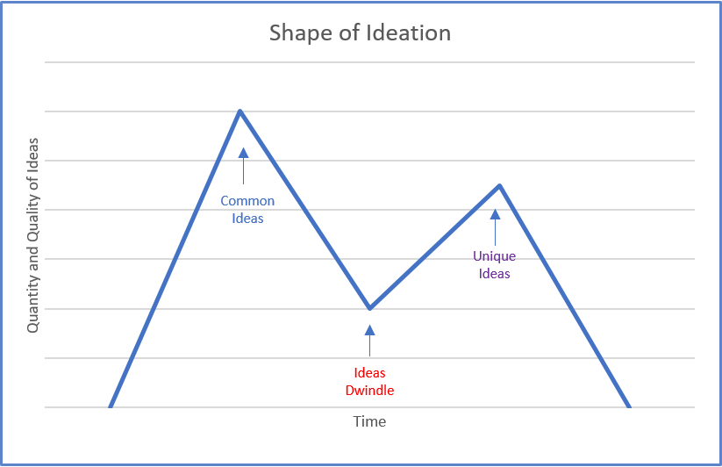

Explore the Concept – Team Creativity Exercise
A common problem experienced during creative collaboration is interpreting what team members mean when they explain abstract concepts. This is a fun, and quite enlightening game of interpretation that addresses this issue. You may even find yourself using it as a party game outside of work!
You’ll need strips of paper with phrases or actions written out on them, something like “singing in the rain” or “Mother Earth.” Everyone starts with their own phrase and, to the best of their ability, draws it out on the first page of their notebook. After 30 seconds, everyone passes their notebook to the person on their left. That person then has 30 seconds to interpret the drawing and write down what they think it is on the next page in the notebook. The next person draws what the last person wrote. The notebook gets passed again and again until it makes it back to the original owner. Once each notebook is back where it started, the owner of the notebook shows each page to the group to see how the original phrase got interpreted down the line.
This exercise really demonstrates how meaning can get misconstrued and the importance of explaining things with other people’s sensibilities taken into account.

Barriers to Creativity
Below is a list of some of the things that can be barriers to personal, team, and organizational creativity.
- Functional fixedness. You see objects, components, and things around you, and you can’t imagine them doing different functions than what they’re designed to do.
- Structural fixedness. This makes it really hard to imagine objects having a different structure than what we’re used to.
- Relational fixedness. This type of fixedness makes it very hard to imagine two objects having a relationship that wasn’t there before.
- Self-censorship. Get the critic out of your mind. Stop telling yourself your ideas are not good enough.
- Micro-Management. Micro-Management stifles a person’s ability to be creative as micromanagers provide too much detail related to how a particular task or problem should be tackled. This reduces the ability for the person to think for themselves and add their own creative flair.
- Overthinking. Overthinking about a problem or task uses the logical conscious side of our mind. Often creativity comes from the subconscious mind so rather than overthinking it might be wise to go for a walk or simply start daydreaming.
- Concerns about Image. Image risks are where people worry about the impression that people will have of them after suggesting an idea.
- Lack of Time. Lack of time and/or opportunity. People often feel that they are too busy with their day-to-day efforts to have time to focus on being creative. Resolve this by setting some planned time aside each and every day for creative efforts.
- Lack of Sleep. Lack of sleep not only forms barriers to creativity but to most other things too! Try and lead a healthy well-balanced life with lots of exercise and water and healthy nutrition.
- Criticism. Criticism from others can off-put you from proceeding any further with your ideas. Try and dismiss negative thinkers or win them over by demonstrating the validity of your idea with a prototype.
- Rules, Policies, and Procedures. If the organization that you work in has lots of rules, policies, and procedures then these can sometimes stifle creativity due to the bureaucracy that they create. If you can’t advance your project forward without five signatures then you will find it difficult to maintain momentum.
- Fear of Rejection. Just having that underlying fear that others will reject your ideas can be a barrier to creativity. Work with your passions, enjoy your creative moments, and don’t let others put you off.
- Stress. Stress is not only a distraction that drains the energy we might channel into being creative, it is also very bad for our health and concentration.
- Lack of Motivation, commitment, skills to perform creative tasks, or employee preparation to persist.
- Lack of organizational or managerial support or sufficient resources for creative work.

Importance of Creativity and Innovation to Business
Creativity fuels innovation. Creativity is a thought process, while innovation is an action. For a business to survive it needs both. Some of the top reasons businesses nurture creativity and innovation include:
- Innovation helps organizations grow.
- Innovation keeps organizations relevant.
- Innovation helps organizations differentiate themselves.
- Innovation increases productivity in the workplace by sparking excitement and feelings of purpose in employees.
- Innovation improves a team’s problem-solving skills by challenging the team to dive deeper and develop novel solutions.
- Innovation helps organizations position themselves as innovators in the marketplace.
- Innovation helps organizations generate more profits.
- Innovation helps organizations reduce expenses.
- Innovation helps organizations attract employees, investors, partners, and contractors.
- Innovation helps organizations gain a competitive advantage.

Key Takeaways
- Eight creative thinking tips you can try any time. Schedule creative free time, Set a timer, Think quantity over quality, Become an “Idea Machine,” Switch up your routine, Look at something familiar through a new lens, Read more often, and Freewrite more often.
- Commands for being creative. Get stupid! Want the box. Can the critic.
- Benefits of doing creativity exercises. Improved flexible thinking, Discovery of multi-dimensional ideas, Embracing work challenges, Seeing new concepts, and Improved teamwork.
- Team creativity is based on having open debates, and a free flow of ideas.
- Enhancing creativity and collaboration in teams. Collaboration works best when team members have complementary skill sets required to complete the project. Engaging in purposeful conversations and the ability to resolve conflicts are essential ingredients for collaboration. Open communication must be there. Facilitate diverse ways of working. Establish ground rules for working together.
- Threats to team creativity. Social loafing, Conformity, Production blocking, and Performance matching.
- Team ideation session: Graphing the process. When given a problem to solve in a specific amount of time what happens in our thinking process? If we graphed this ideation process we would see a graph that at first has many ideas, but after a short period of time the group feels they have exhausted all the good ideas, and the ideas stall. What happens next, is that someone offers a different, silly, or absurd idea, then more ideas come from that idea and the tide has turned. The best ideas often come after this turn in the graph. This is known as the shape of ideation because it consistently reveals itself this way.
- Barriers to creativity. Functional, structural, and relational fixedness; self-censorship; micro-management; overthinking; concerns about image; lack of time; lack of sleep; criticism; rules, policies, and procedures; fear of rejection; stress; lack of motivation; and lack of organizational or managerial support.
- Importance of Creativity and Innovation to Business.

  - Innovation helps organizations grow.
  - Innovation keeps organizations relevant.
  - Innovation helps organizations differentiate themselves.
  - Innovation increases productivity in the workplace by sparking excitement and feelings of purpose in employees.
  - Innovation improves a team’s problem-solving skills by challenging the team to dive deeper and develop novel solutions.
  - Innovation helps organizations position themselves as innovators in the marketplace.
  - Innovation helps organizations generate more growth and profits.
  - Innovation helps organizations reduce expenses.
  - Innovation helps organizations attract employees, investors, partners, and contractors.
  - Innovation helps organizations gain a competitive advantage.

End-of-Chapter Exercises

  - Wild Westios. Most people think of the Wild West as a uniquely American era in history. However, during the same time, Canada was also expanding westward. With this expansion came a collection of interesting personalities, including brave lawmen, tricky outlaws, and proud, hard-working cowboys.
    - Grab a partner to try this creative exercise. Together you are going to write down as many cereal box toys as you can think of if boxes of cereal were around during the days of the wild, wild, west. You have three minutes to compile one list together; write down as many ideas as you can.
    - Compare Groups. How many ideas did you and your partner come up with in three minutes? Sometimes people say they don’t have time to come up with more ideas, but as you can see given only three minutes you and your partner were able to come up with some ideas. So time is not a problem, motivation may be an issue when it comes to thinking creatively. For this exercise you may have been motivated because the exercise was silly and fun, you had a partner to work with, maybe your professor was observing you, and you only had three minutes to finish the task. This exercise is adapted from one called Wild Westios shared in the LinkedIn Learning, Creativity Boot Camp module.

  - Ultimate Desk. You have been sitting behind a desk of some form for almost your entire professional life. It’s time to retire whatever weak desk you’ve been using and come up with the most awesome desk ever devised by humankind. Money is not an issue, design is no issue, and materials are not an issue. There is only one rule and it is that the desk you create must actually perform the function of a desk in some way.
    - Grab a partner. You have five minutes to create the ultimate desk. Discuss and sketch it out.
    - Compare Groups. How many desks had a beverage dispenser? How many desks were mobile, roll or fly? How many desks have some sort of water feature? How many desks come with some sort of extra person, such as a chef or masseuse? How many desks have a large flat surface? Why a large flat surface? Because that is what you know. We start with what we know a desk to be. We attach ideas to what we know, so we become improvers. We have to stop starting with other people’s solutions and we have to ask questions. What is a desk and what does a desk need to do? We insert restrictions that are not really there. This exercise is adapted from one called Ultimate Desk shared in the LinkedIn Learning, Creativity Boot Camp module.

  - Squiggles. This exercise should take you five minutes. Take a sheet of paper and draw 5 to 10 squiggles in different shapes and sizes. Now turn your squiggles into birds. Think about the main characteristics of a bird (beak, tail, legs) and start adding them. First, draw a beak which is a simple triangle – make variations in size and position. Then, do the same with the tale, which is also a triangle. Finally, add legs that are made out of sticks. That is how simple it is! Take a look at the drawings and spend a minute considering how easily the brain finds patterns.
  - Write a Six-Word Story. Ernest Hemingway, one of the greatest authors of all time, was once challenged to write a complete story in just six words. Never one to shy from a challenge, he wrote: “For sale: baby shoes, never worn.” What would your complete six-word story be?
  - Packaging Yourself. If you were a product, available for sale at your favourite retail store, what store would you be sold in? What would the packaging look like? What would your catchy product title be? What would it say on the box? This is not just an exercise in creative thinking, but of establishing your own personal brand in a fun and inventive way.
  - Find Creative Uses for Everyday Objects. A pen is just a pen…or is it? What do you have around you right now that could be used for something completely different? Alton Brown, the chef who knows his science, refuses to buy objects that have just one use. He finds ways to use kitchen tools in the most inventive ways. So what can you do with that stapler, the pair of scissors, or that old bookend?
  - How Creative Are You? quiz Try the quiz at How Creative Are You? (QUIZ) | HuffPost Life

Self-Check Exercise – Quiz – Thinking Creativity

An interactive H5P element has been excluded from this version of the text. You can view it online here:
https://ecampusontario.pressbooks.pub/leadinginnovation/?p=38#h5p-5

Additional Resources
- LinkedIn Learning Creativity Bootcamp Training
- 50 Fun Creativity Exercises to Boost the Power of Your Creative Mind
- 21 Ways to Boost Your Personal Creativity
- 5 Team Building Exercises Guaranteed to Spark Creativity
- Business Innovation – Canada Periodical Fund – Canada.ca
- Innovation Canada (ic.gc.ca)
- MaRS Discovery District

References
(Note: This list of sources used is NOT in APA citation style instead the auto-footnote and media citation features of Pressbooks were utilized to cite references throughout the chapter and generate a list at the end of the chapter.)

Media Attributions
- The Shape of Ideation © Stefan Mumaw adapted by Kerri Shields is licensed under a All Rights Reserved license

Otazo, K. (n.d.).

Johnson, S. (2010, September 17).
[Video]. YouTube.

Elmansy, R. (n.d.).

Serrat, O. (2009, February 31).

Indeed. (2021, March 19).

Creativity at Work. (n.d.).

Creativity at Work. (n.d.).

Kelly. (2019, August 22).

Kelly. (2019, August 22).

Solomon, Y. (n.d.).

Solomon, Y. (n.d.).

Kaur, S. (n.d.).

Kaur, S. (n.d.).

Kaur, S. (n.d.).

Kaur, S. (n.d.).

Mumaw, S. (2014, November 19).
[Video]. LinkedIn Learning.

Zvonek, R. (2017, June 7).

Innovation-Creativity. (n.d.).

Ozment, D. (2020, September 22).

Ozment, D. (2020, September 22).

Ozment, D. (2020, September 22).

Mumaw, S. (2014, November 19).

Strimaityte, A. (2019, November 26).

Sugget, P. (2020, February 6).

Sugget, P. (2020, February 6).

Sugget, P. (2020, February 6).

3

Chapter 3: Service Innovation

Chapter 3 Learning Outcomes
After reading this chapter, you should be able to do the following:
- Define “service innovation”.
- Explain four evolving trends in service innovation.
- Discuss how service attributes, benefits, and values are connected.
- List five things businesses can do to increase customer value.
- Explain the importance of considering the user, buyer, and payer when innovating.
- Discuss the Customer Star Framework for aligning service innovations.

The New Service Landscape
Service innovations take place across all industries and around the world. Of course, this involves service firms, but product-based companies can also develop service innovations. A service innovation changes the way customers are served to create value for customers and revenue for the company. Through a new service innovation, a company may increase its revenue due to existing customers spending more, improved positive company image, referrals, etc.
This sector accounts for 75% of Canadian jobs and 78% of the country’s GDP. The sector includes the following sectors; transportation, economic, health care, construction, banking, communication, retail, tourism, and government. As a vital part of the Canadian economy, the most popular sector is retail with some big franchise names including Walmart and Future Shop. In recent years, the financial services, real estate, and communications industries have grown exponentially, especially in the business hubs of Vancouver, Montreal, and Toronto.

A service innovation changes the way customers are served to create value for customers and revenue for the company.

Four Evolving Trends in Service
The nature of services and the pace of change have shifted dramatically in recent years, and mastering the traditional aspects of service delivery will no longer be enough. To seize the opportunities, companies must learn to tap the potential for service innovation made possible by four evolving trends.
- Higher customer expectations. More than ever, consumers demand greater involvement, customization, personalization, and mobility from services—with immediate results. When they see cutting-edge service innovations in one industry, they expect to find them in others as well; witness the spread of self-service kiosks from airline check-ins to the retailing and hospitality industries.
- The rise of the mobile Internet. Just about everyone has a cell phone today and the number of apps is extensive. The resulting mobile and self-service possibilities are transforming service delivery. Uber’s disruption of the taxi business is just one prominent example. Advances in digital payments are increasingly spurring mobile commerce, with far-reaching implications in financial services and retailing. Remote access and monitoring in healthcare are also potential game-changers made possible by increased connectivity. The proliferation of smart devices unlocks growth opportunities, reduces the cost to develop services, and dramatically lowers barriers to entry.
- Big data and advanced analytics. Companies such as Amazon and Harrah’s are known for using customer data to personalize and tailor their services. Continued advances in analytic capabilities allow companies to draw insights from massive, previously untapped sources, leading to new service possibilities.
- The Internet of things (IoT). The prevalence of connected devices opens up possibilities for proactive, even “touchless” service, as well as new commercial models quite unlike the traditional fee-for-service one.

Service Innovation Examples
An interesting thing about service innovations is that they are often combined with other types of innovations. For example, if you are a customer of Tim Hortons then you may have used their loyalty program. When you place a product order you gain points and when you get enough points you can use those points to purchase a product. The app is a service innovation for customers as it improves the customer experience and adds value to their transactions. The app is also a technological innovation as well as a process innovation for the company. When customers use the points program it changes the payment process for staff and the technology integrates with the payment system which allows the company to gather data about consumer purchases and preferences.
Airbnb’s business is primarily based on service innovation. The creative entrepreneurial innovation allows people to travel and stay at different hosts connecting them in advance. Airbnb is giving tough competition to the hotels in the hospitality industry, thus disrupting the industry, and forcing the existing way of doing things to evolve and the existing companies to innovate to keep up.
Netflix produced a series of disruptive innovations that revolutionized how people get their daily dose of entertainment at cheap prices.
Need a snack on the go? Forgot your toothbrush or charger? It’s not a problem at Grab, a line of taxis in Singapore that offers in-car convenience stores. The simple solution shows that innovative ideas don’t need to be flashy as long as they meet customers’ needs. Providing items to customers when they need them most solves a major pain point.

Discover What Customers Want
Many companies start their service innovation journey at the wrong end. They look at their existing services and try to find ways to improve them. For a more promising approach through service innovation, they should begin by asking the following questions.
- How can we relieve customers from activities they do not like to perform?
- How can we enable customers to perform activities they cannot do without our service?
- How can we make it easier for customers to do what they need or want to do?
In order to create break-thru innovations, a company must do more than just add an element or a single attribute to an existing service or product. Unfortunately, most of the customer surveys businesses use today are trying to do just that, evaluate customer satisfaction based on current attributes. When you ask a customer what they want from their car mechanic they might say, “to pay less,” “to know my car is repaired and safe to drive, peace of mind,” or “to be quick and save me time by getting me back on the road again.” In order to successfully innovate, a business must have a very clear and systematic understanding of what they do and how the customer benefits from it. For example, if the bank offers a drive-through ATM, which is an attribute, the benefit to the customer might be that the bank helps them to save time. If the bank stays open until 10 p.m. they are meeting the customer’s need for convenient hours of service. There is often more than one relationship between the attributes and the benefits. For example, a drive-through ATM may not only offer time savings but also safety, or it increases personal mobility and freedom for handicapped customers who cannot walk to the bank. When you meet with customers to find out what they really want it is helpful to take notes, ask questions, and separate attributes from benefits. If an attribute is not a benefit to customers then you may need to consider removing it.
Linking (also known as laddering) product or service attributes to benefits and benefits to customer values helps companies sell products and services to customers. Customers seek attributes in products and services that bring them the benefits they value, and they will not pay for attributes that do not bring them the benefits they value. The formula for customer value can be written as: (Total Customer Benefits – Total Customer Costs) = Customer Value, or (B – C = CV).

Tips for Businesses to Increase Customer Value
- Evaluate your customer experience. Make it convenient for the customer to buy, and provide options in how the customer wants to buy and pay.
- Focus on more than price. Reduce the price, or don’t, but provide something extra over the competition (this could be improved service, better attention, community, improved quality, warranties, and other add-ons to the product or service).
- Collect customer data. Consider surveys, focus groups, observation, trends analysis, buying behaviour, needs/wants, and preference history.
- Target your most loyal customers. Keep these customers by providing the benefits that bring them value.
- Segment your customer base. Different segments have different needs for different benefits.

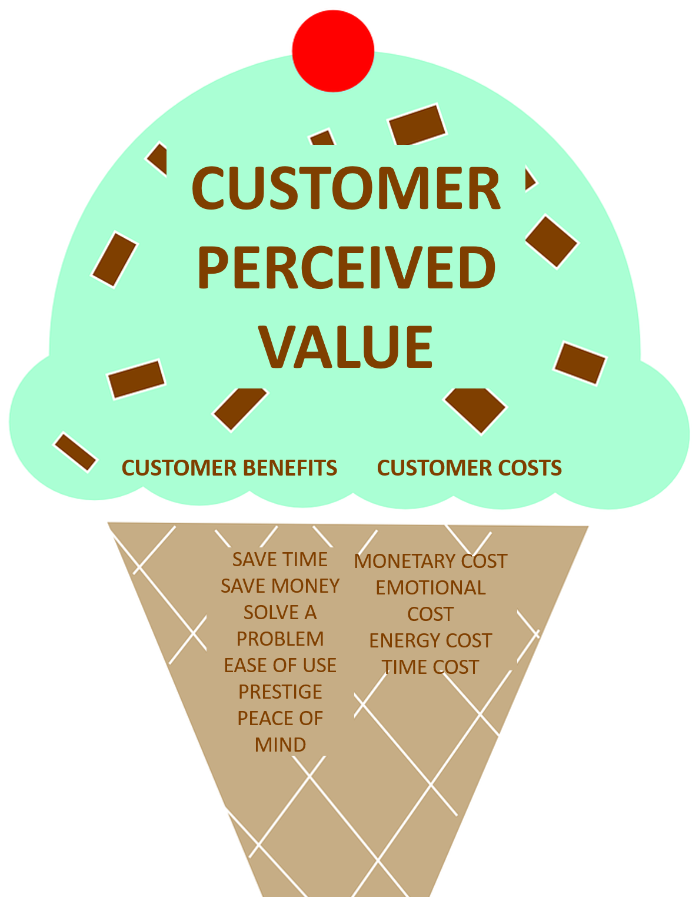

Explore the Concept – Attributes, Benefits, Values
If you were to purchase a pair of new running shoes, which attributes would bring you benefits that you consider of value?
Product and service benefits are the features that are most important to the customer. More often than not these are conceptual and change according to the individual shopper or customer segment. Different types of customers will find different attributes valuable. Some may like the no-tie laces (maybe they have problems with dexterity), while others may be more enticed to buy because of the recycled soles (maybe they have a concern for the environment). A company will segment its customers and devise promotions to emphasize the benefits that may be of value to specific target groups. For example, a senior may like the extra cushioning and water-repellent attributes, and they may also hope to find arch support. A business can create a customer segment for seniors (e.g., over 60) and survey these customers or potential customers to determine which attributes would bring benefits of value to that customer segment, then design products and services to provide those benefits. Offering products or services customers do not need or want will mean the innovation will probably not be successful.

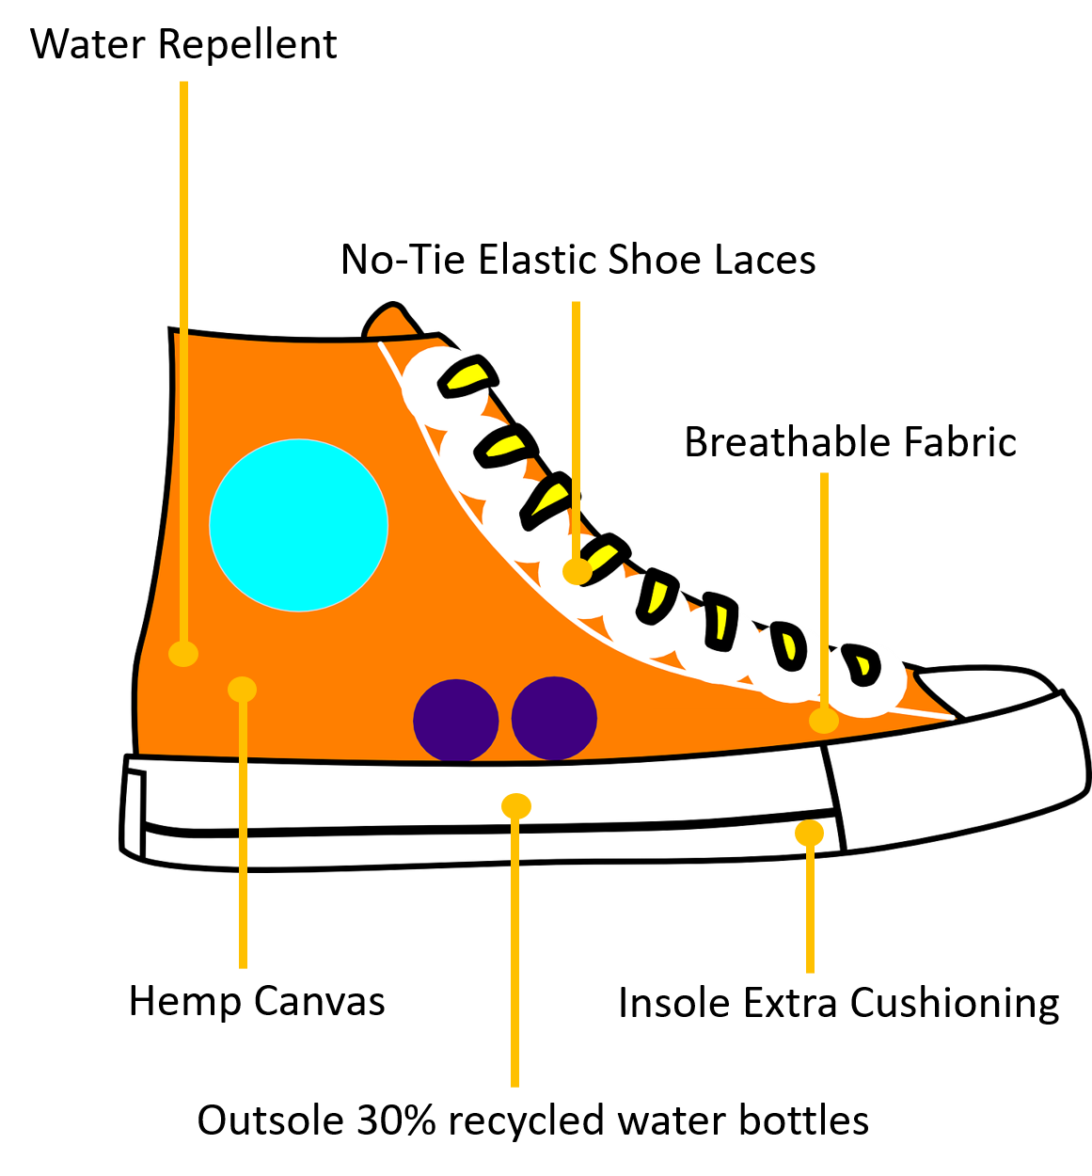

Now imagine that this same company also offers three services with the purchase of this running shoe: 1) As a customer of the company you can join a loyalty program to collect points and when you have a certain number of points you will receive a discount on your next purchase. 2) This company also offers a running club for customers, in which customers join the group and go running with other avid runners each week. 3) There is a warranty for one year that covers any product defects or issues such as not fitting well or sole wearing out too quickly and they will repair the shoe for free.
Which of the above service attributes would be a benefit to you? Which brings you added value? Which of these services would you consider of no benefit or value to you? Why? Can you think of someone else who might enjoy the benefit of these services?

The Customer: The User, The Buyer, The Payer
First, you need to understand the customer roles – user, buyer, and payer. The user, buyer, and payer may not always be the same customer. When you go to the store and buy groceries, you are the user, the buyer, and the payer because you will use the groceries, you selected the store to shop at, and used your credit card to pay. Now imagine that you are buying groceries for your grandmother who asked you to purchase a few items on a list at a grocery store, and she gave you her credit card to pay for the items. In this scenario, she is the user and the payer, and you are the buyer as you selected the grocery store to shop at. If she had sent you to a specific grocery store then she would also be the buyer and you are just the lovable delivery person.
If you attend a marketing convention out of town as approved by your manager, the payer of the hotel room is your employer, the user of the hotel room is you, and the buyer of the hotel room is the marketing association since it determined where the conference would be and which hotels would hold rooms for convention attendees.
Another example; if you work in the procurement department at a hospital, your job would be to buy the materials needed by surgeons to conduct surgeries. The surgeons are the users, and the payer is the hospital department that Accounting charges when the invoice is paid.
A deep understanding of the three roles is crucial for innovation success. The user, needs the right materials, in the right place, at the right time. They need the materials to do the job they are supposed to do. The buyer requires a catalogue of all the materials the supplier provides, the prices, and the uses of each product or service. They need to know about warranties, inventory in and out, repair or replacement options, time for delivery, etc. They must also understand the needs of the users and communicate with them. The payer needs to know what was ordered and if the full order was delivered and which department is paying for the order. They also need to know the budget maximum and communicate this information to the buyer.
When a business tries to understand the customer’s needs they must be specific–they must understand the user’s needs, the buyer’s needs, and the payer’s needs since they might be quite different. When a company defines a new service innovation the best innovations are those that simultaneously improve the job to be done for the user, the buyer, and the payer.

Aligning Service Innovations
Organizations must align service innovations with the company mission, vision, values and goals as well as with customer expectations. The Customer Star framework (below) helps executives and entrepreneurs align their decisions and actions around what customers really want.

Align with Company Brand
Companies need to align service innovations with the company’s mission, vision, values, and goals to retain existing customers and obtain new customers. Sharing with customers the company mission, vision, values, and goals will help set customer expectations around product and service offerings and attract customers that want the company offerings. There is not much sense in offering a sauna at a fitness center if the customers would not use it or if the mission of the fitness center is to offer a quick workout at a low price. Adding a sauna might be expensive and there would be considerations around safety and hygiene, so not a cheap innovation to implement. Adding a sauna would probably not bring the benefits the fitness center customers would want; therefore, they would not pay extra to use it, so the company may lose money on this innovation. If the fitness center is a place that promotes luxury and various spa treatments as service offerings after a workout, then a sauna may be right in line with the company’s mission and vision, and it would bring added value to the customer segment that frequents the fitness center.
To confirm this assumption, the fitness center would need to conduct research through customer surveys or focus groups, for example, in order to gather customer feedback. Psychographics are all about understanding customers’ lifestyles, values, beliefs, and optimizing marketing to demonstrate to customers how the company can fulfill these psychographic variables by providing the benefits sought thus providing customers value.
The fitness center would also conduct a competitive analysis to see if saunas are offered at competitor locations in the area. The company would examine costs and expected returns on investment as well as internal and external strengths and weaknesses, opportunities, and threats (SWOT). The company might conduct a PEST analysis as well to determine if this innovative idea for a new service offering will be successful. After the research is complete and the results analyzed the company management team would decide if this new service innovation is feasible.

Align with Evolving Customer Expectations
Key areas of customer service have evolved, including the emergence of analytics, personalization, and employee engagement. Companies that thrive in an era of rapidly evolving customer expectations need to align their initiatives accordingly. It’s about going beyond short-term goals to building a self-sustaining customer-centric organization. The companies below are not only part of the service industry — they are also shaping its future. By extension, these and other companies like them are changing the way we live our lives.
- Facebook, Twitter, Yelp, et al. Social media sites should be recognized for their role in changing the service industry. Customers are increasingly turning to online outlets to share reviews, ask questions, and solicit feedback from brands that play a role in their lives. These interactions provide companies with an opportunity to learn more about their customers so they can better tailor their services to consumers’ needs.
- Motif Investing. The personal finance industry doesn’t exactly have a reputation for innovation. Motif Investing is the exception that proves the rule. The company is making investments accessible to a broad segment of the population by creating an investment structure that is affordable and easy to understand.
- Noma. The restaurant has both driven innovations in the food industry and capitalized on them. Led by world-renowned chef René Redzepi, noma embodies the farm-to-table movement by utilizing local and wildly sourced ingredients, avoiding GMOs, and emphasizing quality at all costs. In the process, it’s put Nordic cuisine on the international map.
- City CoPilot. More and more individuals and companies are enlisting personalized service from concierge companies—and not just when they’re staying in a hotel. City CoPilot and other innovative concierge companies have moved these services beyond the hotel lobby. Whether clients need assistance with luggage storage and delivery, package acceptance, airport transportation, finding discounted tickets to tours and attractions, or something else entirely, this new brand of concierge is here to make people’s lives easier at all times.
- UberEATS. Uber has already transformed the service industry with its innovative approach to transportation, but the company isn’t stopping there. It’s now attempting to disrupt the food delivery market with UberEATS. The company has more opportunities for distribution than any other business in the market, and thanks to their pre-existing name recognition, they have had an easy time identifying partners in the restaurant industry. It’s a winning combination that’s threatening even the companies that have long sat at the top of the food delivery chain.
The service industry entails a vast variety of services ranging from food delivery to digital investing tools. Still, these companies all share something in common. They’re innovating existing services and transforming the country’s economy in the process.

Alignment Tool: The Customer Star Framework
The Customer Star framework created by Stefan Michel helps executives and entrepreneurs align their decisions and actions around what customers really want. In order to successfully implement any service innovation, a firm must make choices in regard to each point of the customer star. Those choices must then align and support each other. When you apply the Customer Star Framework you can begin with any of its points. Service innovations may fail when the eight dimensions of the customer star are not in alignment.

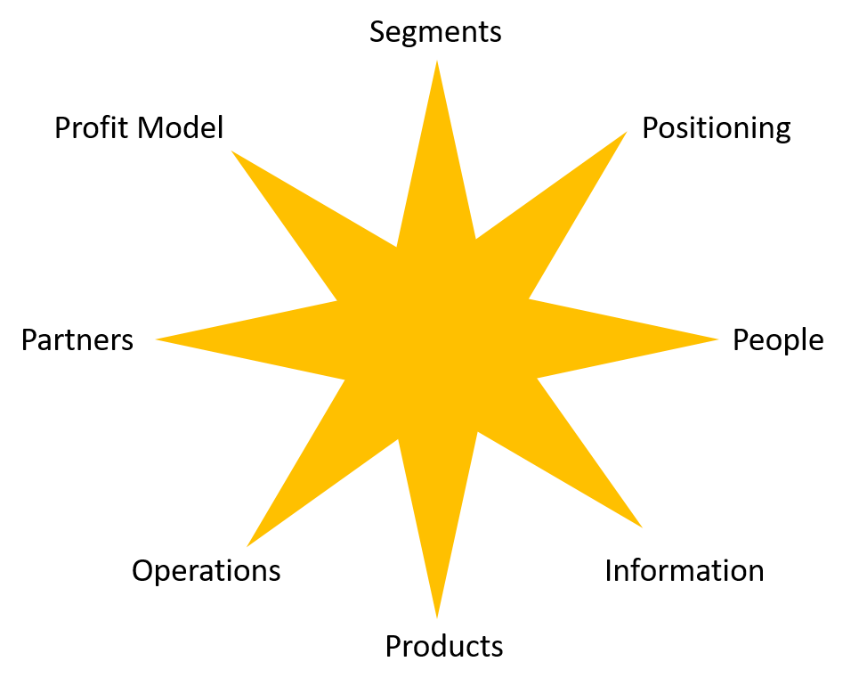

When using the Customer Star Framework to check service innovation alignment, a company must ask the following questions about the eight dimensions.
- Customer Segments. Which current and future segments can we identify in our market? Which of these segments are we interested in? How do we serve different segments differently?
- Positioning. What does our brand stand for?
- People. What are the employee skills required? What is the leadership style and how does it shape the culture in the organization?
- Information/IT. How do we use the Internet and other IT systems for gathering, storing, and disseminating data? Which analytics do we use to convert data to insights?
- Products. How do we innovate, manufacture, and distribute our products? How do we customize our products to each customer’s needs? How do we bundle our products with services?
- Operations. How do we design and manage our processes in all phases of the customer relationship? How do we link customer-facing processes with back-office work? How do we handle variability in terms of customer needs and demand/supply cycles?
- Partners. In addition to suppliers and distributors, which partners are essential to serve your customers? What is our organization’s role in providing customer value in the partnership?
- Profit Model. What are our major revenue drivers, and what are our major cost drivers? How sensitive is the profit model in respect to fluctuating demand and costs?
For example, if you operate a 4-star resort then you need to be sure that your products are of high quality, your employees understand how to provide excellent customer service, and the services you offer at the resort are what your target customers want, thus, will pay for. If you put a fast-food restaurant in a prestigious, high-class resort, the customers may frown upon it, as they want fine dining and they have expensive tastes. You may need to go back and determine your resort’s positioning dimension. If you position the company as prestigious then you need the other dimensions to align with that in order to obtain and retain the customers in the segment you are seeking. Some brands that are thought of as prestige or luxury brands include Apple, BMW, Gucci, Ritz-Carlton, Tiffany, Rolex, and Cartier. If your resort is to be considered a luxury or prestige resort then you would want to align the eight dimensions accordingly, otherwise, your service innovation may fail to meet customer needs and expectations. On the other hand, if you operate a resort that is considered a fair price, economy class resort, then you would position your resort that way in your marketing efforts and you would serve the needs of the customer segment who would be spending their money in this type of resort.

Issues Outside The Company
Business challenges and customer dissatisfaction are often due to problems, for which the company is NOT responsible, and to solve them, managers will need to think beyond the firm. Organizations may need to partner with external firms to solve problems stemming from the external environment, they may need to adapt processes to meet new government regulations, or they may need to change their business model in order to remain relevant with changing social trends and customer buying behaviours.
For example, many international students who wish to attend college or university in Canada are told by recruiters from their home country that they can come to Canada and work at the same time they attend school. When the students arrive they find that it is very difficult to be successful in their studies when they are working 30, 40, 60 hours per week. Many need the income to pay the bills, they may not have a place to stay, or even understand how much living in Canada costs. Students end up failing many courses due to a lack of time to commit to schoolwork, becoming depressed, and some end up spending far more money than they budgeted for on college course fees when they have to retake courses they failed. While this may not be an issue directly related to the specific Canadian college they attend, it is probably an issue the Canadian colleges and universities need to address with the recruiting agencies in foreign countries. What might the colleges do to improve this situation? The colleges might implement an orientation course that all international students must take before they arrive in Canada or before they enroll and pay fees at a Canadian institution. This would set the expectations for students before they spend their money as well as acclimatize students to Canadian culture and Canadian college expectations. Can you think of other possible solutions?
Another example might be a retailer who is always out of stock with specific items. Customers may become upset or dissatisfied with the retailer when the items are not in stock. This problem may be an internal issue pertaining to incorrect ordering, but what if the issue is with the supplier? The retailer will have to decide if they need to switch suppliers, but what if they are locked into a contract, what then? During COVID many products were in short supply, including bicycles, toilet paper, hand sanitizer, refrigerators, and kayaks. Production shutdowns sent the price of lumber sky-high. Months spent quarantining led homeowners to spend more time outdoors, some taking on more do-it-yourself (DIY) renovation projects. And the fear of the unknown led to hoarding and stockpiling.
Nearly two years after the pandemic began, the global supply chain mostly stabilized, but there was still one industry where shortages continue to abound: semiconductor chip manufacturing in the auto industry was one of the hardest hit. A semiconductor chip, also called a microchip, serves as the “brain” of modern electronics. With every new model, cars and trucks feature bigger infotainment systems and a host of other high-tech car safety features. Each of these technology-packed features relies on semiconductor chips. Building semiconductor chips is an extremely complex, expensive, and time-consuming process. For that reason, there are only a handful of chip manufacturers in the world, and all of those manufacturers were currently operating at full capacity.
You may have found it hard to visit your favourite retailer, see a doctor, or get into a restaurant during COVID. This was not the organization’s fault or problem, but a larger national and global problem. The retailers, restaurants, and other service companies must abide by government health regulations and they took the health safety actions they were told to take. Some retailers and restaurants began offering services such as pickup, delivery, and online ordering with pickup in the parking lot. You could order groceries and pull up to the grocer’s location and the staff would load your groceries into the trunk of your vehicle. Some companies already had those services in place which made it easier and quicker for them to adapt to COVID health regulations. These were some of the service solutions retailers came up with while they were NOT allowed to serve customers in-store or in-person or were restricted on the number of patrons they could have in the physical store at one time.

Key Takeaways
- A service innovation changes the way customers are served to create value for customers and revenue for the company.
- Companies must learn to tap the potential for service innovation made possible by four evolving trends: Higher customer expectations, the rise of the mobile Internet, Big data and advanced analytics, the Internet of Things (IoT).
- For a more promising approach through service innovation, companies should begin by asking the following questions.
  - How can we relieve customers from activities they do not like to perform?
  - How can we enable customers to perform activities they cannot do without our service?
  - How can we make it easier for customers to do what they need or want to do?

- Customers will often not pay more for attributes that do not bring them benefits, as from the customers’ perspective this would not be of value. The formula for customer value can be written as: (Total Customer Benefits – Total Customer Costs) = Customer Value, or (B – C = CV)
- Tips for Businesses to Increase Customer Value: Evaluate your customer experience, Focus on more than price, Collect customer data, Target your most loyal customers, Segment your customer base.
- When a company defines a new service innovation the best innovations are those that simultaneously improve the job to be done for the user, the buyer, and the payer because each may have different needs.
- Psychographics are all about understanding customers’ lifestyles, values, beliefs, and optimizing marketing to demonstrate to customers how the company can fulfill these psychographic variables by providing the benefits sought thus providing customers value.
- Companies that thrive in an era of rapidly evolving customer expectations need to align their initiatives accordingly. The Customer Star framework created by Stefan Michel helps executives and entrepreneurs align their decisions and actions around what customers really want.
- Business challenges and customer dissatisfaction are often due to problems, for which your company is NOT responsible, and to solve them, you will need to think beyond your firm.

End-of-Chapter Exercises

- Changes Impacting the Service Sector. Research one of these companies and explain how this company is addressing the changes impacting the service sector: Bank of Nova Scotia, Canadian Tire, PepsiCo, McDonald’s, or IKEA. Does the research relate to this chapter’s content? If so, what does it say?
- Walmart Service Innovation. Conceptualize five ways in which Walmart could innovate its customer service offerings. Share your thoughts with the class and/or professor. Do your ideas align with Walmart’s mission, vision, values, and goals? Do your ideas align with the customer segment that shops at Walmart? Do you think your ideas will be successful? Why or why not?
- Nordstrom Customer Insights. Nordstrom is known for customer support excellence. Search the Internet to find information about how the business is using AI-powered analytics and customer insights to transform its digital approach. Discuss your findings with the class and/or professor.
- McDonalds Customer Star Framework. Try applying the Customer Star Framework for McDonalds and start with Products=Fast Food and Profit Model=Franchised and Labour Costs=Low. Fill in the other points on the Customer Star Framework as you can and determine with a partner, your class and/or professor if the Customer Star dimensions are aligned. You may wish to watch the LinkedIn Learning module, Service Innovation by Stefan Michel who created the Customer Star Framework (you may require a subscription).
- User, Buyer, Payer Scenarios. Come up with three (3) different scenarios, one where you are the user, buyer, and payer. A second scenario in which you are only the payer and someone else is the user and buyer. A third scenario in which you are the user and someone else is the buyer and payer. Share with a partner, the class and/or the professor and see if they agree with your positions in these scenarios.
- Services Customers Value. Assume you own a Hair Salon, besides cutting hair, what other services could you offer customers that would be a benefit they would value? Consider the value for different customer segments. Discuss with the class and/or professor.



Self-Check Exercise – Dialog Cards – Service Innovation

An interactive H5P element has been excluded from this version of the text. You can view it online here:
https://ecampusontario.pressbooks.pub/leadinginnovation/?p=40#h5p-6

Additional Resources
- Taxis cars install mini convenience stores
- 20 Fresh Examples of Customer Experience Innovation
- The 30 Things Your Customers Value Most
- A list of Innovative Customer Service Ideas to Create Happier Customers

References
(Note: This list of sources used is NOT in APA citation style instead the auto-footnote and media citation features of Pressbooks were utilized to cite references throughout the chapter and generate a list at the end of the chapter.)

Media Attributions
- Customer Benefits versus Customer Costs © Pixabay adapted by Kerri Shields is licensed under a CC0 (Creative Commons Zero) license
- Attribute Benefits © Adapted by Kerri Shields from Pixabay is licensed under a CC0 (Creative Commons Zero) license
- custstar © Stefan Michel adapted by Kerri Shields is licensed under a All Rights Reserved license
- Hair Salon © Pixabay is licensed under a CC0 (Creative Commons Zero) license

Canadian Visa. (n.d.).

McKinsey Quarterly. (2015, February 1).

Morgan, B. (2019, October 21 ). 20

Michel, S. (2020, June 4).
[Video]. LinkedIn Learning.

Fontanella, C. (n.d.).

Scalco, D. (2017, February 19).

Michel, S. (2020, June 4).

Metz, J. (2021, October 22).

Metz, J. (2021, October 22).

4

Chapter 4: Process Innovation

Chapter 4 Learning Outcomes
After reading this chapter, you should be able to do the following:
- List the requirements for creating a good business process.
- Explain four things that contribute to the development of a bad business process.
- Explain why employees may choose to follow what is known as a business process “cow path”.
- Explain what it means to measure the right things when improving processes.
- Describe what a BPMN diagram is and who benefits from it.

Business Process Improvement
Process innovation is probably the least attractive form of innovation. It is the combination of facilities, skills, and technologies used to produce, deliver, and support a product or provide a service. There are many ways business processes can be designed or improved. Process innovation can include changes in the equipment and technology used in manufacturing (including the software used in product design and development), improvement in the tools, techniques, and software solutions used to help in the supply chain and delivery system, changes in the tools used to sell and maintain goods, as well as methods used for accounting and customer service.
Good business processes enable companies to satisfy both customers and employees. Good business processes can drive reliable and consistent results and support company growth. A business process is a sequence of steps progressing toward a business goal. This sequence of steps can be clearly depicted using a flowchart and may also be referred to as a business method. Developing and implementing business processes can help a company improve efficiency, consistency, and quality. It can also reduce costs and risks. Business processes occur at all organizational levels and some are visible to customers, while others are not.

Types of Business Processes
- Management Processes: The processes that plan, organize, coordinate and control all the functions of the business.
- Operational Processes: The processes that constitute the core business of the organization and create the primary value stream.
- Supporting Processes: The processes that support the core processes. They help the business create an environment where the core processes can work better. Examples include accounting and technical support.
Often processes are documented and taught to employees. Employees are expected to follow the business processes as the processes support the company brand, function, mission/vision/values/goals, and service objectives. A great example of a company using processes to streamline operations and maintain consistency and quality is McDonald’s fast-food restaurant. McDonald’s operating processes would include taking orders, making food, and serving it to the customers. The processes for making fries, burgers, and pies are each documented and employees are trained on these processes. Machines are used to cook and warm food and timers are used to enable employees to cook each hamburger or Egg McMuffin exactly the same way each time for every customer.
A simple business process might include the steps an employee follows to take a pizza order over the phone or the steps a college registrar’s office takes to enroll a student in a course. More complex processes might include the steps required to purchase new medical equipment for a hospital, the steps a furniture company follows to manufacture their most popular desk or the steps an executive chef takes to prepare a dinner for six customers.
New employees have a good chance of job success once they learn the business processes. Processes in the kitchen at a restaurant might utilize ingredients, utensils, cooking equipment, recipes, etc. Processes in an office might utilize computers, software, office space, people, documents, etc. Processes in a paper factory might utilize people, machines, safety equipment and procedures, raw materials such as pulp/paper, etc. Most big companies have hundreds of interconnected business processes. Knowing how to design, manage, and improve business processes gives companies the power to manage and grow the business.



Good business processes can improve customer satisfaction while missing or badly designed processes can have a negative effect on customer satisfaction. Assume you are a student at a college and you wish to add another course to your schedule, which includes paying additional fees. If there is a good process in place, all employees and computer systems you interact with consistently guide you in the same direction in order for you to complete the process of adding and paying for an additional course. If the process is not clearly designed or it is missing, then employees will be confused and may have their own personal way of doing tasks and systems may not be designed for self-service tasks that enable you to add a course to your timetable.

Business Process Requirements
A good business process meets the following requirements.
- Provides clear instruction
- Answers frequently asked questions
- Teaches new things
- Measures success
- Provides corrective actions
Why do bad business processes exist?
- Assumptions. Often companies assume they know what customers want. It is important to challenge these assumptions through research and analysis.
- Ambiguity. Employees are uncertain of the process. Maybe the process needs more clarification.
- Miscommunication. The process may not be communicated to employees and employees develop their own processes.
- Misalignment. Advertising and actions are not aligned with the goals of the process.
Since processes are interrelated, each process should consider its relationships with other processes. Good business processes always need to be looking forward and require periodic review and revision to keep up with changes in the internal and external business environments. If a company experiences massive growth, will the processes still be effective and efficient? If a process is good at supporting 20 customers, does it still work when supporting 200 customers? Some processes cannot be changed significantly due to a lack of availability of technology and tools. Maybe the steps in the process are not the problem, perhaps the company tools and technology need to be improved. Companies need to ensure their processes are built for both present demand and future growth; that processes are scalable.
Lack of a good process can lead to inconsistency, time loss, employee frustration, customer frustration and dissatisfaction, lost revenue, etc. So you can see why it is important to have good processes in place and ensure staff understands these processes and apply them consistently. Without a good business process company growth and success are difficult to achieve.
Not only is it important to have processes but it is also equally important that these processes be effective and efficient in reaching the goal. If the goal is to add a course to your college timetable, then the process and procedures you follow to do that should help you obtain that goal (effective) and should do it in a timely and user-friendly way (efficient). When processes are created with these things in mind, they increase employee effectiveness and efficiency, maintain consistency and quality, and improve customer satisfaction. Customers continue to shop with a business because of reliability in product or service quality, price, design, etc. Employees become good at their jobs because they follow the business process they were given. Once good processes are established at one business location, the organization can adopt the same processes at multiple locations (just like McDonald’s does).

Explore the Concept – Review an Amanzon.com Process
Business Process Requirements
Does the following Amazon.com Seller process meet the following business requirements for processes?
- Provides clear instruction
- Answers frequently asked questions
- Teaches new things
- Measures success
- Provides corrective actions
Amazon.com Seller: Print a packing slip process

Use Manage Ordersto print a packing slip for each individual order. To print a packing slip for an order:
- Click OrdersManage Orders.
- In your list of orders, find the order, and then click the Print packing slip button. A print dialog box and your packing slip will appear.
- In the print dialog box, click OKto print the packing slip.
- Put the packing slip in the box with the items you are sending, then seal the box.
You can reprint a packing slip for an order using these steps at any time.
To print multiple packing slips at the same time, select the check box in the upper-left corner of the list, choose
from the drop-down menu, and then click
.
Need some
See more on Seller Central

Cow Path Theory

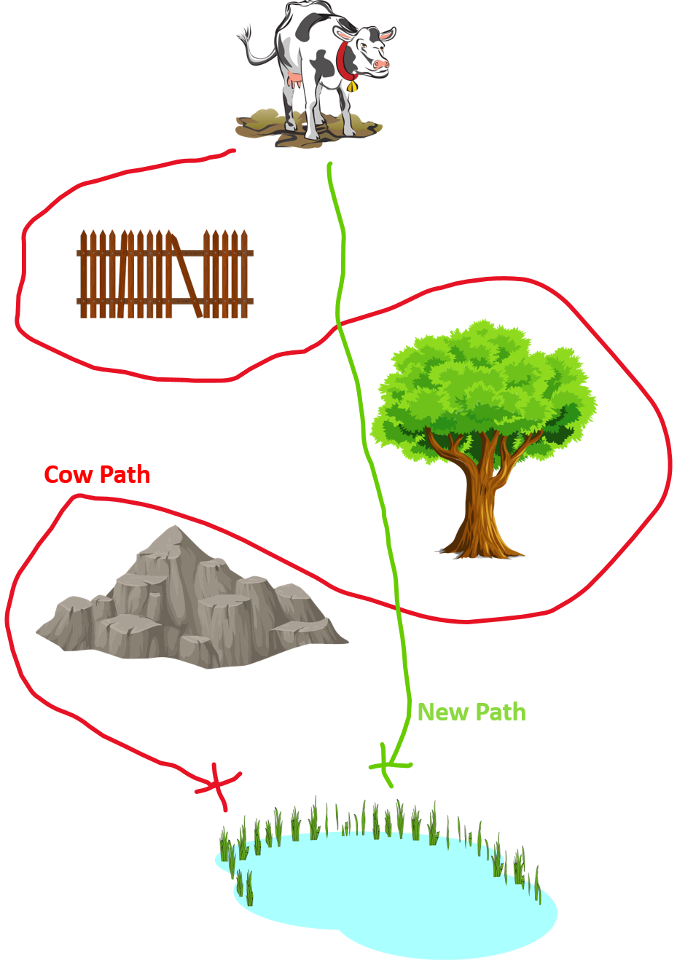

The Cow Path Theoryis a theory that many organizations have processes they have been following for years and may not notice that these existing processes may no longer be efficient or effective. New employees follow the processes they are told to follow and often without questioning them because new employees don’t want to make a fuss or they feel the process must be right because someone in the company developed it and everyone has been following it for years. Existing employees may continue to follow the old, outdated processes because they are used to them and don’t wish to put in the effort to learn something new, or they don’t feel it is their job to question the processes that have been in place for many years.
Basically, when leaders follow the cow path they are just doing things the way they have always been done without making changes to it. But there are exceptions to this rule. Just because something has always been done a certain way doesn’t mean that it can’t be improved upon or even replaced with something better. Think about how many times you’ve ordered a pizza. It’s not as though the process of ordering one has changed much in recent years, but it is now more efficient and effective than ever before. A problem with “cow paths” is that they are so common that no one notices them. The more common something is, the less likely it is that anyone will notice when it’s being done wrong. This means that people who are in a position to change things have little incentive to do so. Cow paths are the result of an unhealthy work environment, where there is no accountability for poor results, and where people are rewarded for failure. Cow paths are usually difficult to detect because they tend to be systemic and non-discriminatory. “Don’t pave the cow path” often refers specifically to businesses that create their own way of doing things in order to innovate and improve on what has been done before.

Process Improvement Steps
The first step in improving any process is setting a goal, then the next step is measuring your progress toward that goal. If there is an existing process in place then you must ask the following questions. Is the business process currently effective in achieving the goal it was designed to do? Is the original goal still the goal to achieve now? Is the original goal efficient? If the answer to any of these questions is “no” then there may be an opportunity to improve the business process.
Watch the “Business Process Improvement Tutorial for Beginners” YouTube video below for an introduction to business process improvement. Transcript for “Business Process Improvement Tutorial for Beginners” Video [PDF–New Tab]. Closed captioning is available on YouTube.
One or more interactive elements has been excluded from this version of the text. You can view them online here: https://ecampusontario.pressbooks.pub/leadinginnovation/?p=42#oembed-1
Before a process can be improved it must be measured so the company will know if the changes have made a difference. For instance, you will want to know if the changes in results were due to something you did, or something else, or just pure chance. There is a 50/50 chance that this year will be better than last year even if you make no changes.

Measure the Right Things
Most process improvements have one or more of the following goals: improve quality, decrease lead time (the time between the initiation and completion of a production process), or decrease costs. Should each goal be measured? Which goal should get priority? It is difficult to achieve all three goals at the same time. For example, if a company reduces costs, that may also reduce quality or something else that is important. If time is reduced, that may increase costs. A company can reduce costs by reducing quality, while higher quality products may take a longer time to produce.
Never try to measure just one number without context. For example, if sales revenue has gone up, that seems good, but what else is happening? Was there a sale, were employees reducing prices so they could sell more and gain higher commissions or has something else affected revenue? If customer complaints have increased, at first this seems bad, but what if employees have just gotten better at listening to customers and reporting complaints, or maybe you implemented an online complaint process that has resulted in customers being able to submit complaints more easily and this has contributed to the rise in complaints. So never measure just one number.
If you find out that your school’s student satisfaction score is 5% worse than another school you must question what “worse” really means, and whether or not 5% is really significant. Maybe your school is better at other things and worse at one thing. Maybe it is just that this year your school was under construction and that affected student satisfaction negatively, but usually your school has much higher scores. Take measurements as a starting point to asking the question “why?” (Why are these numbers as they are?) This will help you understand the causes of the lower numbers or scores so you can begin to take action.

Implement a Process Improvement Plan
Given how process improvements deliver a range of organizational benefits from better communication to increased profitability, it’s essential to know how to implement a process improvement plan. Listed below are the steps to do so.
- Identify the improvement opportunity. Map the current process. Identify the pain points (things that are not working well).
- Obtain stakeholder buy-in. Clarify stakeholders’ roles and degree of involvement with the process change. Explain the rationale for change.
- Design the process improvement plan. Determine the changes required to improve the process and decide how you will measure the effectiveness of the changes, evaluate any risks, and identify how the changes will affect the customer experience; for example, introducing a technical solution to streamline the workflow helps, particularly if the solution automates many of the process steps. Transforming processes affects an organization to varying degrees depending on the extent of the changes. If the process improvement is larger than small adjustments affecting a single team, project planning may be needed with a full project plan incorporating the five project management process groups. This includes identifying budgets to cover costs like training and any additional resource requirements needed to execute the changes.
- Test the changes. Often when designing new processes a company might test in a single department at a single location before implementing the changes in all departments at multiple locations, or before integrating a new technology system with an old technology system. Take time to test thoroughly and compile measurable results for analysis. Make adjustments as needed, then when you are sure the new process works according to plan then you can roll it out across the organization.
- Monitor and optimize. Even after thorough testing, process improvements require daily monitoring in the early weeks of a rollout to catch any issues that may have been missed during the test phase. The monitoring should compare the results of the improved process against the goals identified at the start of the project. Collect more feedback from stakeholders and continue to optimize until you have met or exceeded all benchmarks for the process.
Once a company improves a process, the reality is that it must review the process again in the future. Business goals, market forces, and new technologies evolve, making established processes and procedures inefficient or obsolete. Rather than execute a big project whenever a change is required, most organizations adopt an approach of small, iterative, improvements that happen routinely over time.

Tools and Techniques for Improving Processes
The tools and techniques most commonly used in process improvement are:
- Problem-solving methodology, such as DRIVE
- Process mapping
- Process flowcharting
- Force field analysis
- Cause effect diagrams
- CEDAC
- Brainstorming
- Pareto analysis
- Statistical process control (SPC)
- Control charts
- Check sheets
- Block Diagrams
- Flowcharts
- Bar charts
- Scatter diagrams
- Matrix analysis
- Dot plot or tally chart
- Histograms
The most commonly used business process diagramming tools are Business Process Modeling Notation (BPMN), Data Flow Diagram (DFD), and the Unified Modeling Language (UML). BPMN (Business Process Modeling Notation) is a graphical method of representing business processes within a business process diagram. ​BPMN diagrams help the whole team see the flow of the process. For example, the process improvement team may be a cross-functional team consisting of various stakeholders, such as technical personnel who manage Information technology, managers responsible for the process as well as managers of other departments who may be affected by the process change, employees who apply the process, and possibly users (customers, clients, students).
Review the example below of a partial BPMN diagram for a Fast Food Restaurant, Customer Order Process.

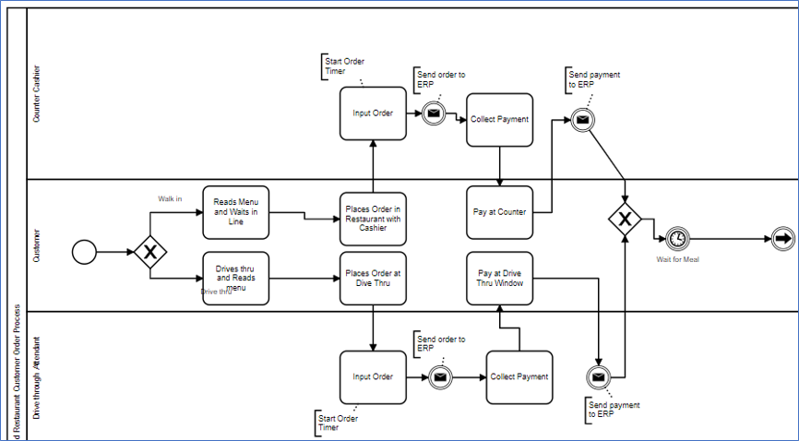

The BPMN above diagrams the process for the current way the customer order process happens (current state). There are many ways to create this diagram and before starting to diagram the business analyst must first gather information from the stakeholders who implemented, manage, and use the process so as to gain an understanding of who does what, when things get done, how things get done, what is necessary to do and when one step depends upon another (triggers). Once that information has been gathered and analyzed, the business analyst diagrams the process and then gains confirmation and approval from the stakeholders that the diagram does indeed reflect what is currently happening.
After diagramming and gaining an understanding of the current state of the process (the way things are done), the business analyst will analyze the process to determine if improvements could be made. They will question the stakeholders on pain points, what works, what doesn’t and ask them to share their goals for improvements. The business analyst will then diagram a future state process (what the process will be after the improvements are implemented) and again, gain approval for the proposed changes. Then the changes are implemented, first on a small scale or in one location only, to ensure all works as planned. Maybe a few adjustments are made, then the new process is implemented fully.
In the example above you see the partial process you see is diagrammed in a pool called “Fast Food Restaurant Customer Order Process” Each role gets its own lane (swimlane) and each role is an actor (person or system that is part of the process). The customer can be diagrammed in their own pool or within the company pool. If we follow the process flow we see that the process begins with the customer (start symbol), then the customer makes a decision (Xor gateway) to either use the drive-thru or go into the restaurant to eat. After that, the order is placed with the corresponding actor (employee) who then enters the order into the enterprise resource system (ERP) and collects the payment from the customer. The order and the payment details are sent to the ERP (diagrammed in its own lane (swimlane)). After that, the process flow comes back together (convergent gateway) and the customer waits for their meal (timer). What do you think the next step would be? That’s sort of a trick question because many things are happening while the customer waits. There are actually quite a few more steps because the kitchen staff would need to prepare the meal, a staff member would get the drinks/fries, a staff member would package the meal, and a staff member would deliver the order to the customer either at the drive-thru or front counter. These tasks may be done by the same staff member or several staff members. You see there are lots of things to think about when diagramming a business process. Learning how to diagram processes is a course in itself, but don’t let that stop you from giving it a try. Check out the chapter exercises below for some ideas.

Process Improvement Methodologies
Process improvement is so important to business success that a number of methodologies have developed over time to address this key concept. Listed below are some of the most common process improvement models.
- Six Sigma. One of the most famous process improvement frameworks is Six Sigma. It is a set of techniques designed to make business processes more effective and efficient. In addition to establishing a culture dedicated to continuous process improvement, Six Sigma offers tools and techniques that reduce variance, eliminate defects, and help identify the root causes of errors, allowing organizations to create better products and services for consumers. General Electric, one of the most successful companies implementing Six Sigma, has estimated benefits on the order of $10 billion during the first five years of implementation. GE first began Six Sigma in 1995 after Motorola and Allied Signal blazed the Six Sigma trail. Since then, thousands of companies around the world have discovered the far-reaching benefits of Six Sigma.
- Kaizen. When applied to the workplace KAIZEN™ means continuing improvement involving everyone – managers and workers alike. This methodology originated in Japan, aims to eliminate all waste from process flows to achieve a high level of efficiency and productivity. Kaizen is known for its team approach where everyone in the organization shares ideas and works together to keep improving every area of a business. If mistakes occur, the goal is to learn from them as part of the cycle of continuous improvement.
- PDCA (plan-do-check-act). Plan-do-check-act (PDCA) outlines a four-step scientific approach spelled out in its name. First, identify the problem or opportunity and the improvements you hope to achieve. Once a potential solution is identified, test it safely with a small-scale pilot project. Then, analyze if the changes had the desired impact. Finally, you take action based on your data analysis.
- BPR. Business process re-engineering (BPR) is a framework that tackles process improvement at scale. Rather than address a small component of an overall workflow, BPR attempts to address issues and eliminate unnecessary steps by holistically redesigning an entire process from end to end. The changes can be so substantial that a change management plantypically accompanies the use of BPR.
- Gap Analysis. A gap is a problem, issue or challenge, and could be an opportunity for improvement. Gap analysis compares two different states of something, the current state, and the desired state. It is mainly used to assess where a company or process is today (current state), where it needs to be in the future (future state), and how the gap between current and future states can be closed. Gap analysis is also known as need analysis or needs assessment. You can implement this methodology to confront many types of gaps such as gaps in operational processes, product features, profitability, and labour shortages.
- Process Mapping. A useful approach that applies careful analysis and a visualization tool to address process issues — or to create a new workflow from scratch — is process mapping. In this method, you create a document that details the steps in a procedure, usually captured in a flowchart. The document allows you to see the entire process and identify areas to change. It then serves as a reference tool for subsequent process changes, or for writing a runbook.

Key Takeaways
- A business process is a sequence of steps progressing toward a business goal. This sequence of steps can be clearly depicted using a flowchart and may also be referred to as a business method. Developing and implementing business processes can help a company improve efficiency, consistency, and quality. It can also reduce costs and risks. Business processes occur at all organizational levels and some are visible to customers, while others are not.
- Good business processes can improve customer satisfaction while missing or badly designed processes can have a negative effect on customer satisfaction. A good business process meets the following requirements: Provides clear instruction, Answers frequently asked questions, Teaches new things, Measures success, and Provides corrective actions.
- Why do bad business processes exist? Because of assumptions, ambiguity, miscommunication, and misalignment.
- The Cow Path Theory is a theory that many organizations have processes they have been following for years and may not notice that these old processes may no longer be efficient or effective.
- The first step in improving any process is setting a goal, then the next step is measuring your progress toward that goal. Most process improvements attempt to do one or more of the following: improve quality, decrease lead time (the time between the initiation and completion of a production process), or decrease costs. Never try to measure just one number without context. Ask the question “why” one number is up and another is down. Compare changes in different measurements.
- Given how process improvements deliver a range of organizational benefits from better communication to increased profitability, it’s essential to know how to implement a process improvement plan. Below are the steps to do so.
  - Identify the improvement opportunity
  - Obtain stakeholder buy-in
  - Design the process improvement plan
  - Test the changes
  - Monitor and optimize

- The most commonly used business process diagramming tools are Business Process Modeling Notation (BPMN), Data Flow Diagram (DFD), and the Unified Modeling Language (UML).
- Process improvement is so important to business success that a number of methodologies have developed over time to address this key concept. Some of the most common process improvement models include Six Sigma, Kaizen, PDCA, BPR, Gap Analysis, and Process Mapping.

End-of-Chapter Exercises

- Procedure. A procedure is like a step-by-step recipe for how to complete a task. Procedures are often written down and are part of a larger process. For example, If you are a student who wants to change your timetable, there is a process for that, and the first step would be to log in to the computer system. What are the steps involved (the procedure) in logging into the computer system?
- Order Process. Review the “Order Process” from Amazon.com Seller Central Help. Discuss with a partner, the class, and/or your professor whether or not the process meets the business process requirements provided in this chapter. What suggestions might you make to improve the process? What procedures do you think are involved in specific steps of the process? For example, when an order is canceled what procedure(s) occurs?
- Daily Process. Think about a process you do each day, getting dressed, going to work, making breakfast, etc. Write down the steps (the process) you take to complete the objective (goal). Share your process with a partner, the class, and/or your professor, and together, consider how you might improve the process for better efficiency and/or effectiveness.
- BPMN Diagram. Assume you are helping your friend prepare for a dinner party. You need to help make fish tacos for the party. Use a BPMN diagramming tool to diagram the “Make Fish Taco” process. Assume two roles (actors): a stationary assembler in the kitchen and a runner who gets items from different spots in the kitchen. Tip: To begin write on a piece of paper a sequential list of activities needed to make a fish taco. Use a free diagramming tool such as Draw.IO and select new swimlane diagram, OR use Camunda which also has a free tutorial and download or use online.

Self-Check Exercise – Quiz – Process Innovation

An interactive H5P element has been excluded from this version of the text. You can view it online here:
https://ecampusontario.pressbooks.pub/leadinginnovation/?p=42#h5p-7

Additional Resources
- LinkedIn Learning Business Process Improvement Training video
- BPMN 2.0 Tutorial: Get started with Process Modeling – Camunda
- What is Business Process Innovation and How Can It Improve Organization and Efficiency?
- Kaizen methodology tutorial for continuous improvement – YouTube video

References
(Note: This list of sources used is NOT in APA citation style instead the auto-footnote and media citation features of Pressbooks were utilized to cite references throughout the chapter and generate a list at the end of the chapter.)

Media Attributions
- Student working on laptop © Image by Jan Vašek from Pixabay is licensed under a CC0 (Creative Commons Zero) license
- Cow Path Theory © Kerri Shields is licensed under a CC0 (Creative Commons Zero) license
- BPMN © Kerri Shields is licensed under a CC BY-NC-SA (Attribution NonCommercial ShareAlike) license

Differential, (2020, March 20).

Davila, E. (2019, February 25).
[Video]. LinkedIn Learning.

Narayanamurthi, (2021, September 30).

Invensis Learning. (2021, February 25).
. [Video]. YouTube.

Croft, C. (2020, January 9).
foundations. [Video]. LinkedIn Learning.

Croft, C. (2020, January 9).
[Video]. LinkedIn Learning.

Izquierdo, R. (2020, November 17).

Izquierdo, R. (2020, November 17).

ISIXSIGMA, (n.d.).

Izquierdo, R. (2020, November 17).

Izquierdo, R. (2020, November 17).

