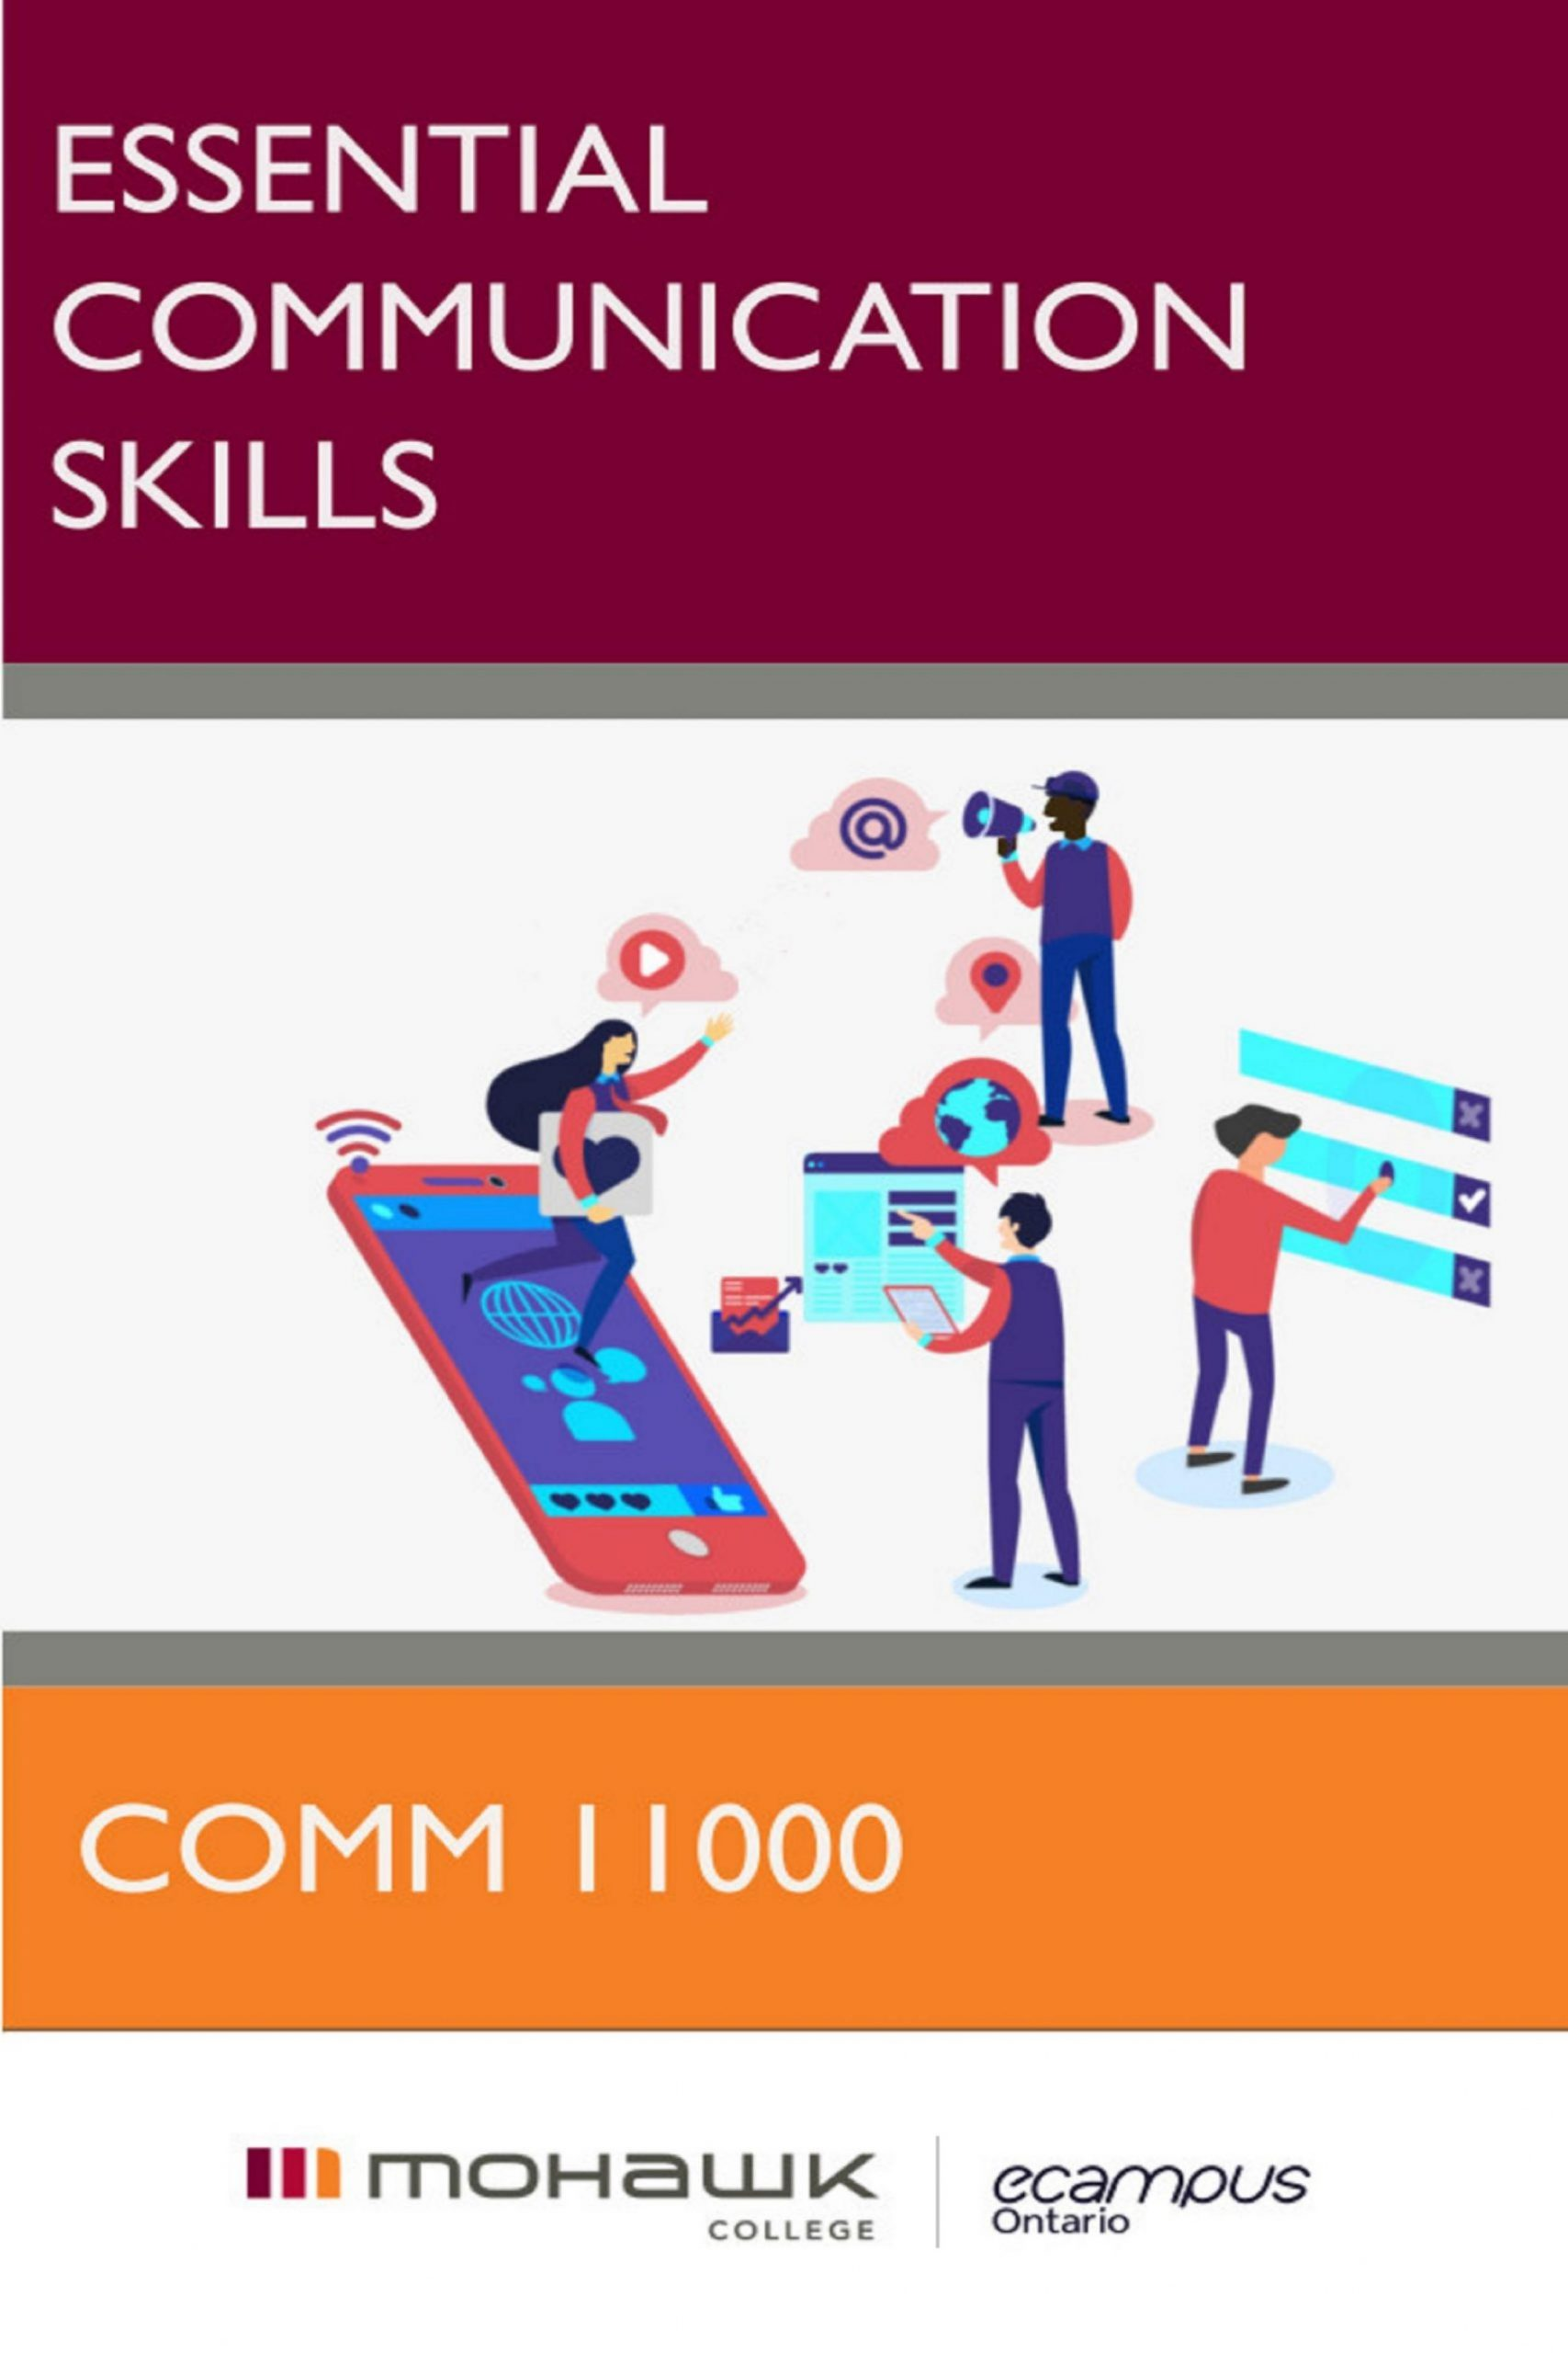

Essential Communication Skills: Mohawk College

Essential Communication Skills: Mohawk College

COMM 11000
John Corr; Grant Coleman; Betti Sheldrick; and Scott Bunyan
eCampus Pressbooks
London, ON

Essential Communication Skills: Mohawk College Copyright © 2022 by John Corr; Grant Coleman; Betti Sheldrick; and Scott Bunyan is licensed under a Creative Commons Attribution-NonCommercial-ShareAlike 4.0 International License, except where otherwise noted.

Contents
- Acknowledgements
- Introduction to the Text
- Unit 1: Communication as Problem-Solving
- Chapter 1: Communication as Problem-Solving
John Corr
- 1.1: FACED Problem-Solving Steps
John Corr
- FACED Activity: Crossword Puzzle
- FACED Activity: Step Sheet / Template (with Hints)
- 1.2: A Model of How Communication Works
- 1.3: Troubleshooting Miscommunication
- 1.4: Listening Effectively
- 1.5 The Problem of Getting the Job
- Unit 2: The Writing Process
- Chapter 2: The Writing Process I: MAPS
- 2.1: Purpose: Know Why You're Writing
- 2.2: Audience: Analyze Your Reader/Listener
- 2.3: Style: Choose the Right Channel
- Chapter 3: The Writing Process II: Researching
- 3.1: Choosing a Research Methodology
- 3.2: Locating Credible Sources
- 3.3: Collecting Sources by Reading with a Purpose
- 3.4: Using Source Text: Quoting, Paraphrasing, and Summarizing
- 3.5: Documenting Sources in APA Style
- Chapter 4: The Writing Process III: Drafting
- 4.1: Choosing an Organizational Pattern
- 4.2: Outlining Your Message
- 4.3: Forming Effective Sentences
- 4.4: Forming Effective Paragraphs
- 4.5: Standard Business Style
- 4.6: Effective Document Design
- 4.7 Writing Essays: Style, Strategy, and Structure
- Chapter 5: The Writing Process IV: Editing
- 5.1: Substantial Revisions
- 5.2: Proofreading for Grammar
- 5.3: Proofreading for Punctuation
- 5.4: Proofreading for Spelling
- 5.5: Proofreading for Mechanics
- Unit 3: Workplace Communication
- Chapter 6: Electronic Communication
- 6.1: Email
- 6.2: Netiquette and Social Media
- 6.3: Text, Instant Message, and Direct Message
- Chapter 7: Traditional Written Communication
- 7.1: Letters
- 7.2: Memos
- 7.3: Reports
- 7.4: Proposals
- Chapter 8: Solution Messages for Communication Problems
- 8.1: Information Shares, Action Requests, and Replies
- 8.2: Complaints and Claims
- 8.3: Negative Messages
- 8.4: Persuasive Messages
- 8.5: Goodwill Messages and Recommendations
- Unit 4: Employment and Interpersonal Communication
- Chapter 9: The Job Search, Résumé / Resume, and Cover Letter
- 9.1: The Job Search
- 9.2: The Résumé / Resume and Online Applications
- 9.3: Cover Letters
- Chapter 10: Interpersonal Workplace Communication
- 10.1: Verbal Communication and Conversation
- 10.2: Professionalism, Etiquette, and Ethical Behaviour
- 10.3: Job Interviews and Follow-up Messages
- 10.4: Intercultural Communication
- Unit 5: Presentations and Group Communication
- Chapter 11: The Problem of Groupwork
- 11.1: Team Roles and Group Contracts
- 11.2: Group Meetings and Video Conferencing
- 11.3: Constructive Criticism
- Chapter 12: Developing Presentations
eCampusOntario
- 12.1 Introduction
- 12.2 Methods of Presentation Delivery
- 12.3 Preparing For Your Delivery
- 12.4 Practising Your Delivery
- 12.5 What to Do When Delivering Your Speech
- 12.6 Conclusion
- Chapter 13: Presentations to Inform
eCampusOntario
- 13.1 Introduction
- 13.2 Functions of the Presentation to Inform
- 13.3 Types of Presentations to Inform
- 13.4 Adapting Your Presentation to Teach
- 13.5 Preparing Your Speech to Inform
- 13.6 Creating an Informative Presentation
- 13.7 Conclusion
- Chapter 14: Presentations to Persuade
eCampusOntario
- 14.1 Introduction
- 14.2 Principles of Persuasion
- 14.3 Making An Argument
- 14.4 Speaking Ethically and Avoiding Fallacies
- 14.5 Conclusion
- Unit 6: Technical Communication
- Ch. 15: Technical Communication
- 15.1: How To Instructions / Standard Operating Procedure
- Appendix A: Visual Communication
- A.1 Using Graphics
- A.2 Drawings, diagrams, and photos
- A.3 Tables, charts, and graphs
- A.4 Headings
- A.5 Lists
- A.6 Emphasis
- Appendix B: Work-integrated Learning Resources
- B.1 Workplace Communication Modules
- B.2 Employment Communication Modules
- B.3 Interpersonal and Group Communication Modules

1

Acknowledgements


About this Textbook
This open textbook has been written, revised, and remixed by faculty from the Department of Communication and Global Studies at Mohawk College in Hamilton, Ontario, Canada. We created this version by building on existing open educational sources available through a Creative Commons ShareAlike attribution license.
This textbook is the result of a team effort, and it builds on team efforts of previously published Open Education Resources. As such, there are many perspectives, insights, and approaches layered throughout. This blend of voices reflects the collaborative nature of academic collegiality and scholarship. The teamwork that shaped this textbook also speaks to the reality of professional communication.
We would like to acknowledge and thank the following authors/entities who made their work available for the remix, reuse, and redistribution of this text:
- Ashman, M. (2018). Introduction to Professional Communications. eCampus Ontario/Pressbooks.
- Dunphy, B. and Stracuzzi, A. (2019). Professional Communications: a Common Approach to Work-place Writing. eCampus Ontario/Pressbooks.
- eCampus Ontario. (2019). Communication for Business Professionals: Canadian Edition. Toronto: eCampus Ontario/Pressbooks.
- Smith, J. (2019). Communication At Work: A College-to-Career Guide to Success (Alqonquin College). eCampus Ontario/Pressbooks.

About eCampusOntario
eCampusOntario is a not-for-profit corporation funded by the Government of Ontario. It serves as a centre of excellence in online and technology-enabled learning for all publicly funded colleges and universities in Ontario and has embarked on a bold mission to widen access to post-secondary education and training in Ontario. This textbook is part of eCampusOntario’s open textbook library, which provides free learning resources in a wide range of subject areas. These open textbooks can be assigned by instructors for their classes and can be downloaded by learners to electronic devices or printed-on-demand by our printing partner, The University of Waterloo. These free and open educational resources are customizable to meet a wide range of learning needs, and we invite instructors to review and adopt the resources for use in their courses.

Share
If you adopt this book, as a core or supplemental resource, please report your adoption in order for us to celebrate your support of students’ savings. Report your commitment at https://openlibrary.ecampusontario.ca/.
We invite you to adapt this book further to meet your and your students’ needs. Please let us know if you do! If you would like to use Pressbooks, the platform used to make this book, contact eCampusOntario for an account using open@ecampusontario.ca.
If this text does not meet your needs, please check out our full library at https://openlibrary.ecampusontario.ca/ . If you still cannot find what you are looking for, connect with colleagues and eCampusOntario to explore creating your own open education resource (OER).

Cover Image
The illustration that appears on this cover is adapted from an image created by Joseph Mucira. The original image is indexed with the tag “Social Media” and posted under the account name webtechexperts on https://pixabay.com/. Under the simplified Pixabay licensing system, attribution is not required and the image is free for commercial and non-commerical use.

2

Introduction to the Text

Essential Communication Skills

Why Communication 11000?
This course helps to solve a problem identified by employers.
Take a quick look at job postings in your field. The advertisements will always list some kind of technical competencies that you learn in your program area. Alongside those, there will be other essential skills required, too. An applicant might have to “deliver on customer satisfaction,” “read and write in English,” “follow instructions unsupervised,” “manage conflict,” or “work on a team.” The phrasing isn’t always the same, but these examples have something in common: they are all code for “communication skills.”
Many hiring managers have told Mohawk College that a career-ready graduate is only career-ready if they have been trained in communication. There are many different skills that fall under this umbrella, and it is true that each employer has their own way of doing things. However, if you approach a new career with a strong foundation in this area, you’ll be able to adapt more easily to unfamiliar situations. When problems do arise, it will be your communication skills that help you solve them and share the results.
This course will also serve you well before graduation. The lessons here will strengthen your performance in other courses. Students have many different educational backgrounds and life experiences. This course helps make sure that everyone has an equal opportunity to succeed in their program areas. If you can learn how to problem-solve, ask questions, express your ideas in writing, share your thoughts verbally, and follow assignment instructions, you will meet–and possibly exceed–your program’s expectations.
All in all, this course may not be the reason you came to Mohawk, but it will help you make the most of the program you chose.
Unit 1:Communication as Problem-Solving
Unit 2:The Writing Process
Unit 3:Workplace Communication
Unit 4:Employment and Interpersonal Communication
Unit 5:Presentations and Group Communication
From the above units, you can further explore the full range of topics in the textbook’s chapters, sections, and subsections.

I

Unit 1: Communication as Problem-Solving

Chapter 1: Communication as Problem-Solving
John Corr
We all solve problems every day.
- Have you ever thought about trying out a new restaurant with an unfamiliar menu? What if the dishes were listed in a language that you don’t speak? What if they were made with ingredients that you’ve never tasted? Would you figure out a way to order something? Or would you go hungry?
- Have you ever taught a friend how to post on a social media app like Instagram or Twitter? If you or your friend isn’t skilled at coding, how could you teach such complex software?
- Have you ever said or texted something you didn’t really mean? Then tried to take it back? If you said the wrong thing the first time, what made you think you could “fix it” by saying more?
The fact is, we all face communication problems all the time. We face them at school, at work, and in our personal lives. Pause for a second and think about your day. You probably have at least one communication challenge that you need to overcome before the day is done. Maybe you’re facing a situation that you’ve never had to deal with before. Maybe the situation is familiar, but the person you’re communicating with is a stranger or the pressure intimidates you. Maybe neither the message or audience is complicated, but the timing needs to be just right.
Whatever the scenario, you almost certainly have a built-in way of coming at it. This is true whether you’re aware of it or not. Every day, we are all constantly running small experiments in effective communication. If a strategy seems to work, we’ll most likely use it again. If a strategy seems ineffective, we won’t be inclined to repeat it. We all develop habits over time that we turn to when breaking down a challenge and figuring out the best way forward. For instance:
- If you went to a restaurant with an unfamiliar menu, you might use your phone to translate the name of a dish or ask the server for a recommendation (doing research, forming questions, consulting an expert, communicating with a purpose)
- If you were teaching someone how to use an app, maybe you would open it and demonstrate step-by-step (assessing audience wants and needs, explaining a process, demonstrating with visuals)
- If you offended a friend and wanted to make it right, maybe you would ask to speak face-to-face or over the telephone to clear it up (expressing a message, interpreting feedback, revising word choice, strategically choosing a communication channel)
Whatever your habits are, hopefully you see how all communication is essentially a form of problem-solving.
How does this course help with that?
Once you graduate, you may not hit “pause” on life to pull out your COMM 11000 textbook and look for specific solutions to specific scenarios. However, by learning what this course has to teach, you can become more aware of your communication options. Instead of relying on habits formed by problem-solving experiments you didn’t know your brain was running, you can make informed, empowered choices about the best strategies to apply in school and in your future career.
With this in mind, hopefully you don’t see COMM 11000 as a problem, but as a set of communication solutions!

1.1: FACED Problem-Solving Steps
John Corr

In every case, the problem must be FACED!
We all have days where we feel like avoiding our problems. This can happen when we’re facing a new situation or when we feel overwhelmed. Sometimes it happens when we have an idea of what the solution might “feel” like, but we don’t know how to start reaching for that solution. Or maybe you just don’t feel like dealing with it! Even on those days, the only way forward is to face your problems.
Facing your problems becomes much easier when you have a specific script to follow. You empower yourself when you work through a routine set of steps instead of waiting to feel inspired. The more familiar you become with the steps, the more motivated you will be to solve whatever problem is in front of you. This is true whether the problem is an academic assignment, a personal issue, or professional challenge.
When you work systematically through the series of steps below, you wake up the problem-solving part of your brain. This way, you don’t need to rely on having a grand epiphany before you start working towards a solution.
There are many different approaches to problem-solving. This is a simplified model to make sure that your problem is faced!
- Find the problem
- Ask “what is at stake?”
- Consider resources / options
- Evaluate solutions
- Draft and deliver the solution
To help you remember this approach, the first letter of each step creates the acronym FACED.

