Individual Case Study – Ablexis LLC
Myles Mcilveen, University of Guelph
April 9th, 2019

CASE OBJECTIVES AND USE
The information provided in this case has been prepared for the course Cases in Biotech Management. This case will provide meaningful data for undergraduate and graduate students who have a keen interest in the strategic management of biotech companies or have general interests in monoclonal antibodies and their distribution and sale. By preparing and discussing this case I hope to better understand how management teams for biotech companies make strategic business decisions to ensure the viability of their company.
Case Synopsis
It is June 2010, and Dr. Larry Green and his team at Ablexis LCC are beaming ear to ear after having just secured 12 million dollars in series A financing. Pfizer Venture Investments and Third Rock Ventures have just invested considerable capital in Ablexis’ proprietary AlivaMaB Mouse transgenic platform for the discovery of human therapeutic antibodies³. However, in this incredibly lucrative industry, 12 million dollars will only take you so far. By October 2010, Dr. Green and his management team have nearly sequestered all the capital they had just acquired not four months prior. To keep his company afloat, and his investors satisfied, Dr. Green and his team would have to make a key strategic business decision that would make Ablexis LCC a household name in monoclonal antibody discovery.
Monoclonal Antibodies
One of the most revolutionary therapeutic molecules every devised are monoclonal antibodies. Their inception in the early 1980s would begin the initial arms race for the discovery and development of newer more advanced platforms for human therapeutic antibodies. However, the growth and sales of monoclonal antibodies was initially very slow, and It was not until the 1990s with the approval of chimeric monoclonal antibodies that we witnessed the cascade of approvals towards humanized, and then fully functional human monoclonal antibodies⁴ (Figure 1). The applications for these antibodies are numerous, with each targeting a specific antigen in the body. They are important reagents in biomedical research and are commonly used to treat cancer, rheumatoid arthritis, Crohn's disease, and ulcerative colitis.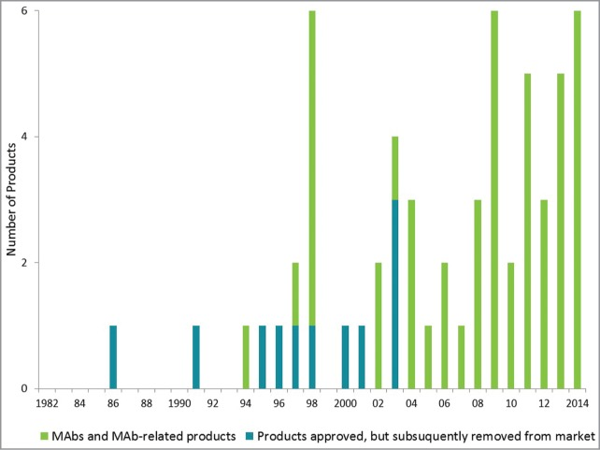
Figure 1. Annual approvals of monoclonal antibody products²
The Massive Monoclonal Marketplace (MMM)
Evidently, the marketplace for monoclonal antibodies has never been larger, with new products coming to market each year. It is anticipated that there could be as many as 70 or more monoclonal antibody products on the market by 2020, with one of the highest approval rates from regulatory agencies among all biopharmaceutical products⁴. Therefore, the value of fully functional monoclonal antibodies cannot be understated. With a current growth rate of 8%, the worldwide sale of monoclonal antibodies surpassed 100 billion in 2017 and is anticipated to reach close to 125 billion dollars by the year 2020⁵ (Figure 2).

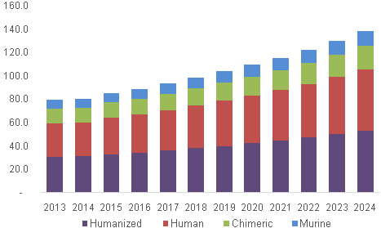
Figure 2. Predicted total global sales of humanized, human, chimeric, and murine monoclonal antibodies¹.

Humble Beginnings…
Looking to make an impact in the lucrative monoclonal antibody marketplace, our protagonist, Dr. Larry Green, enters the picture in early 2009. A founding scientist at the former company Abgenix, Inc., Larry quickly ascended from the role of entry-level scientist to VP. Along the way, he gained valuable knowledge about the technologies and business side of antibody drug discovery and development. In 2008 Larry joined Aliva Biopharmaceuticals Inc., as the acting CEO. It was here where he would pioneer the initial design for his AlivaMab mouse model for monoclonal antibody production, culminating in 12 million dollars in series A financing from Pfrizer and Third Rock Ventures^{3,6}. The proceeds of this financing instilled confidence in Dr. Green, driving him to leave Aliva in 2009 and go on to found Ablexis LLC. Dr. Green brings with him over 18 years of experience in antibody discover, as well as the leadership skills required for collaborative research and product development.
The AlivaMab mouse
There are several key factors that make the AlivaMab mouse a leader in drug discovery through monoclonal antibody production. Firstly, the platform has been validated to target a wide range of applications, whether you want to target tricky GPCRs or sequence diverse panels of mAbs. It can also be manipulated to produce regular antibodies, bispecifics, and CAR-Ts. Furthermore, it features the first and only synthetic, autonomously functioning heavy, kappa and lambda immunoglobulin transgenes. Additionally, the unique combinations of human and mouse coding and non-coding elements, coupled with a patented human/mouse chimeric antibody composition, make the AlivaMaB mouse a world leader in the discovery of therapeutic antibodies².
A wrench in the works…
By October of 2009, the money was beginning to dry up. Apparently, 12 million dollars will only last you four months when you are working on developing a next-generation drug discover platform. With the clock ticking and impatient investors nipping at Dr. Green and his management teams’ heels, they knew it was only a matter of time before they would have to make a crucial decision. Ablexis also recognized that they would need significant capital to continue to develop the AlivaMab Mouse in such a way that they could deliver a personalized antibody in a timely fashion for their big pharma clientele.
Crafting a Clever Consortium (CCC)
With careful planning and a little bit of luck, the management team at Ablexis managed to craft a rather unusual deal. This deal would become a key turning point for this organization while saving them from lucrative company take over. The deal Ablexis signed in October of 2009 was to form a consortium with five of the pharmaceutical giants, allowing Ablexis to provide each company with access to its precious AlivaMab technology. Pfizer, along with four other unnamed companies obtained access to the technology for a paltry 1 million dollars each. Furthermore, once Ablexis has developed and delivered an AlivaMab mouse that meets each partners specification, Ablexis would then receive and juicy 10-million-dollar licensing fee⁷. Meanwhile, big pharma can start pumping out those sweet, sweet monoclonal antibodies from their expertly crafted mouse, making this deal a win-win for both parties. Now don’t get me wrong, the money did a lovely job at keeping investors and venture capitalists smiling, but I think the real benefit of the consortium comes from the freedom it provides.

Funding Future Freedom (FFF)
More traditionally, companies in Ablexis’ position in would have given one company exclusive access to AlivaMab and its associated assets or divided up the technology for narrower usage. However, Dr. Green and his management team found this option unappealing and had likely learned from his previous position at Abgenix Inc. At Abgenix, Dr. green had seen exactly what happens when his company elected to take the more “traditional” route. When Abgenix was strapped for cash they signed a deal with Amgen to be bought out – for a mere 2.2 billion dollars⁹. While investors in Abgenix were understandably thrilled with the deal, it had left a sour taste in Dr. Green’s mouth. By purchasing Abgenix, Amgen was able to escape additive royalties specified in one of their licensing deals. Furthermore, the buyout and resulting loss of royalties forced Abgenix to layoff 15% of their workforce. By taking this sobering experience and learning from it, Dr. Green and his management team at Ablexis crafted the aforementioned consortium. The consortium would provide Ablexis with the freedom to pursue deals outside of the original five pharma companies, reduce the risks to investors in forming new deals in the competitive monoclonal antibody space, and lastly retain the AlivaMab Mouse technology thus providing more income in the future. Moreover, all this was done while keeping those pesky venture capitalists satisfied – pretty clever huh?
Present State of Ablexis LCC
Following the five-company consortium deal announcement, a key partner at Third Rock Venture and a board member at Ablexis, Cary Pfeffer was quoted saying: “Ablexis’ partnership with five leading pharmaceutical companies brings a resounding endorsement of the potential of the AlivaMab Mouse platform,”. She was spot on with this statement, as big pharma companies flocked to Ablexis who have now made similar deals with all of the top 15 pharmaceutical companies in the world. This has made Ablexis LCC to be widely considered the gold standard for the antibody drug discovery and antibody drug development. Ablexis LCC has even expanded to work in tandem with their sister company, AlivaMab Discovery services. They founded this second company to meet the demands of customers who may not have the talent required for antibody drug discovery and were looking to outsource to a scientifically-driven organization. However, Ablexis has not limited themselves to just big pharma, they have signed deals with smaller companies as well. In 2018 they signed two deals, one with the Memorial Sloan Kettering Cancer Center and one with Voyager Therapeutics. These deals are likely the product of the acquisition of Ablexis LCC by the investment management firm, Deerfield. By acquiring Ablexis, Deerfield would likely allow for increased industry access to the AlivaMab mouse technology¹⁰. The pace of signing licensing deals has not slowed in 2019, with Ablexis signing another three deals in January. Firstly, Ablexis would licence the rights to AlivaMab antibodies to Allogene Therapeutics for the use in CAR-T research, a promising new field in the treatment of various cancers⁸. The second deal was to Corvidia Therapeutics, for their promising new treatments for chronic kidney disease. And finally, the third deal was to Eli Lilly another pharmaceutical giant who sells products in over 125 different countries¹¹.
Concluding remarks
As an outside looking in, the rapid ascent of Ablexis LCC from that first endorsement of 12 million dollars in series A funding to becoming the gold standard among monoclonal antibody platforms seems nothing short of a miracle. However, In Dr. Larry Green’s eyes, I’m sure it was all part of his master plan. His 25 plus years of experience using and building transgenic platforms for antibody drug discovery and drug development, coupled with a keen eye for understanding how big pharmaceutical companies go about their business in monoclonal antibody marketplace made him the perfect man to lead Ablexis LCC to financial freedom. Dr. Green’s ability to recognize how voracious big pharma companies like Amgen could be from his time at Abgenix while working alongside his management team develop a creative solution speaks volume to the leadership qualities Dr. Green possesses. Without Dr. Green’s expertise, Ablexis LCC would have more than likely met the same fate as so many other monoclonal antibodies companies before them. Instead, they have become endorsed by investors and big pharma alike, for not only their revolutionary AlivaMab technology but their forward-thinking management style, all stemming from that crucial decision to create that initial consortium.

References:
- Monoclonal Antibodies (mAbs) Market Analysis By Source (Chimeric, Murine, Humanized, Human), By Type of Production, By Indication (Cancer, Autoimmune, Inflammatory, Infectious, Microbial, Viral Diseases), By End-use (Hospitals, Research, Academic Institutes, Clinics, Diagnostic Laboratories) And Segment Forecasts, 2018 – 2024 Retrieved from: https://www.grandviewresearch.com/industry-analysis/monoclonal-antibodies-market
- http://www.ablexis.com/pdfs/ablexis-news-061210.pdf
- Ecker, D.M., Jones, S.D. and Levine, H.L., 2015, January. The therapeutic monoclonal antibody market. In MAbs (Vol. 7, No. 1, pp. 9-14). Taylor & Francis.
- BCC Research Biologic therapeutic drugs: technologies and global markets. Wellesley: (MA: ): BCC Research, LLC; 2013 Jan. 142 p.
- Of Mice and mAbs: Dr. Larry Green, Ablexis. Retrieved from: http://www.pharmexec.com/mice-and-men-dr-larry-green-ablexis
- Ablexis to advance transgenic mouse platform for antibody discovery with $12M Series A financing. June 2nd 2010. Retrieved from https://www.news-medical.net/news/20100602/Ablexis-to-advance-transgenic-mouse-platform-for-antibody-discovery-with-2412M-Series-A-financing.aspx
- Ablexis Cuts Deal With Pfizer, Four Other Pharmas, For Antibody Drug Discovery Tool. October 26th, 2010. Retrieved from: https://xconomy.com/san-francisco/2010/10/26/ablexis-cuts-deal-with-pfizer-four-other-pharmas-for-antibody-drug-discovery-tool/
- Ablexis licenses antibodies for CAR-T development. January 3rd, 2019. Maggie Lynch. Retrieved from: https://www.outsourcing-pharma.com/Article/2019/01/03/Ablexis-licenses-antibodies-for-CAR-T-development
- Scott, Christopher. Liquid Refreshment. Nature Biotechnology volume 31, page 115 (2013)
- Deerfield buys AlivaMab Mouse technology developer Ablexis. June 25th,2018. Retrieved from: https://www.pharmaceutical-technology.com/news/deerfield-acquires-alivamab-mouse-ablexis-antibody-drug/
- Ablexis Announces Expansion Of Non-Exclusive Perpetual License Agreement With Eli Lilly And Company. January 17th, 2019. Retrieved from https://www.pharmajournalist.com/pharma-news/ablexis-announces-expansion-of-non-exclusive-perpetual-license-agreement-with-eli-lilly-and-company/
- Ablexis Announces Licensing Agreement with Corvidia Therapeutics. January 3rd, 2019. Retrieved from: https://www.businesswire.com/news/home/20190103005037/en/Ablexis-Announces-Licensing-Agreement-Corvidia-Therapeutics.

