Exhibits
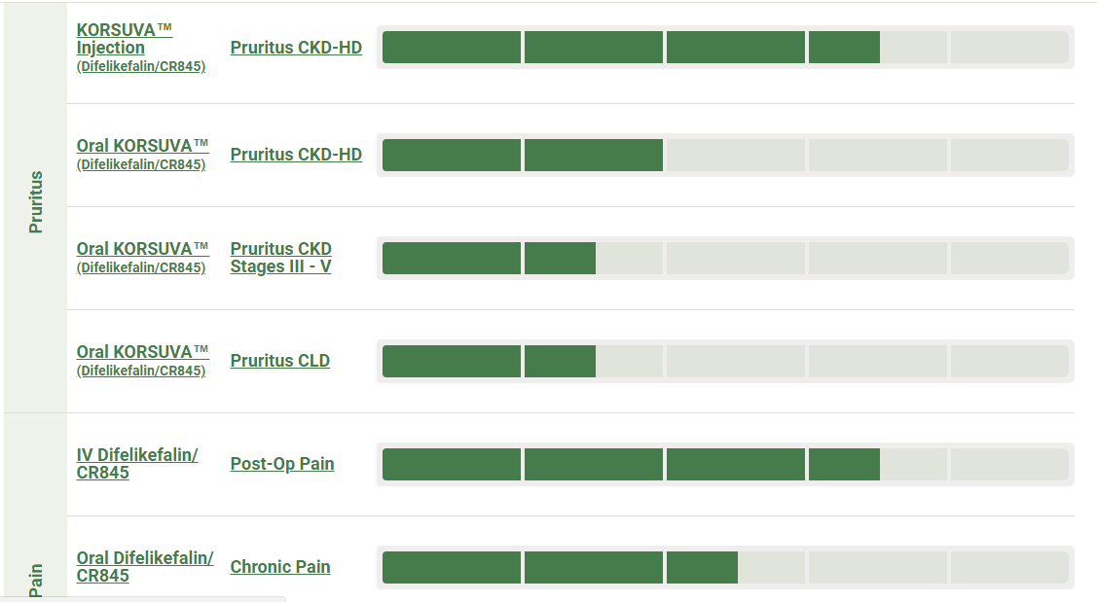
Figure 1: Stages of Several pipelines of KORVUSA (Stage indicated in green)
Retrieved from: https://www.caratherapeutics.com/pipeline-technology/our-pipeline/
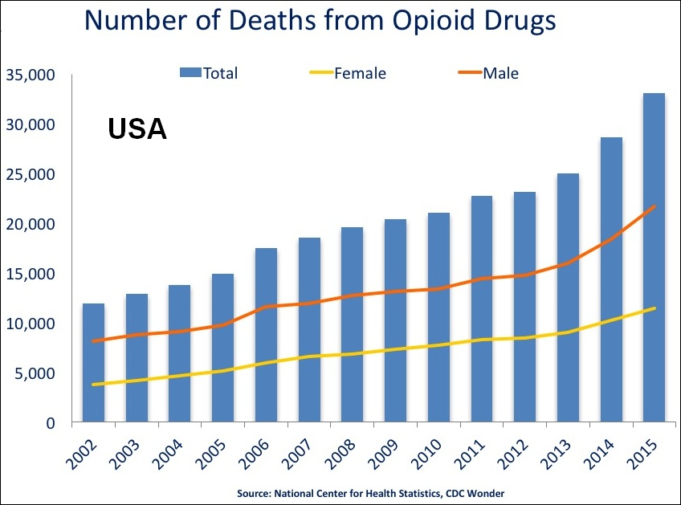
Figure 2: Total Number of Deaths from Opioid Drugs
Retrieved from: https://www.drugabuse.gov/related-topics/trends-statistics/overdose-death-rates

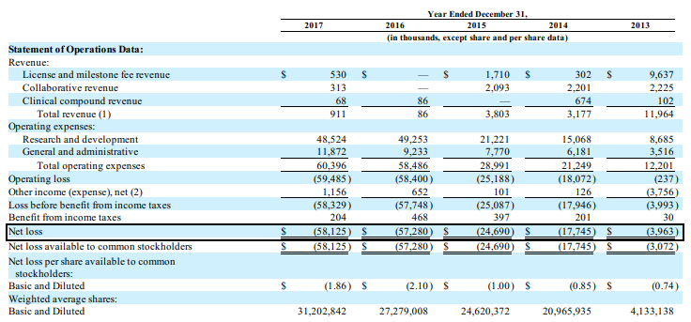
Figure 3: Balance Sheet Highlighting Net Losses of Cara
Retrieved from: http://ir.caratherapeutics.com/static-files/06ede789-724f-4dc2-a348-d82df36a5adc

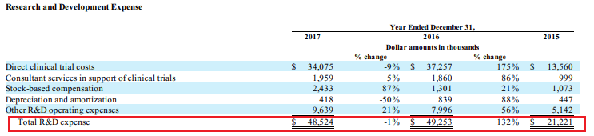
Figure 4: Cara’s Total Research and Development Expenses
Retrieved from: http://ir.caratherapeutics.com/static-files/06ede789-724f-4dc2-a348-d82df36a5adc

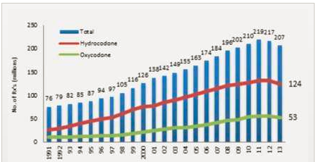
Figure 5: Opioid Prescriptions from 1991 to 2013 (Prescriptions on y axis)
Retrieved from: https://www.drugabuse.gov/about-nida/legislative-activities/testimony-to-congress/2016/americas-addiction-to-opioids-heroin-prescription-drug-abuse

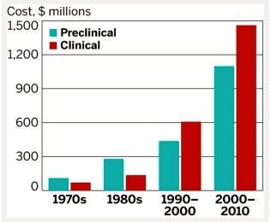
Figure 6: Cost to get a Drug FDA Approved over the Past Decades
Retrieved from: https://cen.acs.org/articles/92/web/2014/11/Tufts-Study-Finds-Big-Rise.html

