**CONGESTIVE HEART FAILURE**

***Uvbi Osatohangbon***

Congestive heart failure, often referred to as CHF, is a condition that develops after the heart muscles have been weakened or damaged. CHF occurs when the heat’s ability to pump blood around the body has been compromised and the blood backs up into the lungs or other parts of the body such as the feet and ankles. Left sided HF causes the fluid to back up into the lungs creating a lack of oxygen which in turn causes fatigue and shortness of breath. “Sometimes the fluid in your lungs can accumulate to the point where it can cause a life-threatening condition” **(Heart and Stroke Foundation, 2018, para. 4).**

CHF has many causes or risk factors. The most common is damage to the heart muscle caused by a heart attack (myocardial infarction or MI). The second most common cause of heart failure is hypertension (high blood pressure) that has been left untreated for a prolonged period. Other less common causes include heart valve dysfunction, myocarditis, drug or alcohol use, diabetes, obesity or high cholesterol. **(Potter et al., 2019).**

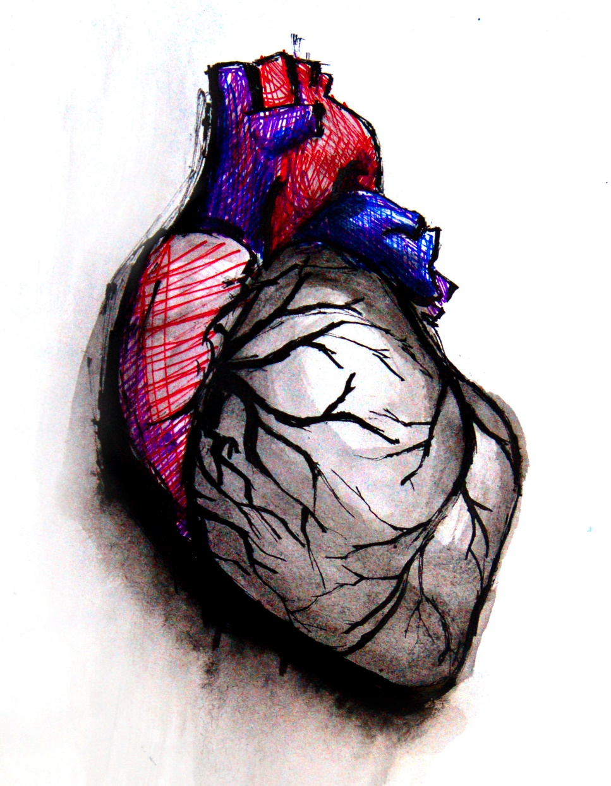

[This Photo](https://www.ecgguru.com/heart-illustrations/heart) by Unknown Author is licensed under [CC BY-SA-NC](https://creativecommons.org/licenses/by-nc-sa/3.0/)

**CONGESTIVE HEART FAILURE**

**Reference List**

Heart and Stroke Foundation. (2018, January 4). Heart failure: Also called congestive heart failure. Heart Stroke. <https://www.heartandstroke.ca/heart-disease/conditions/heart-failure>

Patricia, P., Anne, P., Patricia, S., Amy, H., Barbara, A., Wendy, D. (2019). Canadian Fundamentals of Nursing (6th Edition). Elsevier Canada.