**Analyzing a trend: [****Changes in the Scope of Practice for Nurses]**

Uvbi Osatohangbon, Lambert Orowere, and Justine Nabiddo

Sir Sandford Fleming College

COMM202: Communications II

School of Health and Community Services

Date: March 19, 2022

Bill Templeman March 19,2023

Instructor

Sir Sandford Fleming College

Peterborough, ON, K9J 7BI

Dear Mr. Bill,

The report, attached as per your request, contains the results of our investigation and discoveries about the alterations that have occurred in the duties and responsibilities of nurses. We are writing to you today to share an important update regarding the scope of practice for nurses. As you may already know, the healthcare industry has undergone significant changes over the years, and the role of nurses has evolved accordingly. Recently, we came across an insightful article titled “Then and now” which highlighted some of these changes in detail. The article shed light on how the nursing profession has expanded beyond traditional patient care duties to include a broader range of responsibilities, such as clinical research, health education, and patient advocacy. After reading this article, we believe it is crucial for us to acknowledge and recognize these changes and their impact on the nursing profession. As a result, we propose that we revise our current scope of practice guidelines to reflect these new roles and responsibilities for nurses. By embracing these changes and expanding our scope of practice, we can improve the quality of care for our patients and help meet the evolving needs of the healthcare industry. Thank you for taking the time to read this letter. We look forward to discussing this matter further with you.

Sincerely,

Uvbi Osatohangbon, Lambert Orowere, and Justine Nabiddo

Table of Contents

Executive Summary……………………………………………………………………… 4

Introduction……………………………………………………………............................. 5

Findings and Analysis

Trend Description………………………….……………………………………… 5

Causes and Effects………………………………………...………………………. 7

Looking Ahead……………………………………………………………………... 8

Conclusion…………………………………. ……………………………………………… 8

References…………………………………………………………………………………... 10

**Executive Summary**

The nursing department in healthcare has experienced various changes based on nursing practices. The article "THEN AND NOW: Here is how being a nurse has changed in the last 50 years" reveals nurses have less formal education when they only knew about scientific medical care fifty years ago (Akhtar and Ward, par. 2, 2020). Technological advancement has enhanced various nursing practices, such as lab and nursing reports, improving nursing practice. This report examines the trend in the rise of scope for nursing practice. The report uses credible sources dividing the report into three, with detailed descriptions, the effects and causes of the trends, and an analysis of steps required to follow the movement successfully. The study's results reveal that advancement in technology and knowledge changes the nursing career scope of practice initiating the need for extra nurses, thus encouraging nursing education. The change in trend leads to fast and efficient work from the nurses, improving patients' welfare in healthcare. The rise in technological advancement makes a future demand for nurses to learn information management that would aid them in collecting and analyzing data for short-term and long-term illnesses. Nurses will also have to develop various leadership roles that would steer new adequate directions. Technology initiates different nursing practices, which have improved the welfare of patients due to practical nurses' performance. The report is essential in revealing the essentialness of technological advancement towards better implementation of nurses in health.

Analyzing a trend: [Changes in the Scope of Practice for Nurses]

**Introduction**

According to the writers of the article, “*THEN AND NOW: Here is how being a nurse has changed in the last 50 years*” the role of a nurse, “Fifty years ago... required less formal education, and nurses had just a “rudimentary” understanding of scientific medical care” (Akhtar and Ward, para. 2, 2020). In the Practical Nursing industry, we can see that as years have gone by the curriculum, knowledge and technology have increased, making the job include much more than what was included decades ago; while at the same time introducing new ways of doing things that make certain actions much easier than they were in the past, such as writing nurse reports, checking lab results, communicating with doctors, and taking vital signs. Within the context of education and employment for nurses, the purpose of this report is to examine the trend of the increase in the scope of practice for nurses. There are things that 50 years ago nurses would never be seen doing today and we see this happening across the world. This report will explore many ways or reasons that have contributed and continue to contribute to the development of this trend across Canada. To prove this, the report will use information from a variety of credible sources to demonstrate the changes in the scope of practice of nurses.

The report will be divided into three main steps all of which will include a detailed description of the trend using research to demonstrate that it is occurring within the profession, an overview that will identify its causes and effects as well as a description and analysis of steps that can be taken to best prepare people to enter the workforce in which the trend is active in.

**Findings and Analysis**

**Trend Description**

According to Phil Cohen (2022), “although the primary focus of nursing – taking care of patients – is still the same, almost everything else has been modified” (para. 1). The evolution of the nursing scope of practice began with a change in the education where nurses who were merely seen as physicians' assistants began receiving training that lasted two to three years to be able to work as full-time nurses in hospitals. Nursing continued to evolve and enlarge as time and technology advanced it became more comprehensive to the point where specialized nurses as well as nurses of all background and races joined the profession. The advance in technology has also allowed for nurses to be able to train in virtual spaces and monitor patients' vital signs, distribute their medicine and measure weight in a way that is faster and easier. Although, education and technology has not been the only thing that has evolved for instance according to Cohen (2022), “modern nurses have also traded in all-white uniforms for multicoloured scrubs and rubber shoes” (Para. 13). The more education, technology and the world in general advanced the more the nursing career scope of practice changed and continues to change creating the need for more nurses which allowed for nursing education to move from hospitals to classrooms, certification programs, an increase in nurses' duties and degree programs (Cohen, para. 8, 2022).

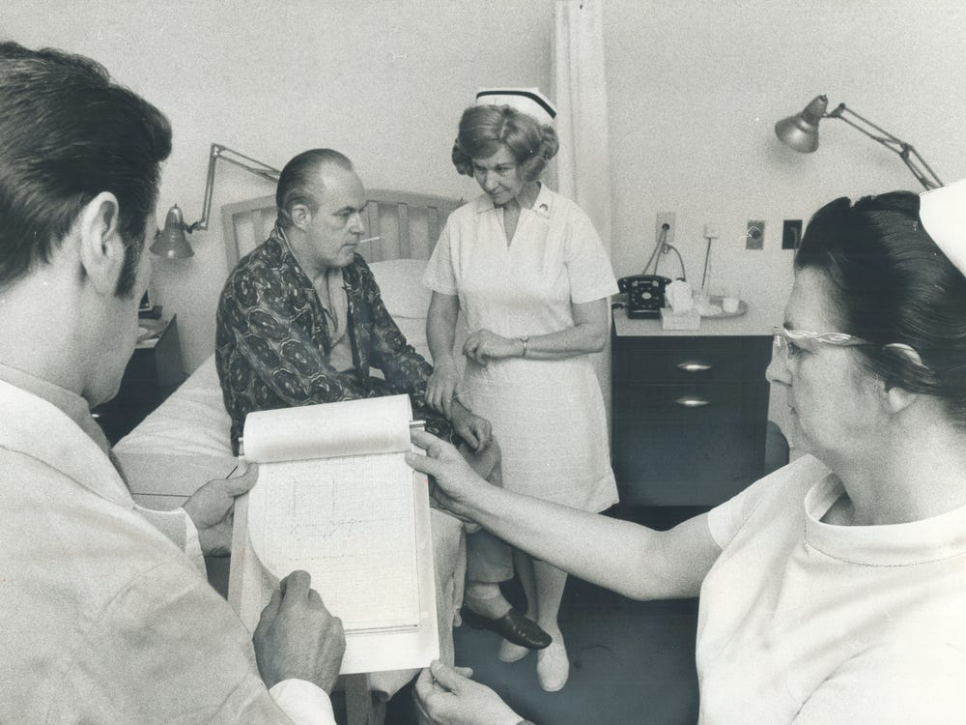

Don Dutton / Contributor / Getty Images

Source: [*Fast Company*](https://www.fastcompany.com/90324489/ive-been-a-nurse-for-20-years-the-male-nurses-i-work-with-have-a-different-pay-track)

**Causes and Effects**

There are constant new advances in today’s education, technology and medicine and these factors also happen to represent the largest differences between the nursing past and present (Cohen, para. 9, 2022). As technology increases new ways of doing things are always being introduced making a nurse’s job faster and more efficient, for example in the past nurses drafted reports or patient record primarily on paper this has now been shifted to mostly digital saving nurses a lot of time while also promoting and increasing the effectiveness of patient privacy and confidentiality. According to Global Health (2020), longer patient spans and growing population have resulted in a shortfall in the number of physicians creating opportunities and expanding education for nurses. As education as and continues to expand, more schools have offered specialized degrees and training as become a more formal, complex, and accessible type of education (Global Health, para. 33, 2020). In addition, many opportunities to access the education online have also been introduced. This increase in extensive education has resulted in a higher value and respect for nurses making them leaders and partners with more responsibilities and not just assistants. All these changes have resulted in a more diverse and educated nursing workforce environment.

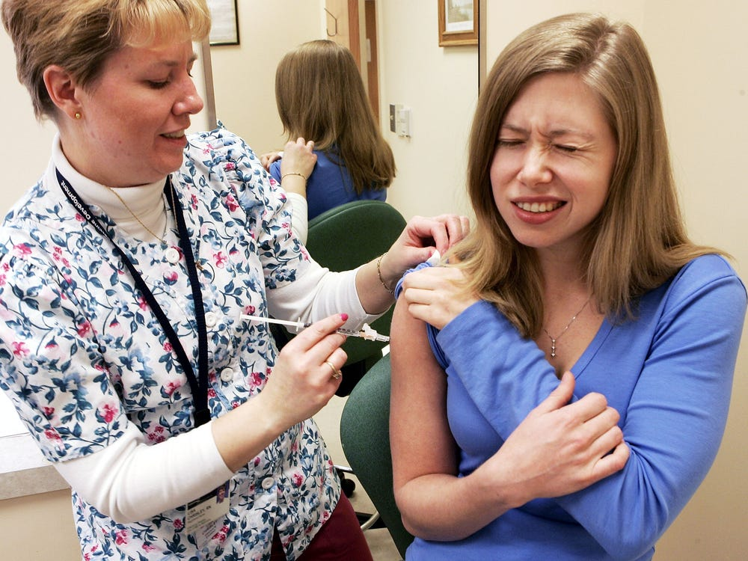

Alex Wong / Staff / Getty Images

Source: [*Fast Company*](https://www.fastcompany.com/90324489/ive-been-a-nurse-for-20-years-the-male-nurses-i-work-with-have-a-different-pay-track), [*Bureau of Labor Statistics*](https://www.bls.gov/ooh/healthcare/registered-nurses.htm)

**Looking Ahead**

According to Global Health (2020), Technology continues to relentlessly advance, which will not only change patient care, but nursing education. More automation, mobility, and access to remote care are anticipated to create a new atmosphere in the nursing landscape” (para. 40). As the world continues to advance more education and modern technology continues to expand. “Today, 57% of nurses hold at least a Bachelor of Science degree. 18% of nurses have completed a graduate program” (Cohen, para. 14, 2022). With an increase in faculty, higher budgets, and more classrooms these number could potentially increase. Since technology has had a significant impact on the nursing scope of practice Phil Cohen (2022) predicts that in the future nurses will have to learn more on information management due to their need to understand how to analyze and gather data that could predict and treat long term and short-term illnesses presented by technology. Due to the profession becoming increasingly extensive in the future nurses could be asked to take on new types of leadership roles in hospitals, to help steer them into new directions.

**Conclusions**

As evidenced by the report’s description of the trend occurring within the profession, there are things that 50 years ago nurses would never be seen doing today. For instance, In the Practical Nursing industry, as years have gone by the job includes much more than what was included decades ago, making some actions much easier than they were in the past, such as checking lab results or taking vital signs. This report examined the trend of the increase in the scope of practice for nurses and identified causes, effects, and steps that could prepare people to work where the trend is active, in this way also demonstrating numerous benefits associated with this trend, as well as the potential disadvantages. Many ways and reasons that have contributed and continue to contribute to the development of this trend were explored using different credible sources. With all this, it is apparent that the scope of practice for nurse has drastically changed over the years making it so that what a nurse was yesterday is different from what a nurse is today.

**References**

Akhtar, A. (2019, April 30). *Then and now: Here's how being a nurse has changed in the last 50 years*. Business Insider. Retrieved March 12, 2023, from <https://www.businessinsider.in/then-and-now-heres-how-being-a-nurse-has-changed-in-the-last-50-years/articleshow/69117867.cms>

Cohen, P. (2022, July 13). *The evolution of nursing: Then, now and what's to come*. PRN Funding. Retrieved March 12, 2023, from <https://www.prnfunding.com/the-evolution-of-nursing>

Global Health Education. (2020, January 15). *Recent changes in Nursing Practice & Education*. Global Health Education. Retrieved March 12, 2023, from <https://globalhealtheducation.com/article/recent-changes-nursing-practice-education>