Skin, Hair & Nails – Lab Submissions

Choose two images from the images below and describe your objective findings below the image.

Image | Objective Description
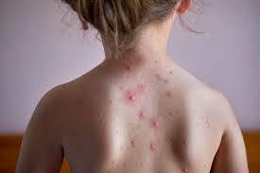 | Distinct individual lesions that remain separate (Discrete)
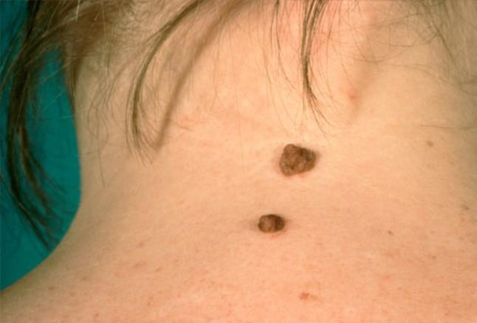 | Brown colour raised nevi. Symmetrical, one smaller in size while the other larger in size and of one single pigmentation with even borders.
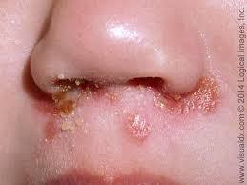 | Thickened, dried put exudate from burst and dried up vesicles/pustules
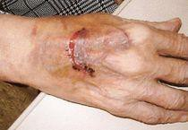 | Large patch of capillary bleeding into tissue. Colour red blue. (contusion)

