# Your AOT ePortfolio

**Administrative Office Technology**

**ePortfolios Put You A Step Ahead**



You, like all other students, are busy attending classes, writing papers, making presentations, completing projects, and solving problems. Have you ever wondered why you are taking all these courses? How will these courses help you meet your goals? Do you want to get a head start on demonstrating work in your program major? An ePortfolio is a great way for you to answer those questions and make connections between your learning experiences.

Just as a visual artist has a collection of work that demonstrates his/her abilities and perspectives, as an AOT student, you, too, will assemble a collection of artifacts that relates to your career major. These artifacts will be presented in the form of an ePortfolio. Ideally your ePortfolio will be a highly individualized resource that will showcase exemplary work and bears witness to your learning and working potential. More than just a catalog of learning artifacts, your ePortfolio is a living document. As you select the artifacts to include in your ePorfolio, you will include a space to write about how those assignments affected you, how they related to each other, or how they helped you meet the AOT Program’s learning outcomes.

**Introducing ePortfolio 1**

**Building Your ePortfolio 2-3**

**How to Structure Your ePortfolio 4**

**Sample ePortfolio Pages 5-7**

**Frequently Asked Questions 8-9**

**Choosing Your ePortfolio Platform 10-11**

**Getting Help with Your ePortfolio 11**

Your ePortfolio is also a great way for the AOT Program faculty to know how well students are meeting learning outcomes essential to career and personal success. Your ePortfolio allows you to document your work in your major as well as General Education courses. Because you can share your ePortfolio with whomever you choose, it is also an exciting way for you to “show off” to the rest of the world – family, friends, scholarship committees, or potential employers. And you’ll be able to take your ePortfolio with you wherever you go.

Your ePortfolio will help you step ahead with your education by providing a venue to reflect upon and share your best work. Good luck!

**Building Your ePortfolio**

**ELECTRONIC PORTFOLIOS**

##### Q: Is the ePortfolio required?

**A:** Yes, it is a course-level requirement in AOT 134 and may be used in other AOT courses. Think of it as an assignment that is common to all AOT courses. Create/Build the ePortfolio outline once and use it for all of your AOT and General Education courses.

##### Q: Are there resources to help me construct my ePortfolio?

**A:** Yes. You can build your ePortfolio with many different software platforms, as long as you end up with a web-based site that can be shared with AOT faculty. Some of these platforms include: Weebly, Wix, Google Sites, and Prezi. Note that TCTC does not endorse these particular sites, nor is the College responsible if you have a bad experience with one of them. Pages 10-11 of this handbook has more information about each platform. **Please do not use Myspace, Facebook, Blogger,** or similar social networking sites to create your ePortfolio.

##### Q: Will my instructor teach me how to build an ePortfolio?

**A:** No. Because students have a choice of ePortfolio platforms to use, instructors will not be expected to teach you how to use your chosen platform. Instructors can, however, allow class time to work on your ePortfolio in order to provide guidance on content. Don’t worry, these sites are fairly easy to use.

##### Q: Does this result in more work for students?

**A:** The truth is that the ePortfolio results in a little more work for students. Students will need to build the ePortfolio outline once, and then use it as you continue through your program courses. Students put one or more assignments from each class into their ePortfolio along with a couple of paragraphs of reflective writing. It takes less than 15 minutes to add a page to your portfolio, upload your assignments, and paste in your reflection.

##### Q: I noticed some ePortfolio platforms have versions that cost money. Do I have to purchase it?

**A:** No. You can build an excellent ePortfolio without upgrading to a paid version. The paid versions are reasonably priced and give you increased capabilities and features; but it is not required.

##### Q: Can I put assignments or other material in the ePortfolio that are not mine?

**A: Absolutely not**. Plagiarism is a violation of the Student Code of Conduct and will be taken very seriously. You should know that the College subscribes to anti-plagiarism software that faculty use to compare current digital artifacts with those appearing anywhere else on the Web.

##### Q: How much personal information should I put in my ePortfolio?

**A:** Only as much as you feel comfortable sharing. This is supposed to be a public representation of your learning, but you certainly don’t have to put your photo, full name, address, email address, or other information in the portfolio if you don’t want to. You’ll have to decide how best to balance your privacy concerns with the desire to use the ePortfolio to showcase your educational aspirations and accomplishments. The primary audiences for your ePortfolio should be your instructors, your family, and possibly scholarship committees and future employers. Depending on the platform you choose, you will be able to either hide your ePortfolio from Web searches, or password protect key pages within it.

# Five Important ePortfolio Steps:

**ELECTRONIC PORTFOLIOS**

### Step One

#### Get Informed.

* Carefully read through this ePortfolio Handbook, which will answer many of your questions.

**Step Two**

**Pick a Platform.**

* The ePortfolio Handbook will help you choose from several free platforms: Google Sites, Weebly, Wix, and Prezi. They are all easy to use.

**Step Three**

**Watch the Video Tutorials.**

* Google Sites
  + [How to use the New Google Sites](https://www.youtube.com/watch?v=Dm8nEq4jVJg)
  + [NEW Google Sites EASY Student Portfolio](https://www.youtube.com/watch?v=0IjuM2VoLgU)
* Weebly
  + [How to Create a Portfolio on Weebly](https://www.youtube.com/watch?v=Lui3uV70Tk0)
  + [How to Build a Weebly Portfolio Website in 5 minutes or less](https://www.youtube.com/watch?v=_aQSo1fB6W0)
* Wix
  + [How to Build a Wix Portfolio Website in 5 minutes or less](https://www.youtube.com/watch?v=6d9UBt1XoaE)
  + [How to Create an E-Portfolio Using Wix](https://www.youtube.com/watch?v=QYwJ8At-wgs)
* Prezi
  + [Prezi Next 2017 – New Version of Prezi 2017](https://www.youtube.com/watch?v=mEqbJ1sulWA)

**Step Four**

**Build Your ePortfolio.**

* After you’ve watched the video tutorials all the way through, use them to build your ePortfolio as instructed. Put your own style into it by picking a theme and using your creativity but remember to follow the standard ePortfolio outline described on page 4 of this Handbook.

**Step Five**

**Enter the Address of Your ePortfolio into Blackboard.**

* Copy the URL (address) of your ePortfolio’s Welcome page, log into Blackboard, click on the ePortfolio drop box, paste the URL for the ePortfolio’s Welcome page into the “Comments” box, and click “submit.” This will make your ePortfolio accessible by the instructor.

### How to Structure Your ePortfolio

**ELECTRONIC PORTFOLIOS**

The AOT Program requires that you follow a basic outline for your ePortfolio. Beyond that, we encourage you to use your imagination and creativity to make your ePortfolio uniquely yours. Structure your ePortfolio according to this chart. Note that the headings in the purple boxes are required:

|  |  |  |  |  |  |
| --- | --- | --- | --- | --- | --- |
| **Welcome** | **Résumé** | **Skills** | **Coursework** | **Letters of Recommendation** | **Reflections** |
| Welcome people to your ePortfolio and tell them about what they’ll find there. | A current résumé in either web or pdf format | Include information about skills you have acquired and the various software programs you have learned. These can be skills learned through your college studies or from community/ volunteer activities.  When adding skills to your portfolio, relevancy to jobs you *want* is what’s important. | Your work samples provide evidence of your skills, knowledge, experience, and uniqueness.  Clearly label and describe the samples you post. | Include a minimum of two letters of recommendation: one must be from a teacher (other than the instructor for this course), counselor, or administrator who knows you well at TCTC. | Include the Mid-Project and Final Project reflections |

##### Q: Why is it important to structure the ePortfolio this way?

A: The AOT Program allows students the freedom to choose which software platform they want to use to build their ePortfolio, but it is very important for faculty looking at ePortfolios that they all follow a common organizational scheme. This makes it easier for your instructors to quickly understand how to navigate the ePortfolios of all their students.

##### Q: How much freedom do I have in designing my ePortfolio?

**A:** All ePortfolios should have the outline indicated above – if you would like to add more sections to your ePortfolio, discuss that with your instructor. Beyond that, you are completely free to design the “look and feel” of your portfolio. In fact, we encourage it. Think about the process of creating your AOT ePortfolio as constructing your intellectual persona. It should be as individual as you are.

The following Sample ePortfolio pages can be seen here:   
<https://sites.google.com/view/aot-eportfolio-sample/welcome>

**The Welcome Page in Your ePortfolio**

**ELECTRONIC PORTFOLIOS**

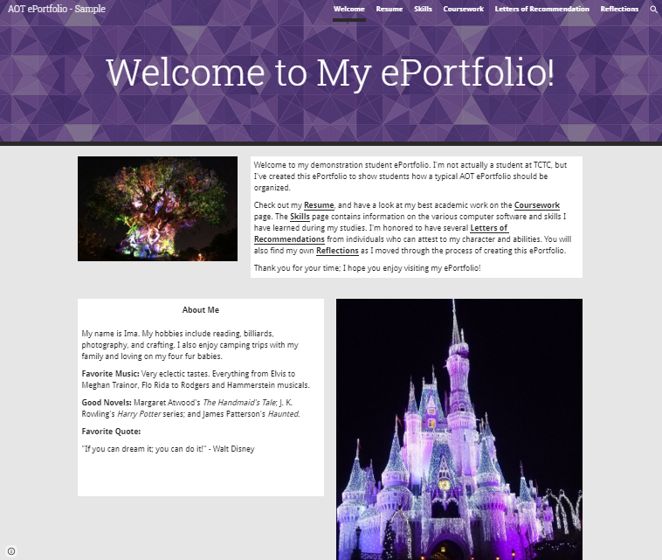

#### The image above is a good example of a Welcome page in an ePortfolio. Notice the following elements:

* A balancing of text and images. You do not need to put a photo of yourself in the portfolio, but you should include some photos you’ve taken...perhaps vacation photos, photos of some of your favorite things, photos pertaining to your hobbies, etc.
* A nice welcome paragraph that welcomes people to your site and tells them what they’ll find there. Primary audience should be your instructors, scholarship committees, and potential employers.
* An “About Me” section in which you tell a little bit about yourself. What do you want your audience to know about you? Make a positive impression.

# The Coursework Page in Your ePortfolio

**ELECTRONIC PORTFOLIOS**

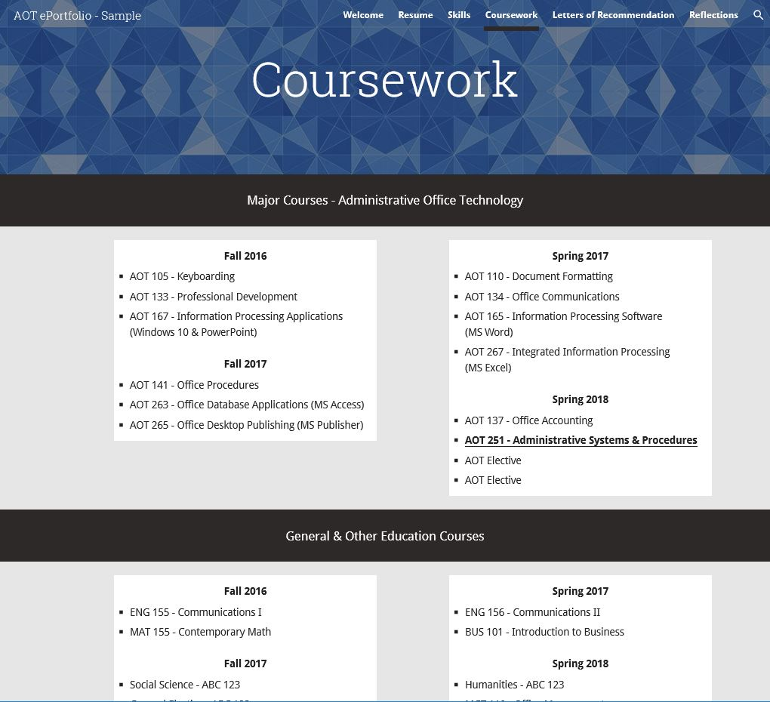

#### The image above is a good example of a Coursework page in an ePortfolio. Notice the following elements:

* Two sections: Majors Courses and General & Other Education Courses.
* Each section is organized by semester.
* In the Major Courses sections, include the course number and name. In the General & Other Education Courses section, list the specific General Education requirements **and** the course number you used to satisfy each requirement.
* Each course descriptor (like AOT 251 – Admin. Systems & Procedures) becomes a hyperlink to a hidden page in the ePortfolio that contains your work and reflection in that course.
* The page is clean--there are no assignments on it. This makes it easy on the viewer.

# A Typical Course Page in Your ePortfolio

**ELECTRONIC PORTFOLIOS**

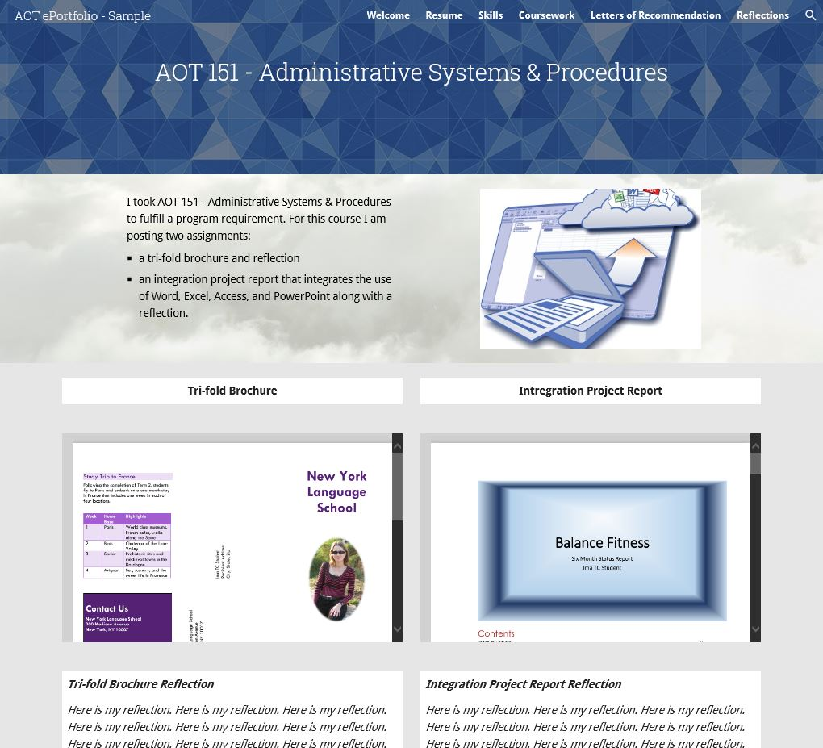

#### The image above is a good example of a course page in an ePortfolio. Notice the following elements:

* + The page header clearly identifies the course.
  + A brief introductory paragraph indicating what assignments you are putting into the ePortfolio.
  + An image or graphic that pertains to the course or to one of the assignments. Web sites look better if they contain graphics in addition to text. Try to find public domain images to include in your site. Credit the creator of the image. If you cannot find a public domain image, you can still use a graphic if you cite its source and claim fair educational use.
  + Uploaded student work. In this example, the student has uploaded two separate assignments and clearly labeled them. Many faculty prefer pdf files, but you can use just about any file type except for .docx files in Google Sites.
  + Reflective writing. You can see that the instructor is asking for two separate reflections--one for each document presented. Each reflection should be 3-4 paragraphs in length.

# Frequently Asked Questions

**ELECTRONIC PORTFOLIOS**

##### Q: What kinds of things can I put in my ePortfolio?

**A:** We use the term “artifact” for the assignments you put in your ePortfolio. You can talk with your instructors to help you decide which assignments will result in appropriate artifacts that you can put in your ePortfolio. You can put many different kinds of digital artifacts in your ePortfolio, including text files, images, audio, video, and links to webpages. Two things to remember: (1) Do not put .docx files in Google Sites; save them as .doc files. (2) Better yet, convert as many of your files to pdf as you can, because they end up being smaller files and they open quickly.

##### Q: What the heck is reflection?

**A:** Reflection is very important to your learning, for it allows you to place the assignment in an academic or personal context. For each artifact you put in your ePortfolio, your instructor may ask you to respond to questions like these:

* How does your performance on this assignment demonstrate achievement of--or progress toward—your career goal?
* How does this assignment (or the whole course) connect with what you learned in another course?
* How does this assignment connect with the real world?
* What challenges did you face in completing the assignment? How did you address them?
* Why did you pick this assignment to put in your ePortfolio? What does it demonstrate about your learning? [Assumes that instructor has given students a choice of assignments to include in the ePortfolio]
* How did participation in this assignment help you better understand how the main concepts in this course apply to your life or community?
* How does the assignment illustrate the growth/change/progression you have had in this class?

Reflection is a way for you to think about your thinking--the fancy word for that is *metacognition*--and think about your learning process. **Reflection helps you “own” your learning, so take this part of the ePortfolio process seriously.** You can expect each instructor to assign three to four paragraphs of reflective writing to accompany the artifact(s) you put into your ePortfolio.

Please keep in mind that reflection in your ePortfolio is not a place to evaluate your courses or your instructors. The College conducts regular student evaluations of all instructors and courses, and those surveys are a much better venue to express your positive or negative impressions of your teachers and courses. Reflection is a place for you to critically think about **your** learning and focus on **self**-investigation.

##### Q: Do I have to use a specific kind of computer? What if I don’t have one?

**A:** No. You can use a Windows or Mac computer. No special software is required, but you should use the latest versions of browsers such as Safari, Chrome, Firefox, and Internet Explorer (do **not** use Edge); just be sure the browser you use is supported by the ePortfolio platform you choose. You can use any lab computer on campus to create and upload your artifacts, assuming you have them on a jump drive. You may also use a computer available from family, friends, or the public library.

##### Q: Should I save a digital copy of what I turn in to my instructors?

**A:** Yes! And if it’s a physical thing like a sculpture or a poster presentation, take photos! Invest in a jump drive so you can store backup copies of your work.

# Frequently Asked Questions – cont’d

**ELECTRONIC PORTFOLIOS**

##### Q: Who owns the ePortfolio when I’m finished at TCTC?

**A:** Each student owns his or her ePortfolio and can continue to use it after leaving TCTC. If you transfer to a four-year college or university, our advice to you is to keep using it to document your learning--regardless of whether your new professors know anything about it. When you get into your major at the four-year college or university, use that section of the Coursework page to document your learning. That way, you’ll be able to chart your progress through TCTC all the way to achieving your bachelor’s degree.

##### Q: What if one of these sites loses my data?

**A:** TCTC cannot be responsible for the performance of these third-party sites. The situation is analogous to your instructor requiring you to create a spreadsheet on your computer. If your spreadsheet program eats your data, the manufacturer of the software is responsible rather than the College. For this reason, *we highly recommend that you keep a digital copy of the work you put in your ePortfolio as well as a copy of other work you do at TCTC*. Invest in a thumb or jump drive to store your coursework.

##### Q: What if I’m concerned about my privacy?

**A:** There is little to worry about here, because you can either hide your ePortfolio from search engines or password protect pages within it. You own your ePortfolio, so you determine the visibility of your ePortfolio. Some tips:

* + Share your ePortfolio’s URL only with TCTC faculty and staff, as well as family, trusted friends, scholarship committees, and potential employers. Otherwise, keep the address to yourself.
  + When you sign up for your ePortfolio, don’t use your name in the domain name, so an address like www.kb345.weebly.com is far better than www.katyburklie.weebly.com.
  + Similarly, don’t title the ePortfolio heading with “Katy Burklie’s TCTC ePortfolio,” as that will make it easier to find on a web search.
  + You can use the site settings in several platforms to make your ePortfolio invisible to search engines.
  + Use only your first name throughout the portfolio--on assignments, on the Welcome page, and on your resume.
  + Don’t put pictures of yourself in the portfolio.
  + Finally, several of the ePortfolio platforms allow you to hide your site from search engines, allowing only those with the URL to see it.

##### Q: May I be excused from the ePortfolio requirement?

**A:** No. However, if you have severe concerns about the ePortfolio, you can petition the instructor for a waiver that will allow you to make an offline ePortfolio that follows the outline on page 4 of this handbook. If you are granted a waiver, you will be given instructions on several possible ways to make an offline ePortfolio. You must present your offline electronic portfolio to any instructors who ask for it. Otherwise, if you elect not to complete the ePortfolio project, you will receive a grade of zero on the project which will impact your overall course grade.

##### Q: What is the grade-weight of the ePortfolio requirement?

**A:** The ePortfolio falls under the Projects category for grading purposes – Projects are worth 20% of your overall course grade. The grade component breakdown of this project is as follows:

* ePortfolio 50% of the project grade
* Oral Presentation 40% of the project grade
* Reflections 10% of the project grade

# Choosing Your ePortfolio Platform

**ELECTRONIC PORTFOLIOS**

##### Q: Which platform does TCTC support?

**A:** TCTC does not endorse particular ePortfolio platforms nor does it provide technical support. Below is information to consider when selecting an ePortfolio platform.

|  |  |  |
| --- | --- | --- |
| **Platform** | **Considerations** | |
| **Google Sites**  [www.sites.google.com](http://www.sites.google.com/) | * Fairly easy to use. * Excellent integration with Google Docs. * Hide site from search engines. * Many templates to choose from. | * Link YouTube, Facebook and others. * Very generous 10GB of total storage. * Add a blog page. |
| **Weebly**  [www.weebly.com](http://www.weebly.com) | * Fairly easy to use. * Unlimited storage for two free sites. * File upload limit of 5 MB* * Many excellent templates to choose from. | * Really doesn’t like it when you use Internet Explorer. * Hide site from search engines. * Link YouTube, Facebook and others. * Add a blog page. |
| **Wix** [www.wix.com](http://www.wix.com) | * Fairly easy to use. * Drag ‘n Drop editor * 500 MB storage * Many templates to choose from. | * Link YouTube, Facebook and others. * Hide site from search engines. * Add a blog page. |
| **Prezi** [**prezi.com**](http://www.prezi.com) | * Fairly easy to use. * Unlimited presentations. * Many templates to choose from. | * Privacy settings available with EDU account * Link YouTube, Facebook and others. * Animation of objects. |

* To put this in perspective, a 160-page Microsoft Word document is about 1 MB, so you’ll have no problem uploading any paper you write. For all of these platforms, really large projects like videos and photo galleries are best housed at other locations like Flickr and YouTube, and then linked from the ePortfolio. That way, you won’t be using up storage space on the ePortfolio site and won’t have to worry about file upload limits. Check the specific platform for details about this.

##### Q: Can I create my ePortfolio using another platform?

**A:** Yes. One possibility is to build your ePortfolio using Jimdo ([www.jimdo.com/portfolio-website](http://www.jimdo.com/portfolio-website)) or WordPress ([www.wordpress.com](http://www.wordpress.com)). If you find another platform you prefer over the ones addressed in this manual, just double-check with your instructor before starting your ePortfolio. **Do not use Myspace, Facebook,** or similar social networking sites to create your ePortfolio.

# Getting Help with Your ePortfolio

**ELECTRONIC PORTFOLIOS**

**Online Help Sites**

You may find various video tutorials available on YouTube to help customize your ePortfolio. You may also utilize the tutorials provided on each of the ePortfolio platform websites.

**Help with Reflective Writing**

The TCTC Tutoring Center is a resource that can be used for assistance with writing assignments.

**Ask Your Instructor**

If you have any questions related to the ePortfolio project, please ask your instructor.

# More ePortfolio Samples

**ELECTRONIC PORTFOLIOS**

Google Sites – Lisa Chow  
<https://sites.google.com/site/lisachow23/home>

Weebly – Allison Freiberg  
<http://allisonfreiberg.weebly.com/>

Prezi – Emily Sutherland

<https://prezi.com/g58xke2mpwtd/everyone-but-emily/?utm_campaign=share&utm_medium=copy>

Wix – Patience Marsh  
<https://patiencemarsh.wixsite.com/portfolio>

