Leadership Development Plan (LDP)
IBH 1LD0
Winter 2025

Fill in this template to complete your Leadership Development Plan (LDP).

Leadership Issue 1

1. Use the following sections to outline your first Leadership Issue.

1.1.1 Leadership Issue

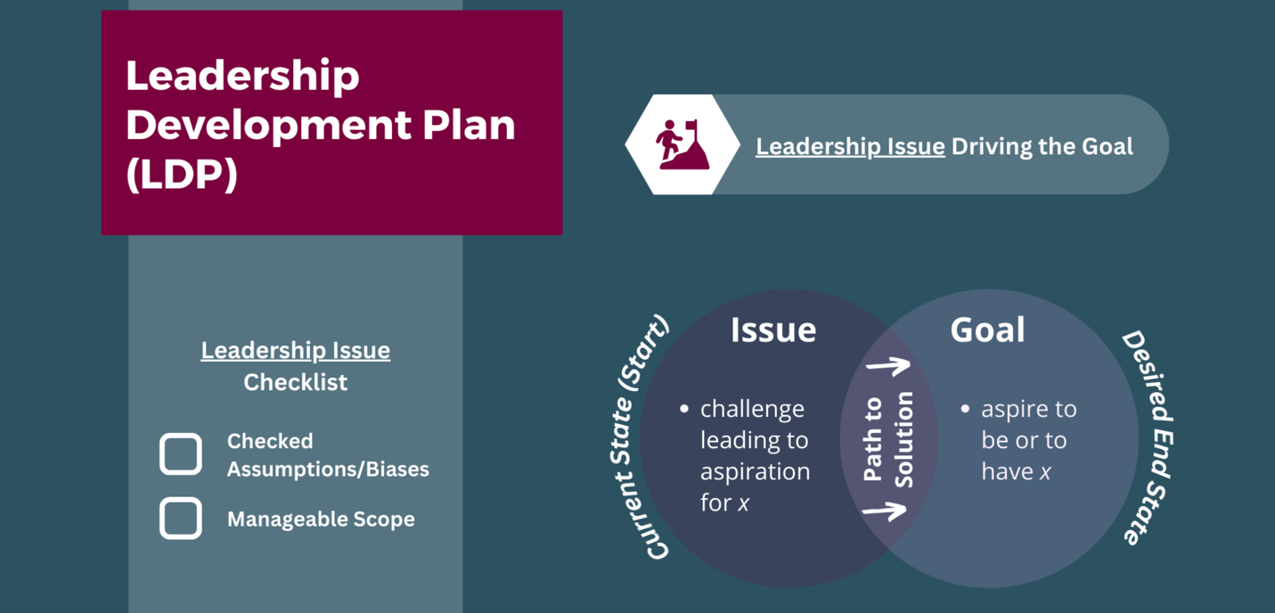
Identify your first Leadership Issue.

1.1.2 Leadership Issue Checklist

Complete the Leadership Issue Checklist for your first Leadership Issue.
Checked assumptions/biases
Manageable scope

1.2.1 Action(s)

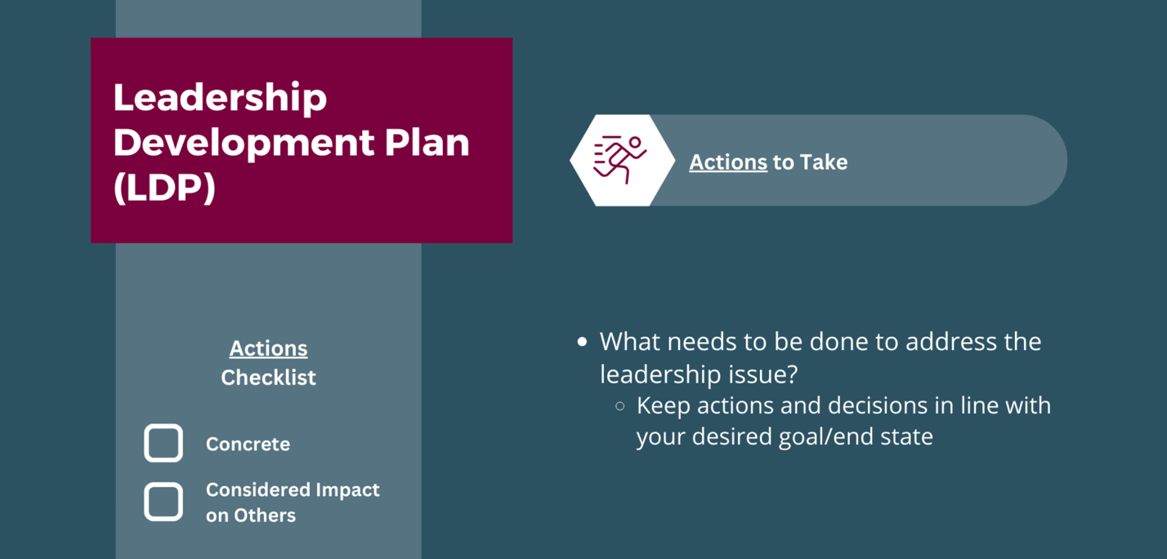
Identify the Action(s) you will take to address your first Leadership Issue.

1.2.2 Action(s) Checklist

Complete the Action(s) Checklist for your first Leadership Issue.
Concrete
Considered Impact on Others

1.3.1 Timeline

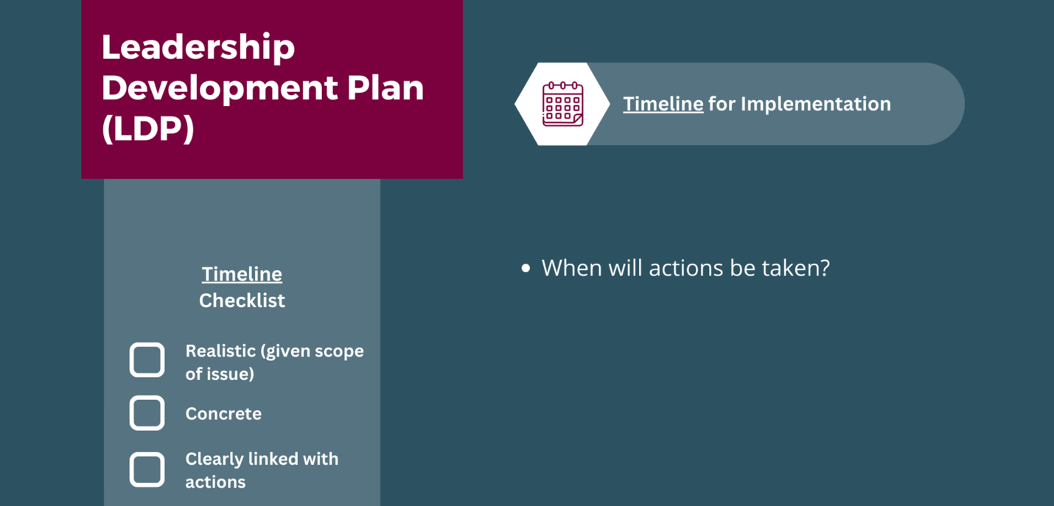
Identify the Timeline to implement your Action(s) for your first Leadership Issue.

1.3.2 Timeline Checklist

Complete the Timeline Checklist for your first Leadership Issue.
Concrete
Clearly Linked to Action(s)
Realistic (Given Scope of Leadership Issue)

1.4.1 Monitor Progress

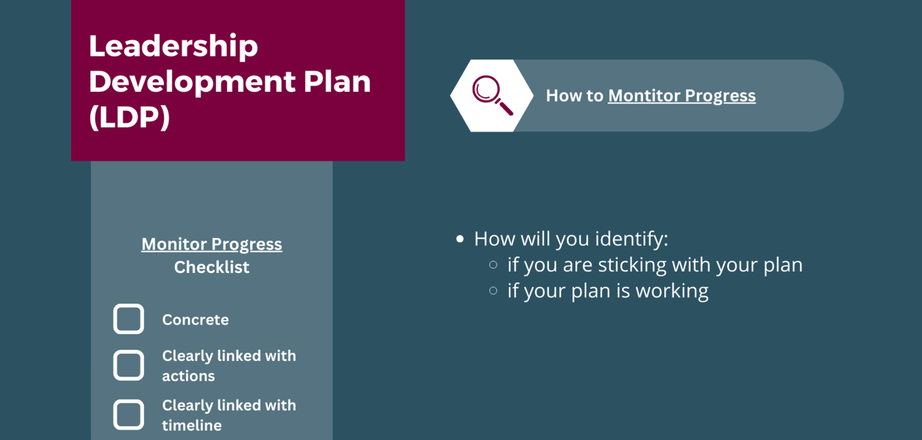
Identify how you will Monitor Progress toward resolving your first Leadership Issue.

1.4.2 Monitor Progress Checklist

Identify how you will Monitor Progress toward resolving your first Leadership Issue.
Concrete
Clearly Linked to Action(s)
Clearly Linked with Timeline

1.5.1 Resource(s)

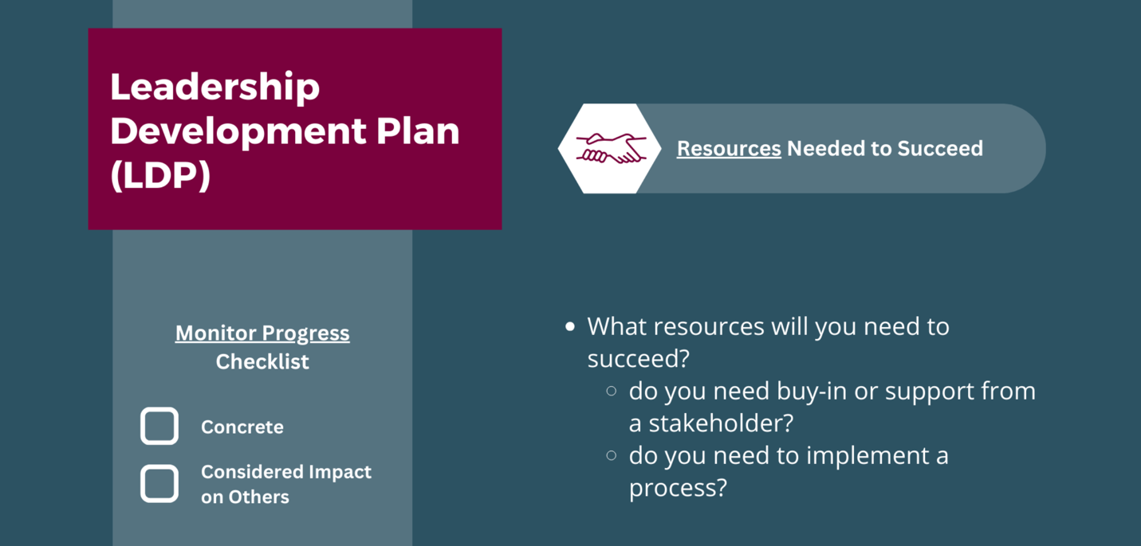
Identify the Resource(s) you will need to successfully address your first Leadership Issue.

1.5.2 Resource(s) Checklist

Complete the Resource(s) Checklist for your first Leadership Issue.
Concrete
Considered Impact on Others

Leadership Issue 2

2. Use the following sections to outline your second Leadership Issue.

2.1.1 Leadership Issue

Identify your second Leadership Issue.

2.1.2 Leadership Issue Checklist

Complete the Leadership Issue Checklist for your second Leadership Issue.
Checked assumptions/biases
Manageable scope

2.2.1 Action(s)

Identify the Action(s) you will take to address your second Leadership Issue.

2.2.2 Action(s) Checklist

Complete the Action(s) Checklist for your second Leadership Issue.
Concrete
Considered Impact on Others

2.3.1 Timeline

Identify the Timeline to implement your Action(s) for your second Leadership Issue.

2.3.2 Timeline Checklist

Complete the Timeline Checklist for your second Leadership Issue.
Concrete
Clearly Linked to Action(s)
Realistic (Given Scope of Leadership Issue)

2.4.1 Monitor Progress

Identify how you will Monitor Progress toward resolving your second Leadership Issue.

2.4.2 Monitor Progress Checklist

Identify how you will Monitor Progress toward resolving your second Leadership Issue.
Concrete
Clearly Linked to Action(s)
Clearly Linked with Timeline

2.5.1 Resource(s)

Identify the Resource(s) you will need to successfully address your second Leadership Issue.

2.5.2 Resource(s) Checklist

Complete the Resource(s) Checklist for your second Leadership Issue.
Concrete
Considered Impact on Others

Leadership Issue 3

3. Use the following sections to outline your third Leadership Issue.

3.1.1 Leadership Issue

Identify your third Leadership Issue.

3.1.2 Leadership Issue Checklist

Complete the Leadership Issue Checklist for your third Leadership Issue.
Checked assumptions/biases
Manageable scope

3.2.1 Action(s)

Identify the Action(s) you will take to address your third Leadership Issue.

3.2.2 Action(s) Checklist

Complete the Action(s) Checklist for your third Leadership Issue.
Concrete
Considered Impact on Others

3.3.1 Timeline

Identify the Timeline to implement your Action(s) for your third Leadership Issue.

3.3.2 Timeline Checklist

Complete the Timeline Checklist for your third Leadership Issue.
Concrete
Clearly Linked to Action(s)
Realistic (Given Scope of Leadership Issue)

3.4.1 Monitor Progress

Identify how you will Monitor Progress toward resolving your third Leadership Issue.

3.4.2 Monitor Progress Checklist

Identify how you will Monitor Progress toward resolving your third Leadership Issue.
Concrete
Clearly Linked to Action(s)
Clearly Linked with Timeline

3.5.1 Resource(s)

Identify the Resource(s) you will need to successfully address your third Leadership Issue.

3.5.2 Resource(s) Checklist

Complete the Resource(s) Checklist for your third Leadership Issue.
Concrete
Considered Impact on Others

