Updated December 2023
lawerence kinlin school of business
Final Grades
manual grade entry into webAdvisor

Contents
Manual Final Grades Entry WebAdvisor 2
Accessing WebAdvisor 2
Selecting the Term 4
Cross-Listed Sections 4
Selecting Type of Grading 5
Timing Out 5
Numeric to Letter Grade Chart 6

Manual Final Grades Entry WebAdvisor

Accessing WebAdvisor
- Access WebAdvisor through the Employee Portal
- Scroll to the Fanshawe websites section
- Click on the WebAdvisor tab
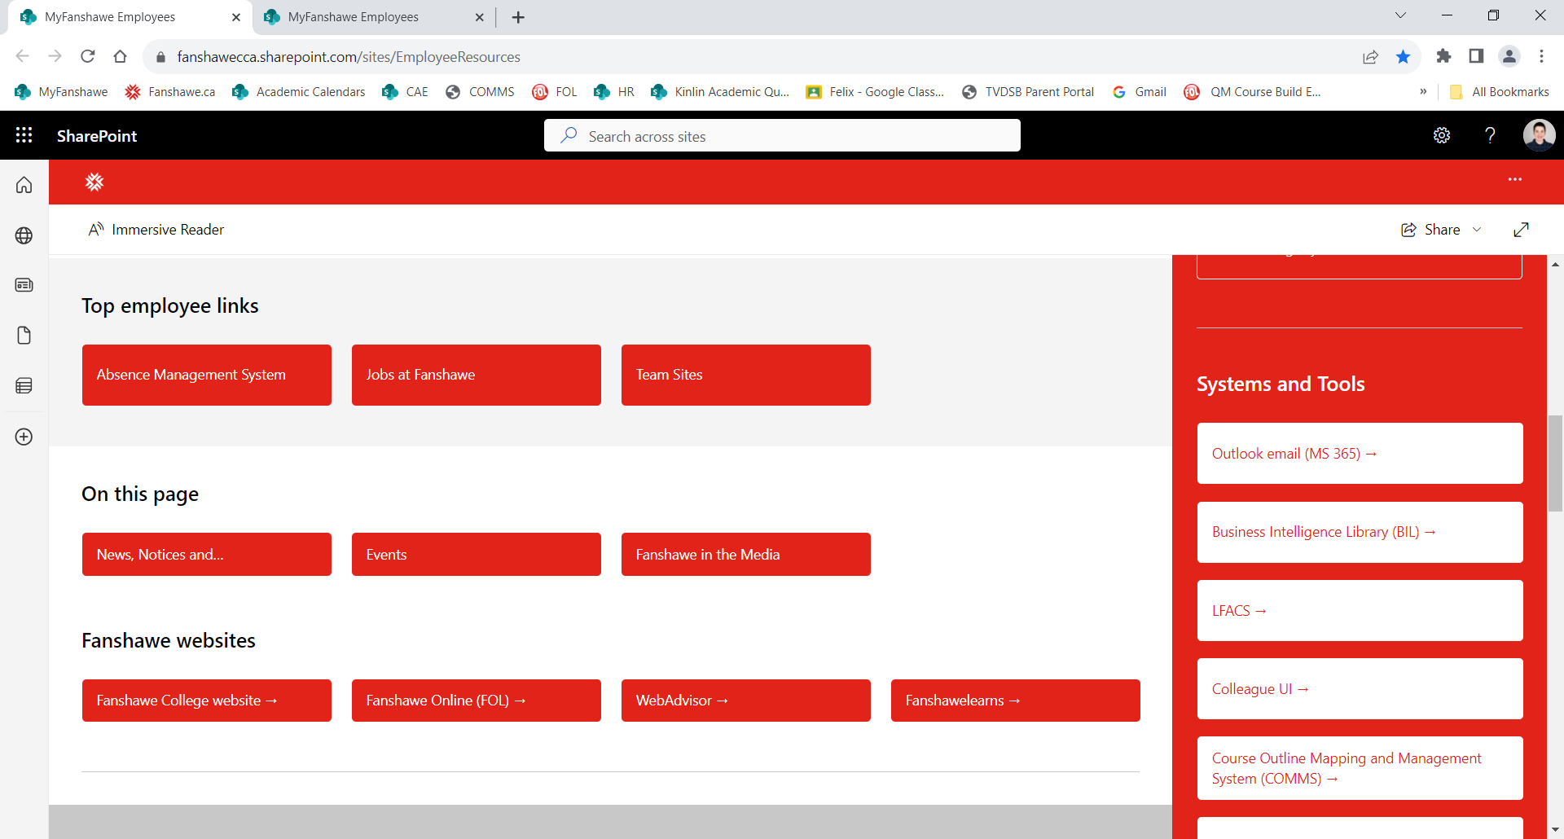
- Click on the Faculty tab
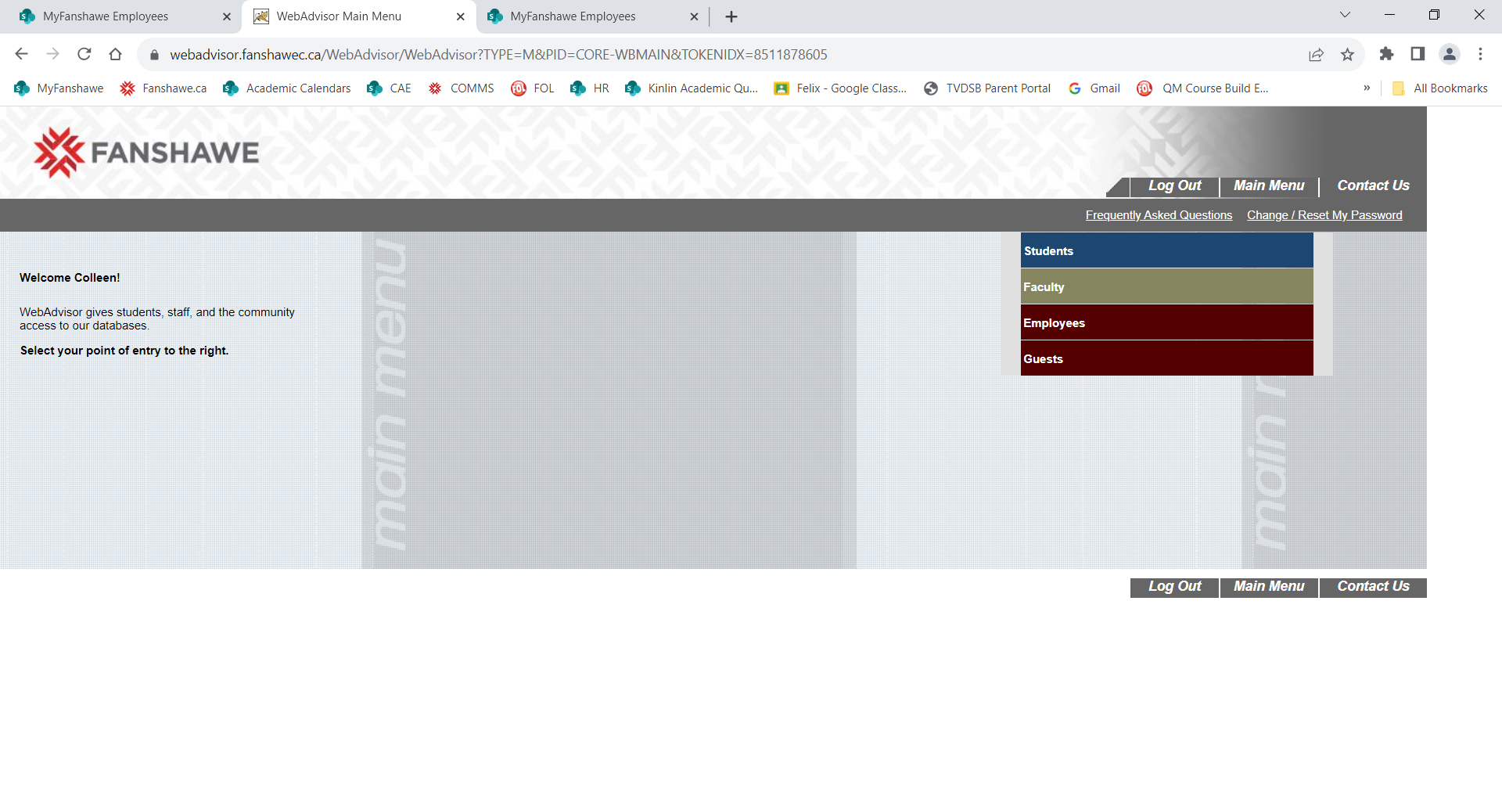

- Select Grading (under ‘Faculty Information’)

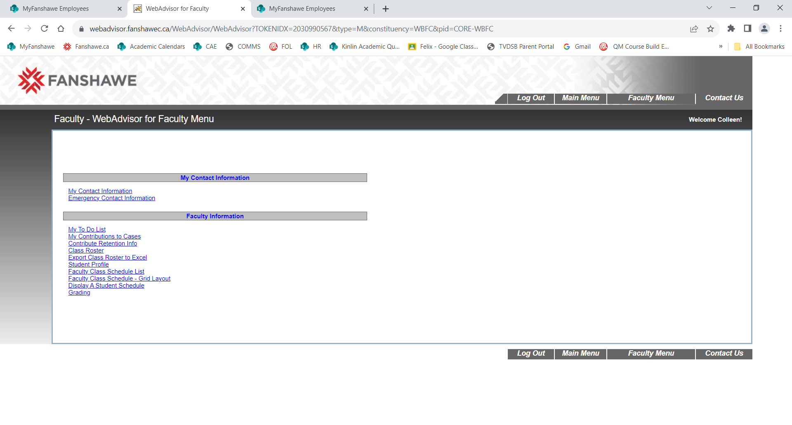

Select the Term
- Selecting the term is an important step for cross-listed students
- Select the appropriate term using the drop down menu options
  - 2023 Fall (for full-time students)
  - 23F – Fall 2023 term for section 01PT (for PTOL students)
  - 23FCE – Fall Continuing Ed for the section 40LC (for CE students)

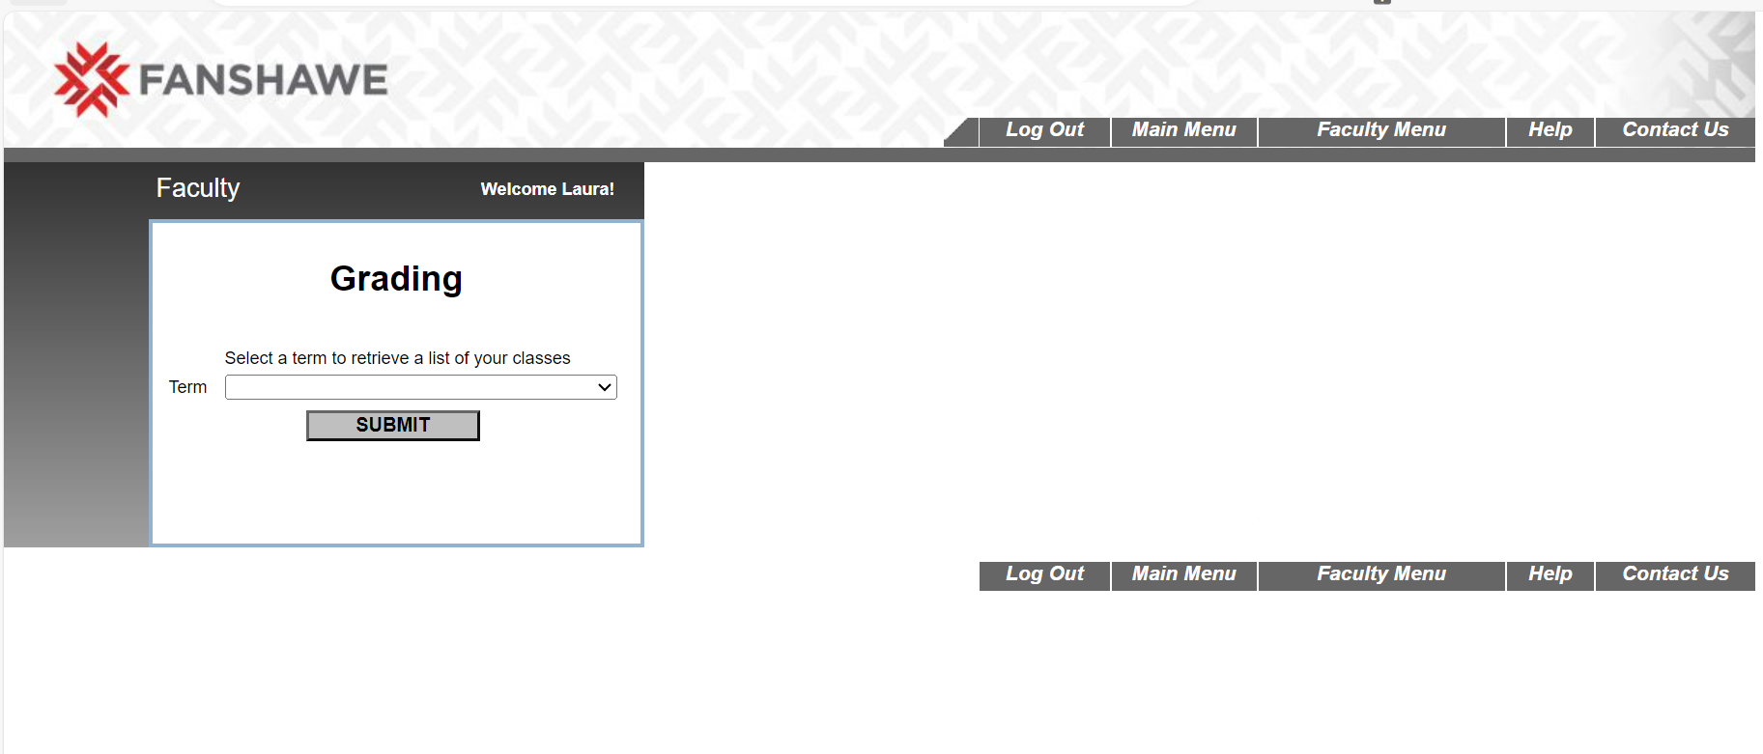

Select the Section
- Cross-listed sections will have students organized in different terms. To enter grades, you must select the appropriate term to access your student lists. Common section examples are:
  - Section ending in 01 (full-time in-person students)
  - Section ending in 01OL (online students)
  - Section ending in 01PT (for PTOL students)
  - Section ending in 40LC (for CE students)
- Click the Submit button.

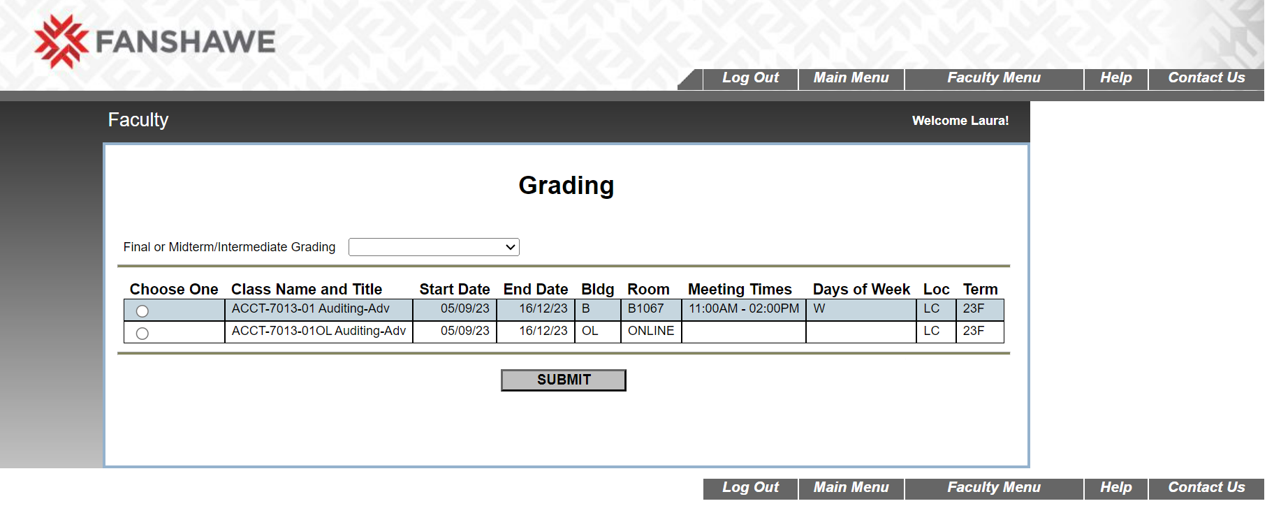

Select the Type of Grading
- From the “Final or Midterm/Intermediate Grading” window select Final.
- Click the Submit button.

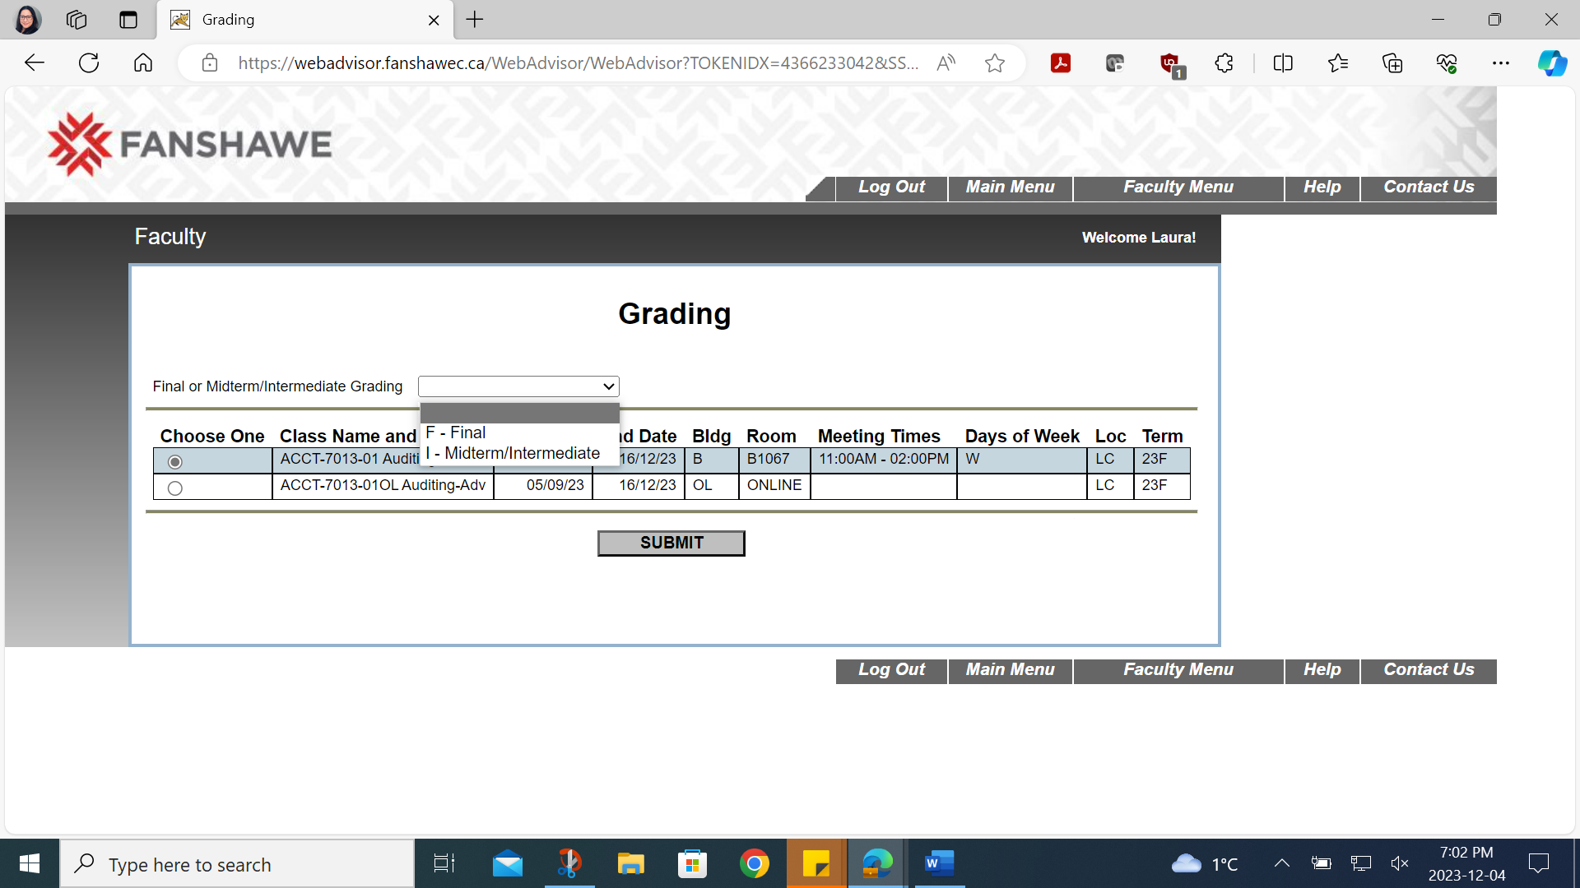

Enter Your Grades
- Enter the letter grade into the ‘Grade’ column for all grades.
- Click the Submit button.

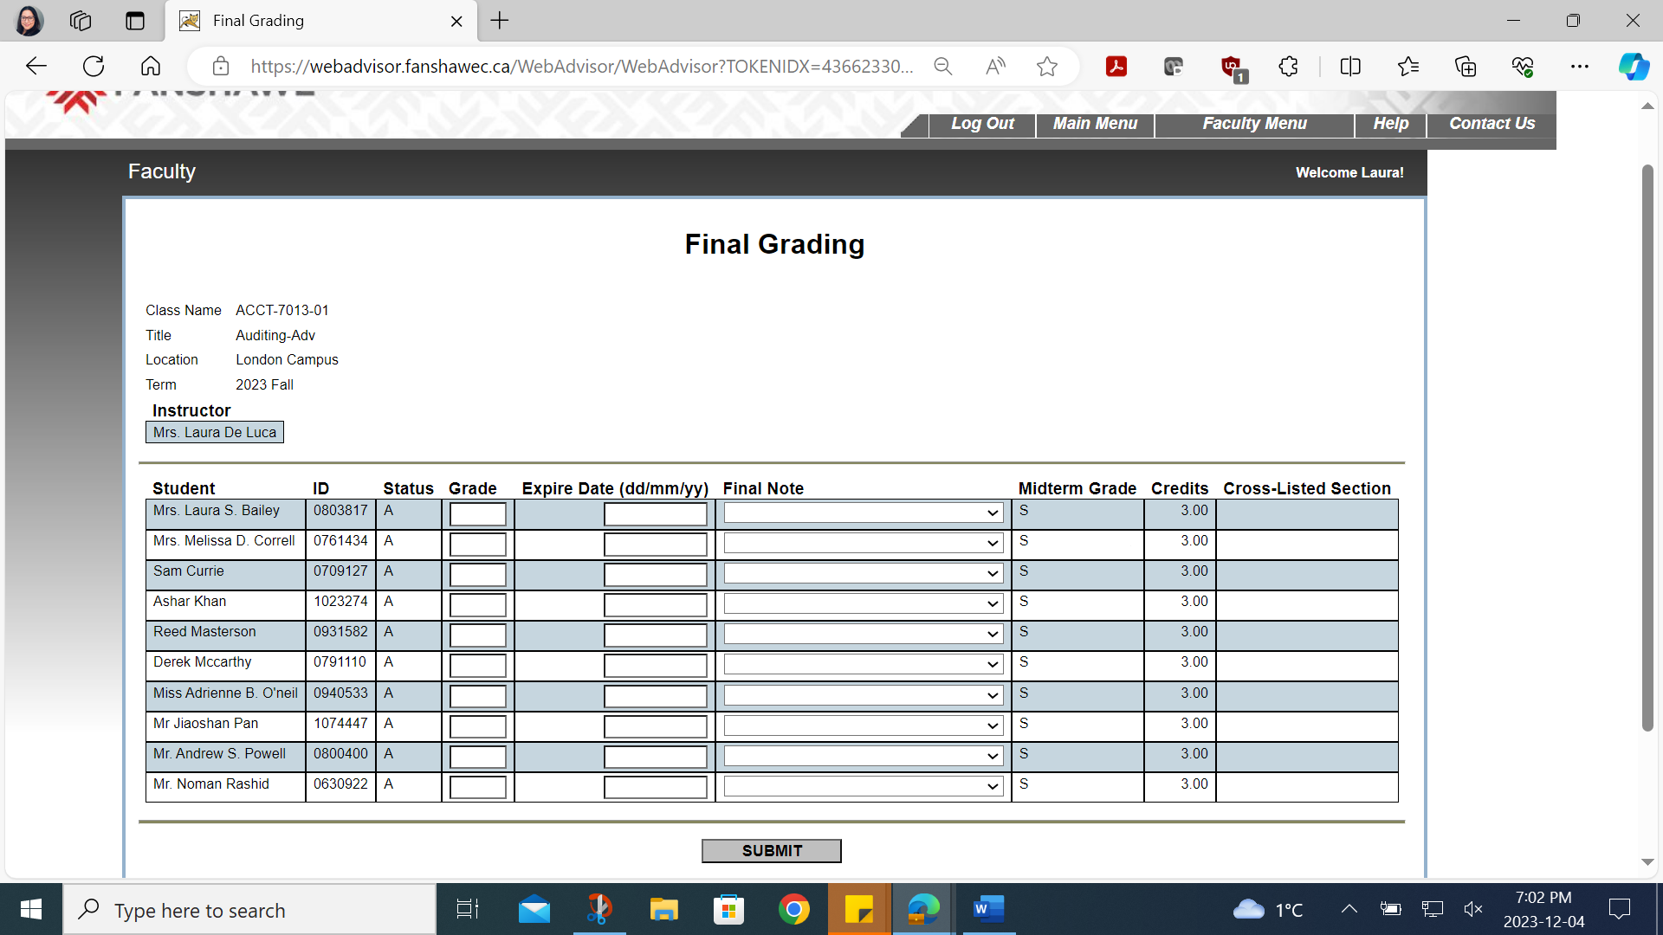

Cross Listed Sections
- You will need to repeat the steps listed above for cross-listed sections.
- Return to ‘Select the Term.’ Repeat the steps.

Timing Out
- It is suggested to submit the work completed after approx. 25 student names.
- WebAdvisor will time out after 10 minutes for security reasons.
- If you are interrupted while entering grades, be sure to submit the work completed.

Numeric to Letter Grade Chart
- Final grades are entered into WebAdvisor as letter grades.
- The conversion chart below is available as a resource.
Numeric Grade Range | Letter Grade | Grade Point
90-100 | A+ | 4.2
80-89 | A | 4.0
75-79 | B+ | 3.5
70-74 | B | 3.0
65-69 | C+ | 2.5
60-64 | C | 2.0
55-59 | D+ | 1.5
50-54 | D | 1.0
0-49 | F | 0

