PRE-LAB 5: STAINS

GRAM STAIN AND POTASSIUM HYDROXIDE STRING TEST
Complete the following table (and the table on page 8). You will refer to this during the lab. It will also help you study for the lab test.
Reagent | Purpose | Appearance of G+ after this step | Appearance of G- after this step
Crystal violet
Iodine
Alcohol
Safranin
You will hand in your results with next week’s lab.
Data management: You will have three weeks' worth of data to report in the next lab report. Make sure to keep track of your data. In your lab notebook, record the samples (strain and media/stain) that you are taking pictures of. Develop a system that works for you. I have found that taking a series of pictures of cultures and then taking a picture of the sample names (so all the data is together in the images). Then, when I make the report, I make the figures.
These are the data that you need to report:
Gram Stain Exercise 9 marks
Species | Gram reaction | Cell morphology (shape and arrangement) | Gram result from KOH test
Control 1:_____________
Control 2:____________
Environmental isolate

Figure 1: Make a figure showing the images of Gram-stained cells under the microscope. The figure should show the three strains (label the images with A, B, and C and refer to them in the figure legend). Indicate the total magnification in the legend. See the end of this report for figure-making guidance. 4 marks
Question 1: Can you interpret the Gram stain result for the environmental isolate based on the results of the controls (E. coli and S. aureus)? Explain. 2 marks
Question 2: Do the environmental isolate Gram staining and KOH string test results agree with each other? 1 mark
Cultural Morphology 4 marks
Species | Colony opacity | Colony pigmentation | Colony description (4 terms) | Colony texture
Environmental isolate
Figure 2: Make a figure of colonies of your environmental isolate on the streak plate. Indicate the source of the bacteria (what was swabbed) and the type of agar it’s grown on in the image. 2 marks.
Lab 5 Technique evaluation
Aseptic technique evaluations will continue this week. You will be observed in the BSC and using the Bunsen burner.
MAKING A FIGURE
The specimen (plate, tube, colony) should be in focus and well-lit.
Crop out the background if it isn’t conveying information.
I like to make figures in PowerPoint to easily align different images, then put the slide in presentation mode and take a screenshot of the slide. Then I crop out the background and paste the single image into Word. The image below is a composite of four images.
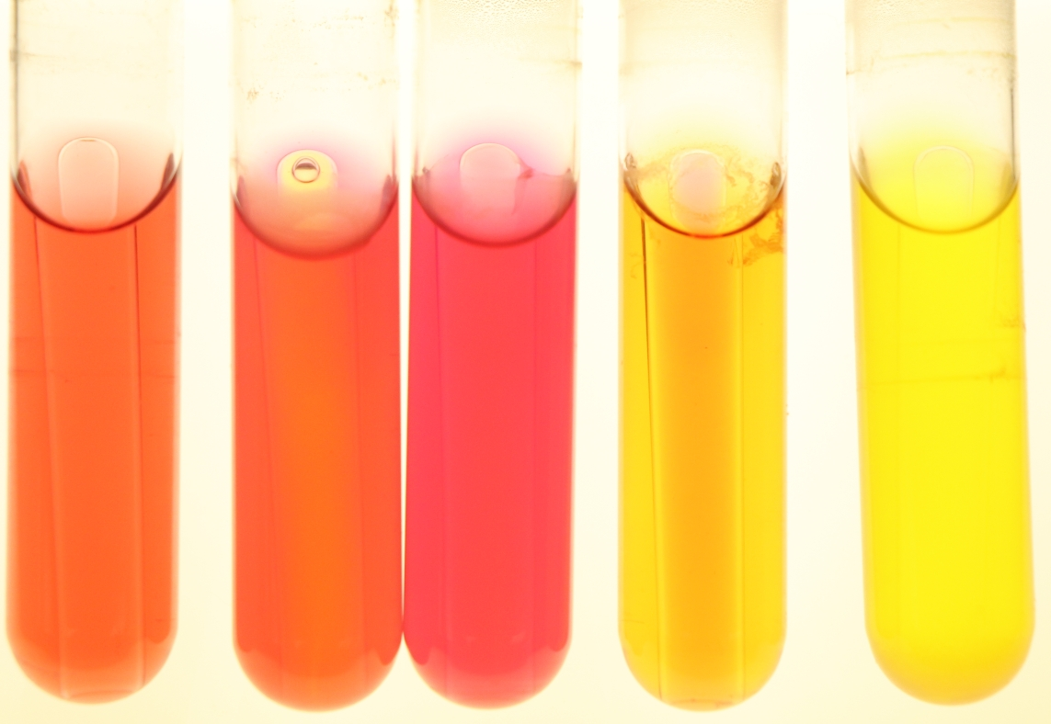
Figure 1: Bacteria growing 24 hours in Phenol Red Sucrose broth. Each tube from left to right: Serratia marcescens, Bacillus subtilis, Pseudomonas aeruginosa, Salmonella typhimurium, Escherichia coli.
(generic) Figure number: Title of figure. Description of items within figure to guide reader.

