SHOURYA ARORA
7089212
FINAL PAPER

Digital Fandom and Participatory Culture: A Case Study of Keanu Reeves and 'John Wick: Chapter 4' on Reddit

INTRODUCTION
The interactive Keanu Reeves fandom on Reddit, especially in relation to "John Wick: Chapter 4," provides a distinctive perspective on contemporary fan culture, its effects on the movie business, and more general social connections. This research attempts to investigate how online communities on sites such as Reddit not only mirror but also influence celebrity fandom, interact with media, and add to the changing fan culture of the digital age. This study will examine the mechanics of fan involvement, community formation, and the interaction between mainstream media and digital fan culture via the prism of Keanu Reeves' fervent and diversified fan base.

OVERVIEW
Keanu Reeves, who is well-known for his captivating roles and mysterious personal life, has amassed a sizable fan base that has flourished on Reddit. This research centres on this distinctive fandom, particularly during the time leading up to the publication of "John Wick: Chapter 4." Reddit is a great place to study these dynamics because of its vibrant community and reputation for fan theories. This study will examine the scope and makeup of Reeves' fan base by drawing on non-academic sources including the FandomWire piece that provides insights into Reeves' life and appeal and the Yahoo story that describes his interactions with followers during a Reddit AMA. Furthermore, scholarly viewpoints on online communities, participatory media, and fan culture will offer a theoretical framework for comprehending these phenomena. Through the integration of various sources, this study seeks to present an all-encompassing perspective on the intricate relationship that exists between a celebrity, their followers, and the digital platforms that both enable and mould these interactions. It aims to comprehend the nature of Reddit fan interaction as well as the effects it has on the movie business and the larger social and cultural scene. This elaboration creates a cohesive introduction and thesis statement for your study by synthesizing the topic and the listed sources. The goal is to provide a well-defined research trajectory that is based on current instances from non-academic sources as well as scholarly theories.

BACKGROUND RESEARCH
The instance of Keanu Reeves and his fanbase—especially on Reddit—offers an intriguing examination of fan culture and celebrity involvement. Throughout his decades-long career, Reeves has proven himself to be a versatile actor with a captivating on-screen persona, most notably in the "John Wick" series. His broad range of roles—from drama to action—combined with his reputation for kindness and humility have fostered a devoted and varied fan base. As stated in a Yahoo post by Li (2023), this is demonstrated by his Reddit AMA, when he interacted with followers personally, enhancing his allure. These exchanges highlight the link between a celebrity's public character and their fan involvement, a topic thoroughly examined in fan culture studies (Stein, 2007).
Reddit, as a digital medium, contributes to this dynamic by giving fan communities a more organized environment.Its subreddit system facilitates targeted conversations and builds a sense of community among users who have similar interests.This is consistent with Jenkins' (2006) concept of participatory culture, in which fans are active participants who contribute to and shape conversations about their interests rather than merely being consumers.In this perspective, the "John Wick" series becomes more than just a franchise of motion pictures; it becomes a touchstone of popular culture.The series' unique blend of captivating storytelling and stylized action, together with Reeves' portrayal of the title character, has struck a deep chord with viewers.The lively debates and speculations around "John Wick: Chapter 4" on Reddit demonstrate the series' enormous cultural influence and show how online communities like Reddit can greatly increase the visibility and impact of motion pictures.
Essentially, there is a rich tapestry for examining modern fan culture at the junction of Reeves' career and character, Reddit's community-centric structure, and the cultural influence of the "John Wick" trilogy. A fuller comprehension of the intricate interactions that exist between celebrities, their works, and their online fan bases is predicated on this foundation.

METHODOLOGY
This study's methodology, which focuses on Keanu Reeves fans' participation culture on Reddit and "John Wick: Chapter 4," is based on a qualitative approach that includes a detailed examination of online fan interactions. This entails closely examining and recording pertinent posts, comments, and discussions from popular Reddit communities like r/KeanuReeves and r/JohnWick. Similar to the fan-actor interactions emphasized in Reeves' Reddit AMA, which was covered in a Yahoo story, the data collection will centre on analyzing these threads in order to comprehend the nature of fan theories, reactions to the movie, and debates about Reeves himself (Li, 2023). This study's methodology, which focuses on Keanu Reeves fans' participation culture on Reddit and "John Wick: Chapter 4," is based on a qualitative approach that includes a detailed examination of online fan interactions. This entails closely examining and recording pertinent posts, comments, and discussions from popular Reddit communities like r/KeanuReeves and r/JohnWick. Similar to the fan-actor interactions emphasized in Reeves' Reddit AMA, which was covered in a Yahoo story, the data collection will centre on analyzing these threads in order to comprehend the nature of fan theories, reactions to the movie, and debates about Reeves himself (Li, 2023).
As discussed in the article haenfler.sites.grinnell.edu, Hill’s (2002) work on fan and participatory culture, examines the interplay between production and the consumerism that fan cultures criticize. Although fandom has generally bifurcated its participants into 'a moral dualism of ‘good’ fandom versus ‘bad’ consumption,' Hills makes the case for a less dichotomous definition of fan culture. “Fans must always occupy a space in which they carve out their own unique identity, separate from conventional consumerism but also bolster their credibility with specific collectors' items (Hills,2002)." This quotation can be used to examine how fans on websites such as Reddit forge their own identities through interaction with media content, considering their roles as both creators and critics in the collaborative fandom culture.

The multifaceted analytical framework is based on theories related to online community dynamics and fan studies. It uses fan culture theory, guided by academic concepts akin to those found in "A Fan Studies Primer: Method, Research, Ethics" (JSTOR), to investigate the interactions and patterns of involvement between fan communities and media celebrities. Furthermore, the research will utilize online community analysis to comprehend Reddit communities' composition and conduct, exploring how these virtual environments promote fan interaction—a notion that is emphasized by participatory culture theories in digital media (Jenkins, H.). Sentiment analysis will be employed to measure the emotional content of these conversations, relating to the emotive component of fan interaction—a topic covered in academic research as well as pieces such as the BCM article on the poisoning of fan culture. The goal of this integrated methodology is to offer a comprehensive knowledge of the Reddit fandom of Keanu Reeves, especially during the "John Wick: Chapter 4" release. The study attempts to shed light on the subtleties of online fan communities and their influence on the film business and public conversation by fusing theoretical viewpoints.

FAN ENGAGEMENT
Within the context of participatory culture, the Reddit discussion thread for "John Wick: Chapter 4" serves as an excellent example of how fans actively participate in influencing the storyline of a movie. Fans' critical and analytical approach is evident in this debate, which goes beyond simple consumption to actively participate in the cultural discourse surrounding the film. When fans' criticism of Chapter 4 is compared to their appreciation of the previous installments, it becomes clear that they have a strong attachment to the story's progression and character growth. This is a sign of participatory culture, in which fans are not just viewers but also active participants in the story's world. The thread also clarifies the concept of hegemonic fandom, which is the dominance of dominant viewpoints within the fan community. The post's review of Chapter 4 may support or contradict the general fan base's prevailing narrative or consensus of the movie. These Reddit debates can represent prevailing trends or opposing viewpoints within the community, acting as a microcosm of broader fan views.

Moreover, these conversations are greatly influenced by the fandom's parameters, which include the action film genre as a whole, promotional materials, and the prior films in the series. As the post makes clear, the fan's expectations and responses are influenced by the marketing methods used by the film industry as well as the larger context of the genre in addition to their experiences with the previous chapters. The intricate dynamics at work in modern fandom, where external stimuli and internal community conversation constantly interact to create the fan experience, are highlighted by this interaction between external influences and fan expectations. Understandings from Zihan Wang's "The Complicated Digital Fandom: Empowerment and Exploitation of Fans in Digital Media Era" (Humanities and Social Sciences, 2020, Volume 8, Issue 2) are extremely pertinent when analyzing the participatory culture found within the "John Wick: Chapter 4" digital fandom, especially on sites like Reddit. Wang's investigation of the changing dynamics between media creators and followers in the digital age highlights the coexisting elements of exploitation and empowerment in online fan networks (Wang, 2020). Fans actively contribute to and build the story of "John Wick: Chapter 4," exemplifying the empowerment element, as seen in the Reddit debates. But this participation also calls into question how these donations are used by media producers, reinforcing Wang's worries about exploitation. Additionally, the work of Henry Jenkins in "A Companion to Media Fandom and Fan Studies," especially in the chapter on "Fandom, Negotiation, and Participatory Culture," provides a framework for comprehending how fans bargain within their communities for the significance and worth of texts such as "John Wick: Chapter 4" (Jenkins, 2020). This bargaining is seen in the Reddit comments, where viewers actively participate in the cultural production of the movie's narrative by critically engaging with the plot and characters. Jenkins' theory of participatory culture offers a lens through which to see these fan exchanges as a type of social negotiation, which enhances the fan community's overall comprehension and love of the movie.

SHAPING MEDIA NARRATIVES
We can see a high degree of emotional commitment and attachment among fans by looking at Reddit fan activity for "John Wick: Chapter 4"The in-depth analyses and conversations centred on the story and character growth throughout the series demonstrate this. Supporters exhibit a strong bond with the plot, voicing dissatisfaction or perplexity with the most recent release in addition to appreciation for previous chapters. Fans connect through common interests and viewpoints, which is fostered by this emotional engagement. With fans offering theories, analyses, and different viewpoints, the direction of content production in these debates is mostly driven by a desire to analyze and comprehend the plot. This fandom's affective dimension is complicated, including a sense of companionship, critical involvement, and enthusiasm. These components show how highly emotive fandom is, and how emotional ties to both the fan community and the content itself are essential for maintaining conversation and engagement. This analysis supports the claim that the dynamic Reddit fandom of Keanu Reeves, particularly about "John Wick: Chapter 4," reflects and shapes the changing landscape of digital fan culture and celebrity fandom. The Reddit discussions surrounding "John Wick: Chapter 4" in the context of participatory culture and fan activism are in line with the observations made by Thomas V. Maher in "Fans and Fan Activism" and the research paper "Fandom and Identity Construction: An Analysis of Thai Fans’ Engagement with Twitter" by Pitchapa Smutradontri & Savitri Gadavanij. Maher's examination of fan activism implies that fan communities, such as the ones debating "John Wick," engage in more than just content consumption; they can actively contribute to the story's development and can even affect broader opinions about a franchise (Maher, 2021). This is seen in the intense discussion and participation of the Reddit community over the movie, which demonstrates a vibrant participatory culture. This theory is further supported by Smutradontri and Gadavanij's study, which demonstrates how fans use social media sites like Twitter to build communities and identities (Smutradontri & Gadavanij, 2020). Like this, Reddit users debating "John Wick: Chapter 4" use the forum to express and negotiate their identity as fans in addition to interacting with the content. The fundamental ideas of participatory culture—in which fans create, critique, and participate in the community—are embodied in this active involvement, which adds to the fandom's dynamic story.

ANTI-FANS AND CONTRASTING PERSPECTIVES
Anti-fans contribute significantly to the world of digital fan culture by offering opposing viewpoints and insightful criticism. When it comes to "John Wick: Chapter 4," these people frequently voice opposing viewpoints, contest popular fan theories, or criticize specific elements of the film or Keanu Reeves' performance. Their presence is essential to comprehending the entire range of fan debate. One such opinion can be found, for example, in Brian Tallerico's assessment on RogerEbert.com. Tallerico praises the movie's action sequences and photography but criticizes the narrative self-indulgence, saying that some of the scenes seem unnecessarily extended. This review offers a counterbalance to the largely favourable response from fans, giving a fair assessment of the movie's reception.
Discussions involving anti-fans, such as those on Reddit, highlight the dynamic character of fan communities by showcasing a range of viewpoints and arguments. They frequently offer criticism based on disparate interpretations of the movie's themes, story points, or more general film industry procedures.

A thorough understanding of digital fan culture necessitates an understanding of the role played by anti-fans. It highlights the nuanced nature of fan relationships in the internet age by revealing a complicated interplay between admiration and critique. This fandom feature adds to our understanding of how digital communities interact with and shape media narratives in a more complex way.

FANDOM AND MOVIE INDUSTRY
The impact of Keanu Reeves' vibrant and engaged fans, especially in light of "John Wick: Chapter 4," is felt not just in the film industry but also in larger society. This ardent fanbase has an impact on marketing tactics in the film industry, as studios use fan-generated buzz and input to inform future film material and advertising campaigns. In addition to increasing box office success, this kind of interaction strengthens the bond between the franchise and its fanbase. In terms of society, this devotion goes beyond simple amusement; it shapes cultural narratives and may even inspire fan activism. Fans discuss more than just a movie on sites like Reddit; they have longer discussions about the themes, morals, and social conventions that are reflected in the media they watch. As a result, a movie's impact is amplified beyond the screen by this participatory culture, which integrates it into broader social and cultural conversations and occasionally ignites change-related initiatives or raises awareness of social issues. In this sense, the fervent fan base surrounding Keanu Reeves and "John Wick: Chapter 4" turns into a miniature representation of the movie's influence on the business and society at large.
A thorough grasp of the digital fandom around "John Wick: Chapter 4" and Keanu Reeves is possible by fusing theoretical ideas with empirical data from Zihan Wang's "The Complicated Digital Fandom" and digital fandom as a "community of practice." These fan networks are excellent examples of 'The Audience Commodity'. On websites like Reddit, fans actively participate in conversations and create content, transforming their group interactions into a useful resource for the media sector. As a result, the audience is changed from being passive viewers to active participants, and their conversations about the movie greatly influence its marketing and general plot development.
Simultaneously, the concept of 'Microcelebrity' is evident in the manner in which enthusiasts develop their virtual identities within these groups. They establish themselves as significant figures or experts within the fanbase by regularly posting, leaving comments, and participating in discussions. This conduct is consistent with microcelebrity strategies, in which people create a particular online persona to gain influence and a following. Furthermore, the idea of "Consumer Fandom" is demonstrated by the stuff that fans of "John Wick: Chapter 4" have created and shared. This goes beyond the typical roles of the consumer because fans actively shape the narrative and reception of the film both inside and outside of the fan community. They create and distribute content in addition to consuming it. These observations shed light on the complex interrelationships that exist between media material, fans, and digital platforms as well as the complex and potent dynamics of digital fandom in modern culture.

CONCLUSION
In summary, a dynamic interaction between fan involvement, media influence, and digital culture is revealed by this research of the Reddit fanbase surrounding "John Wick: Chapter 4" and Keanu Reeves. This study emphasizes how important participatory culture is to contemporary fandom, when viewers actively participate in forming the conversation and story around a film rather than just being passive viewers. The way ideas such as consumer fandom, microcelebrity, and the audience commodity are mixed together in these online groups illustrates how fan relationships are changing in the digital era. The fervent engagement of these fans influences not just the cinema industry through marketing and content creation, but also wider societal and cultural discourse. With its emphasis on the intricate connections between celebrities, their creations, and the digital channels that allow for fan interaction, this study sheds light on how digital fandom shapes the modern media landscape. This study adds to our understanding of fan culture by highlighting the role that online communities play in the survival and development of fandom in the digital age. With its emphasis on the intricate connections between celebrities, their creations, and the digital channels that allow for fan interaction, this study sheds light on how digital fandom shapes the modern media landscape. This study adds to our understanding of fan culture by highlighting the role that online communities play in the survival and development of fandom in the digital age.

Appendix
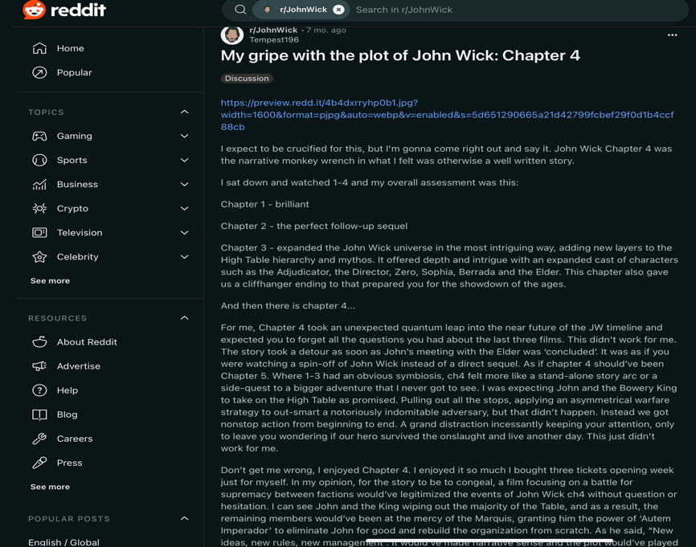
Personal reflection on the plot of John Wick: Chapter 4

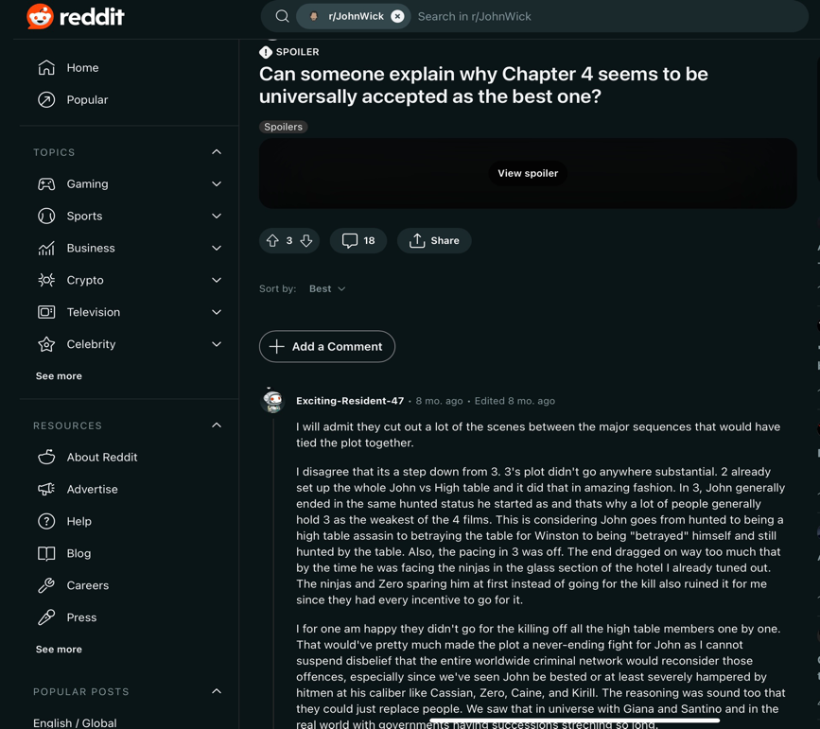
Reddit Discussion on the Merits of john Wick: Chapter 4

Fan experience watching John Wick: Chapter 4 at an empty Cinema
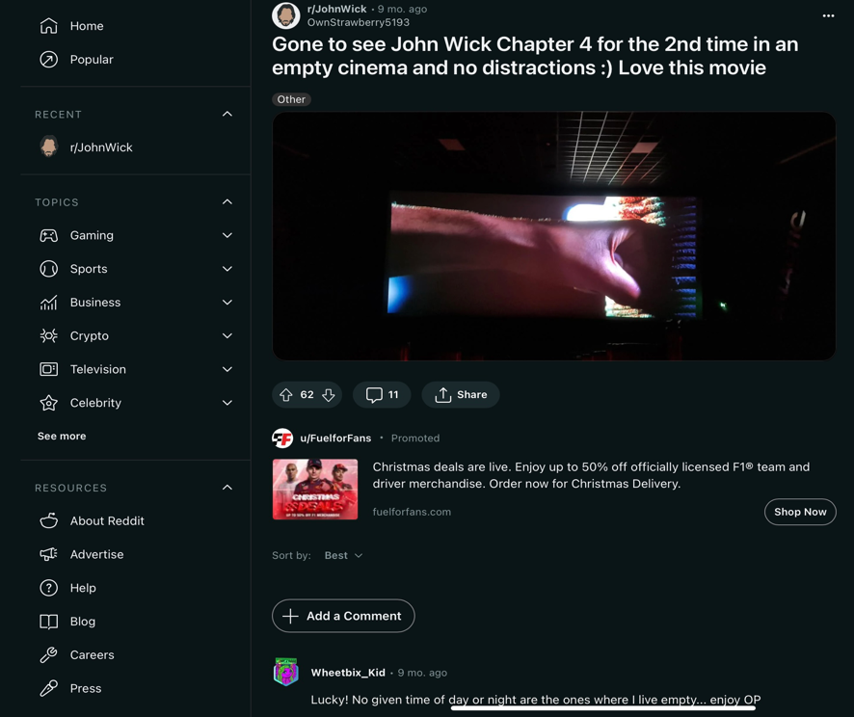
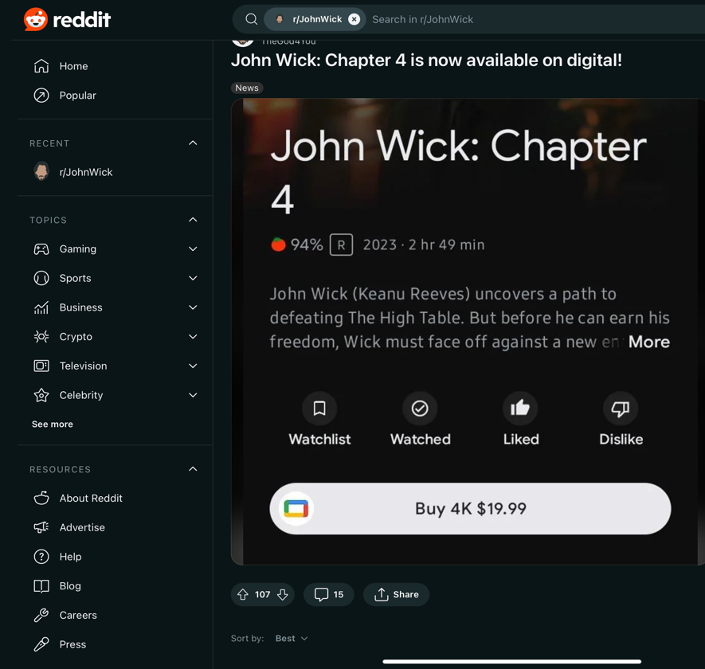
Digital Release Annoucement for John Wick

References

Booth, P., & Williams, R. (2021). A Fan Studies Primer: Method, Research, Ethics. University of Iowa Press. https://doi.org/10.2307/j.ctv20dsbvz

Hills, M. (2002). Fan Cultures. Routledge. Retrieved from https://haenfler.sites.grinnell.edu/subcultures-and-scenes/fandom/

Jenkins, H., & Deuze, M. (2006). Convergence culture: where old and new media collide [Review of Convergence culture: where old and new media collide]. New Media and Society, 8(4), 691–698.

Maher, T. V. (2021). Fans and Fan Activism. In The Oxford Handbook of Digital Media Sociology. Oxford University Press. https://doi.org/10.1093/oxfordhb/9780197510636.013.36

Smutradontri, P., & Gadavanij, S. (2020). Fandom and identity construction: an analysis of Thai fans’ engagement with Twitter. Humanities & Social Sciences Communications, 7(1), 1–13. https://doi.org/10.1057/s41599-020-00653-1

Stein, A. (2007). Fandom: Identities and Communities in a Mediated World [Review of Fandom: Identities and Communities in a Mediated World]. Journalism and Mass Communication Quarterly, 84(4), 851–853. SAGE PUBLICATIONS, INC.

Tallerico, B. (2023). John Wick: Chapter 4 Movie Review. RogerEbert.com. Retrieved from https://www.rogerebert.com/reviews/john-wick-chapter-4-movie-review-2023

Wang, Z. (2020). The Complicated Digital Fandom: Empowerment and Exploitation of Fans in Digital Media Era. Humanities and Social Sciences, 8(2).

