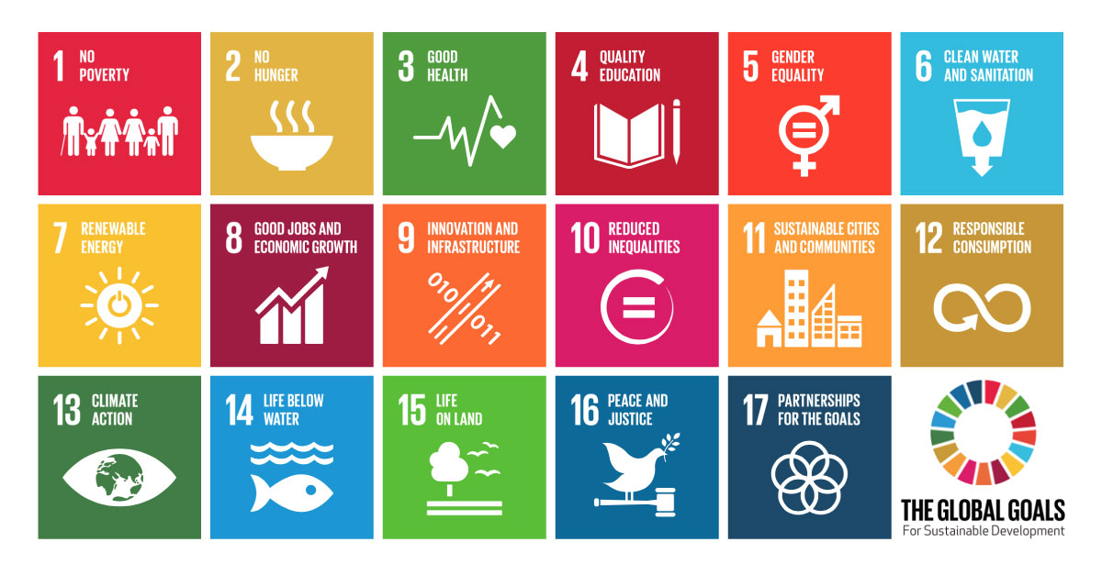

In the graphic above, the United Nations uses uniquely coloured icons to illustrate their 17 Sustainable Development Goals. The 17 goals listed are:

1. No poverty, represented by six individuals holding hands to form a line.
2. No hunger, represented by a bowl with heat lines coming from the top.
3. Good health, represented by a line that moves up and down toward a heart.
4. Quality education, represented by an open book beside a pencil.
5. Gender equality, represented by an intersecting circle with a cross attached to the bottom, arrow pointing up to the right, and two equal lines in the middle of the circle.
6. Clean water, represented by a glass of water with a tear-shaped drop in the centre and a down-facing arrow at the bottom.
7. Renewable energy, represented by a sun with a circle and intersecting line in the centre.
8. Good jobs and economic growth, represented by a bar and line graph.
9. Innovation and infrastructure, represented by two long lines that enclose two short, dotted lines and an arrow. On either side of the long lines are the numbers 0 and 1.
10. Reduced inequalities, represented by a circle with two equal lines in the centre.
11. Sustainable cities and communities, represented by apartment buildings.
12. Responsible consumption, represented by an intersecting arrow in the shape of a figure eight.
13. Climate action, represented by an eyeball with earth in the centre.
14. Life below water, represented by two wavy lines with a fish below.
15. Life on land, represented by two equal lines with a tree and birds on top.
16. Peace and justice, represented by a bird holding a leaf standing on top of a gavel.
17. Partnerships for the goals, represented by five equal and intersecting circles.