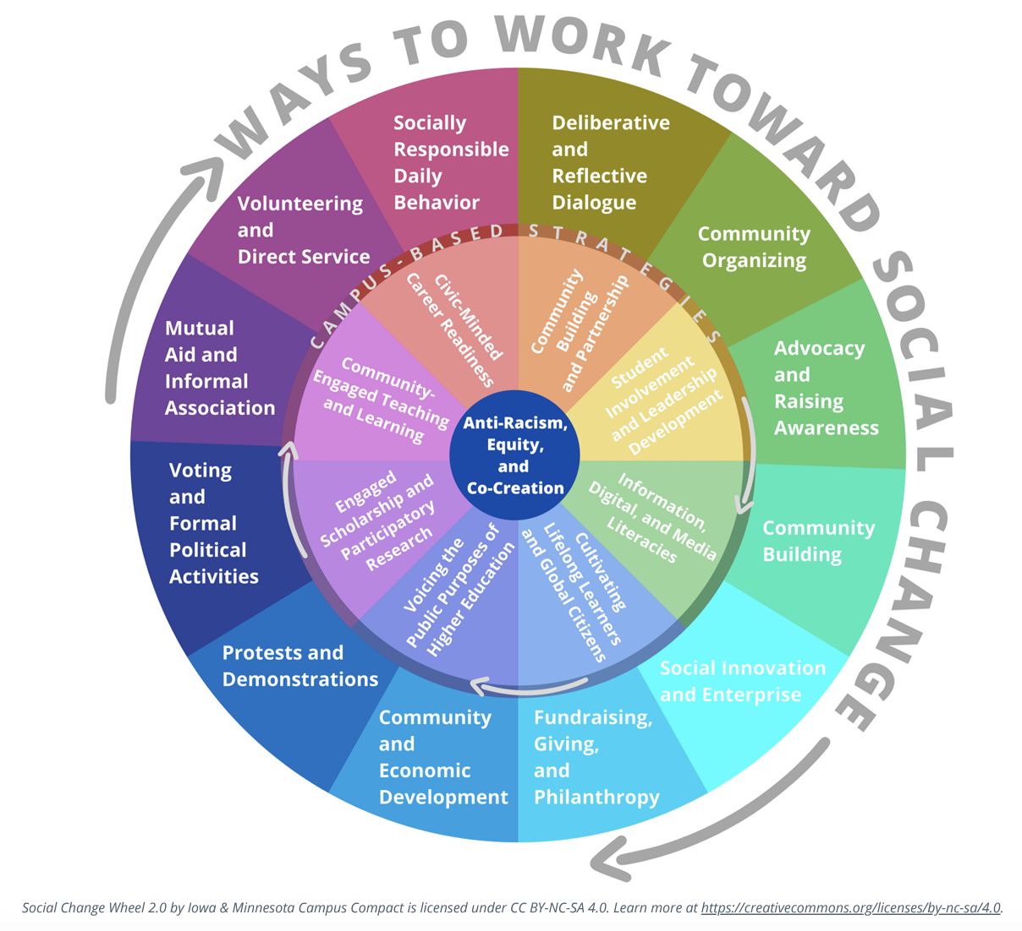
In the graphic above, Iowa & Minnesota Campus Compact uses a wheel to illustrate the multitude of ways to work toward social change. The rainbow-coloured circle is composed of an outer and inner layer. The outer layer displays 12 ways to work toward social change. The inner layer displays 8 campus-based strategies to work toward social change. At the very centre of the wheel is a blue circle labelled anti-racism, equity, and co-creation.

The Outer Layer
The outer layer is split into 12 equal segments and assigned a unique colour. The 12 ways to work toward social change listed are:
- Deliberative and reflective dialogue
- Community organizing
- Advocacy and raising awareness
- Community building
- Social innovation and enterprise
- Fundraising, giving, and philanthropy
- Community and economic development
- Protests and demonstrations
- Voting and formal political activities
- Mutual aid and informal association
- Volunteering and direct service
- Socially responsible daily behaviour

The Inner Layer
The inner layer is split into 8 equal segments and assigned a unique colour. The 8 campus-based strategies to work toward social change listed are:
- Community-building and partnerships
- Student involvement and leadership development
- Information, digital, and media literacies
- Cultivating lifelong learners and global citizens
- Voicing the public purposes of higher education
- Engaged scholarship and participatory research
- Community-engaged teaching and learning
- Civic-minded career readiness

