Activity Description

Activity 1 – Empathy Role Play

The objective of this activity is to help students become aware of and address the “egocentric empathy gap.” This bias causes innovators to overestimate the similarity between what they value and what others value, and to project their own thoughts and preferences onto others. Creating awareness will make it easier for students to recognize the importance and value of learning from the end-user and other stakeholders during the design process.

In this exercise, students are presented with a scenario and introduced to various stakeholders who may be affected by the proposed design project. Students work in small groups where each person takes on the role of one character while a facilitator (either another student or an instructor) guides the discussion. The exercise is completed in two cycles: each framed by a different "mood.” Reframing the discussion using a new emotion that might be viewed as “opposing” the previous (e.g., one is “positive” while the other is “negative”) should elicit different perspectives – even from the same character! This will emphasize to participants that the points of view of diverse stakeholders should be considered without judgement and without assuming that their values will align with those of the designer. Taking into account different perspectives will ensure the creation of new ideas that are valued by the intended beneficiaries of the design.

Step 1 – The Scenario

Introduce the scenario to set the scene for the discussion.

Students at the Concrete Jungle Secondary School love to spend time in nature but feel restless and bored at their school where there is no green space. A wealthy philanthropist has offered to make a large donation to the school to design an “outdoor classroom.” Their only stipulations are that the classroom or learning space
- be accessible to the wider community, and
- must promote environmental sustainability.

You might consider asking students what is meant by the following terms, keeping in mind that there are no “right” or “wrong” answers:
- outdoor classroom,
- wider community,
- environmental sustainability.

Step 2 – The Stakeholder Groups

Introduce the stakeholders using a Stakeholders Map. The primary beneficiaries – the students at the Concrete Jungle Secondary School -- are identified at the centre of the map. Additional stakeholders are those whose needs must be addressed, who have a say in the outcome, or who may be affected by the project or related decisions. Stakeholders are added to each ring of the map based on their degree of interaction or influence on the end-user: those closer to the centre engage to a greater extent with the primary beneficiary than those further away.

The following Stakeholders Map may be provided to the students. Alternatively, as an additional exercise, challenge the students to identify the different stakeholders themselves and add them to map!
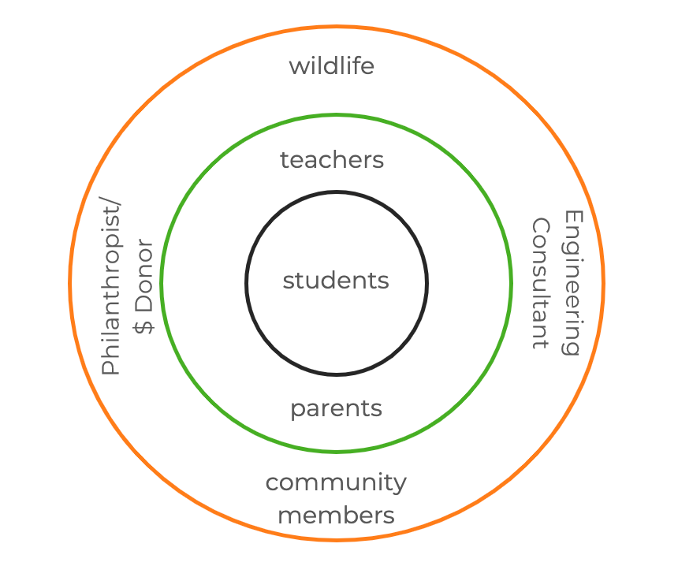

Step 3 – The Characters

This activity will focus on specific stakeholders; however, the exercise can be adapted for different characters or even a different scenario altogether!

The students – as their characters -- have been invited to attend a community meeting to discuss the proposed plans for the outdoor learning space. In break-out rooms, they are to imagine they are playing one of the following roles:

- Maggie, representing her grade 9 classmates;
- Mr. Isaac, Maggie’s teacher;
- Estelle, a resident from the retirement home;
- The flower in the space between the school and retirement home;
- The bee flying near the flower;
- Catherine, a civil engineer and parent.

Divide the students into groups of 4 or 5 including one facilitator. Facilitators ensure that each person in their break-out room has a character (different from one another) with at least one person taking the role of “student.” Use the character descriptions here, selecting one version of the character.

Step 4 – Break-out session

Make sure you have one person playing the role of Maggie in each room. Each facilitator selects a mood from the following list to frame the discussion:
- Excited
- Curious
- Relieved
- Empowered

The facilitator then chooses the first character to share a recent experience they've had as part of the school community. Don’t give them much time to think about it! After the person shares their story (~30 seconds), select the next person to respond with their own experience that conveys the emotion framing the discussion.

The facilitators should make sure everyone has had a chance to share at least once but mix up the order to keep them on their toes!

Step 5 – Main room

Prompt the students to think back to something that was said in their group conversation that was surprising or made them reconsider their initial perspective. They should then write their (paraphrased) quote in the chat window and include the character who said it. Have everyone wait to hit enter when the instructor says, “Go!”

Give the students time to read through the various quotes. Which quotes were most/least surprising?

Step 6 – Back to the break-out session with the same groups and characters

Have the students return to their break-out rooms. The facilitator in each break room will provide another emotion to frame the discussion. Facilitators should ensure that each person in their break-out room is back in their previous character. The facilitator then selects another mood from the next list to frame the discussion:
- Annoyed
- Worried
- Confused
- Resentful
- Resigned

Repeat the previous exercise, contributing to the conversation while conveying the emotion framing the discussion.

Step 7 – Main room

Again, have the students share another (paraphrased) quote about something unexpected they heard in the second break-out session. Use the chat window; have the students write their quote, including the character who said it, sharing once everyone is ready.

Step 8 – Reflection

Ask the students to reflect on the following questions:
- What was unexpected? Why?
- What did the surprising quotes suggest about what the different characters value? How is this similar/dissimilar to what your character values? How is this similar/dissimilar to what you value?
- How did the emotion that framed each discussion affect the values identified? Did the values stay the same or change for each character?

Summary of learning:

As innovators embarking on a new design challenge for societal impact, it is important that we engage with different stakeholders to understand their different experiences. By listening actively and openly without judgement, we can empathize with diverse perspectives – both obvious and unexpected. Empathy can help us check our assumptions and overcome our biases by learning about what is valued by others. This will lead to ideas that have a greater chance of being embraced by those we wish to serve.

Role Play Map
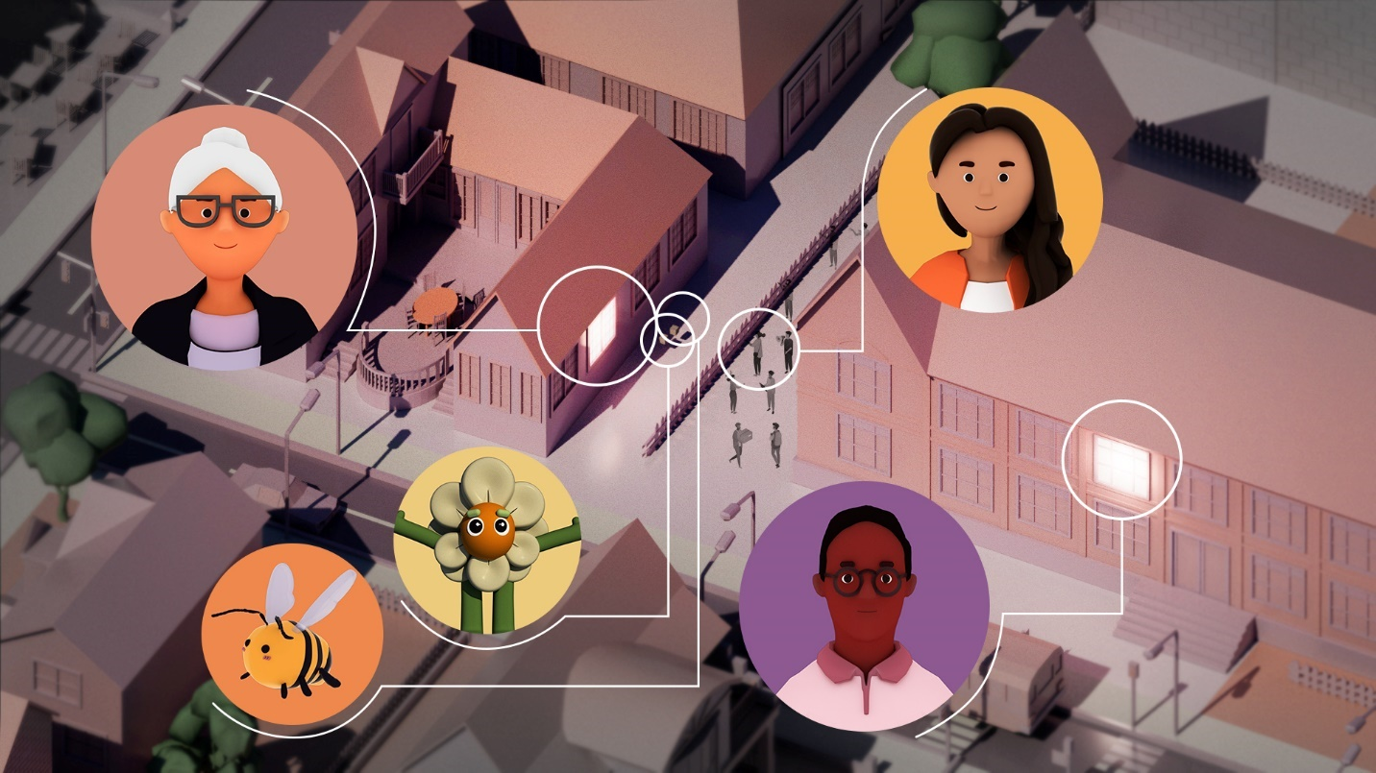

Character Descriptions
Maggie, a student

Version 1 | Version 2
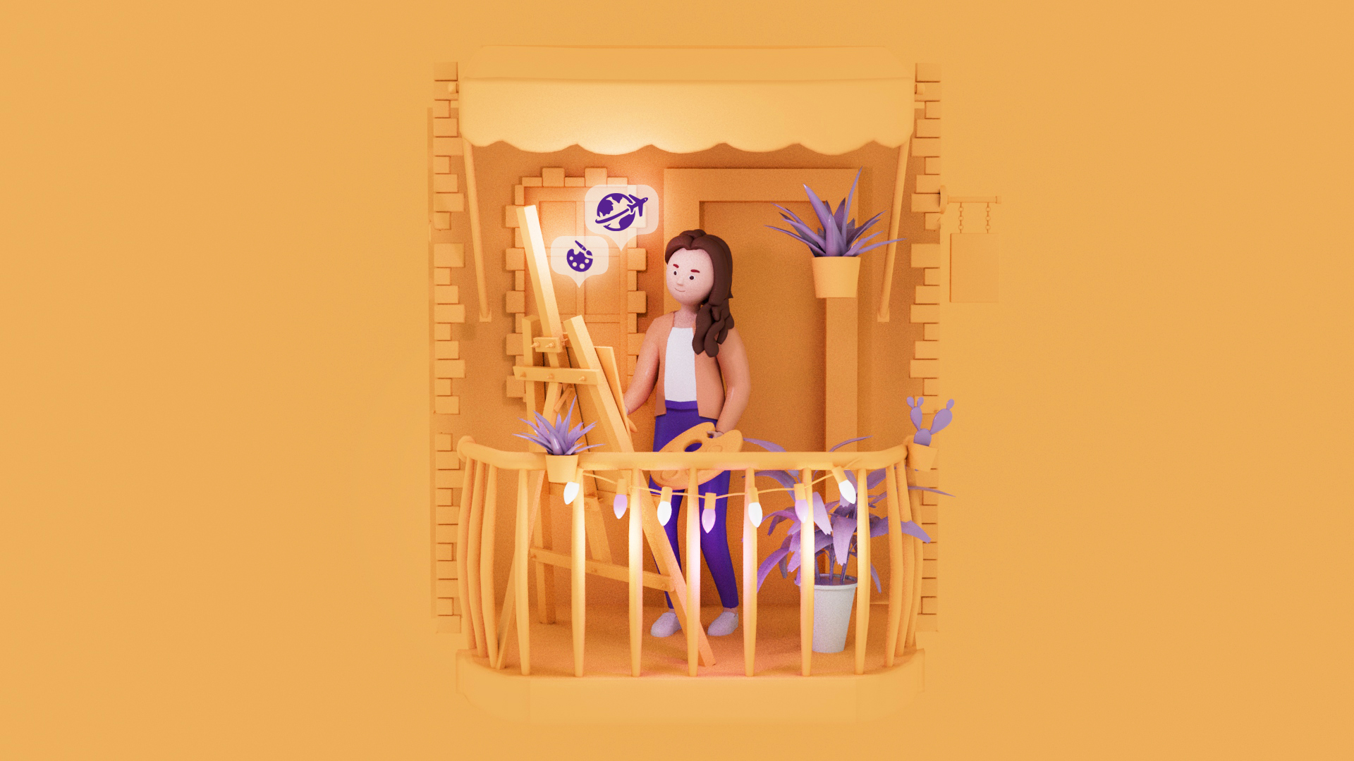 | 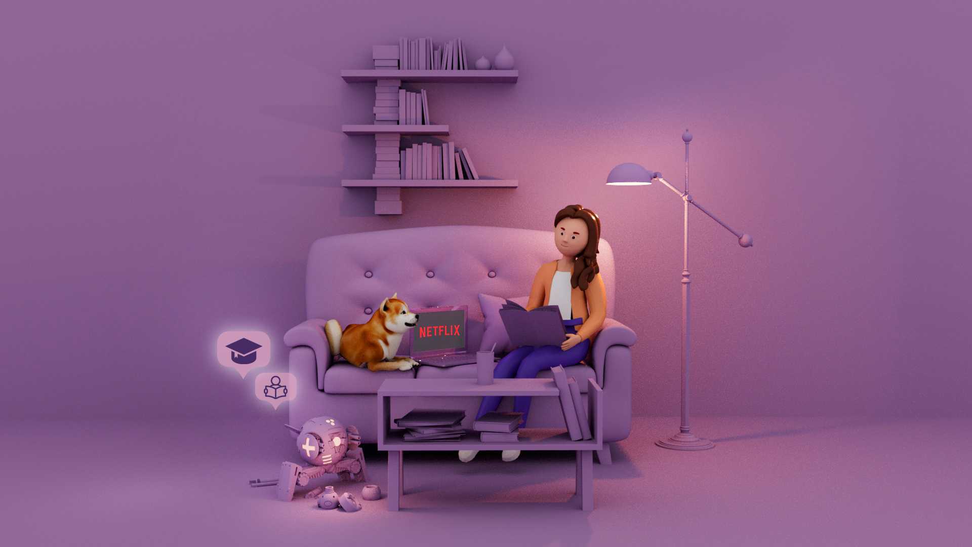
Hi! My name is Maggie. I’m into gardening; I have all kinds of plants on my balcony at home. But I’m terrified of wasps – I had an allergic reaction when I was stung once as a kid. I would consider myself an artistic person; I love painting, literature, and theater. I also really enjoy travelling and eating at outdoor cafes. I'm active on social media (Instagram) and regularly posts pictures of different places I’ve been. I want to become an art teacher but don’t know what I'd need to do to become one. | I’m Maggie. I’d say I’m an introverted person who actually loves studying when my teachers give us interesting projects – though I wouldn’t admit that to some of my classmates who might judge me for it. In my spare time, I like watching Netflix with my dog, Einstein. I'm considering taking advanced placement courses in order to get into a good university. I'm a member of the robotics club at my high school.

Character Descriptions
Estelle, a resident from the retirement home
Version 1 | Version 2
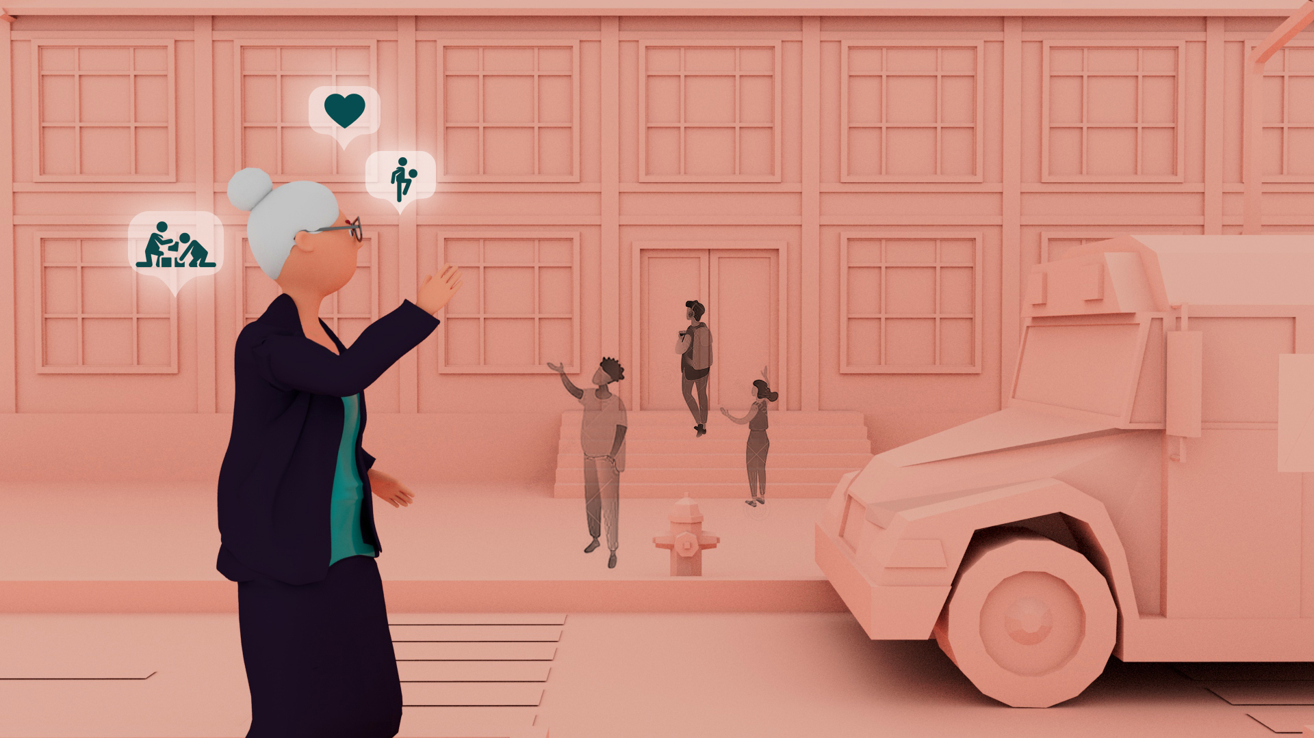 | 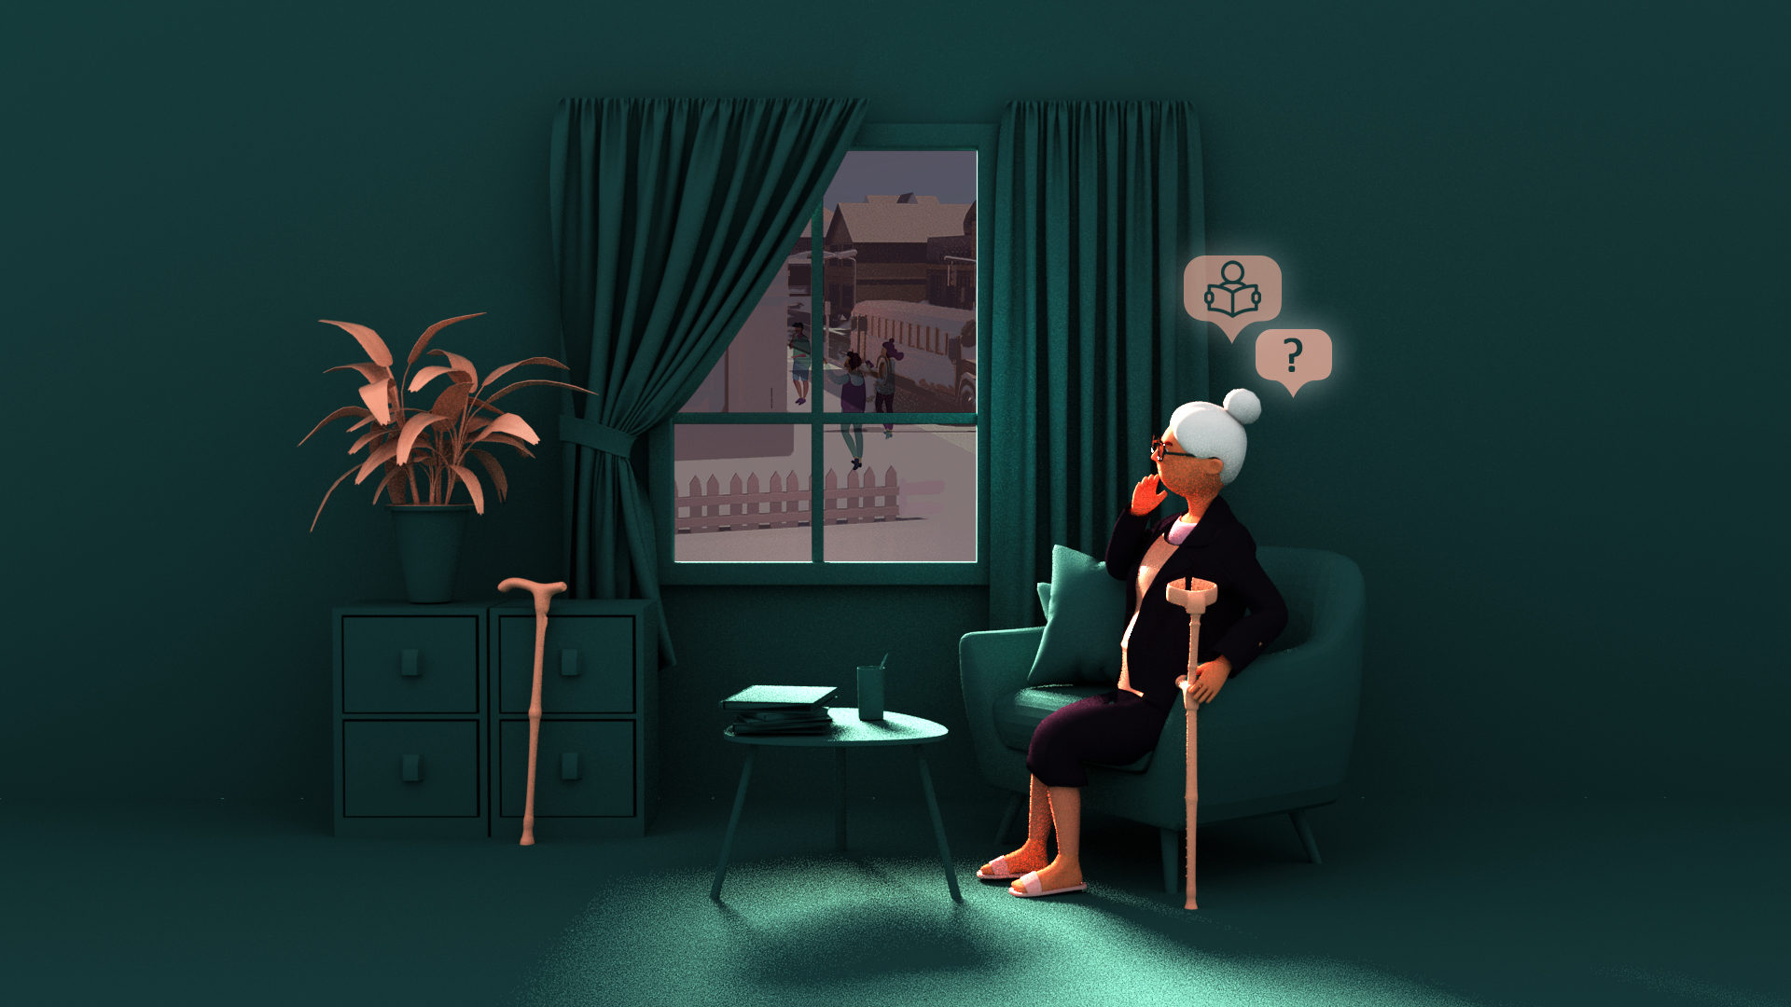
My name is Mrs. Estelle Shulman and I’m a retired teacher. I’ve always loved working with students and still enjoy spending time with kids – I have three great-grandchildren! I feel happy even just seeing kids playing fun games when I'm on my daily walk in the neighbourhood. It's unfortunate that the high school across the courtyard doesn’t have any engaging facilities for kids … not even any green space. Kids should be able to grow up the way my friends and I did: we were almost always outside, playing, and socializing. | Hello, my name is Estelle and I am 91 years old. I walk with a cane since breaking my hip a couple of years ago and don’t get outside very much anymore, especially in the winter with the ice and snow. I've experienced a lot in my life; I’m so grateful that today’s children haven't seen war the way I did. But I know they face other challenges that didn’t exist when I was young. I sometimes wonder if the teenagers I see from my window huddled in the schoolyard across the courtyard are up to no good. Shouldn’t they be at home doing homework?

Character Descriptions
The flower in the space between the school and retirement home
Version 1 | Version 2
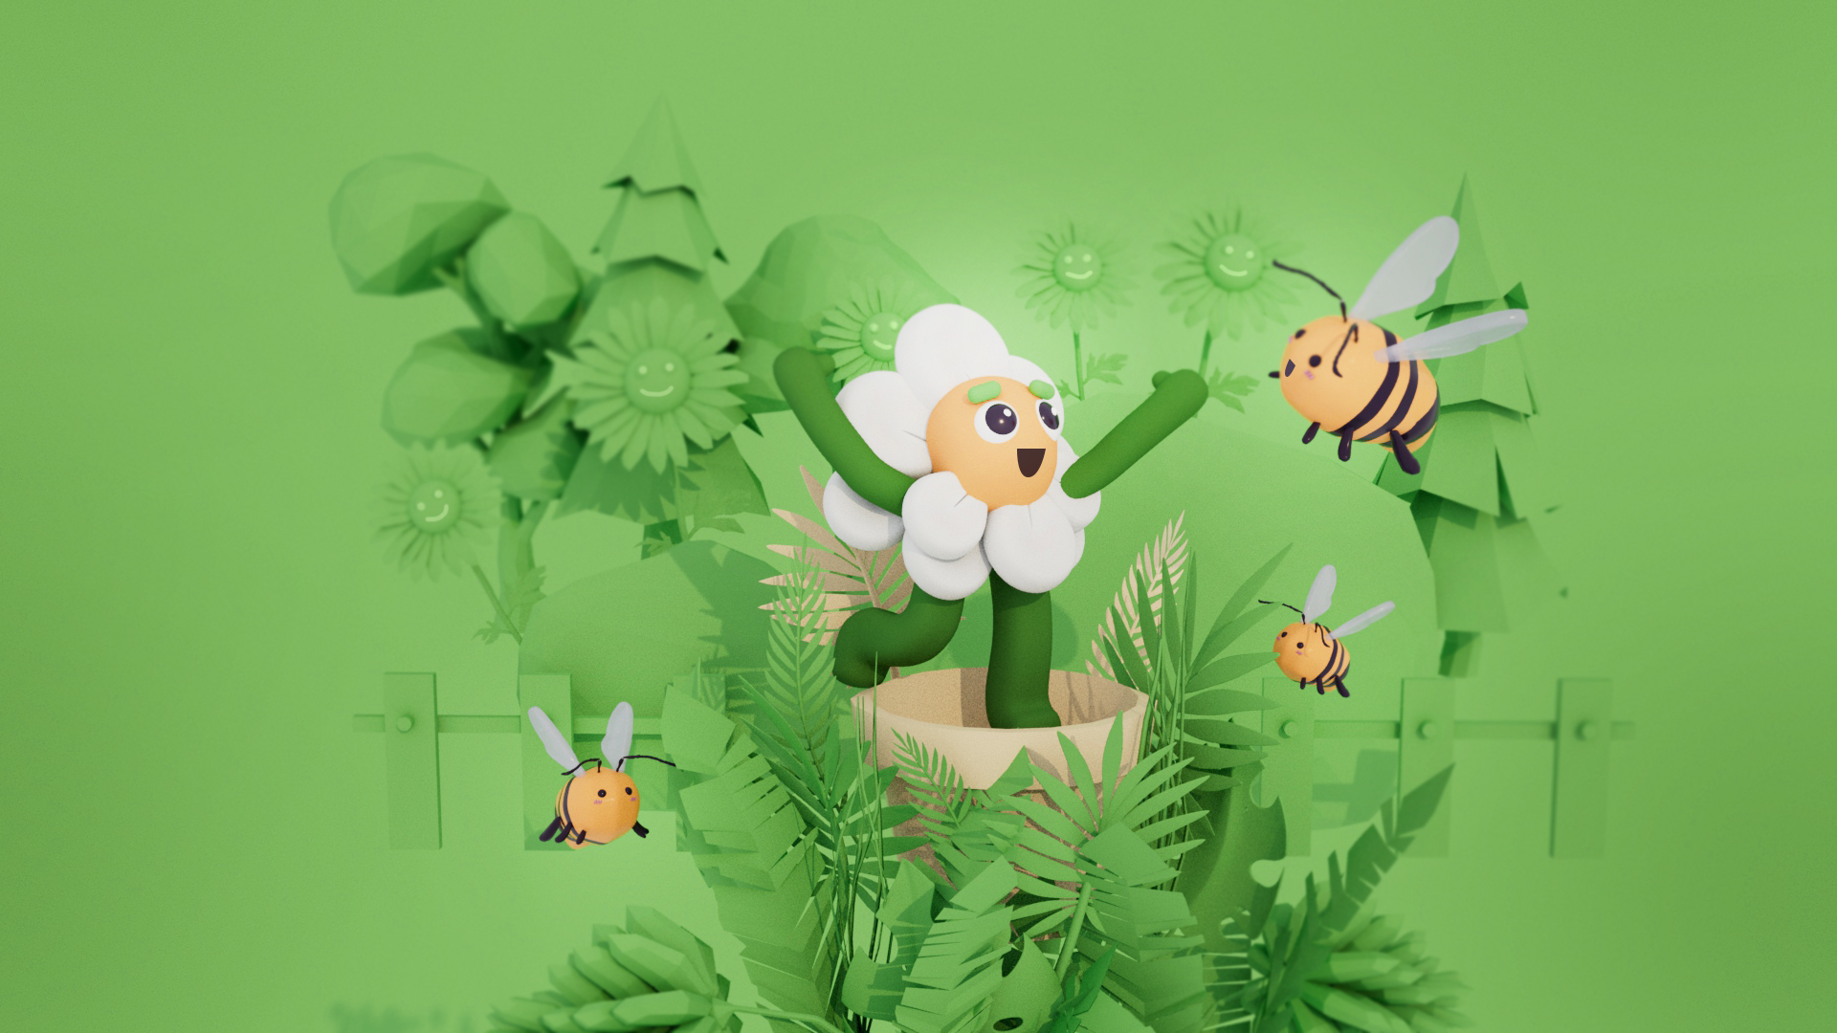 | 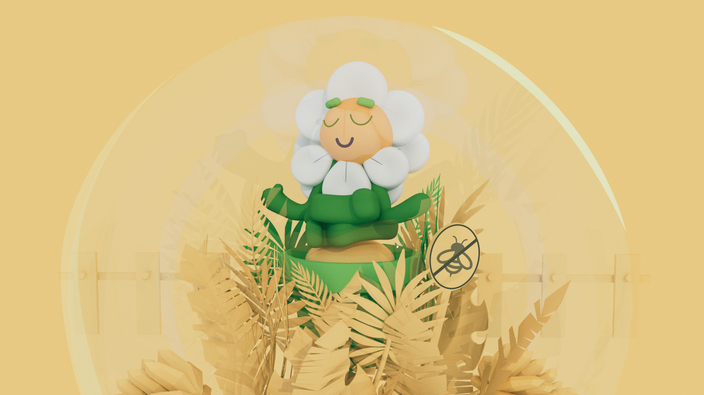
I am a flower. I have lived alone all my life and I desperately want a friend. Recently, I heard rumors about a garden at the nearby school. It would be so nice to live in a garden with other plants and animals nearby. | I am a flower and live a calm life behind a small fence separating me from the walkway to the school. I love to observe what’s happening knowing I'm safe from the crowds on the walkway. I am used to solitude and value it immensely. I don’t want to be surrounded or bothered by annoying neighbors that might take my sunlight. I'm glad I’m not a flower that attracts bees.

Character Descriptions
Catherine (Civil Engineering Consultant and parent)

Version 1 | Version 2
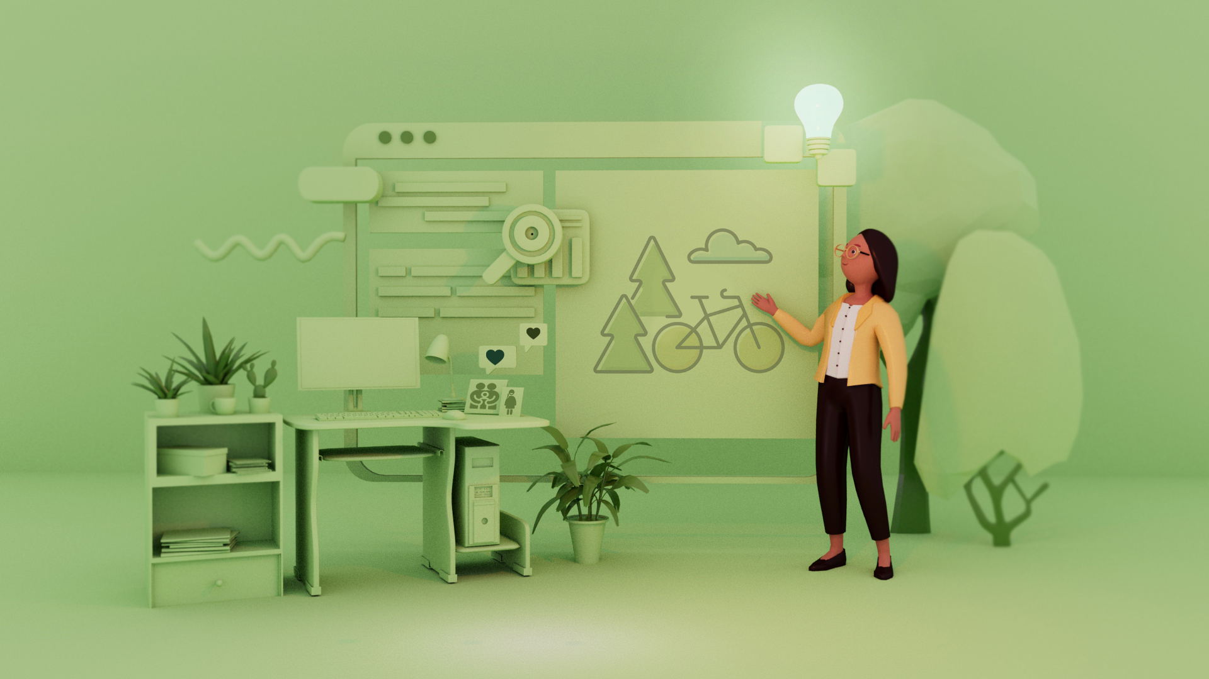
My name is Catherine and I’m a civil engineer. I'm also a parent and realize I’m emotionally invested in this project. I truly want the students to have a natural environment where they can interact with the real world. I want them to have a learning space that will motivate them to get outside and away from their screens and devices. | I’m Catherine. As an “expert” with 20 years of consulting experience in civil engineering, I feel constrained by the limited budget and space for this project. I feel a “low-maintenance” classroom designed using durable, artificial materials would be best for long-term sustainability. I have also seen amazing spaces created using virtual reality; this might be something to consider for this project.

Character Descriptions
Mr. Isaac, grade 9 and 10 science teacher at the school

Version 1 | Version 2
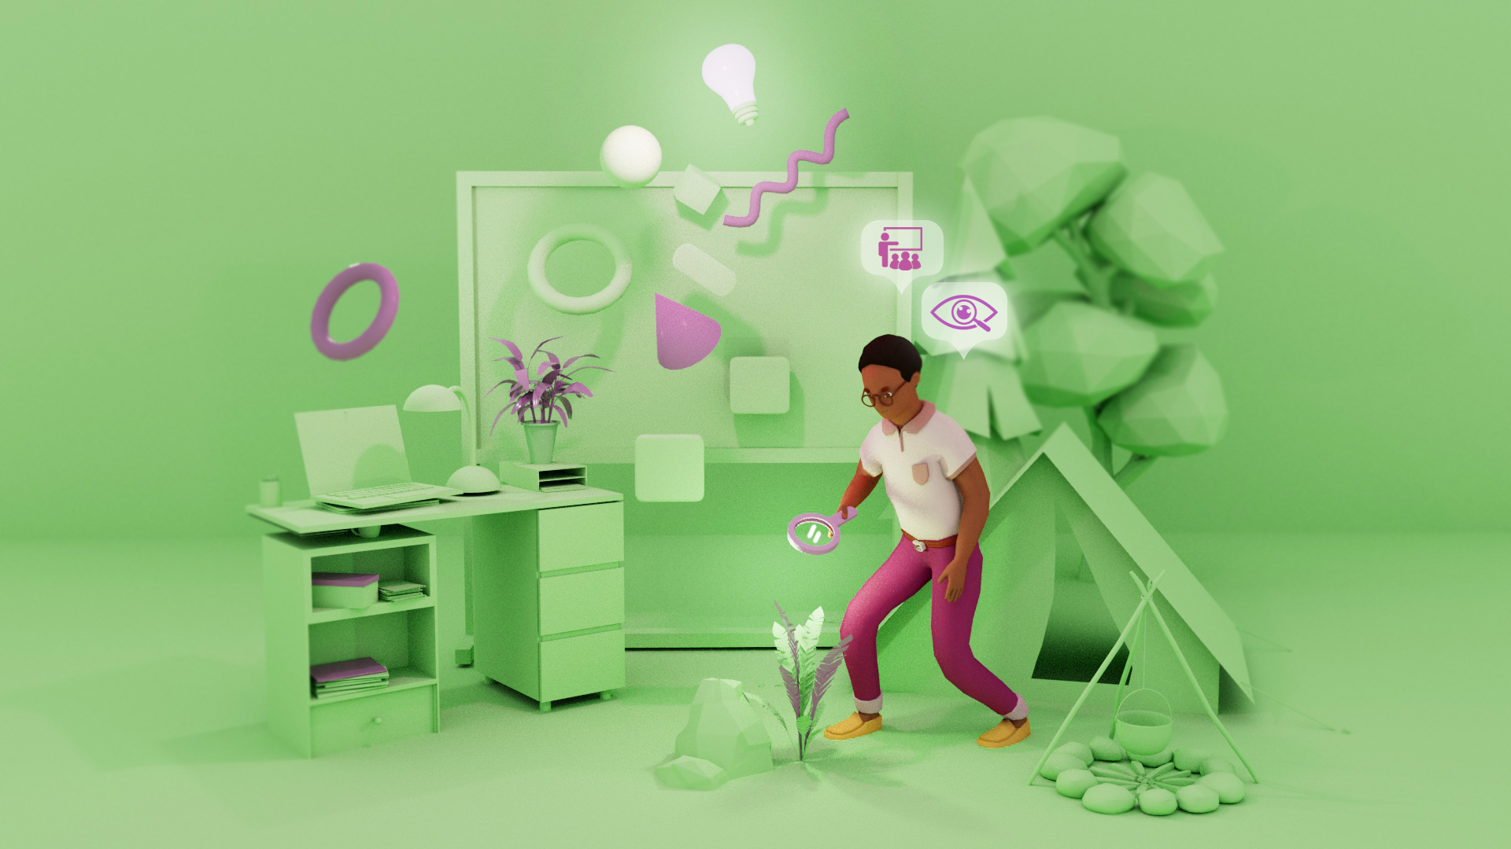
Hi, I’m Mr. Isaac and I just recently moved to the city when I started teaching at the Concrete Jungle Secondary School. I often go camping on weekends – even in winter - and love the outdoors. I’d say teaching is my passion; I want my students to not only learn science concepts but also to develop a love of learning. I've been involved in experiential learning initiatives at other schools in the past and want to bring it into my curriculum here too. | My name is Mr. Isaac. I’ve been teaching at this school since the beginning of my career and have been the Head of Science for the last 10 years. I’m proud of having a history of achieving high averages in my classes and I make sure that my students acquire the knowledge needed to pursue a career in math or science. I want my students to stay focussed during class and challenge them with fun theory-related exercises.

Character Descriptions
The bee that visits the flower

Version 1 | Version 2
I am a bee and spend my days exploring my surroundings away from my hive in search of new nectar sources. There aren’t many flowers all in one place, so I must travel far to get to them. I often stop by to visit the flower at Concrete Jungle Secondary School. I'm aware that I need to stay away from plants that have been sprayed by insecticides to keep from getting sick. But it’s getting harder to find those blossoms, so I only go to a few locations. I hope my bee family in the hive is successful so that the hive will continue to function. | I am a bee and live in a place surrounded by buildings. I've been struggling to survive due to the lack of flowers and abundance of predators. Wasps are one of my most common predators, and they thrive in this urban environment. I hope that someday there will be fewer wasps around so that I don’t have to worry about reaching more flowers, getting their nectar, and helping to pollinate them.

