What is Self-Regulated Learning?

The cycle of self-regulated learning (SRL) consists of three key phases: reflect, plan, and act. Ideally, you should repeat this cycle multiple times as you create goals and tackle challenges.
As a student, going through the SRL cycle will help you take strategic control of how you approach your coursework and goals, help you be prepared, face challenges and seize opportunities that might arise as you work to make your goals your reality.
Within the three phases there are different steps you should take including: analyzing the task, self-assessing, planning and goal setting, monitoring and evaluating performance, and adapting.
The Cycle of Self-Regulated Learning (.pdf)
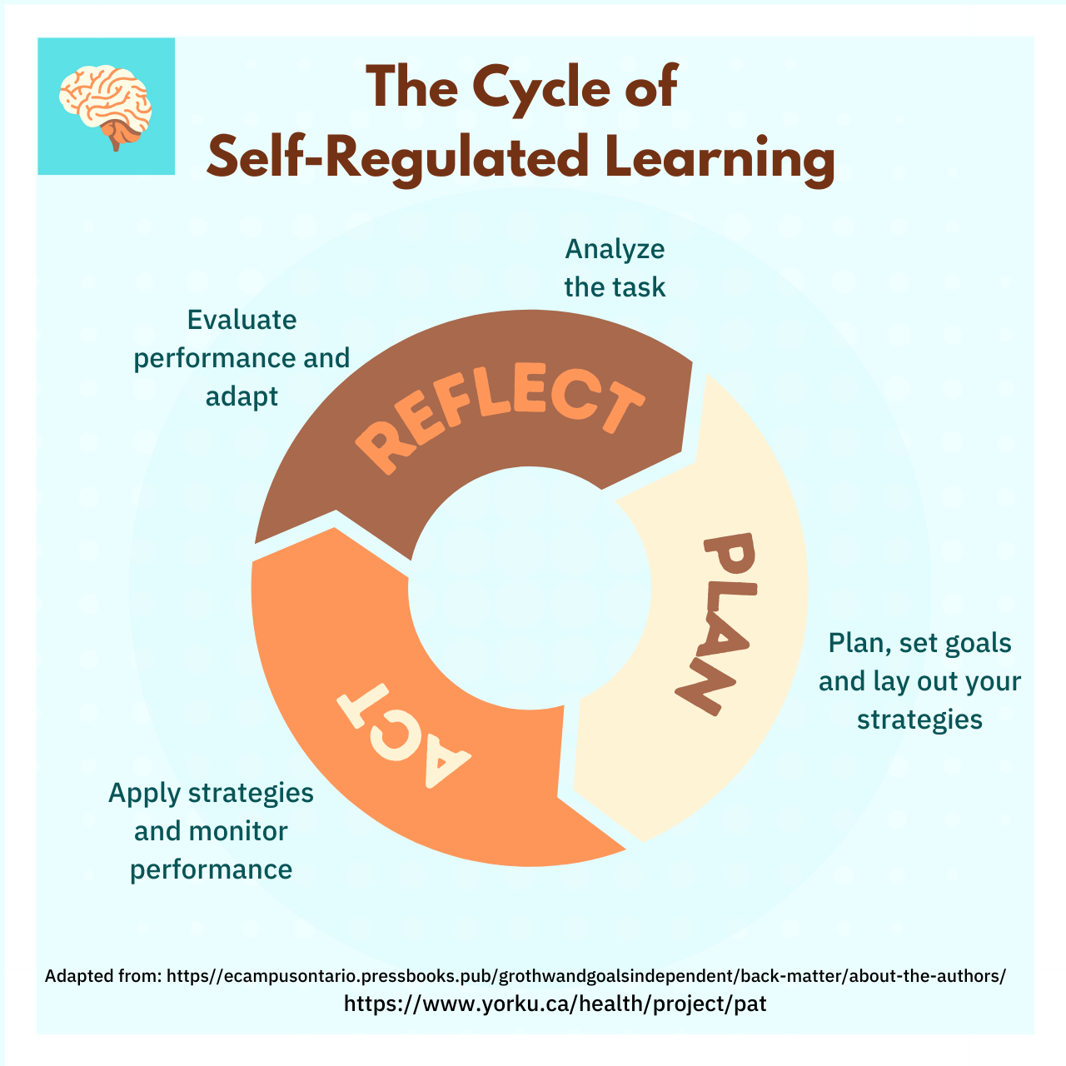

Learning Outcomes
This activity focuses on the reflection phase of the SRL cycle. You will analyze the task and self-assess before moving into the planning phase.
After you complete this activity, you will be able to:
- Analyze an upcoming learning task.
- Identify personal feelings towards an upcoming task.
- Assess your preparedness towards an upcoming task.
- Identify general tasks, timelines and supports you need to be successful in this task.

Step 1: Understanding the task at hand

Analyze the task and self-assess

It’s important to take the time to analyze and think about what the task at hand is before jumping in, this will help you better prepare, stay organized, and on track as well as identify areas where you might need support early on.

It’s also just as important to check in with yourself to gage your feelings and thoughts about the task at hand which can help you approach your task more mindfully.

To help you analyze and plan, you may want to ask yourself questions like:
- What is the task at hand (e.g., is this an assignment or activity)?
- How do I feel about the task at hand?
- What is my mindset approaching this task?
- Is this a task I've done before or something new?- Does it build off a task that I've done before?
- How can I use and apply my past knowledge and experience to this task?
- How could I do better this time if I’ve done this task before?
- What do I already know about this topic that can guide my learning?
- How much time do I anticipate this task will take me?
- Do I need to get clarity from my instructor or TA about this task?
- What questions do I have and will I ask?
- Do I feel prepared or do I need more support to complete this task?
Write your response below.

Step 2: Plan, set goals, and lay out your strategies

• Identify tasks and set goals
After analyzing your assignment, what tasks and goals do you need to complete to be successful? Think about how you want to structure the task you need to complete and what your goals are.
Before listing your goals, you may want to ask yourself:
- What are all the things I need to do to successfully accomplish this task?
- What are my major goals and what are my sub-goals so I can make sure I am making progress?
- How will I structure the task(s)?
- What are the intermediate checkpoints and goals?
- What do timelines look like to complete this task on time?
- How will I build in buffer time for myself in case I need it?
- How will I effectively divide up my study time?
Write out the goals and associated tasks that you have chosen to work with below.

Plan strategies
To be successful in achieving your goals and tasks, it’s important to think about the strategies you will use to accomplish them and to think about the strategies you will use if your plan is not going as smoothly as you had hoped.

TIP: You may not be able to anticipate every challenge that can arise, but you can focus on the goals and tasks you’ve listed and identify areas you think you may need extra support so that you can get ahead.

Based on the goals and tasks you’ve listed in step 3, identify and align strategies that will help you accomplish these items. You may want to ask yourself questions like:
- What resources do I need to complete the task? How will I make sure I have them?
- Will I need resources from the library or Learning Commons, help from my lab partners, or an appointment for office hours?
- Given my needs, when should I get started on this task?
- What strategies will I use to study (e.g., study groups, problem sets, evaluating text figures, challenging myself with practice quizzes, and/or going to office hours and review sessions)?
- How much time do I plan to allocate to each task?
- Which aspects of the course material should I spend more or less time on, based on my current understanding?
- How will I stay motivated and focused? (e.g., Set focus hours, rewards)
- How will I stay disciplined when I don’t feel motivated?
- What will I do if obstacles arise?
- What will I do if I fall behind on tasks?

Set expectations

While it is important to focus your energy on what you will learn through this experience, it’s also important to set expectations for the outcome you hope to achieve.

You may want to ask yourself questions like:

Given how much time I have available, what I already know about this topic, my strengths, and my current standing in the course, what type of outcome would I like?

Step 3: Monitoring your learning performance and working towards your goals

Instructions and introduction
As you begin to carry out your plan of action and work towards your goals, it’s also important to monitor your own learning and how you are performing so that you can adjust as needed, leverage strategies, prevent potential problems, and save yourself time.
You should observe and reflect on the actions you are taking, and the effectiveness of the results. For example, thinking about how your studying is going, you might find that when you studied in a quiet location in the library, you completed the reading more quickly than when you read at home.

TIP: Take a few minutes each time you study or work on your assignment to go through the questions below to reflect and self-assess.
Monitor your ongoing performance
To help you monitor your performance, you may want to ask yourself questions like:
- Am I meeting my timelines and goals?
- What progress have I made?
- Are things taking longer than I thought they would?
- What strategies am I using that are working well or not working well to help me learn?
- What other resources could I be using to complete this task?
- What could I do differently mid-assignment to address these challenges and confusions?
- To what extent am I taking advantage of all the learning supports available to me?
- Am I asking for feedback on my performance and tasks?
- Am I using the feedback I receive?
- Am I struggling with my motivation and discipline to study?

TIP: If you are using a new strategy (e.g., having a peer edit your paper instead of only editing it yourself), it can be normal to feel uneasy or want to revert back to old strategies that feel more familiar, even though they may not be as effective. Learning a new method or strategy is just as important as learning the content and it’s important to follow through.

Step 4: Evaluating your learning performance and outcome

Instructions and introduction
After you’ve completed an assignment, received evaluation and feedback, or reached a milestone in your course, take time to evaluate and reflect on the outcome and your learning performance so far.
This is a way to gain useful insights about yourself as a learner that will help you in future experiences. For example, what new supports might you need? What new strategy will you try? What skills have you improved? Why didn’t you get the outcome you had hoped for?
Evaluate your learning performance and outcome
To help you evaluate your performance and outcome, you may want to ask yourself questions like:
- How do I feel about my completed task?
- How do I feel about my own learning so far?
- To what extent did I successfully accomplish my goals?
- How did I feel when things didn’t go as planned?
- How did I feel when there was a challenge?
- What helped me stay motivated?
- How did I manage my time and tasks?
- What about my preparation worked well that I should do next time? What didn’t?
- Did I select appropriate strategies to complete my task?
- To what extent did I use resources available to me?
- What confusions do I have that I need to clarify?

Determine next steps
To help you determine next steps, review the questions below:
- If you didn’t achieve your goal, what do you need to do differently for next time?
- How will you overcome any challenges you’ve identified?
- What areas do you need to work on developing? And where will you go to get this support? (e.g., planning, time management, self-monitoring)
- When you do an assignment or task like this again, what do you want to remember to do or to do differently?
- What should you try again going forward? What worked well that you repeat in the future?

