Identifying Connections to Organizations

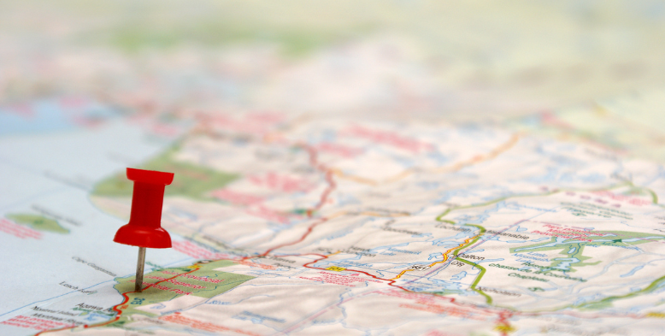
Locating organizations, businesses, or centers of activity that are connected to the topics we explore in this course.

Introduction
In this assignment, we will be using Google My Maps to map out various organizations, businesses, or centers of activity that are connected to the topics we explore in this course. This will help us identify where these organizations or businesses are concentrated, where there is little access to them, and what factors influence their location. The map will also be a valuable resource to guide your own networking and career research activities moving forward and for future students of this course.
For example, this map (pictured above) was created as a part of a project. Students collected and displayed information about diverse groups and organizations that partnered with students for social, economic, environmental, and other causes. This initiative was called “C4: Cross Campus Capstone Classroom.” If you click on the map markers, you will see information about each partner organization.

Learning Outcomes
By the end of this activity, you will be able to:
- Identify connections between course content and the external organizations.
- Construct an interactive map of organizations across Toronto in collaboration with other students.
- Discern patterns in the distribution of organizations and hypothesize causes for these.
- Develop a fact-finding plan to independently explore these organizations further for the purpose of career exploration.

Links
- Google My Maps
- C4 Project Partners Map
- C4: Cross Campus Capstone Classroom

Step 1: Identify Organizations or Businesses of Interest
Google My Maps provides a customizable interface for you to highlight important places in your local neighborhood, across the GTA, or even the world. There are a variety of creative ways that My Maps have been used. For example, there are maps that have been created to:
Map food resources in Toronto
Map COVID-19 support services in North London
Map Civil War sites when teaching American history
As you do this assignment, you create pins on your map to show important locations for the focus of your map. These could include non-profit organizations, government and educational institutions, companies, and/or general places that may offer you opportunities to pursue your passions.
For this assignment, find at least five organizations and businesses that you consider relevant to this course and to your interests, within a specific geographical area of your choosing. Google Maps can help you find these and then you can create pins in the proper location on your map. You may have come across potential additions to your map in the readings or lectures in this course or other courses you have taken, though the internet, in informational interviews or you may find them through the Finding Competitors section of the Libraries' Company Research Guide.
Compile your list of the organizations you will use in your map in the space below.

Step 2: Collect Information
Collect information for each organization/business including (where possible):
- Contact information (e.g., website, phone, address, LinkedIn, Instagram, Facebook, etc.)
- Number of employees, who owns and/or runs the organization
- How many York alumni work there - find this out by using the LinkedIn Alumni Tool
- A brief description of the main purpose or focus of each organization
- Links to video content on YouTube or Vimeo about the organization
- Links for internships, volunteer positions, paid positions
You can supplement any missing information with searchable company/organizational search engines that are offered through the York Libraries.

Links
- LinkedIn Alumni Tool
- York University's Company Research Guides

Step 3: Compiling Your Map

Accessing My Maps
You will need a Gmail account to access My Maps. You can start by:
- Open your Google Drive and Select “New” in the top left-hand corner.
- Click on the “New” drop down menu and the “More” option, select “Google My Maps”. You can also click here to access My Maps.

Creating a New Map
- Title your new map and add a description.
- Decide on what kind of information the layers of your map will include. A layer is an organizing tool to help you sort and label places with the same overarching theme. For example, you may want one layer of organizations to be non-profit organizations that focus on homelessness and another layer could focus on harm-reduction sites. Use the menu beside your untitled layer to name each layer.
- Next you can use the “Add Marker” feature in the top menu to place a pin on a location of interest.
- You can then title your marker and add the information you’ve collected about each organization.
- Add all the locations that are relevant to the layer and then add a new layer. You can have a maximum of ten layers.

My Maps Tips!
Tips: You can use tools like “Draw a Line” or “Measure Distances and Areas” tools to add even more information to show the relationships between the various locations on your map. For example, you can use the “Measure Distances and Areas” tool to foreground the concentration of similar types of organizations in an area.

Additional Resources
Everything you ever wanted to know about my maps (but were too afraid to ask)
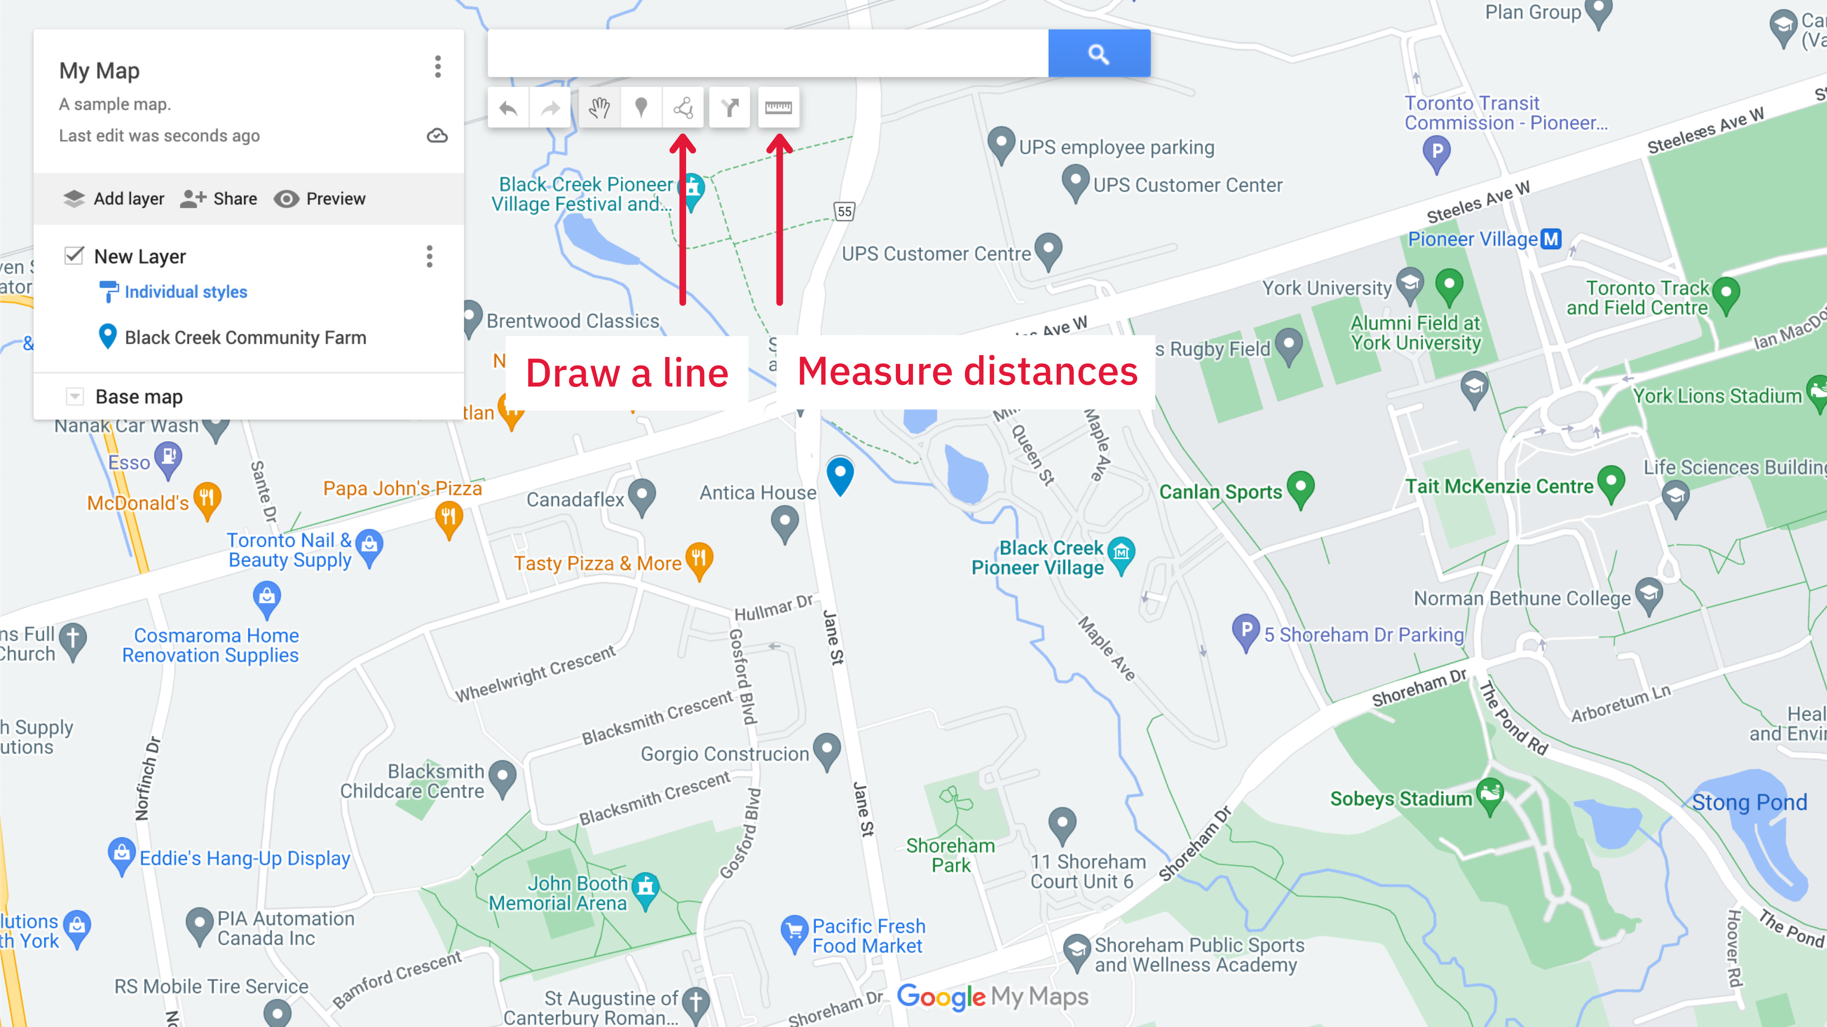

Step 4: Analyze Your Map
Having compiled your map, what patterns do you notice? E.g., areas of high concentration, areas with no makers? What might account for these patterns? How might these patterns impact equity, access and inclusion? How many of these patterns are due to lack of data? For instance, maybe an area you’ve identified as lacking service actually has service, but that information was not included in the organizations you included in your map? Do a search on Google Maps to test the viability of your map and explain what you discover.
Write a 200-300 words summary of your analysis here:

What surprised or interested you about what you learned in this process?
What would you do differently next time you create a map like this?
What possibilities for improvement do you see appearing from the information on this map?
How does this map relate to any of the topics we’ve discussed in this course?
How might you use the information on this map in the future?
Which organizations on your map are most closely related to your interests and aspirations? Explain what information you would be most interested in learning about these. How would you go about doing this?

