Three-Step Self-Reflection Guided Writing Activity
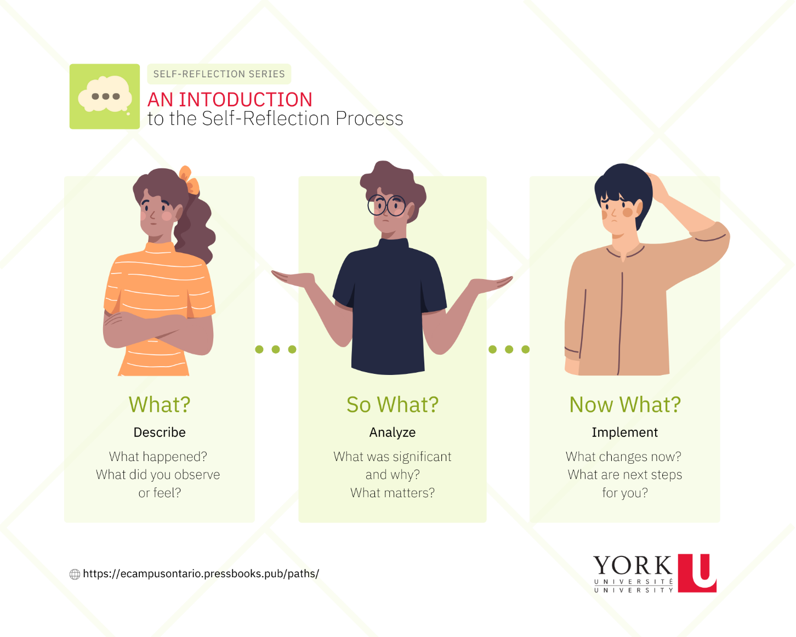
An Introduction to the Self-Reflection Process (.pdf)

What is self-reflection and why is it important?
What is self-reflection/ reflection?
Self-reflection or reflection is about careful thought that can bring important change or action. We can reflect on situations or events, both positive and negative, and what we learn in class, but we can also practice self-reflection when we examine and think more deeply about ourselves as learners to gain transformative insights to apply to future situations.
But reflection is not just about focusing on the positive and listing out all the things that went well or providing a summary of your day. Reflection is a powerful learning tool that can help you navigate university life.
Why does self-reflection/ reflection matter?
Reflection can help in many ways, including:
- Learning and understanding
- Academic performance
- Skills development
- Personal or professional development
- Identifying strengths and weaknesses
- Identifying gaps and connections
- Decision-making
- Problem solving and innovating
- Preparing for interviews and presentations
- Working with others
How do you self-reflect/reflect?
We often reflect on ourselves or experiences we've had, whether we are aware of it or not, we reflect all the time!
To strengthen your self-reflection skills, following a framework is helpful.
- You can practice reflecting with this three-step process: What? So What? Now What?, but there are many other frameworks and ways we can reflect (mental reflection, written reflection, reflecting as a team/group).
Practice self-reflection daily:
- You can develop reflection skills through practice and feedback. The more you practice reflection, the more you develop this skill and gain its benefits.
Reflection does not have to revolve around a big event or situation!
- For example, is there something you want to examine or explore about yourself more deeply? Did you have a hard time focusing in class today? Did you receive feedback on an assignment that made you happy? Did you try a new approach that worked well?
Learning outcomes
After you complete this learning activity, you will be able to:
- Describe self-reflection/ reflection and its benefits.
- Complete a written reflection using the What, So what, Now what framework in an academic context.
- Assess your internal state (feelings, thoughts, motivations) in a learning context.
- Discuss connections between learning experiences, course content and/or yourself as a student.

Instructions for students
You can use this three-step framework to practice reflecting at any time or use it to help you structure your written reflections for a course. You can save and export your document when you are done.
You should also consider these questions before completing this activity:
- Do you need to submit a written reflection for class?
  - You can find more specific resources about reflective writing here
- Who is your audience? Who will be reading your reflection?
- Are there specific questions you need to answer as part of your assignment?
- Were you asked to reflect on a particular experience or event?
Tip: Consider focusing on the reflection process just as much as what you are reflecting about.

Step 1: What?

Start your reflection by first understanding the situation, experience, or event you want to reflect on by describing it.

Questions you can answer in your response:
- What did I do or experience?
- What happened?
- What was I feeling?
- What went well?
- What went poorly/wrong?
- What was my goal?
- What did I learn?

Tip: Find a reflective process that works for you and your needs.
- Do you prefer writing down your thoughts when you reflect? Or, can you use this framework while mentally reflecting during a walk or your commute?
- Does music help or distract you when reflecting?
- Does doodling and drawing help you articulate your thoughts?
- Does being in nature help you think reflectively?

Step 2: So What?

Next, think about the significance and implications of the experience/situation/event you've just described in Step 1, or what you've examined about yourself. Focus on explaining why this was significant or meaningful to you.

Questions you can answer in your response:
- What was important and why?
- What connections do I see (personally, to class content), and why?
- How does this relate to what I have learned in my courses?
- Does this challenge or confirm my previous knowledge/beliefs?
- What is meaningful about this and why is it meaningful?
- How did this affect me?
- What did this tell me or teach me about myself and why does this matter?

Tip: Be sure to give yourself time and space during this step.

Ask a friend or peer to be a thought partner if you are struggling with this step. Take your time here. Making meaning and connections by finding significance in your experience is a critical step in this process and can take more time than Step 1.

Step 3: Now What?

In this last step, using all the information you've gathered and your new insights from Steps 1 and 2, what do next steps look like?

Questions you can answer in your response:
- What can I do better or differently in the future?
- What worked really well that I should try again?
- What new ideas or content will I explore?
- What skills can I improve?
- What next steps will I take?

Tip: To gain the benefits of reflection, apply your new insights, actions or goals to future situations and see how things go.

