Reflecting on Your Interests and Values

Introduction
Identifying your interests and values can be useful in determining activities and fields you would enjoy in your life and in your career. This activity will help you to make connections between course content and your academic and career plans.

Learning Outcomes:
By the end of this activity, you will be able to:
- Articulate the types of goals that you may consider pursuing based on your interests and values.
- Discuss how course content and extracurricular opportunities at York University can support your goals.
- Plan and reflect on your short-term and long-term goals.

Clarifying Interests and Values
One popular model to assess personality, interests, and career matches is the RIASEC model proposed by Holland (1997). Assessments that use this model are not perfect because they are generalizations that do not capture all of you. However, they do provide a starting place for clarifying potential areas of interest to explore further. This exercise can help you build a fuller picture of yourself and your emerging interests and values.
Like interests, your values inform your actions and day-to-day decision-making (Feather 1995). Understanding your values can help you recognize opportunities that might be a ‘good fit’ for you. When the things that you are doing in life align with your values, you have a greater likelihood of being satisfied with your life choices. Truity.com offers a Holland code career test that highlights interests areas, values, and careers that you may be interested in exploring based on your results. But remember, only you can decide which interest-areas resonate with you, regardless of your questionnaire results.
At the end of this test, you will receive results like this:
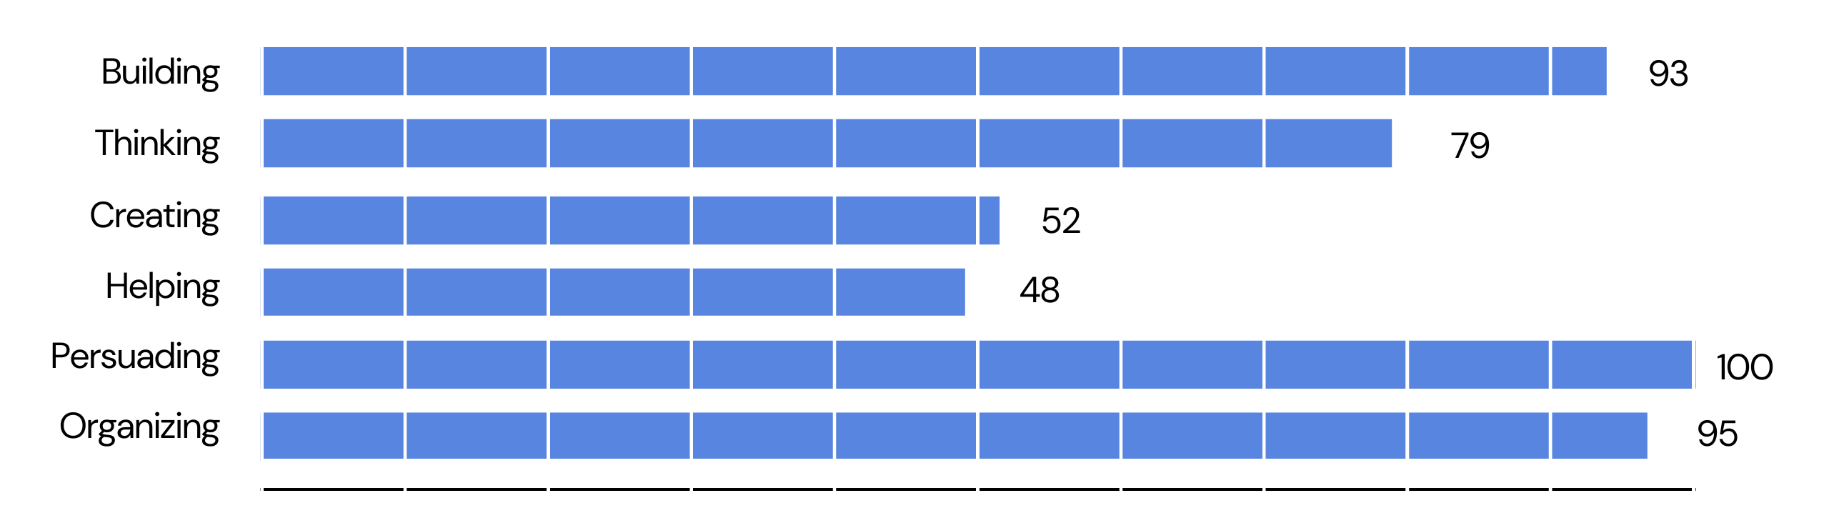
The results will also include a list of values, traits, and job tasks that you may enjoy.

Top Job Tasks:
- Managing
- Deciding
- Strategizing
- Motivating

Your Core Values:
- Influence
- Leadership
- Risk-Taking
- Achievement
- Initiative

Key Personality Traits:
- Assertive
- Energetic
- Confident
- Ambitious
- Adventurous
Review the descriptions of each category to better answer the questions below and take the Holland code career test. Click on the links in each category for more information on top job tasks, core values, personality traits and career options in that area of interest.
Write a couple sentences about how you feel about your interest results using the following questions as prompts. Answer at least one question from each reflections category [or each question selected by the instructor] – What, So What, Now What.
What

After reviewing the descriptions of each personality category, which one(s) do you think sound(s) most like you, regardless of your assessment outcome?
- Which are your top three interests and why?
- In what order would you place them, and why?

After deciding for yourself which categories best describe you, how do these compare with your questionnaire results?
- Why do you think the questionnaire results might have been different from your own choices?

What are your first thoughts about the core values that are associated with your top three interest categories?
- Which values do you agree with?
- Which values are most important for you? (i.e., you would not be willing to compromise on them)
- What other values do have that weren’t included in the quiz?

So What?

Review some of the sample careers for the interest area(s) that you think best suit(s) you.
- Explore two or three of these career choices. Which one sounds interesting to you? Why?
- Make a note of anything you may not like about each of these careers as well.

How do the courses you are currently taking, connect to these interest areas?
- For example think back to a speaker, activity, or reading that we have done in this course. Identify one or two that you found most interesting and see if you can link these with your questionnaire results. In what ways do they align? If they do not seem to be related, how can you explain this? Consider the other areas of interest that may not have rated strongly in your questionnaire results.

How are your values reflected in the aspects of a course you most enjoy?
- Think back to a topic, speaker, activity, and/or reading that we have done in this course and discuss how your values could contribute to your preference for this aspect of the course.

If none of the career suggestions interest you, explore the What Can I Do with My Degree? resources offered by Career Centre at York University. After reviewing the careers for your program, which interests you the most? What other careers do you think you would enjoy? Write these down.

Now What

When you click on the suggested careers for your top interest areas, details about education, training, certification, and personality are included. After reading these sections, what would be your next steps if you were to pursue the suggested career?

Envisioning your future life, what challenges do you see staying true to your core values? What impact might these values have in the various areas of your life such as career, family life, hobbies, and recreation?

If you have enjoyed thinking about your interests and values and want to explore further or are feeling a little lost, one useful practice is to picture your ideal life. The envision YU resources includes two additional self-exploration activities (Reflecting on Your Competencies and Reflecting on Your Life Priorities activities) that can be helpful in envisioning what a fulfilling life could look like for you.

References:
Holland, J. L. (1997). Making vocational choices: A theory of vocational personalities and work environments (3rd ed.). Odessa, FL: Psychological Assessment Resources
Feather, N. T., (1995) “Values, valences, and choice: The Influence of values on the perceived attractiveness and choice of alternatives.” Journal of Personality and Social Psychology 68(6) 1135-1151. DOI:10.1037/0022-3514.68.6.1135

