Reflecting on Experiential Learning Activities

Introduction
In this assignment, you will strengthen your ability to use critical thinking to translate experience to knowledge. Reflect on an in-class activity such as a class debate, case study exercise, guest speaker, video or presentation and consider the ways it contributed to or shifted your perspective of the course content, yourself and/or your future.
Learning Outcomes
By the end of this activity, you will be able to:
- Articulate how course activities amplify course concepts in ways that relate to or challenge previous understandings about self and world.
- Analyze how personal experience of course-based activities shift your perceptions about course content and yourself in ways that invite further inquiry.
- Explore new possibilities for personal growth or career exploration from insights gleaned through course activities.
Respond to the questions on the next page.

Prior to Completing Experiential Activity
Answer these questions before you complete the experiential learning activity.

What?
In the “What” section you will notice aspects of your experience, form opinions, and identify an initial emotional response to an issue or experience. You will make connections between the experience or issue with your own skills, knowledge, and/or prior experiences.

Reflection Questions

What do you think you will gain from this activity? Think about what you might gain relative to this course and your own interests.

So What?
In the “So What” section, you will develop new insights about yourself, and your future aspirations based on course experiences.

Reflection Questions
- Why do you think your professor included [specify activity] in the course?
- What questions or concerns do you have about this issue/ topic/ activity?

After Completing Experiential Activity

Answer these questions after you have completed the experiential learning activity

What?
In the “What” section you notice aspects of your experience, form opinions, and identify an initial emotional response to an issue or experience. You will make connections between the experience or issue with your own skills, knowledge, and/or prior experiences.

Reflection Questions
- How accurately did you predict what you would gain from this activity? What aspect(s) of your experience were not predictable? Explain.
- What did you enjoy the most/ least from this experience? Why?
- What have you learned about your interests/preferences through this experience?
- What do you see as being the most valuable or useful take-away from this experiential experience in terms of the course? Why?

So What?
In the “So What” section, you will develop new insights about yourself, and your future aspirations based on course experiences.

Reflection Questions
- In what way(s), if any, did this activity help you better understand course concepts - explain? If it did not improve your understanding, why not? What would have been more helpful for you?
- What questions or concerns do you still have or emerged for you because of this activity?
- In what way(s) might this insight influence your actions/ choices in the future? Why?
- In what ways, if any, does this experience shift your understanding of the relevancy of this issue/ topic/ course for you now or in the future? Explain.

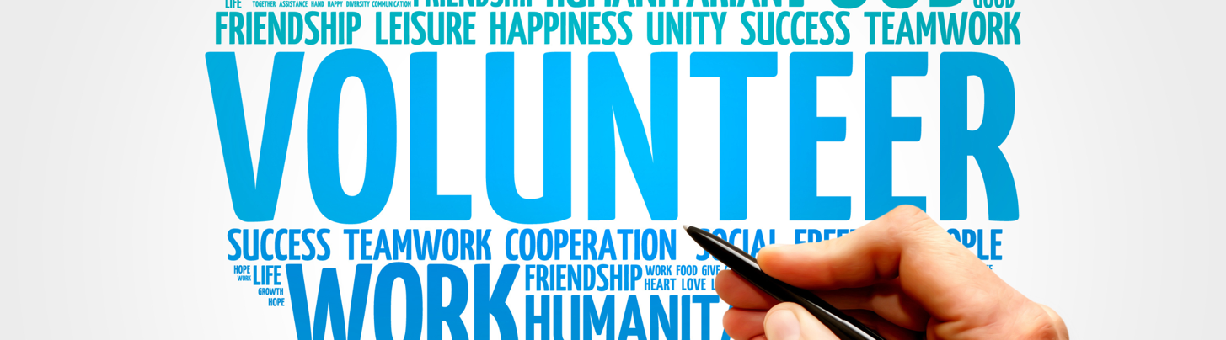

Now What?
In this section, you will integrate new knowledge and think about how to use your new insights to create plans or take (immediate) next steps to put their new insights into action.

Reflection Question:
- Does this experience alter your desire to learn more about this topic/ issue? Explain.
  - If yes, what options do you see for pursuing this interest further within this course or after it ends?
  - Create a list of student groups, community activities, volunteer work, where you could explore any emerging or existing interests related to this activity or this course. You can by checking out the following resources:
    - Student Community & Leadership Development: Student Engagement
    - Career Centre: How to build skills and experience; Wondering about career options.
    - Drop-in sessions at the Career Lounge to speak with a Peer Career Educator to get an orientation to these resources.
    - York Experience Hub: Experiential Education options
- What insights regarding your future goals were confirmed or emerged from this activity?
- Describe how you would redesign this activity/ event in the future to be more useful/valuable for you. Why?

