Page number on right side of header
(In MS Word: Insert => Header => Edit Header => Page Number => Alignment Right => Ok)

1-inch (2.54 cm) margin
(In MS Word: Layout => Margins => Normal)

Paper size: US Letter 8^{1/2} x 11 NOT A4
(In MS Word: Layout => Size => US Letter)

bolded
Capitalize Main Words
2 rows above your name
The title should be based on the topic of your paper

Title of Your Paper
Your instructor may also ask for your student number

Your Name
Program name, school name

English for Academic Purposes, Georgian College
Course Code: Course Name => Look in the top left corner of the Blackboard shell of the course you are taking:
Example:
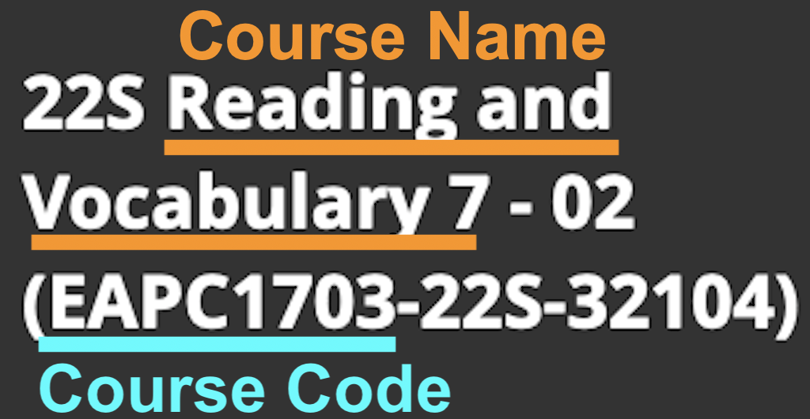
Course Code: Course Name
Instructor’s Name
August xx, 2022
Due date

Title of Your Paper
Font: Times New Roman – 12 point
Centered and double spaced in the top half of the paper.
For more information, see the APA Style Guide: https://apastyle.apa.org/style-grammar-guidelines/paper-format/title-page

The title is the same as on your title page, centered, bolded, not underlined, and not italicized
The introduction is indented one tab and begins immediately after the title with no line space. The introduction begins with a general statement about the topic to get the reader’s attention. Often, the last sentence in the introduction clearly states the topic of the paper and is called the thesis statement. You should, however, be sure to follow your professor’s instructions on how to write an introduction, body and conclusion for the type of assignment you are submitting.
Each body paragraph is indented one tab and begins immediately after the previous paragraph with no line space. Look at the last page of this document to see how to set the paragraph spacing before and after the paragraph to 0 pt. Each body paragraph usually begins with a topic sentence, gives examples or proof of what you state in the topic sentence, then ends with a concluding sentence.
If you are quoting the exacts words of another author, make sure that you introduce the quote and use “quotation marks around the author’s words” (Saint Paul’s High School, 2022, Quoting, Paraphrasing and Summarizing). Also, as stated by Purdue University (2021), “you will need to include the author, year of publication, and page number for the reference” (Short Quotations), and then explain to the reader how this quote supports or proves your claim. If you paraphrase the author’s words, you may include the page number, but it is not required, and you do not need to use quotation marks (American Psychological Association, 2020).
The final paragraph restates the thesis statement in other words, then usually ends with a general statement about the topic or something to get the reader thinking more about the topic.
The font for the entire paper is Times New Roman 12.
The paper size is US Letter 8 1/2” x 11” (check under Layout that it is not set to A4)
Double space the entire paper and indent one tab at the beginning of each paragraph.
Do not put a line space between paragraphs.

References
Use the singular heading Reference if you have only one reference.
American Psychological Association. (2020). Publication manual of the American Psychological Association (7th ed.). https://doi.org/10.1037/0000165-000
Give the doi if available, not the html. web address.
Purdue University. (2021). In-text citations: The basics. https://owl.purdue.edu/owl/research_and_citation/apa_style/apa_formatting_and_style_guide/in_text_citations_the_basics.html
Saint Paul’s High School. (2022, April 6). Citing Sources: In-text Citations – APA. https://stpauls-mb.libguides.com/citations/intext-apa
For your reference page:
- Every source you have an in-text citation for should also be listed on the reference page.
- If there is more than one author, do not change the order in which the authors’ names are listed in the article.
- Put the references in alphabetical order using the last name of the first author listed or by the organization name.
- Use a hanging indent so that author’s name is further left than the rest of the citation.
- 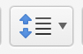 In MS Word click the line and spacing icon then choose hanging indent

For your whole document: from the Line and Paragraph spacing icon
- Set the alignment to “Left” not justified.
- Select double spacing
- Set the spacing Before and After a paragraph to 0 pt.
.