Page number on right side of header
(In MS Word: Insert => Header => Edit Header => Page Number => Alignment Right => Ok)

1-inch (2.54 cm) margin
(In MS Word: Layout => Margins => Normal)

Paper size: US Letter 8^{1/2} x 11 NOT A4
(In MS Word: Layout => Size => US Letter)

3 or 4 lines down from the top of the page
Bolded
Capitalize Main Words
Extra blank line above your name
The title should be based on the topic of your paper

Title of Your Paper
Your instructor may also ask for your student number

Your First and Last Name
Program name, school name

English for Academic Purposes, Georgian College
Course Code: Course Name => Look in the top left corner of the Blackboard shell of the course you are taking:
Example:
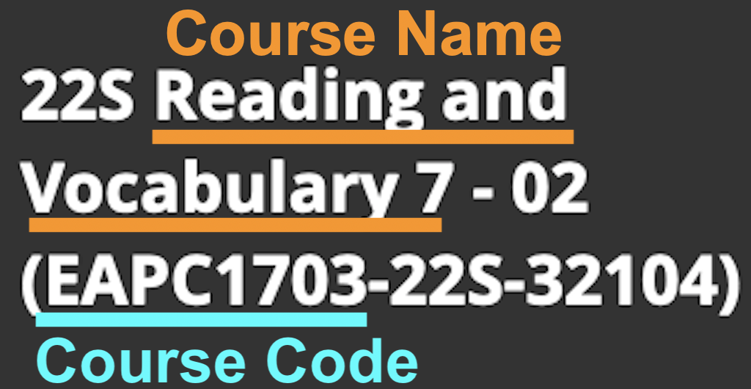
Course Code: Course Name
Instructor’s First and Last Name
December 16, 2022
Due date
Write the month in full

Title of Your Paper
Centered and double spaced in the top half of the paper.
Font: Times New Roman – 12 point is recommended, but some other fonts are permitted: https://apastyle.apa.org/style-grammar-guidelines/paper-format/font
For more information, see the APA Style Website: https://apastyle.apa.org/style-grammar-guidelines/paper-format/title-page

The title is the same as on your title page, centered, bolded, not underlined, and not italicized
The introduction is indented one tab (0.5 inches or 1.27 cm) and begins immediately after the title with no line space. The introduction begins with a general statement about the topic to get the reader’s attention. Often, the last sentence in the introduction clearly states the topic of the paper and is called the thesis statement. You should, however, be sure to follow your professor’s instructions on how to write an introduction, body and conclusion for the type of assignment you are submitting.
Each body paragraph is indented one tab (0.5 inches or 1.27 cm) and begins immediately after the previous paragraph with no line space. Look at the last page of this document to see how to set the paragraph spacing before and after the paragraph to 0 pt. Each body paragraph usually begins with a topic sentence, gives examples or proof of what you state in the topic sentence, then ends with a concluding sentence.
If you are quoting the exact words of another author, make sure that you introduce the quote and use quotation marks around the author’s words. In an essay about pets for example, the writer may say that dogs may help their older owners to stay healthy as researchers found that “those with a dog and who were involved in its care were less likely to be lonely” (Opdebeeck et al., 2021, p. 1559). After the direct quote, you need to have an in-text citation which includes the author’s last name, year of publication, and page number of the reference and then explain to the reader how this quote supports or proves your claim. If you paraphrase the author’s words, you may include the page number, but it is not required, and you do not need to use quotation marks (American Psychological Association, 2020).
The final paragraph restates the thesis statement in other words, then usually ends with a general statement about the topic or something to get the reader thinking more about the topic.
The recommended font for the entire paper is Times New Roman 12.
The paper size is US Letter 8 1/2” x 11” (check under Layout that it is not set to A4)
Double space the entire paper and indent one tab at the beginning of each paragraph.
Do not put a line space between paragraphs.

References
Use the singular heading Reference if you have only one reference.
American Psychological Association. (2020). Publication manual of the American Psychological Association (7th ed.). https://doi.org/10.1037/0000165-000
Give the DOI if available, not the URL. web address.
Opdebeeck, C., Katsaris, M. A., Martyr, A., Lamont, R. A., Pickett, J. A., Rippon, I., Thom, J. M., Victor, C., & Clare, L. (2021). What are the benefits of pet ownership and care among people with mild-to-moderate dementia? Findings from the IDEAL programme. Journal of Applied Gerontology, 40(11), 1559-1567. https://doi.org/10.1177/0733464820962619
For your reference page:
- Every source you have an in-text citation for should also be listed on the reference page.
- If there is more than one author, do not change the order in which the authors’ names are listed in the source.
- Put the references in alphabetical order using the last name of the first author listed or by the organization name if the organization is the author.
- Use a hanging indent so that author’s name is further left than the rest of the citation.
- In MS Word click the line and spacing icon then choose hanging indent

For your whole document: from the Line and Paragraph spacing icon
- Set the alignment to “Left” not justified.
- Select double spacing
- Set the spacing Before and After a paragraph to 0 pt.
.