PHY1024

Law of Reflection
The angle of reflection equals the angle of incidence.
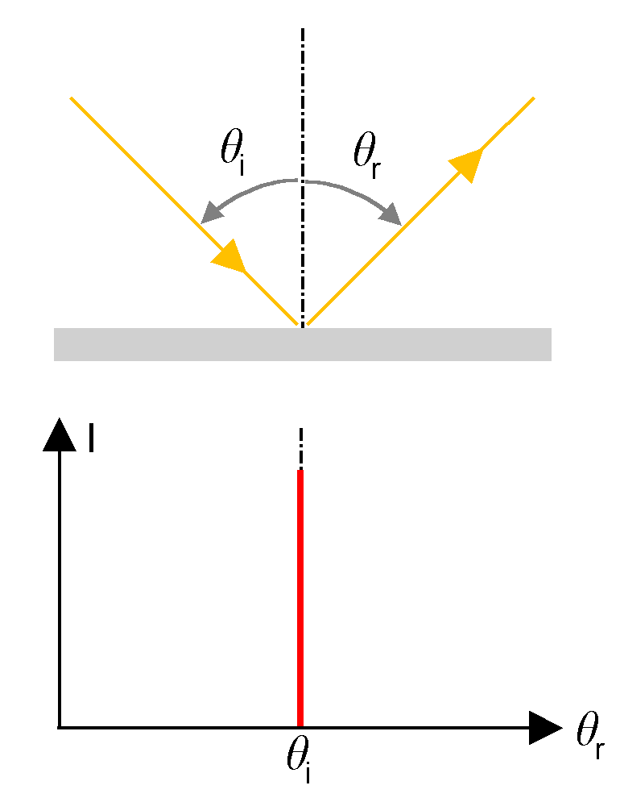
Image credit: Panjasan, CC BY-SA 3.0 <https://creativecommons.org/licenses/by-sa/3.0>, via Wikimedia
https://commons.wikimedia.org/wiki/File:Specular-Reflection-1.png
$$Ɵ_{i}=Ɵ_{r}$$
$Ɵ_{i}$ is angle of incidence; $Ɵ_{r}$ is angle of reflection.

Speed of Light
Speed of light in vacuum is $c=3×{10}^{8}$ m/s.

Law of Refraction
The changing of a light ray’s direction (loosely called bending) when it passes through variations in matter is called refraction.
Index of refraction
$n= \frac{c}{v}$,
$n$ is index of refraction, $c$ is speed of light, $v$ is the observed speed of light in the material.
Snell’s Law
$n_{1}\sin{Ɵ_{1}=n_{2}\sin{Ɵ_{2}}}$,
$n_{1}$ and $n_{2}$ are the indices of refraction for medium 1 and 2, and $Ɵ_{1}$ and $Ɵ_{2}$are the angles between the rays and the perpendicular in medium 1 and 2.

