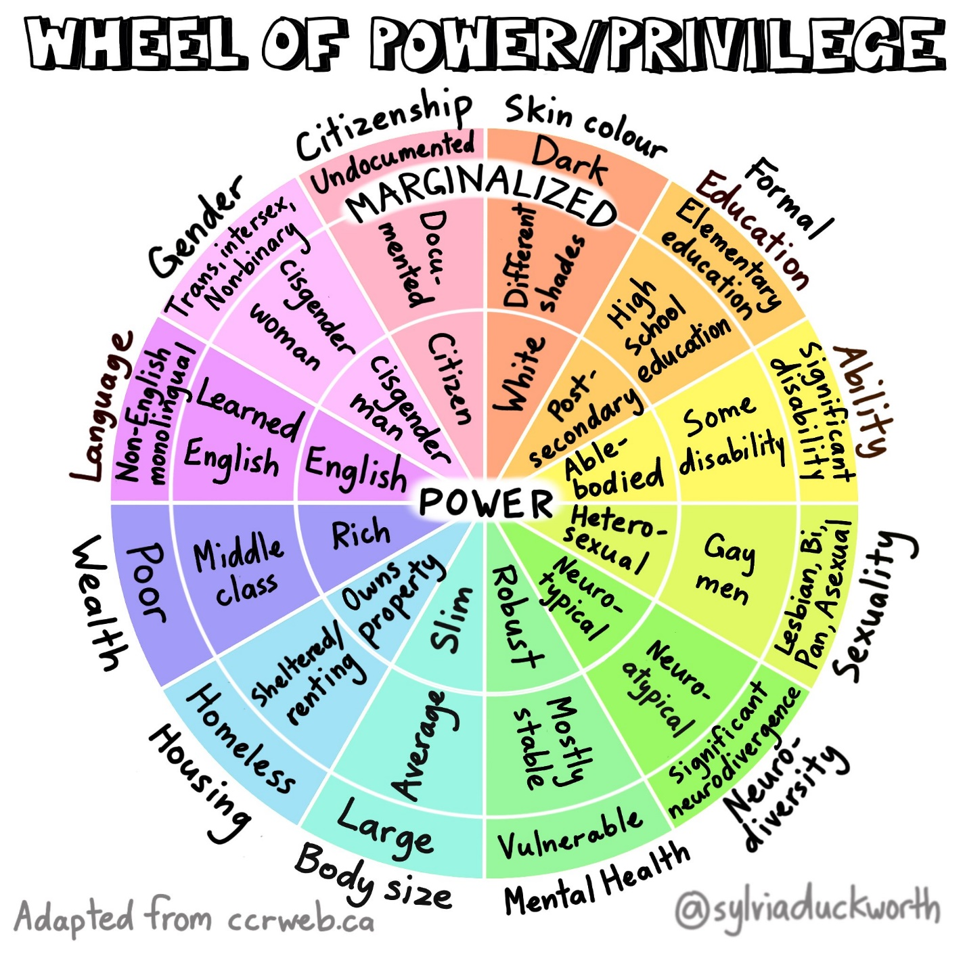
Sylvia Duckworth’s Wheel of Power/Privilege organizes the various identities of a person on a wheel with the identities that hold the most power in our society placed at the center, and the identities that hold the least power in our society on the outskirts. The wheel is sectioned off into 12 categories, each marked by their own unique colour. In order of most powerful to least powerful, the text on image reads:
- Citizenship: citizen, documented, undocumented
- Skin colour: white, different shades, dark
- Formal education: post-secondary, high school, elementary
- Ability: able-bodied, some disability, significant disability
- Sexuality: heterosexual; gay men; lesbian, bi, pan, asexual
- Neurodiversity: neurotypical, neuroatypical, significant neurodivergence
- Mental health: robust, mostly stable, vulnerable
- Body size: slim, average, large
- Housing: owns property, sheltered/renting, homeless
- Wealth: rich, middle class, poor
- Language: English, Learned English, non-English monolingual
- Gender: cisgender man; cisgender woman; trans, intersex, nonbinary

The content of the wheel is adapted into the chart below. As you navigate through, consider using the fill tool, highlight tool or bold tool to identify where your own identity falls.

Identity Categories | Most Power | Neither the most powerful nor the least powerful | Least Power
Citizenship | Citizen | Documented | Undocumented
Skin colour | White | Different shades | Dark
Formal Education | Post-Secondary | High school | Elementary
Ability | Able-Bodied | Some disability | Significant disability
Sexuality | Heterosexual | Gay men | Lesbian, bi, pan, asexual
Neurodiversity | Neurotypical | Some neurodivergence | Significant neurodivergence
Mental health | Robust | Mostly stable | Vulnerable
Body size | Slim | Average | Large
Housing | Owns property | Sheltered/renting | Homeless
Wealth | Rich | Middle Class | Poor
Language | English | Learned English | Non-English monolingual
Gender | Cisgender man | Cisgender woman | Trans, intersex, nonbinary

Looking at the cells you’ve highlighted for yourself, what do you notice? Do most aspects of your identity fall in the most powerful area of the chart? Least?

