Self-Reflection: Mini Writing Tool
Estimated time: 2 minutes

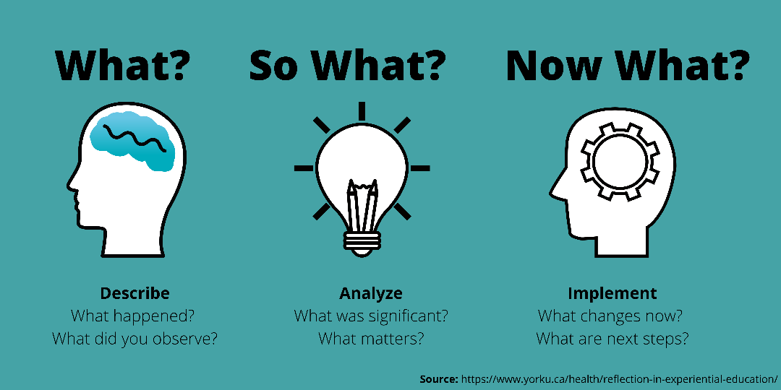

How to write your self-reflection:

Start by describing the situation, event, or learning moment you want to reflect on.

Think about what mattered about this experience and why it matters.

Think about how you will use these insights in the future.

Write your response below:
Pedagogy that Aids Transition for Higher-Ed Students by PATHS, York University is licensed under a Creative Commons Attribution-NonCommercial-ShareAlike 4.0 International License. If you reuse this work, please attribute PATHS, York University and include a link to https://www.yorku.ca/health/project/pat/

