Making Decisions as a Team | PATHS Teamwork Series

Estimated time: 2 minutes

Polling

Option 1: If the meeting is taking place remotely, you can utilize polling software available in the remote meeting platform (eg. Zoom, Microsoft teams) to acquire feedback from all team members.

Option 2: If the meeting is taking place in-person, you can use the Roman voting technique where members cast their vote using hand gestures. In this case, thumbs up indicates you support the idea, thumbs down would mean that you have concerns and do not want to move forward with this idea, and a sideways thumb can be used when you are willing to move forward with the idea without any strong reservations or preference, hence a neutral state.

A team member may also vocalize or signal their preference in a different manner, if they are unable to do so physically.

Roman Voting Technique (PDF)

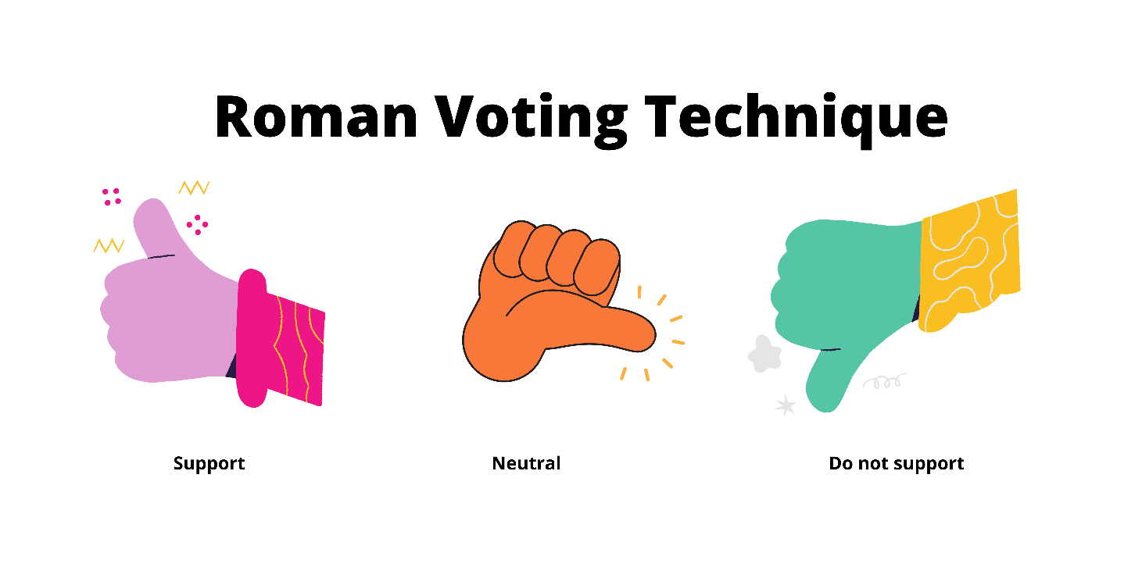

Fist to Five Voting
Deciding on an action can be even more challenging if consensus is to be achieved by a simple yes or no response. Fist to Five Voting is a technique that can be used to gauge and come to a consensus on a topic where a decision needs to be made during a team meeting.

The Fist to Five voting technique is one of the methods used by Agile Teams for decision making. The process is as follows: the meeting Chair or Facilitator asks team members to show their level agreement to the statement presented for decision making by holding up a closed fist if they disagree or depending on their level of agreement to the statement, the corresponding number of fingers. A team member may also vocalize or signal their preference in a different manner, if they are unable to do so physically.

The image below illustrates the definitions for each level. A closed fist suggests you are blocking the consensus, one finger means you strongly disagree, three fingers means you are not certain but are willing to go along with the team, and five means you strongly support the decision and might even champion it. If anyone in the team presents a number less than three fingers, the decision must be deferred for further discussion for concerns to be addressed before voting on the idea or proposal again.
Fist to Five Voting Image (PDF)
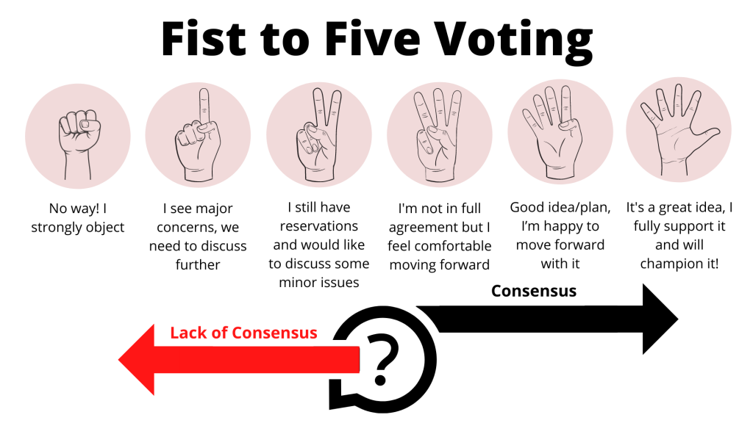

Dot Voting

Another technique that can be used for decision making is dot voting where ideas are presented on a whiteboard (real or virtual) and each team member is provided with a sticky note that they can use to select their top choice. Once everyone has had a chance to vote, you can tally up the results and proceed with the option that had the most votes. If you need to break a tie, you can keep the top choices and eliminate the remaining and just repeat the dot voting process. Alternatively, you can consider other techniques for voting.
Dot Voting (PDF)
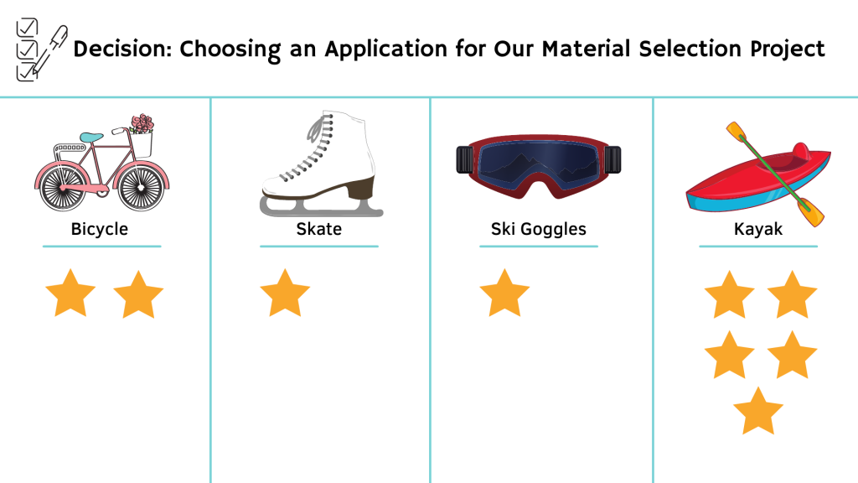
Sources
Hellem, D. (2019 September 19). Team Safety with the Anonymous Fist to Five method. Microsoft Azure DevOps. (Accessed 2022 Jan 23) https://devblogs.microsoft.com/devops/team-safety-with-the-fist-to-five-method/
Rogers, P. (2019 Feb 11). Team Decision Making Techniques. Medium. https://medium.com/agile-outside-the-box/team-decision-making-techniques-80f2138ae31e

Pedagogy that Aids Transition for Higher-Ed Students by PATHS, York University is licensed under a Creative Commons Attribution-NonCommercial-ShareAlike 4.0 International License. If you reuse this work, please attribute PATHS, York University and include a link to https://www.yorku.ca/health/project/pat/

