How growth mindset can help us become self-regulated learners
Estimated time: 15 minutes
Learning Outcomes:
- Describe growth, fixed and false growth mindsets.
- Identify growth and fixed mindset statements.
- Recognize why growth mindset is important to self-regulated learning.
- Reflect on a time you used a fixed mindset in a learning situation and how you could change it.

What is growth mindset?
The term growth mindset comes from Psychology Researcher and Professor, Carol Dweck.
Through her research, Dweck found that:
“Individuals who believe their talents can be developed (through hard work, good strategies, and input from others) have a growth mindset. They tend to achieve more than those with a more fixed mindset (those who believe their talents are innate gifts). This is because they worry less about looking smart and they put more energy into learning.”
Watch: What is growth mindset?
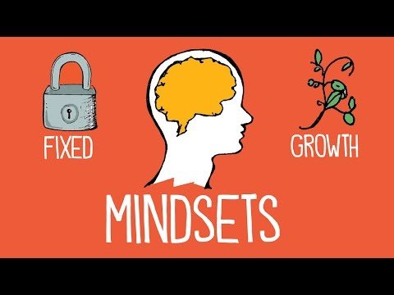
Check your learning
True or False:
A fixed mindset suggests that our abilities are innate and unchangeable, but a growth mindset suggests that we can improve our abilities through practice and feedback.
Answer: True

The science behind growth mindset
A growth mindset is associated with successful learning. Why? The growth mindset principles are supported by what we know about the brain and learning. Adult brains continue to develop over time by through learning. Working to master complex material results in the development of additional neural connections. In other words, by learning difficult material, you can actually become smarter. If you believe that you are able to succeed by working hard, you are more able to persevere through the difficult moments in learning, and continue to make progress towards your learning goals.
Growth mindset does not suggest the belief that unsuccessful learners lack something within themselves to be successful—like grit, or positivity.
There are also many structural, socio-economic and individual factors that can impact our wellbeing and learning, but research shows that leaning into a growth mindset can be a useful approach and learning tool to help you in your academic journey.
Check your learning
Identify the category each statement belongs to:
- I don’t know how to do this, but I can learn.
- If I get feedback, I can learn something new and improve.
- Maybe I can try this a different way.
- That looks challenging, but I’m up for the task.
- I tried so I guess that’s good enough.
- Feedback is a personal attack, so I should avoid it.
- I’ll look dumb if I ask questions.
- I messed up, I guess I’m not good at this.
Answer: Statements 1-4 are examples of a Growth Mindset and statements 5-8 are examples of a Fixed Mindset.
Watch: Three Ways to Spot a False Growth Mindset
Check your learning:
Which of the following describe a false growth mindset? Select all that apply.
- Having a growth mindset is good, so I guess I must have it.
- I tried, so that’s all that matters.
- I’m open and optimistic, so that means I have a growth mindset.
- I always have a growth mindset.
Answer: All of the statements above are examples of a false growth mindset.

Listen: How growth mindset can help us become self-regulated learners
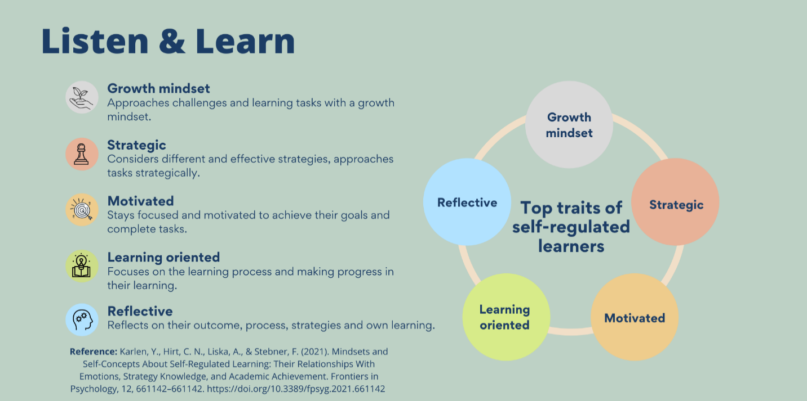
Let’s Reflect: When was a time you approached a learning situation with a fixed mindset? How could you have changed your mindset? You can use the space below to write down your response.
Tip: Save your response and revisit it the next time you are in a similar situation or find yourself stuck in a fixed mindset. How can you use this response to help you change your mindset?
Resources: Want to learn more about growth mindset?
- Reading: A false growth mindset: https://www.theatlantic.com/education/archive/2016/12/how-praise-became-a-consolation-prize/510845/
- Activity: University 101: Study, Strategize and Succeed by Kwantlen Polytechnic University is licensed under a Creative Commons Attribution-ShareAlike 4.0 International License, except where otherwise noted.
- Activity: Growth & Goals: a module for any context, designed to develop learning skills by Alison Flynn; Elizabeth Campbell Brown; Emily O'Connor; Ellyssa Walsh; Fergal O'Hagan; Gisèle Richard; and Kevin Roy is licensed under a Creative Commons Attribution-NonCommercial-ShareAlike 4.0 International License, except where otherwise noted.

Sources:
Dweck, Carol. “What having a growth mindset actually means”.
https://hbr.org/2016/01/what-having-a-growth-mindset-actually-means

University 101: Study, Strategize and Succeed by Kwantlen Polytechnic University is licensed under a Creative Commons Attribution-ShareAlike 4.0 International License, except where otherwise noted.

Gross-Loh, Christine. “How Praise Became a Consolation Prize” https://www.theatlantic.com/education/archive/2016/12/how-praise-became-a-consolation-prize/510845/

Growth & Goals: a module for any context, designed to develop learning skills by Alison Flynn; Elizabeth Campbell Brown; Emily O'Connor; Fergal O'Hagan; Gisèle Richard; and Kevin Roy is licensed under a Creative Commons Attribution-NonCommercial-ShareAlike 4.0 International License, except where otherwise noted.

Mindshift. “Carol Dweck Explains The 'False' Growth Mindset That Worries Her”
https://www.kqed.org/mindshift/47160/carol-dweck-explains-the-false-growth-mindset-that-worries-her

National Education Association. “Impact of Poverty on Students: All in Their Minds?” https://www.nea.org/advocating-for-change/new-from-nea/impact-poverty-students-all-their-minds

Pedagogy that Aids Transition for Higher-Ed Students by PATHS, York University is licensed under a Creative Commons Attribution-NonCommercial-ShareAlike 4.0 International License. If you reuse this work, please attribute PATHS, York University and include a link to https://www.yorku.ca/health/project/pat/

