Formative Mid-Term Self and Peer Evaluation Tool
Estimated time: 4 minutes
What is a formative peer evaluation?
Feedback is an important part of your development as a university student and learner, and later, as a professional. A formative evaluation of your team members is intended to help your team improve performance by providing constructive feedback to your teammates.
When we receive and provide feedback, we have an opportunity to leverage new information to improve our performance, make important changes, and learn in the process.
A formative evaluation means that your team members have an opportunity to work on certain areas and make changes before a formal evaluation is made about their performance. For example, before they receive a final grade.
Instructions
In the following sections, you will write the names of each of your team members and evaluate each member against the criteria provided. You can add a new column if you have more team members.
Based on your evaluation, you can provide a short constructive feedback. It is important that you aim to be consistent when evaluating your team members. You should keep your responses confidential and follow any additional steps based on your instructors' direction for this activity.
Image. Five tips for peer feedback

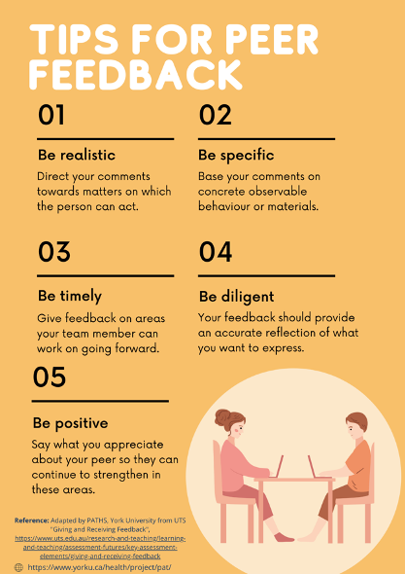

Chart. Formative mid-term evaluation tool
Evaluation Criteria  Evaluate your team members by identifying the extent (Always, Usually, Sometimes, Rarely, Never) to which they achieve the following criteria. |  | Consider the evaluation criteria and provide a short constructive comment for each member, accordingly.
 |  | Team member: | Team member: | Team member: | Team member:
Contributes meaningfully to team discussions | Participates actively and contributes meaningfully to the discussion by coming prepared to meetings, completing assigned tasks in time, building on existing ideas during discussion and suggesting solutions.
Contributions outside of team meetings | Completes their fair share of work on time, updates team on progress, is open to feedback, and is willing to support/help team members improve their work as well.
Facilitates teamwork | Facilitates discussions and promotes cooperation by encouraging others to share their ideas.
Fosters team climate | Displays a positive attitude (e.g., used positive tone and body language), is polite towards others, is constructive in communication (able to give and receive constructive feedback), and actively listens to others.
Manages direct/ indirect conflict | Responds to conflict directly and constructively, helps to manage/resolve conflict in ways that strengthens the overall team cohesiveness and subsequent effectiveness.

Source
Adapted by PATHS, York University from the Association of American Colleges and Universities (AAC&U) Teamwork VALUE Rubric (retrieved from https://www.aacu.org/value-rubrics). This derivative work is licensed under CC BY-NC-SA 4.0.

Pedagogy that Aids Transition for Higher-Ed Students by PATHS, York University is licensed under a Creative Commons Attribution-NonCommercial-ShareAlike 4.0 International License. If you reuse this work, please attribute PATHS, York University and include a link to https://www.yorku.ca/health/project/pat/

