Learn more: What do high-performing teams look like? | PATHS Teamwork Series

Learning outcomes:

After you complete this lesson, you will be able to:
- List key characteristics commonly found in high performing teams
- Discuss strategies to promote psychological safety

- Listen and learn here: https://anchor.fm/patclassroom/episodes/Episode-I--What-High-Performing-Teams-Look-Like-e185q5t

Access the transcript here: https://ecampusontario.pressbooks.pub/app/uploads/sites/2295/2022/01/H5P-What-High-Performing-Teams-Look-Like.docx

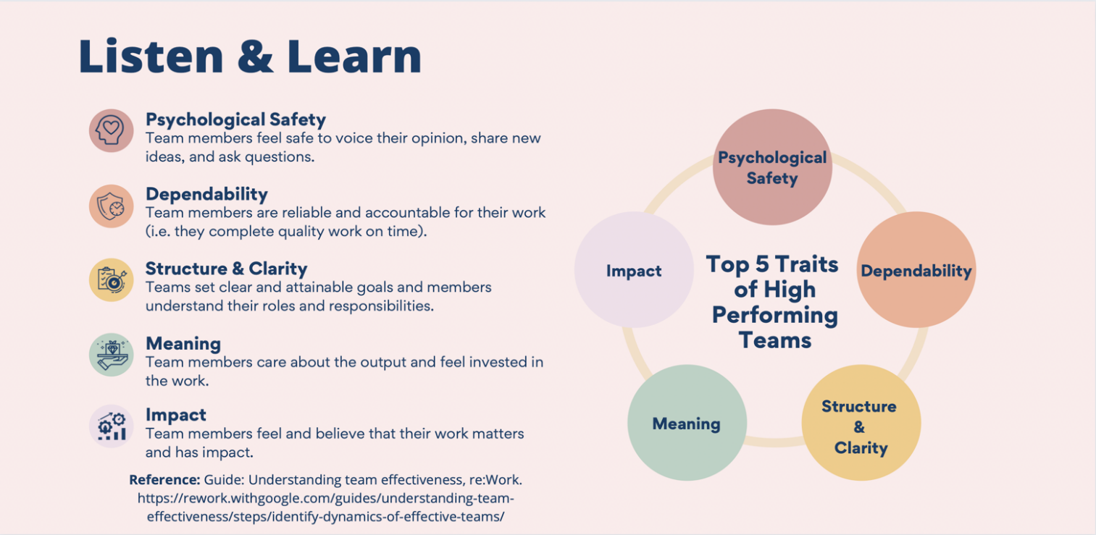

- Check your knowledge:
When there is an unclear decision-making process or lack of rationale for the work being done, this may suggest the team lacks _______.
- Meaning
- Dependability
- Psychological safety
- Impact
- Structure and clarity
Answer: C

- Watch: Building a psychologically safe workplace

Pedagogy that Aids Transition for Higher-Ed Students by PATHS, York University is licensed under a Creative Commons Attribution-NonCommercial-ShareAlike 4.0 International License. If you reuse this work, please attribute PATHS, York University and include a link to https://ecampusontario.pressbooks.pub/paths/

