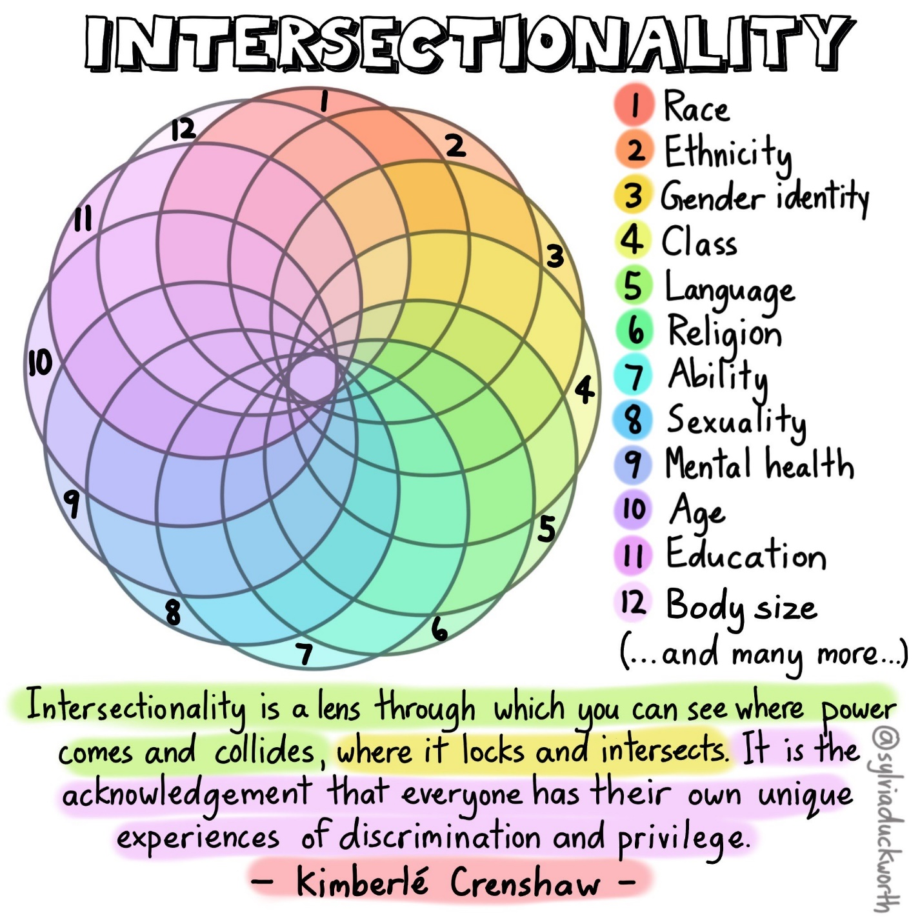
In the graphic above, Sylvia Duckworth uses a Spirograph to illustrate the multitude of ways that social identities might intersect. The Spirograph is split into 12 overlapping circles, each numbered, connected to a specific social identity, and assigned a unique colour. To illustrate the intersections of the different social identities, where each circle intersects, a new shade of the original colour is visible (as would happen when mixing paint colours together). At a glance the graphic shows all colours of the rainbow in different shades. The 12 social identities listed are: race, ethnicity, gender identity, class, language, religion, ability, sexuality, mental health, age, education, and body size. A quote from Kimberlé Crenshaw appears beneath the spirograph that reads “Intersectionality is a lens through which you can see where power comes and collides, where it locks and intersects. It is the acknowledgement that everyone has their own unique experiences of discrimination and privilege.”

