"Developing Your Teaching Dossier" Institutional Guide

Table of Contents

[Click on any items below to jump to the page. Return to the Table of Contents by clicking on the link in the footer.]

About the "Developing Your Teaching Dossier" Series 2
The Series Project Team 2
Our Series Priorities 3

"Developing Your Teaching Dossier" Series Content and Storage 4

Using the "Developing Your Teaching Dossier" Series 5
Level 1 Module Combination 6
Level 2 Section Grouping 8
Level 3 Content Customization 10

Tips for Using H5P Content in Your LMS 11
Tip 1 Add Navigation Instructions 11
Tip 2 Organize the Pages in Groups (Modules or Folders) 12
Tip 3 Provide Framing or Prompts 12
Bonus Tip! Address Possible Usability Issue(s) 14

Embedding the Series 17
Blackboard Learn LMS Embed Instructions in 3 Steps 18
Canvas LMS Embed Instructions in 3 Steps 21
D2L Brightspace LMS Embed Instructions in 3 Steps 23
Moodle LMS Embed and LTI Instructions in 3 Steps 26
Sakai LMS Embed Instructions in 3 Steps 35

Customizing the Content 40
Getting Started: Create an eCampusOntario H5P Studio Account 40
Reusing H5P Content in 3 Steps 41

Appendix A: "Developing Your Teaching Dossier" Series Embed Codes 45
Appendix B: "Developing Your Teaching Dossier" Series Hyperlinked Resources 54
Appendix C: "Developing Your Teaching Dossier" Series Embedded Videos 70
Appendix D: Sample Series Customization Demonstration: Certification of Completion 75

About the "Developing Your Teaching Dossier" Series

The "Developing Your Teaching Dossier" series is a four-module series for graduate students and post-doctoral fellows exploring strategies to reflect on their teaching and develop their teaching dossier. The four 60-minute self-paced asynchronous modules are as follows:

- Module 1: Reflecting on Your Teaching Experience: An Introduction to Teaching Dossiers
- Module 2: Articulating Your Teaching Values and Practices: Developing Your Statement of Teaching Philosophy
- Module 3: Connecting Narratives and Evidence: Developing Components of Your Teaching Dossier
- Module 4: Looking Ahead: Telling New Stories About Our Teaching Experiences

This open-access resource under a Creative Commons Attribution-NonCommercial-ShareAlike 4.0 International (CC BY-NC-SA 4.0) License was co-developed by five institutional partners—Ryerson (X) University, University of Toronto, University of Waterloo, University of Windsor, and Western University—using H5P Studio offered through eCampusOntario. This project is made possible with funding by the Government of Ontario and through eCampusOntario's support of the Virtual Learning Strategy. To learn more about the Virtual Learning Strategy, visit https://vls.ecampusontario.ca.

The Series Project Team

Project Leads
Cristina D'Amico, University of Toronto
Michal Kasprzak, University of Toronto

Project Coordinator
Samantha Chang, University of Toronto

Multimedia Developer
Katarzyna Kochany, University of Toronto

E-Learning and Multimedia Assistant
Graeme Noble, University of Toronto

Subject Matter Experts
Lisa Aikman, Western University
Kristin Brown, University of Waterloo
Alexa Clerke, Western University
Amber Grant, Ryerson (X) University
Elizabeth Ismail, University of Windsor
Erika Kustra, University of Windsor
Sara Mazrouei, Ryerson (X) University
Karyn Olsen, Ryerson (X) University
Toben Racicot, University of Waterloo
Jessica Raffoul, University of Windsor
Nada Savicevic, Ryerson (X) University
Svitlana Taraban-Gordon, University of Waterloo

The project team would like to acknowledge the expertise and support of our colleagues from our five institutions who contributed samples and piloted, reviewed, and provided feedback throughout the project.

Ryerson University renaming process: In August 2021, the university announced that it would begin a renaming process to address the legacy of Egerton Ryerson and build a more inclusive future. Let's write the next chapter together. ryerson.ca/next-chapter

Our Series Priorities

The "Developing Your Teaching Dossiers" series is designed and developed to welcome diverse users, perspectives, and experiences (work and lived experiences). In doing so, the series offers multiple ways for educators and learners to engage with the material through recognition of diverse pathways, various modes of content presentation, and multiple forms of reflection and expression.

Read more about how the series project team increased the accessibility and usability of this open educational resource.

Recognition of Diverse Pathways

- The series includes diverse users, perspectives, and experiences (work and lived experiences) through collaborations with members across five institutions.
- The series content is developed by graduate students and educational developers and reviewed by graduate students, post-doctoral fellows, educational developers, career educators, administrative staff, and faculty members.
- Samples and examples are collected from current graduate students (MAs and PhDs), recent graduates, and post-doctoral fellows from various disciplines, institutions, and communities.
- Bonus resources are provided to support further exploration and development.

Various Modes of Content Presentation

- Text content is presented via H5P interactive books and downloadable as recap documents in PDF and DOCX formats.
- Images are accompanied by alternative texts and described in the main text where appropriate.
- Videos are closed captioned and transcripts in PDF and DOCX formats are available for download.
- The series is accompanied by a glossary, in PDF and DOCX formats, that defines key terms and offers instructions for H5P features.

Multiple Forms of Reflection and Expression

- Users are invited to participate in reflections throughout the series in multiple formats.
- Users who prefer interacting within the H5P interface can type their reflections and notes, and export and save their text as a Word document through the H5P documentation tool.
- Users can also document their reflections and notes as a text document on their computer or as written texts on paper or in a notebook.
- Users are also prompted to engage with their reflection through audio recordings on their device (phone, computer, etc.) and conversations with colleagues, peers, friends, or family members.

"Developing Your Teaching Dossier" Series Content and Storage

Each module in the series is composed of five sections—a Getting Started (common element) section, three body sections, and a module summary (with a Certificate of Completion*). Each section is contained in the form of an H5P interactive book. H5P stands for HTML 5 Package and is an open-source authoring tool. The H5P interactive books are hosted on H5P Studio offered through eCampusOntario.

H5P interactive books can be embedded into each institution's learning management system (LMS) and customized through the H5P reuse function. Each H5P interactive book contains text content (including reference lists), hyperlinked resources, and embedded videos. All elements are included when embedding an H5P interactive book. If you discover broken links, refer to the table below for guidance.

H5P Interactive Book | All H5P interactive books are stored on the eCampusOntario H5P Studio website. Refer to Appendix A for the embed codes of each interactive book.
Text Content | Text content is included when embedding the H5P interactive books. Resources developed by the project team are hyperlinked within each interactive book. Note: Reference lists are not hyperlinked due to concerns about changing URLs. Exceptions are made for the three websites on the "Which land do you teach and learn on" page in the "Getting Started: Welcome to Teaching Dossier Training!" section.
Hyperlinked Resources | Hyperlinked resources in the H5P interactive books are developed by the project team and stored on an eCampusOntario Pressbooks account. The resources are included when embedding the H5P interactive books. In the rare instance when there is a broken link, refer to Appendix B for the URL of each resource.
Embedded Videos | All embedded videos in the H5P interactive books are developed by the project team and stored on the University of Toronto's Centre for Teaching Support & Innovation's YouTube account. The videos are included when embedding the H5P interactive books. In the rare instance when there is a broken video link, refer to Appendix C for the URL of each video.

Besides the H5P interactive book, the "Developing Your Teaching Dossier" series uses three other H5P content types—the accordion, documentation tool, and multiple choice. Download the Developing Your Teaching Dossier Series Glossary (PDF | DOCX) for an introduction to the interactive H5P tools used throughout the series. Further guidance is available via the H5P.org website.

*The Certificate of Completion is a self-serve fillable PDF with no tracking and reporting capabilities. Institutions may want to use their own system for managing training progress and completion. Refer to Appendix D for a sample customization demonstration on removing the self-serve Certificate of Completion from the modules.

Using the "Developing Your Teaching Dossier" Series

The "Developing Your Teaching Dossier" series can be adapted into your current and future graduate student and post-doctoral fellow professional development programming in several ways. There are three levels of customization.

Level 1  Module Combination | Use one or several modules and integrate them into your programming. Each module is composed of five H5P interactive books. Consult the Level 1 Module Combination table below for ideas about which modules to include in your programming.
Level 2  Section Grouping | Use sections of each module and combine them to form a different learning experience. Each section is an H5P interactive book. Refer to Appendix A for the module section titles and embed codes.
Level 3  Content Customization | Customize (add, change, remove) content within each interactive book using the H5P reuse function. Consult the "Customizing the Content "section for instructions and refer to Appendix D for a sample customization demonstration.

Tip: Don't know where to start? Visit our Getting Started: Welcome to Teaching Dossier Training! interactive book for a description of the four modules.

Level 1 Module Combination

Each of the four modules in the series can be integrated into your programing independently or in combination.

For example, in the diagram below, the institution has selected Modules 2 and 3 for their programming. The two modules were chosen because the users have prior knowledge and experience with teaching dossiers and wish to draft or update/revise their dossiers.

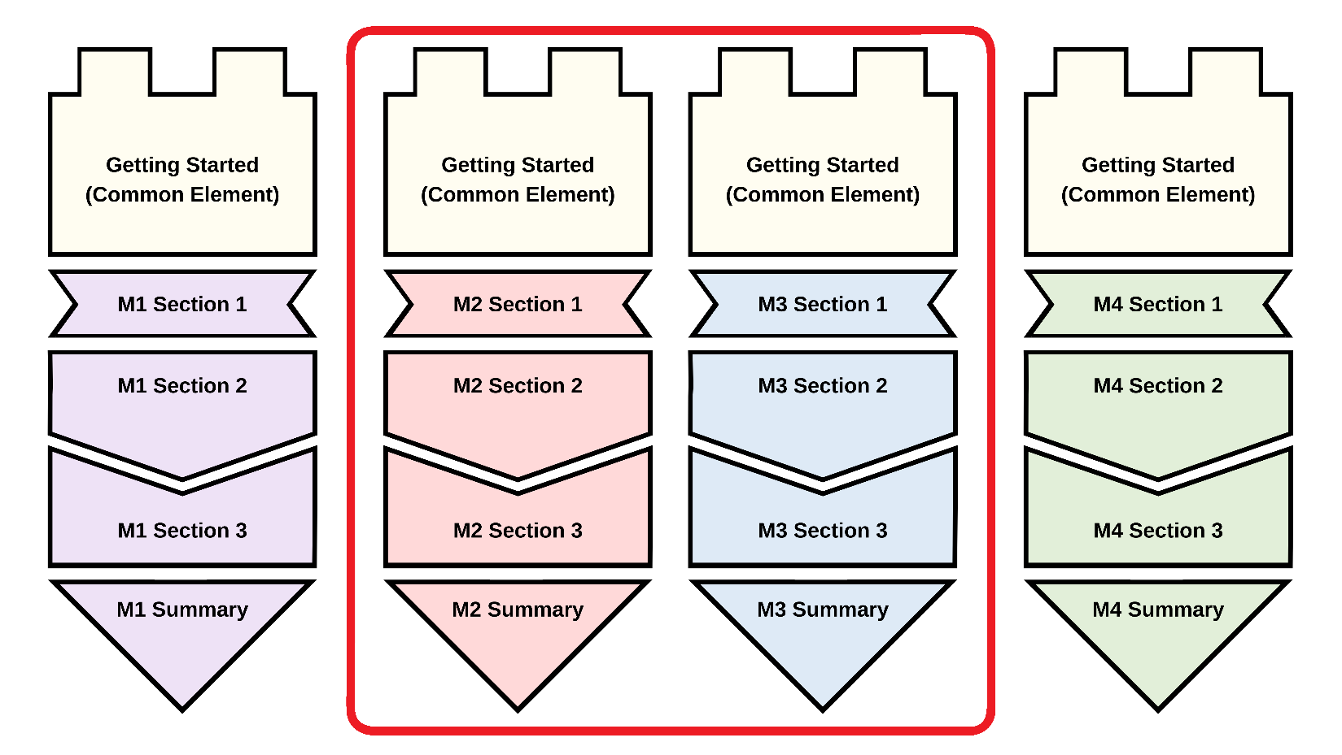

Consult the table on the following page for some module combination ideas that can be integrated into your programming and embedded into your LMS. Remember, every module can be customized to suit your needs!

Refer to the "Embedding the Series" section for LMS-specific embedding instructions. Connect with your institution's LMS support team for additional guidance.

Tip: If you can't decide, why not include all the modules in your programming!

User Context | Module Combination
Has limited prior knowledge and experience with teaching dossiers and has not begun drafting a dossier | - Module 1: Reflecting on Your Teaching Experience: An Introduction to Teaching Dossiers
Has limited prior knowledge and experience with teaching dossiers and has collected artifacts/evidence that can be sorted into each dossier components | - Module 1: Reflecting on Your Teaching Experience: An Introduction to Teaching Dossiers  - Module 3: Connecting Narratives and Evidence: Developing Components of Your Teaching Dossier
Needs to develop a teaching dossier to fulfill their teaching and/or professional development programme requirements | - Module 1: Reflecting on Your Teaching Experience: An Introduction to Teaching Dossiers  - Module 2: Articulating Your Teaching Values and Practices: Developing Your Statement of Teaching Philosophy  - Module 3: Connecting Narratives and Evidence: Developing Components of Your Teaching Dossier
Is interested in reflective writing and/or requires a Statement of Teaching Philosophy | - Module 2: Articulating Your Teaching Values and Practices: Developing Your Statement of Teaching Philosophy
Has some knowledge and experience with teaching dossiers and wishes to draft or update/revise their dossiers | - Module 2: Articulating Your Teaching Values and Practices: Developing Your Statement of Teaching Philosophy  - Module 3: Connecting Narratives and Evidence: Developing Components of Your Teaching Dossier
Is seeking to explore strategies for talking about teaching values and skills in a variety of settings | - Module 2: Articulating Your Teaching Values and Practices: Developing Your Statement of Teaching Philosophy  - Module 4: Looking Ahead: Telling New Stories About Our Teaching Experiences
Is fine-tuning their teaching dossier draft and wishes to strengthen each dossier components | - Module 3: Connecting Narratives and Evidence: Developing Components of Your Teaching Dossier
Is preparing for teaching job applications and interviews and wants to practice strategies for talking about their skills | - Module 3: Connecting Narratives and Evidence: Developing Components of Your Teaching Dossier  - Module 4: Looking Ahead: Telling New Stories About Our Teaching Experiences
Is preparing job applications and interviews and hopes to highlight transferable skills developed through teaching | - Module 4: Looking Ahead: Telling New Stories About Our Teaching Experiences

Level 2 Section Grouping

Pick and choose sections and create a different learning experience. Keep in mind that sections are aligned within each module. New section groupings may disrupt the flow and content revisions may be needed to restore the alignment.

For example, in the diagram below, the institution has selected the following sections to create a "new" module.
- Getting Started (common element)
- Module 1 Section 1
- Module 2 Section 2
- Module 3 Section 2
- Module 4 Section 3
- Module 4 Summary

For this "new" module, the institution may need to expand the learning objectives presented in Module 1 Section 1 and the summary in Module 4 Summary. Further content clarification may help highlight the connections and flow between Module 1 Section 1, Module 2 Section 2, Module 3 Section 2, and Module 4 Section 3.

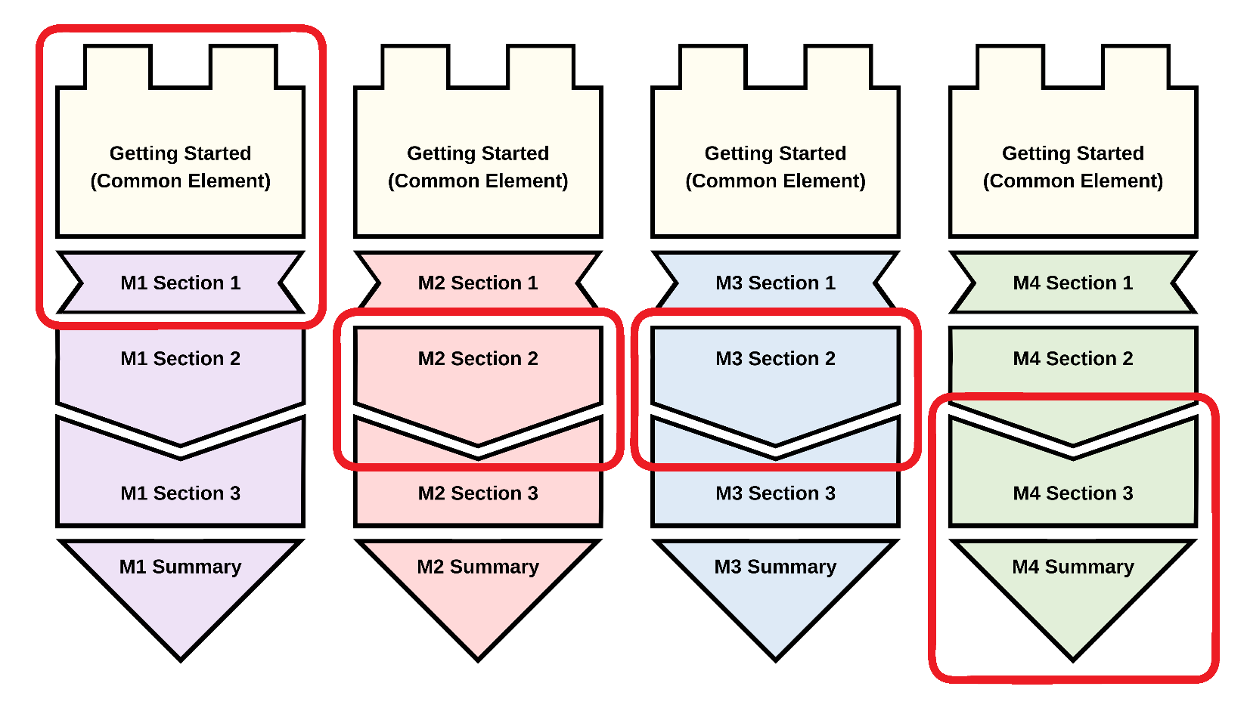

Consult the table on the following page for an overview of all the module section titles. Remember, every section can be customized to suit your needs!

Module 1:  Reflecting on Your Teaching Experience: An Introduction to Teaching Dossiers | Module 2:  Articulating Your Teaching Values and Practices: Developing Your Statement of Teaching Philosophy | Module 3:  Connecting Narratives and Evidence: Developing Components of Your Teaching Dossier | Module 4:  Looking Ahead: Telling New Stories About Our Teaching Experiences
Getting Started:  Welcome to Teaching Dossier Training!  (common element) | Getting Started:  Welcome to Teaching Dossier Training!  (common element) | Getting Started:  Welcome to Teaching Dossier Training!  (common element) | Getting Started:  Welcome to Teaching Dossier Training!  (common element)
Module 1 Section 1:  What Is a Teaching Dossier? | Module 2 Section 1:  What is a Statement of Teaching Philosophy (STP)? | Module 3 Section 1:  Teaching Dossier Components and Alignment | Module 4 Section 1:  Identifying Transferable Teaching Skills
Module 1 Section 2:  Characteristics and Components of a Teaching Dossier | Module 2 Section 2:  Values, Practices, and Evidence | Module 3 Section 2:  Drafting the Dossier Components | Module 4 Section 2:  Aligning Your Teaching and Professional Personas
Module 1 Section 3:  Five-Step Plan for Creating Your Teaching Dossier | Module 2 Section 3:  Completing Your Statement of Teaching Philosophy (STP) | Module 3 Section 3:  Best Practices for Writing Your Dossier | Module 4 Section 3:  Communicating Your Transferable Teaching Skills
Module 1 Summary:  Introduction to Teaching Dossiers | Module 2 Summary:  Developing Your Statement of Teaching Philosophy (STP) | Module 3 Summary:  Developing Components of your Teaching Dossier | Module 4 Summary:  Telling New Stories About Our Teaching Experiences

Refer to the "Customizing the Content" section for step-by-step customization instructions through the H5P reuse function and proceed to the "Embedding the Series" section for LMS-specific embedding instructions. Connect with your institution's LMS support team for additional guidance.

Level 3 Content Customization

Add, change, or remove the content in each page, section, and module using the H5P reuse function. This level of customization allows you to generate unique resources that support the changing needs of your diverse users.

For example, in the diagram below, the institution has decided to adapt the complete series with multiple customizations. The institution has customized the content in the Getting Started (common element) and removed the common element in subsequent modules because users will complete the entire series.

The institution shifted Module 2, with a customized Section 1, to the position of the first module. Users will complete Module 2 first, progress to a new content section developed by the institution, and proceed to Module 1, which features additional activities between Sections 2 and 3. Users then move on to Module 3, which also features additional activities between Sections 2 and 3 and ends with a knowledge check in the Summary section.

Finally, Module 4 begins with a customized Section 1, followed by a bonus programming between Sections 2 and 3. The series concludes with a modified Summary section that features an institution/programme-specific certificate.

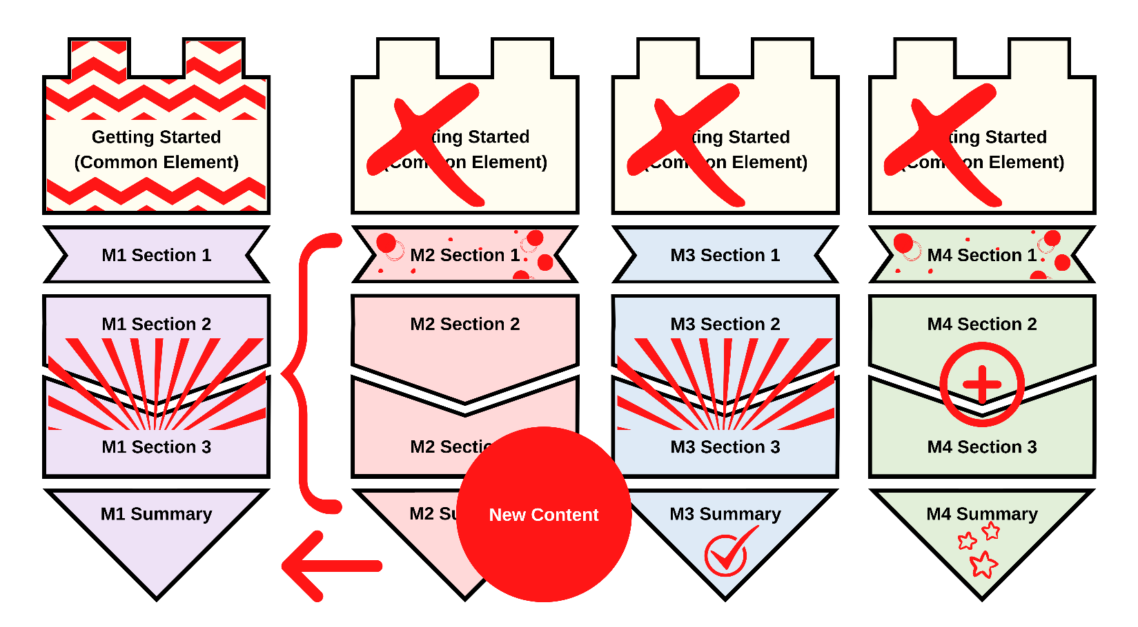

Refer to the "Customizing the Content" section for step-by-step customization instructions through the H5P reuse function. Appendix D features a sample customization demonstration on removing the self-serve Certificate of Completion from the modules.

Tips for Using H5P Content in Your LMS

Tip 1 Add Navigation Instructions

There are many ways to display and navigate between pages within each H5P interactive book. The Getting Started section and the Series Glossary (PDF | DOCX) provide instructions on navigating the interactive book interface. Consider adding additional navigation instructions to help users differentiate between the LMS navigation buttons and the H5P interactive book navigation buttons.

For example, in the D2L Brightspace LMS interface, the LMS's navigation buttons are similar to the H5P interactive book's navigation buttons (both sets of buttons are highlighted in a red box in the screenshot below). The similarity in both sets of navigation buttons will confuse users. Provide additional instructions and clarifications for users to navigate from page to page and section to section.

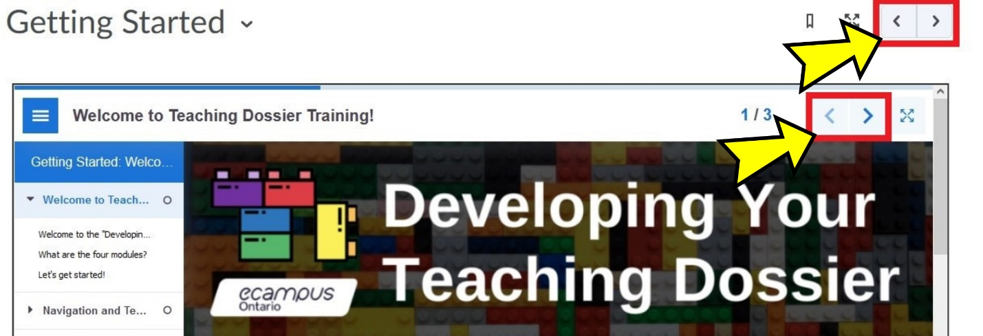

In the Canvas LMS interface, the institution added instructions for users to click "Next" in the bottom-right to proceed to the next section of the module (highlighted in a red box in the screenshot below). Provide clarification about how many pages users should have reviewed before proceeding to the next section.

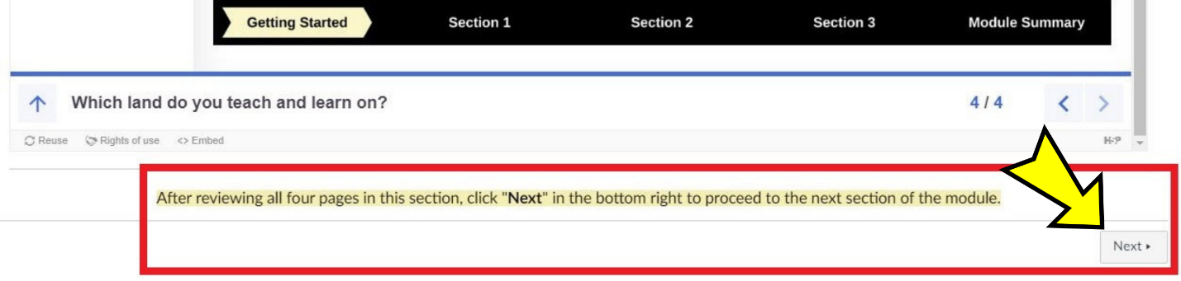

Tip 2 Organize the Pages in Groups (Modules or Folders)

Consider organizing the various sections of the "Developing Your Teaching Dossier" series in groups or folders, depending on the capability of your LMS.

For example, each module section has been embedded on a Canvas page in the Canvas LMS. The Canvas LMS module function can organize the five pages into one module that sequentially guides users through the materials (screenshot below).

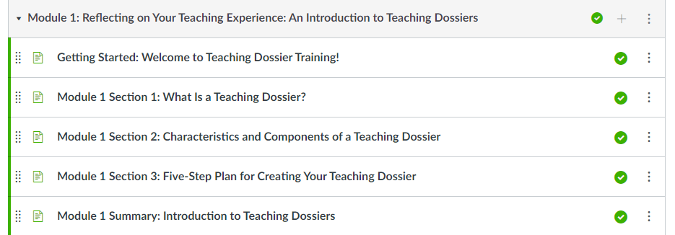

Consult your LMS guide for guidance on organizing pages and materials to enhance the user experience.

Tip 3 Provide Framing or Prompts

Institutions can provide additional framing or prompt on each LMS page to help situate the "Developing Your Teaching Dossier" series within your programming.

Some framing or prompt ideas include:
- Clarifying expectations on how users should complete the module(s);
- Introducing how the module(s) will be used in conjunction with a workshop or training programme; or
- Prompting users to save their notes throughout the module(s) for a range of objectives: to bring to a follow-up session, to share with colleagues in a peer-review context, to submit as proof of completion, etc.

For example, an institution may be conducting a multi-week summer programme focused on developing the Statement of Teaching Philosophy. For this summer programme, the institution embedded Module 2 in their LMS, as shown in the screenshot below.

On top of the embedded Module 2 H5P interactive book, the institution provided a brief introduction that outlines the programme length and objectives, highlights the training checklist, and offers contact information for support.

A training checklist is to the right of the embedded Module 2 H5P interactive book. The training checklist signals that users should download and save their Module 2 reflection responses because they will need the reflection responses for the Week 2 writing session. The checklist offers insight into how the Module 2 content relates to the summer programming structure.

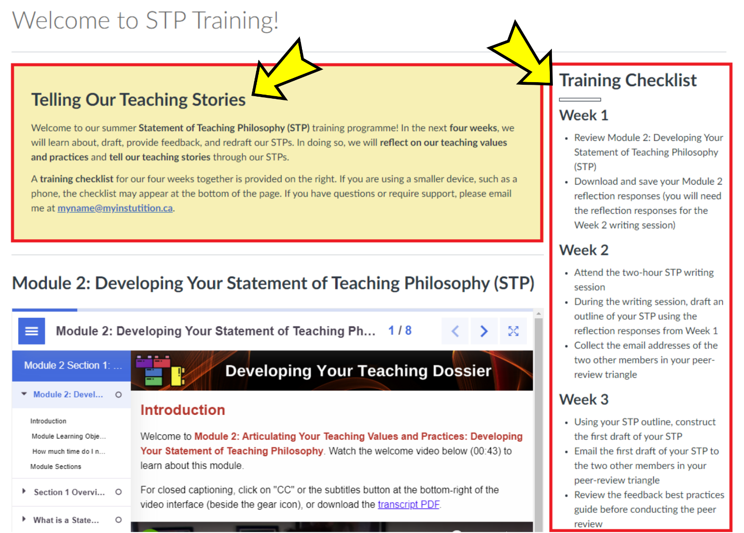

Bonus Tip! Address Possible Usability Issue(s)

In addition to adding navigation instructions (Tip 1), support your users by addressing possible usability issue(s).

We have flagged two possible usability issues on the following pages:
- inner (or double) scrollbars and
- hidden navigation menu.

In addition to the two possible usability issues listed above, H5P content may appear or function differently depending on the type and version of your LMS. Keyboard navigation in the H5P interactive book interface may be disorienting for some users because the H5P navigation is treated as a web app.

Connect with your institution's LMS and accessibility support teams for further tips and guidance on using H5P content in your LMS.

Check the forums on the H5P.org website for further guidance on working with H5P content.

Inner or Double Scrollbars

When embedding H5P interactive books into an LMS page, inner (or double) scrollbars may appear (highlighted in a red box in the screenshot below).

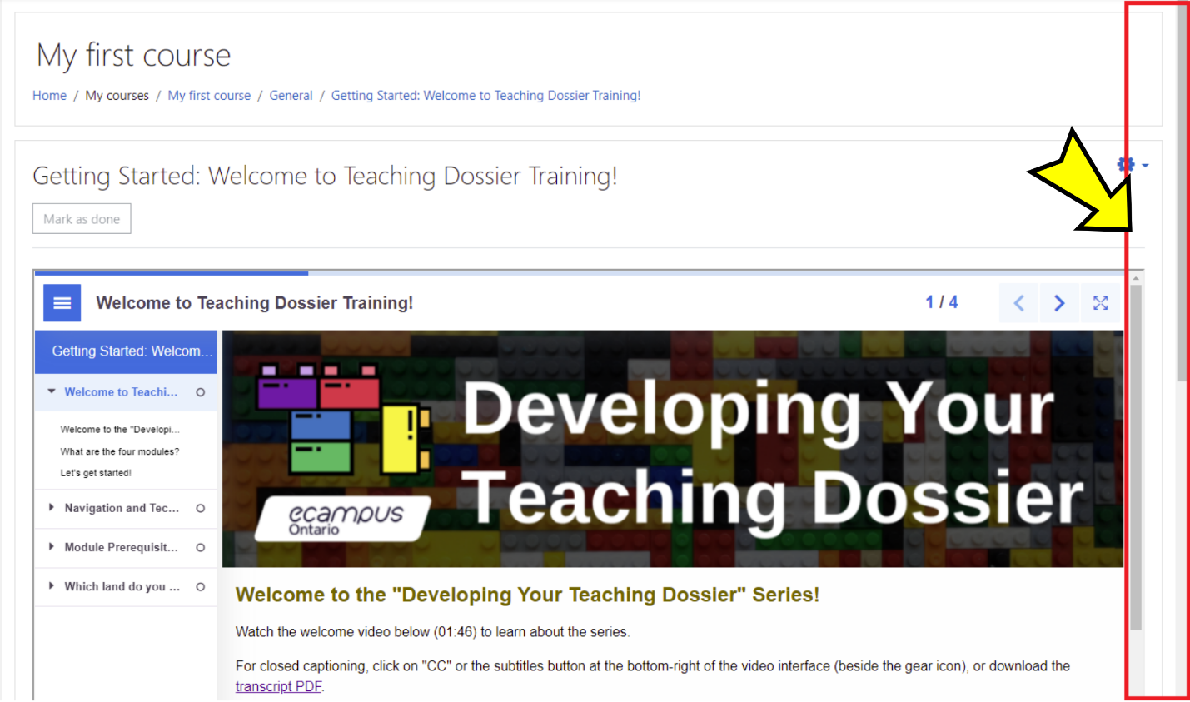

Consider including instructions making users aware of the multiple scrollbars and offer guidance on navigating the scrollbars.

The alternate H5P embed codes provided in Appendix A attempt to address the scrollbar issue by setting a height of 2750px. Depending on the page length of the H5P interactive book, this method may produce large areas of white space beneath the embedded H5P interactive book. If the interactive book page length is shorter, institutions can adjust both instances of height=" 2750px" to minimize white space below the interactive book.

Note: If your institution's LMS (for example, Moodle) has set up the Learning Tools Interoperability (LTI) integration with H5P, use the LTI method for a more seamless integration of H5P interactive books without inner (or double) scrollbars. Connect with your institution's LMS support team for guidance.

Hidden Navigation Menu

The left-hand navigation menu may be hidden when embedding H5P interactive books into an LMS page, as shown in the screenshot below. The hidden navigation menu may cause some confusion for users.

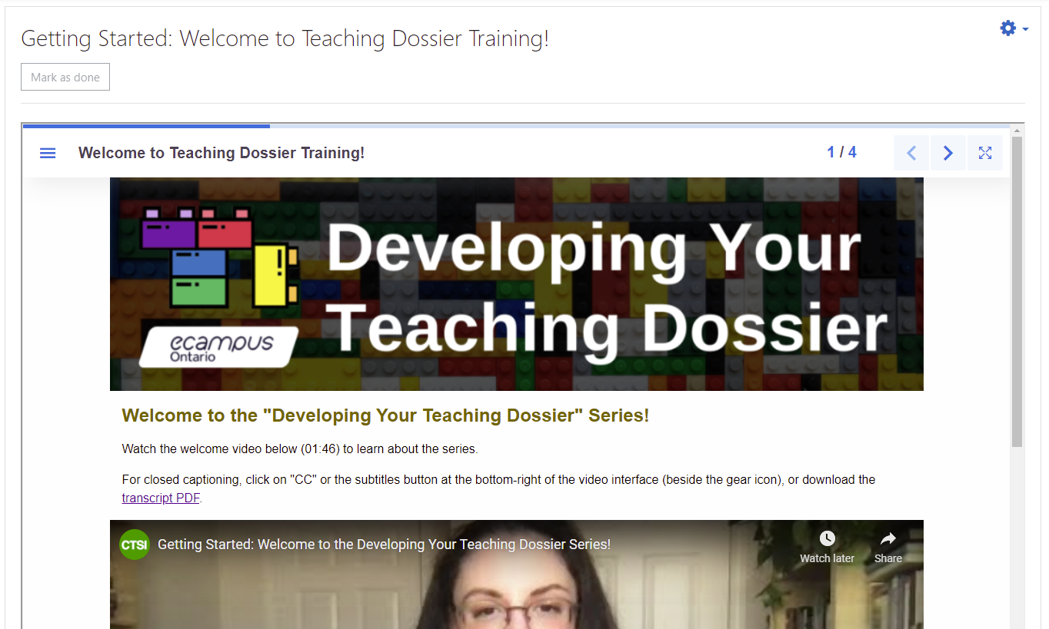

Consider adding instructions on how to open and close the left-hand navigation menu.

For example, click the three short horizontal lines in the top-left corner of the H5P interactive book (highlighted in a red box in the screenshot below) to open the left-hand navigation menu.

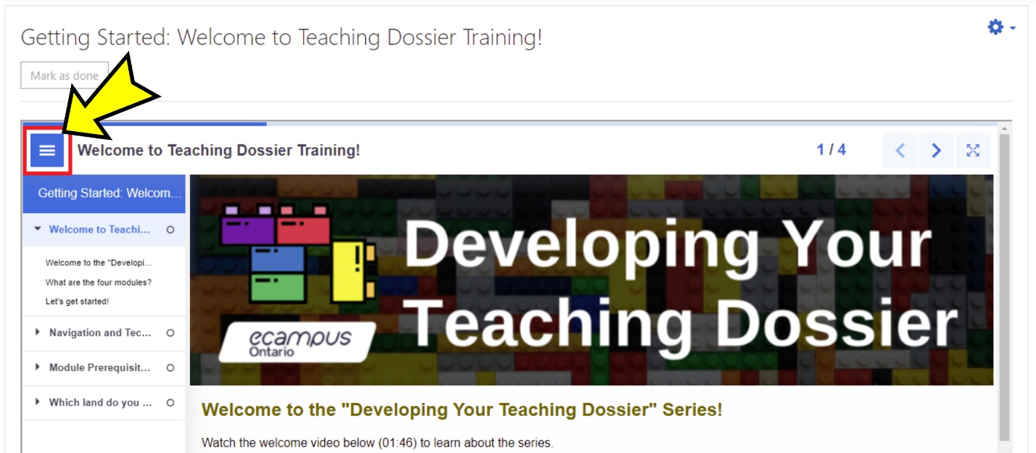

Embedding the Series

Each module in the series is composed of five H5P interactive books, which can be embedded into any page wherever the HTML editor is available within your LMS. The three steps to embedding H5P content are as follows:

- Step 1: Copy the H5P embed code (available from Appendix A).
- Step 2: Locate the HTML editor in your LMS.
- Step 3: Paste the H5P embed code and save/publish the content.

Consult your LMS guide and locate the detailed instructions for embedding HTML content. Our team has provided screenshots of several LMSs below. Connect with your institution's LMS support team if you experience difficulties with any of these steps.

- Blackboard Learn LMS
- Canvas LMS
- D2L Brightspace LMS
- Moodle LMS
- Sakai LMS

Depending on the structure of your LMS and how you plan to use this open-access resource, you may want to provide additional guidance for your users. Refer to the "Tips for Using H5P Content in Your LMS" section for ideas.

Tip: Experiment with the embed codes. Different versions of the LMS may display different embed results. Connect with your institution's LMS support team for further tips and guidance.

Blackboard Learn LMS Embed Instructions in 3 Steps

Step 1: Copy the Embed Code

Copy the section embed code from Appendix A. The embed code should start with <p style= and end with </p>. The embed codes have been optimized to respond to the user's display.

Note: Some versions of the Blackboard Learn LMS may require a modified embed code. We have provided alternate embed codes in Appendix A. The alternate embed codes have a set height of 2750 pixels. If the interactive book page length is shorter, institutions can adjust both instances of height=" 2750px" to minimize white space below the interactive book.

H5P Embed Code Example
<p style="max-width: 100%; height: 2750px;"><iframe src="https://h5pstudio.ecampusontario.ca/h5p/27474/embed" width="100%" height="2750px" allowfullscreen="allowfullscreen"></iframe></p>

Step 2: Open the HTML Source Code Panel in a Blackboard Item

Open a Blackboard item and click the "< >" or "HTML" button (highlighted in a red box in the screenshot below) to open the HTML source code panel.

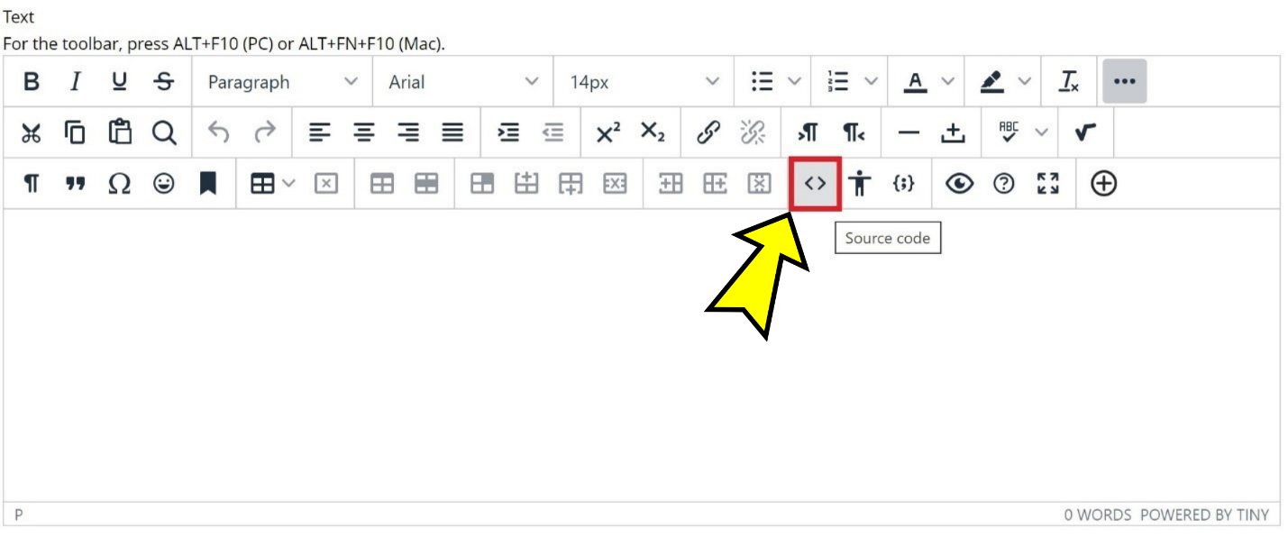

Step 3: Paste the Embed Code in the HTML Source Code Panel, Save, and Submit

Paste the embed code in the HTML editor. Click the "Save" button at the bottom of the HTML source code panel (highlighted in a red box in the screenshot below).

Note: What is on the screen after clicking "Save" may not be the final result.

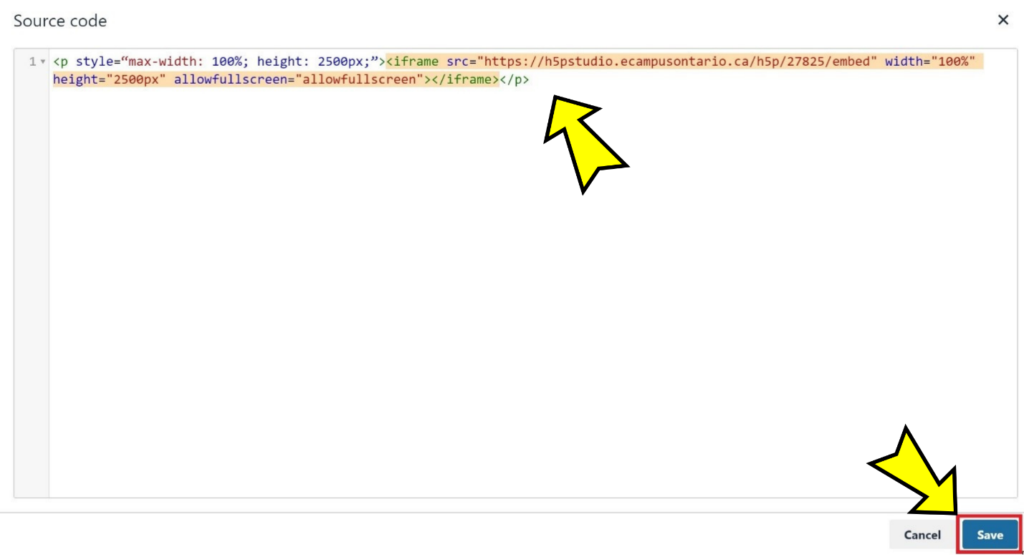

Click the "Submit" button (highlighted in a red box in the screenshot below) on the Blackboard item to view the final result.

Et voilà!

The H5P interactive book is now embedded in a Blackboard item (screenshot below). Refer to the "Tips for Using H5P Content in Your LMS" section for some tips on enhancing user experience.

Note: Some versions of the Blackboard Learn LMS do not display the H5P interactive book fullscreen button.

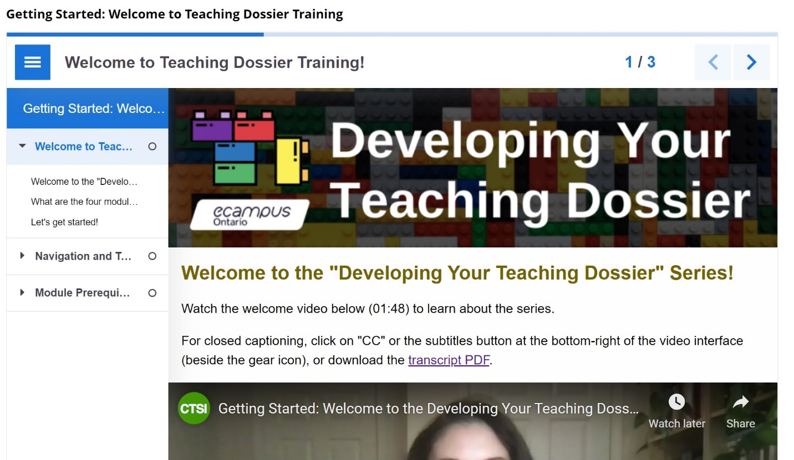

Canvas LMS Embed Instructions in 3 Steps

Step 1: Copy the Embed Code

Copy the section embed code from Appendix A. The embed code should start with <p style= and end with </p>. The embed codes have been optimized to respond to the user's display.

H5P Embed Code Example
<p style="max-width: 100%; height: 100vh;"><iframe src="https://h5pstudio.ecampusontario.ca/h5p/27474/embed" width="100%" height="100%" allowfullscreen="allowfullscreen"></iframe></p>

Step 2: Enable the HTML Editor in a Canvas Page

Open a Canvas page and click the "</>" button near the bottom-right (highlighted in a red box in the screenshot below) to enable the HTML editor.

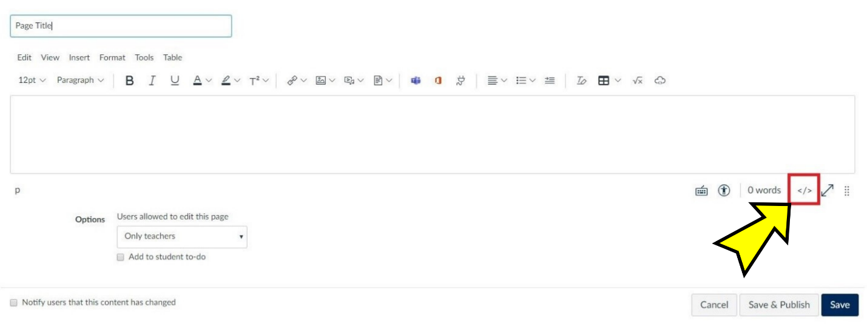

Step 3: Paste the Embed Code in the HTML Editor and Save

Paste the embed code in the HTML editor. Click the "Save" or "Save & Publish" button (highlighted in a red box in the screenshot below) to save and view the result.

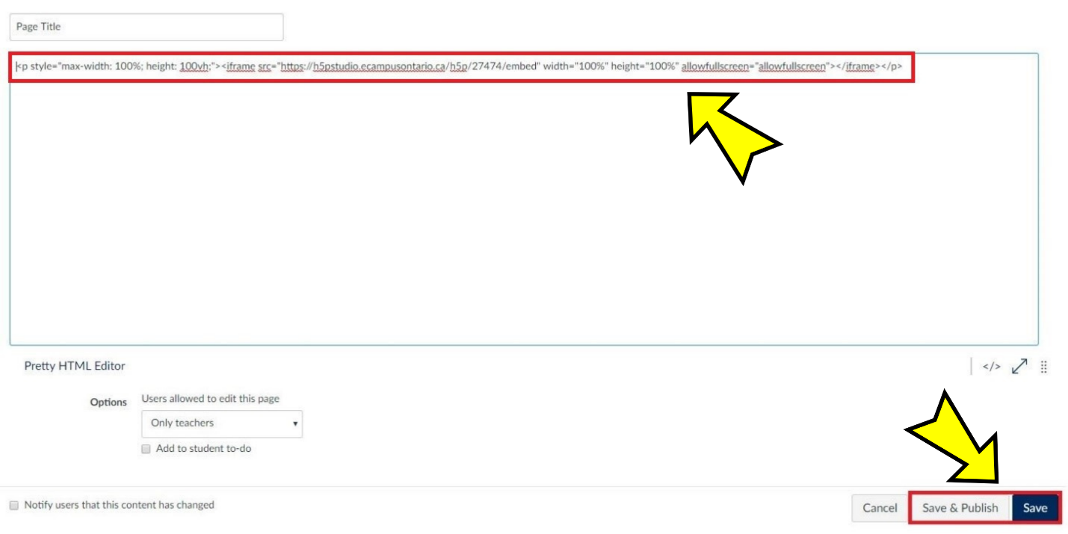

Et voilà!

The H5P interactive book is now embedded in a Canvas page (screenshot below). Refer to the "Tips for Using H5P Content in Your LMS" section for some tips on enhancing user experience.

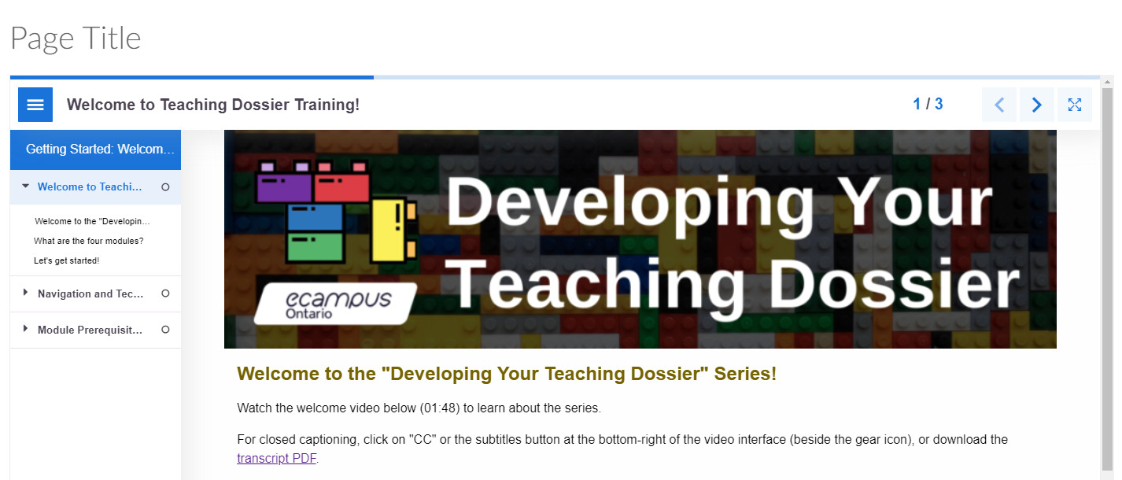

D2L Brightspace LMS Embed Instructions in 3 Steps

Step 1: Copy the Embed Code

Copy the section embed code from Appendix A. The embed code should start with <p style= and end with </p>. The embed codes have been optimized to respond to the user's display.

H5P Embed Code Example
<p style="max-width: 100%; height: 100vh;"><iframe src="https://h5pstudio.ecampusontario.ca/h5p/27474/embed" width="100%" height="100%" allowfullscreen="allowfullscreen"></iframe></p>

Step 2: Enable the HTML Source Editor in a Brightspace Page

Open a Brightspace page and click the click the "</>" button near the bottom-right (highlighted in a red box in the screenshot below) to enable the HTML Source Editor.

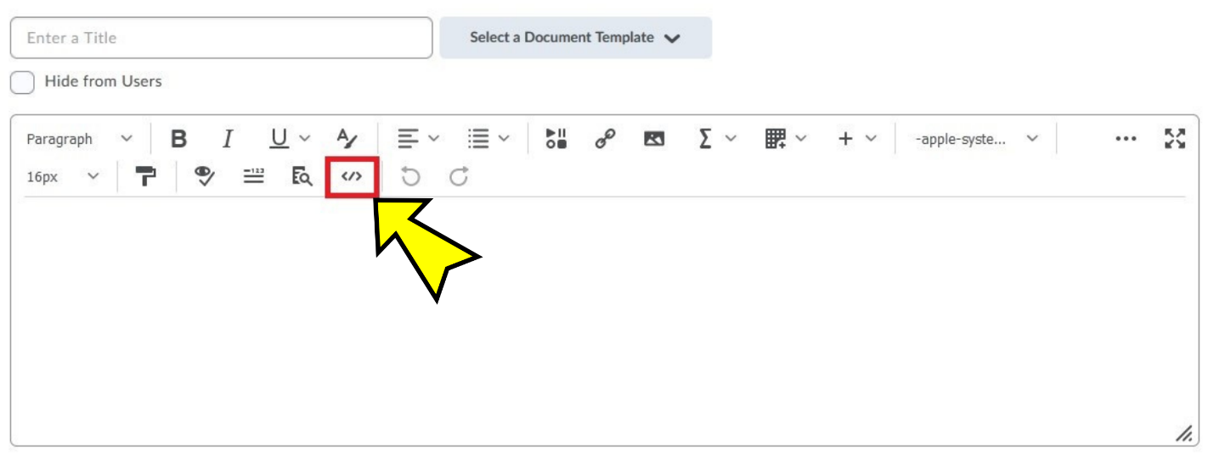

Step 3: Paste the Embed Code in the HTML Source Editor and Save

Paste the embed code in the HTML editor (highlighted in a red box in the screenshot below). Click the "Save" button (highlighted in a red box in the screenshot below) to save and view the result.

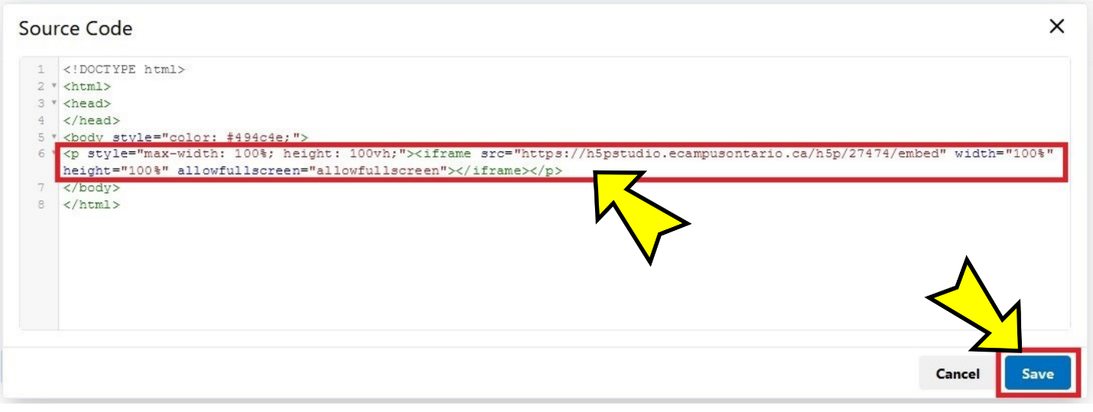

Enter a title (highlighted in a red box in the screenshot below) and click the "Save" button (highlighted in a red box in the screenshot below) to finalize the embedding.

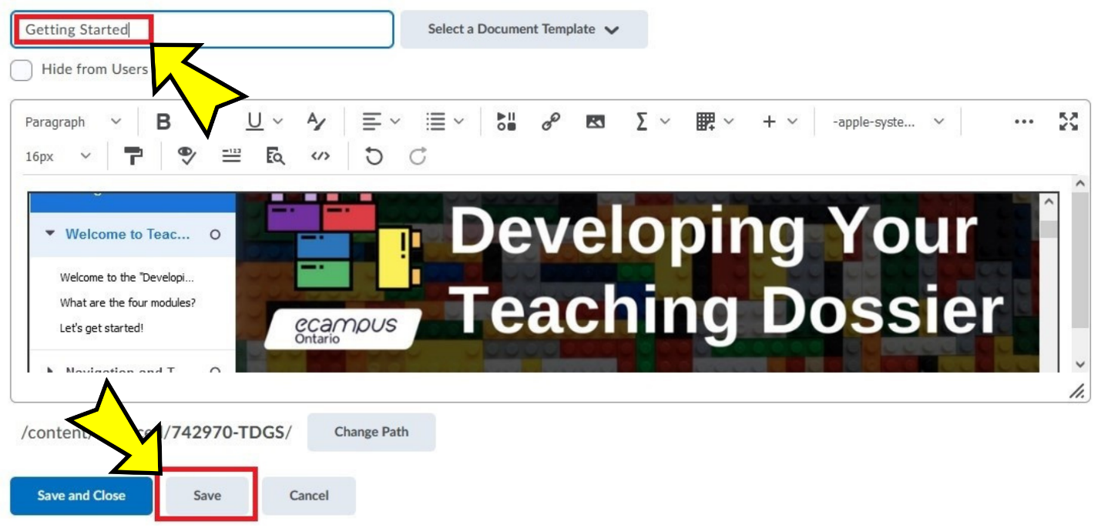

Et voilà!

The H5P interactive book is now embedded in a Brightspace Page (screenshot below). Refer to the "Tips for Using H5P Content in Your LMS" section for some tips on enhancing user experience.

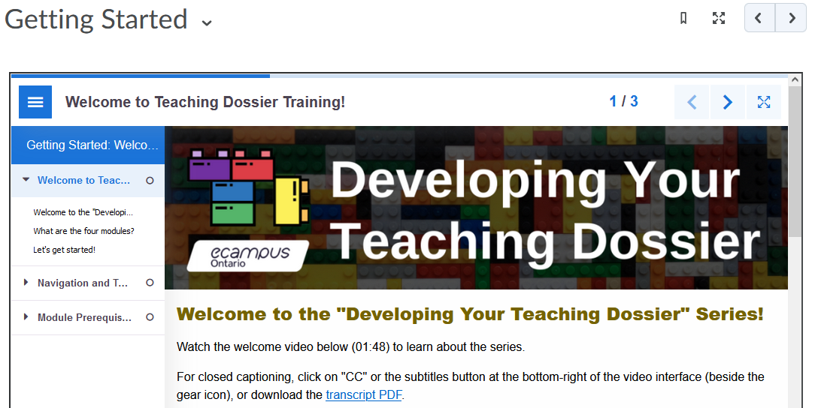

Moodle LMS Embed and LTI Instructions in 3 Steps

There are two methods for incorporating H5P content in the Moodle LMS:
- embedding with H5P embed codes (see below), or
- integrating through the Learning Tools Interoperability (LTI).

Explore both the embed and LTI methods below. The LTI method offers a more seamless integration.

Note: Not all Moodle LMS versions have set up the LTI integration. Connect with your institution's LMS support team for guidance.

Embed Step 1: Copy the Embed Code

Copy the section embed code from Appendix A. The embed code should start with <p style= and end with </p>. The embed codes have been optimized to respond to the user's display.

H5P Embed Code Example
<p style="max-width: 100%; height: 100vh;"><iframe src="https://h5pstudio.ecampusontario.ca/h5p/27474/embed" width="100%" height="100%" allowfullscreen="allowfullscreen"></iframe></p>

Embed Step 2: Enable the HTML Source Editor in a Moodle Page

Click the "Turn editing on" button (highlighted in a red box in the screenshot below) to enable editing.

Click the "+ Add an activity or resource option" function (highlighted in a red box in the screenshot below) to create a new Moodle page.

Select the "Page" option (highlighted in a red box in the screenshot below) from the "Add an activity or resource" menu.
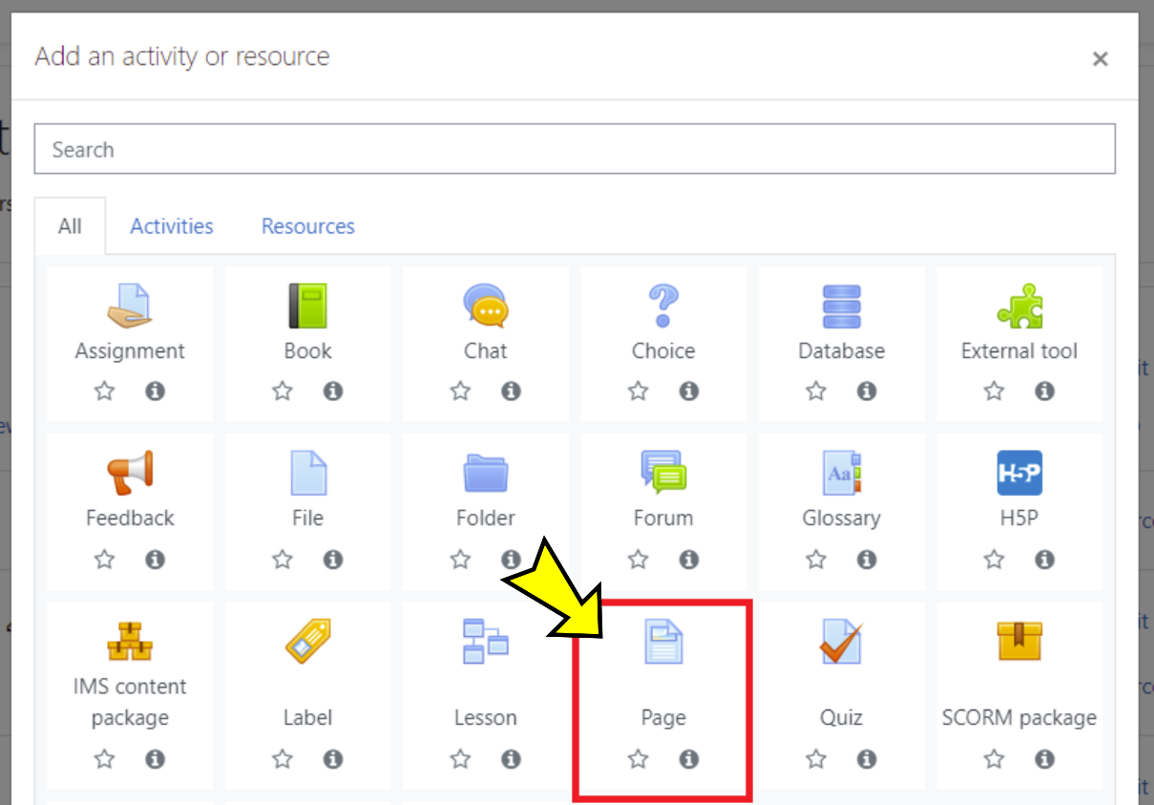

On your new Moodle page, in the "General" section, enter a name in the "Name" text box (highlighted in a red box in the screenshot below).

In the "Content" section, click the downward-pointing arrow (highlighted in a red box in the screenshot below) to reveal more content menu options. Click the "</>" button, the last button on the right in the second row (highlighted in a red box in the screenshot below), to enable the HTML Source Editor.

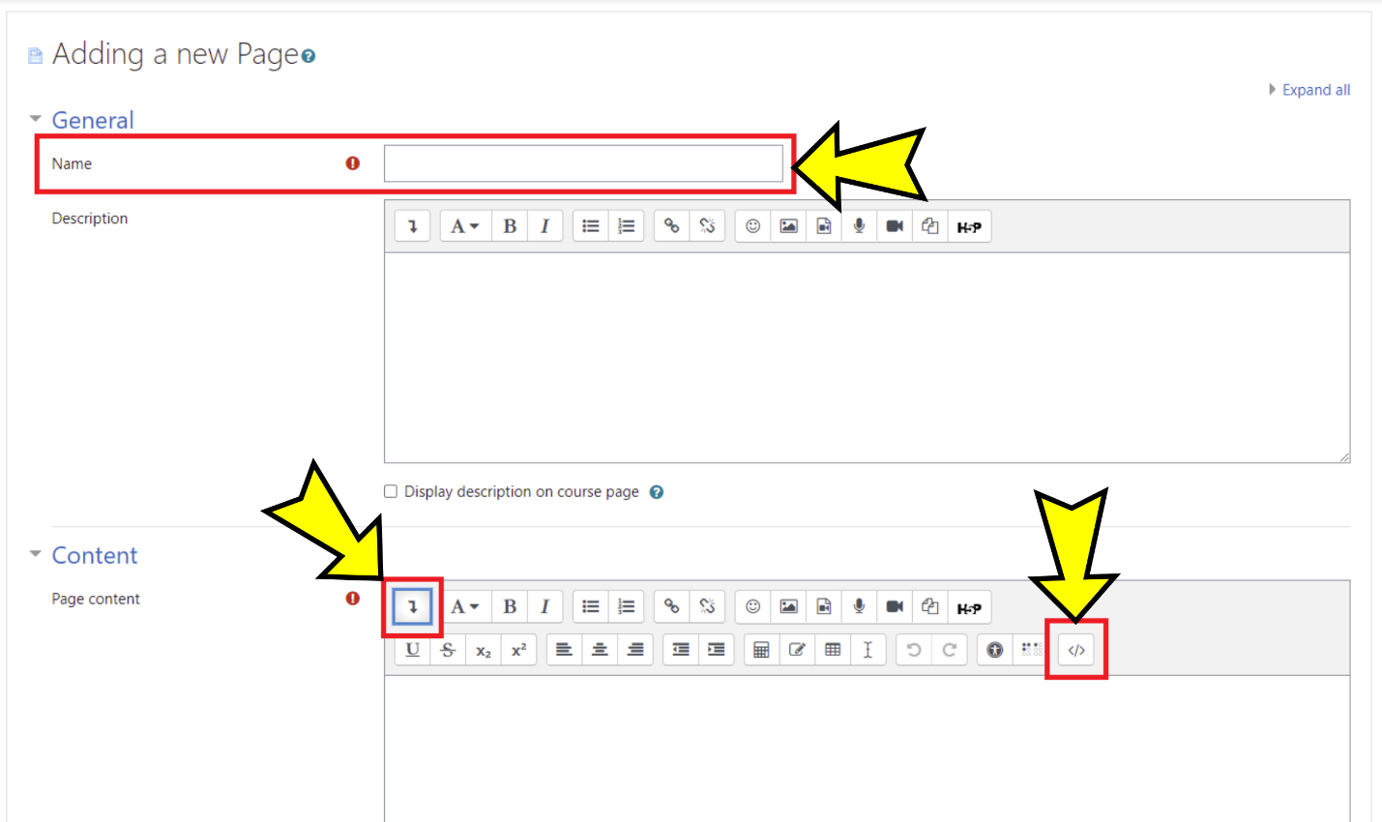

Embed Step 3: Paste the Embed Code in the HTML Source Editor and Save

In some instances, you may have to delete pre-configured HTML codes in the HTML editor. Paste the H5P embed code in the HTML editor (highlighted in a red box in the screenshot below).

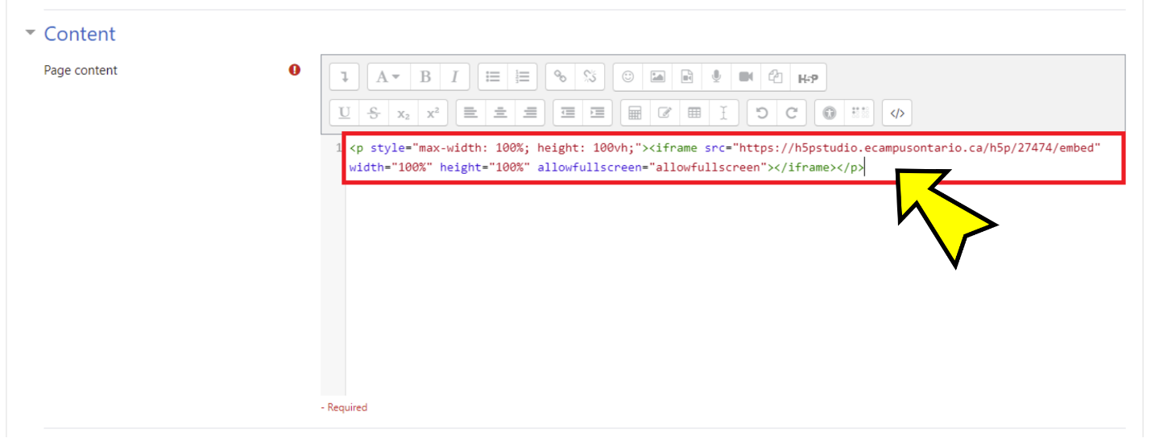

Click the "Save and display" button (highlighted in a red box in the screenshot below) to save and view the result.

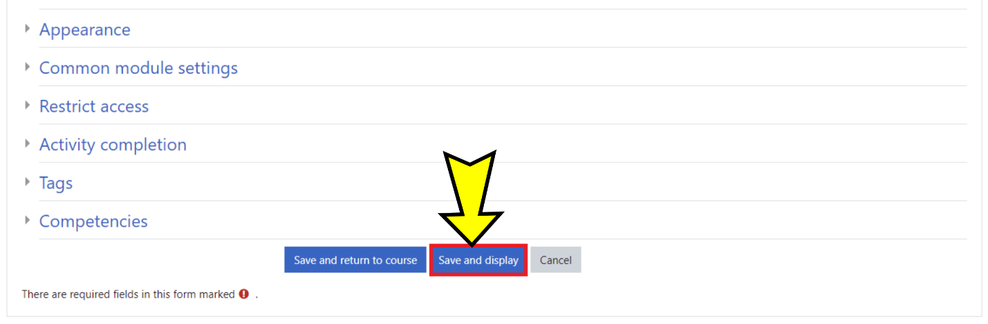

Et voilà!

The H5P interactive book is now embedded in a Moodle Page (screenshot below). Refer to the "Tips for Using H5P Content in Your LMS" section for some tips on enhancing user experience.

Note: The left-hand navigation menu may be hidden when embedding H5P interactive books into a Moodle page, as shown in the screenshot above. Consider adding instructions on how to open and close the left-hand navigation menu.

LTI Step 1: Download the H5P File

Consult Appendix A and identify the URL of the interactive book you want to use. Visit the interactive book using the URL identified and scroll to the bottom of the interactive book.

Click the "Reuse" button near the bottom-left (highlighted in a red box in the screenshot below).

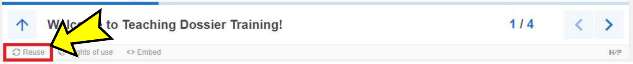

Download the interactive book as an .h5p file (screenshot below).

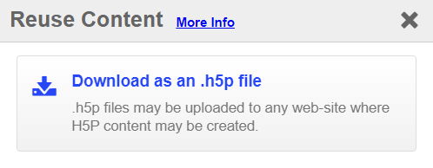

LTI Step 2: Enable the H5P LTI Moodle Integration

Click the "Turn editing on" button (highlighted in a red box in the screenshot below) to enable editing.

Click the "+ Add an activity or resource option" function (highlighted in a red box in the screenshot below).

Select the "H5P" option (highlighted in a red box in the screenshot below) from the "Add an activity or resource" menu.

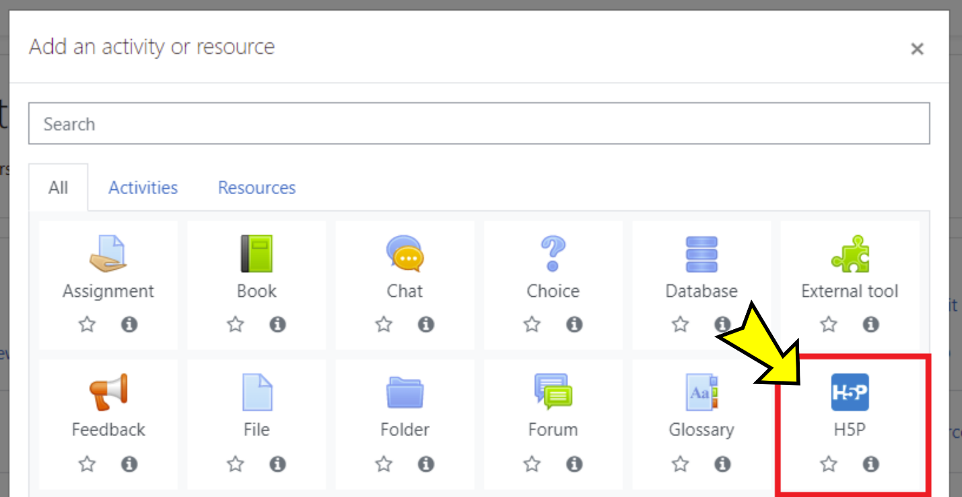

LTI Step 3: Drag and Drop the H5P File and Save

On the "Adding a new H5P" page, in the "General" section, enter a name in the "Name" text box (highlighted in a red box in the screenshot below).

Drag and drop the .h5p file into the "Package file" section.

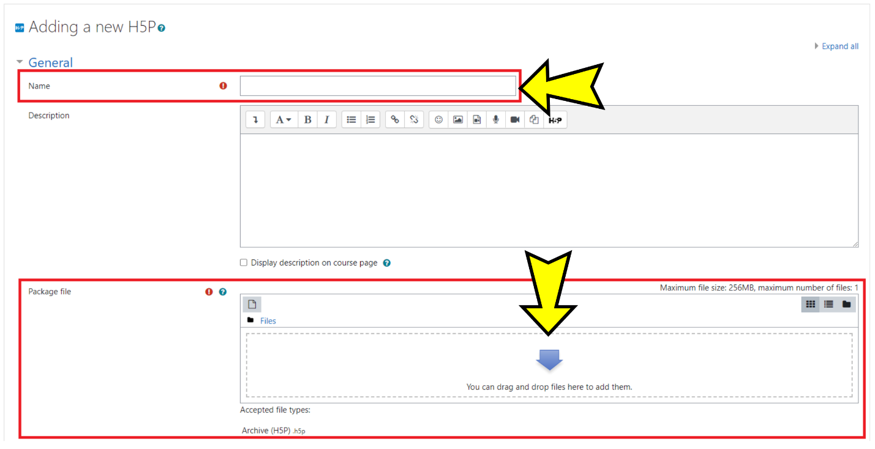

The screenshot below shows an .h5p file (highlighted in a red box) dropped into (uploaded onto) the "Package file" section.

Click the "Save and display" button (highlighted in a red box in the screenshot below) to save and view the result.

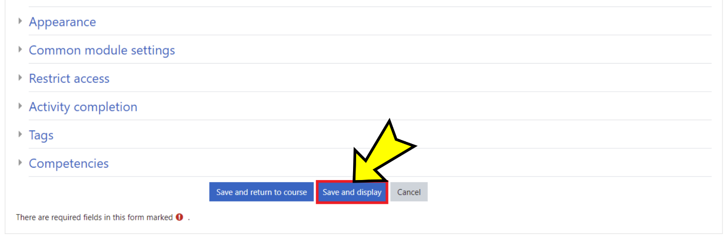

Et voilà!

The H5P interactive book is now integrated into a Moodle course (screenshot below). Refer to the "Tips for Using H5P Content in Your LMS" section for some tips on enhancing user experience.

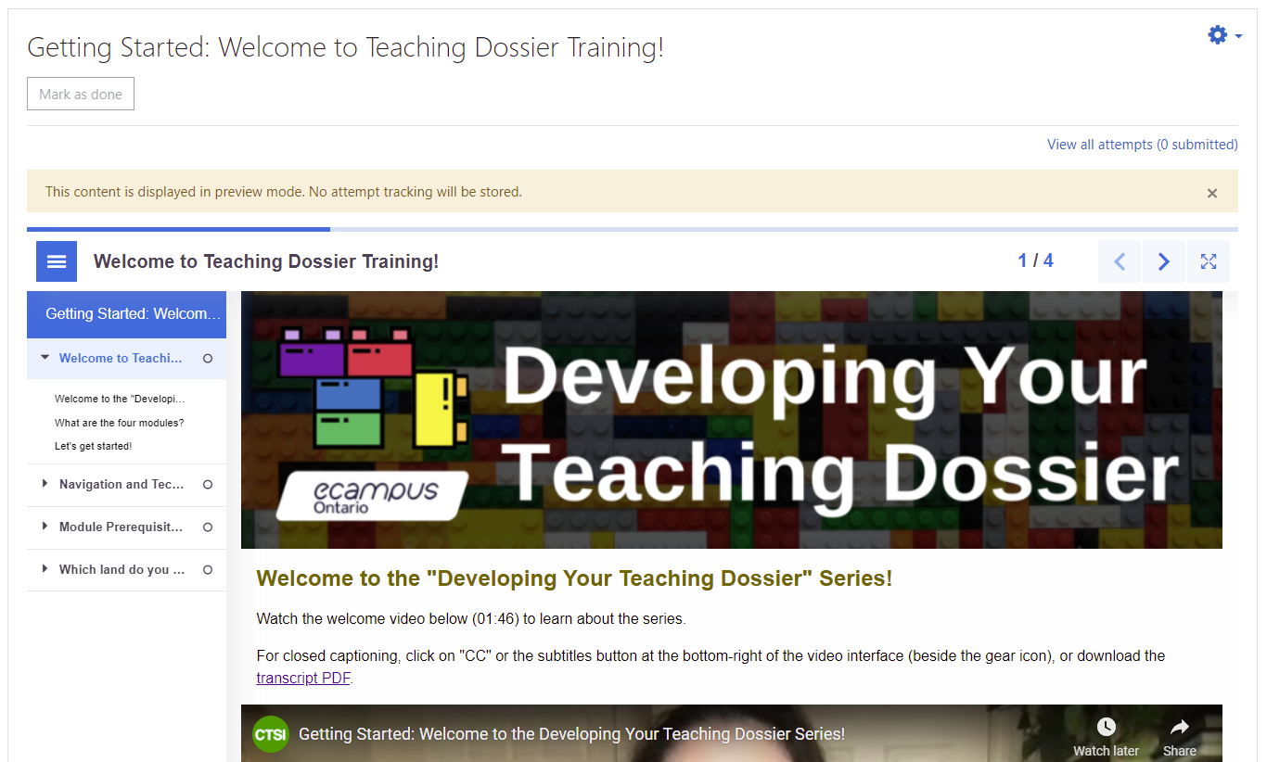

Sakai LMS Embed Instructions in 3 Steps

Step 1: Copy the Embed Code

Copy the section embed code from Appendix A. The embed code should start with <p style= and end with </p>. The embed codes have been optimized to respond to the user's display.

H5P Embed Code Example
<p style="max-width: 100%; height: 100vh;"><iframe src="https://h5pstudio.ecampusontario.ca/h5p/27474/embed" width="100%" height="100%" allowfullscreen="allowfullscreen"></iframe></p>

Step 2: Create an HTML Page in Sakai Resources

Open Sakai resources, click the "Actions" button (highlighted in a red box in the screenshot below), and select "Create HTML Page" (highlighted in a red box in the screenshot below).

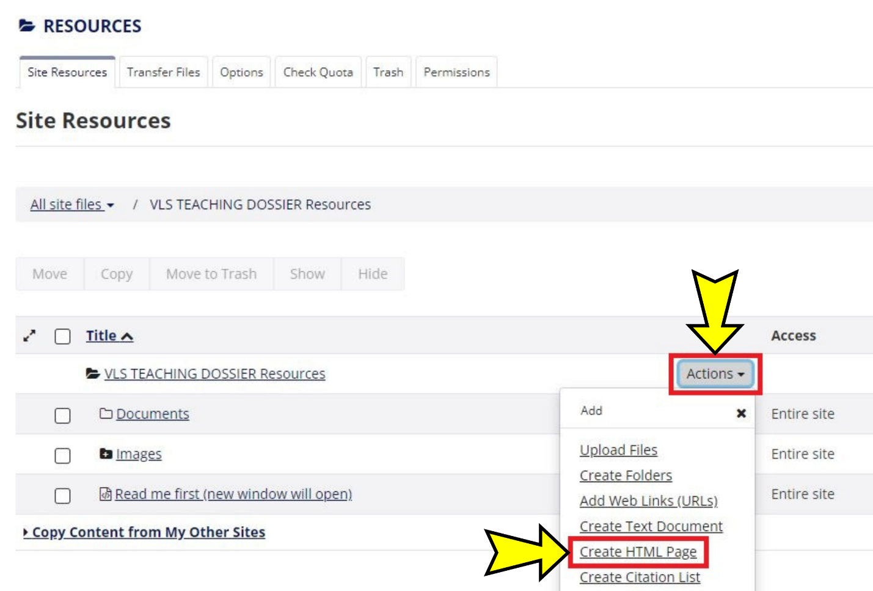

Once the HTML page opens, click the "Source" button (highlighted in a red box in the screenshot below) to enable the HTML editor.

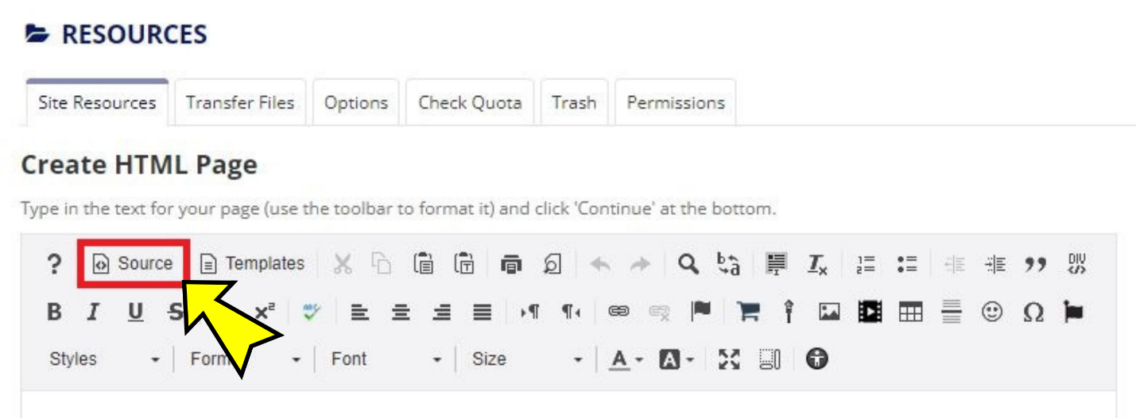

Step 3: Paste the Embed Code in the HTML Page, Continue, and Finish

Paste the embed code in the HTML editor and click the "Continue" button (highlighted in a red box in the screenshot below).

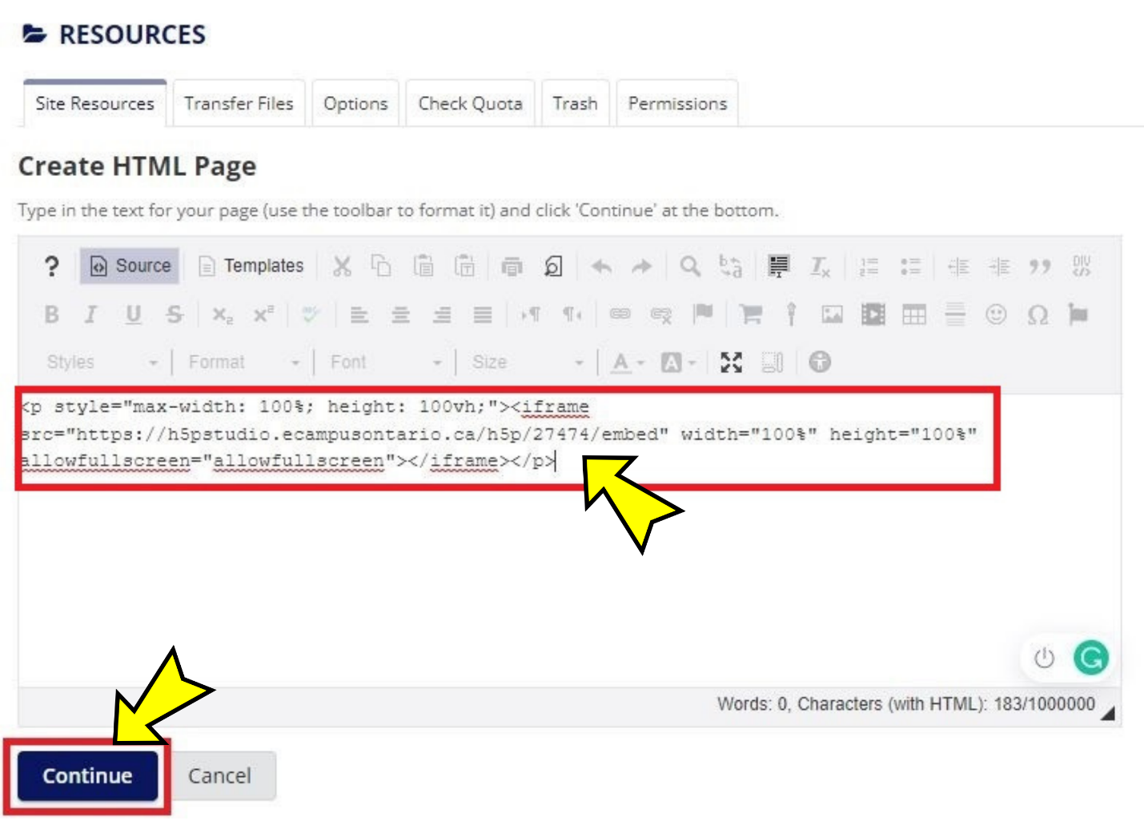

Enter a file name (highlighted in a red box in the screenshot below) and click the "Finish" button (highlighted in a red box in the screenshot below) to finalize the embedding.

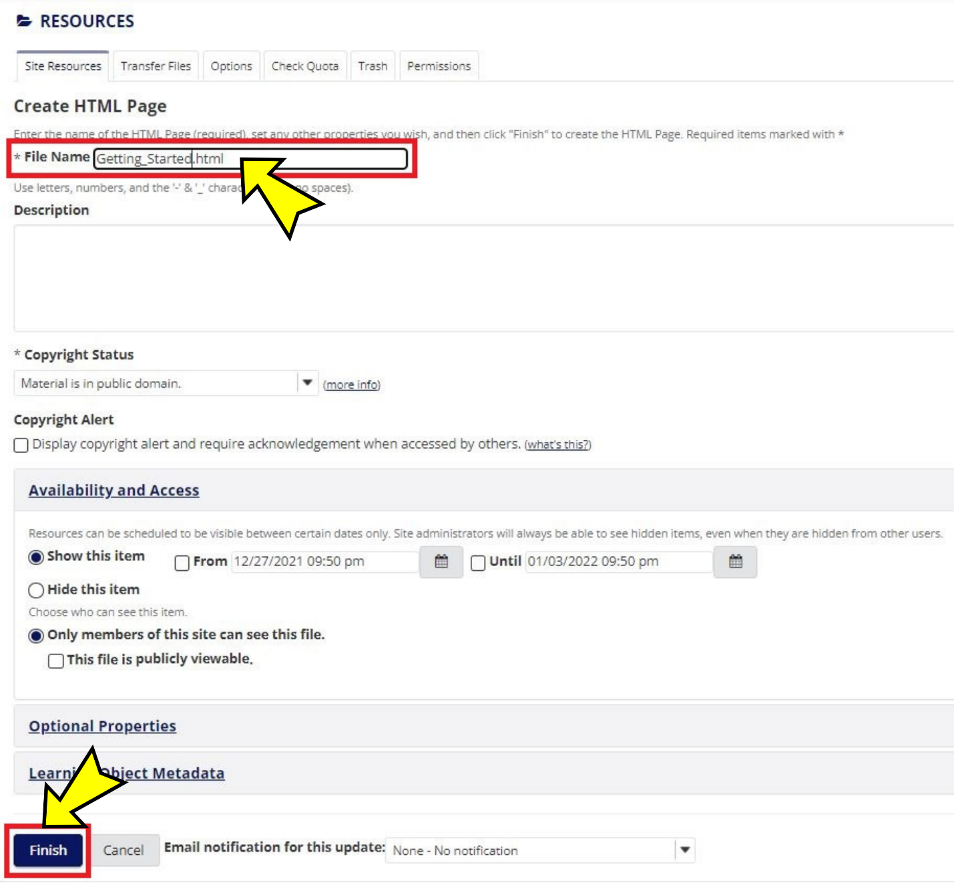

Et voilà!

Click the file name (highlighted in a red box in the screenshot below) that you created to view the page.

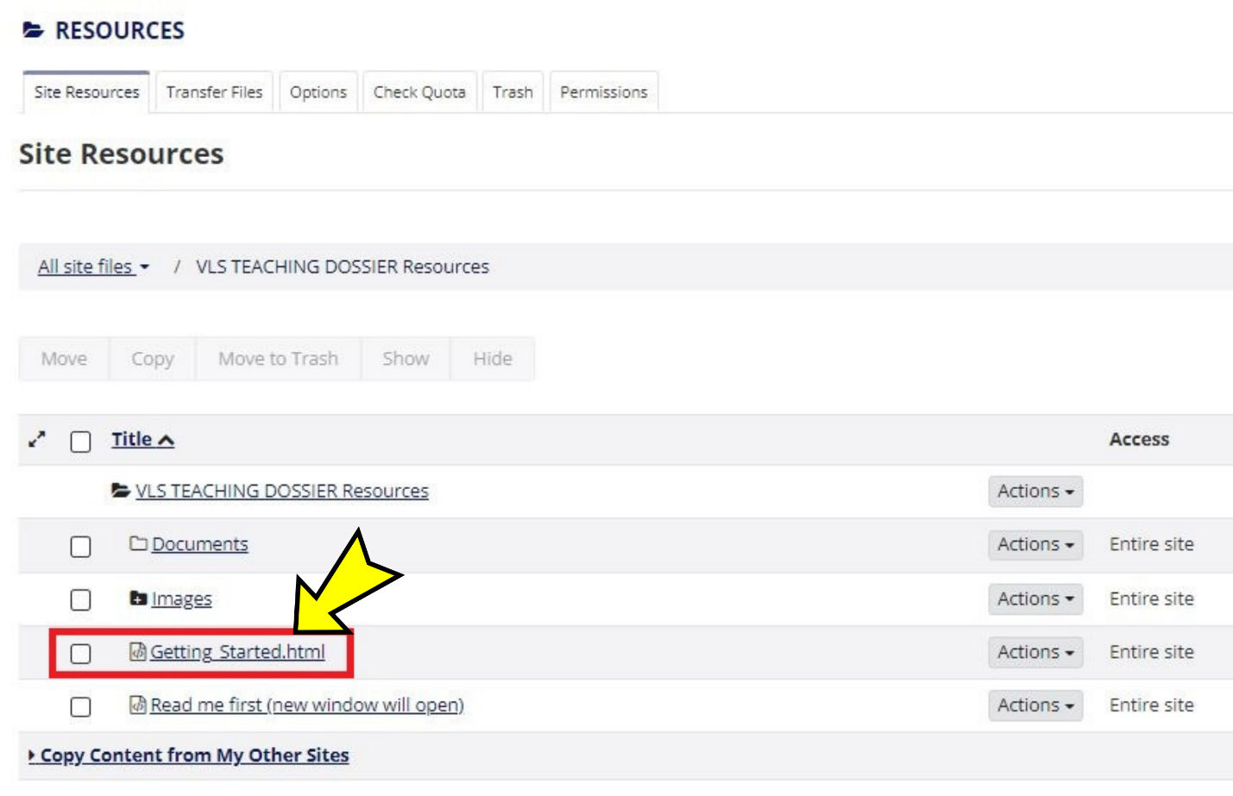

The H5P interactive book is now embedded in a Sakai page (screenshot below). Refer to the "Tips for Using H5P Content in Your LMS" section for some tips on enhancing user experience.

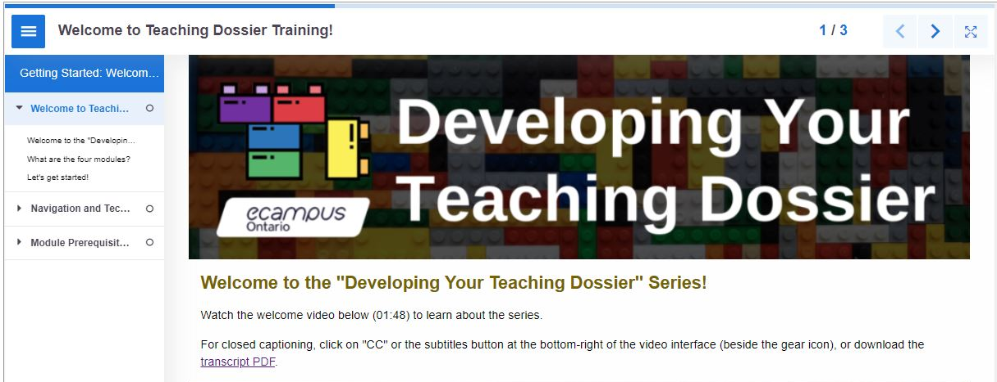

Customizing the Content

Each section of the four modules is an H5P interactive book and can be customized for your context through the H5P reuse function. Refer to the "Using the 'Developing Your Teaching Dossier' Series" section for the three levels of customization.

- Level 1: Module Combination
- Level 2: Section Grouping
- Level 3: Content Customization

Follow the instructions below to customize (add, change, remove) content within each interactive book (Level 3) using the H5P reuse function.

Some ideas for this level of customization include:
- Adding, combining, or removing content within/between module sections (interactive books);
- Inserting institutional videos, resources, knowledge checks, or links;
- Leveraging reflection notes in more comprehensive and interconnected ways; or
- Modifying the certificate of completion and final deliverables.

Getting Started: Create an eCampusOntario H5P Studio Account

All email addresses associated with eCampusOntario member institutions can create an eCampusOntario H5P Studio account.

Visit the eCampusOntario H5P Studio website and click the "Register" button in the top-right corner (highlighted in a red box in the screenshot below) to create an account.

Complete the registration form and click the "Create new account" button at the bottom of the registration form. That's it! You now have an eCampusOntario H5P Studio Account.

The registration form will ask for your name, title/role, institution, email address, username, and social media/website information.

To log in to your account, click the "Login" button near the top-right corner and enter your username or email address and password.

Reusing H5P Content in 3 Steps

Refer to Appendix D for a sample customization demonstration on removing the self-serve Certificate of Completion from the modules.

Step 1: Download the H5P File

Scroll to the bottom-left of the interactive book you want to customize and click the "Reuse" button (highlighted in a red box in the screenshot below).

Download the interactive book as an .h5p file (screenshot below).

Step 2: Upload the H5P File

Log in to your H5P account and click the "Create" button near the top-right corner (highlighted in a red box in the screenshot below).

Click the "Upload" button (highlighted in a red box in the screenshot below) and click the "Upload a file" button (highlighted in a red box in the screenshot below) to upload the .h5p file from Step 1.

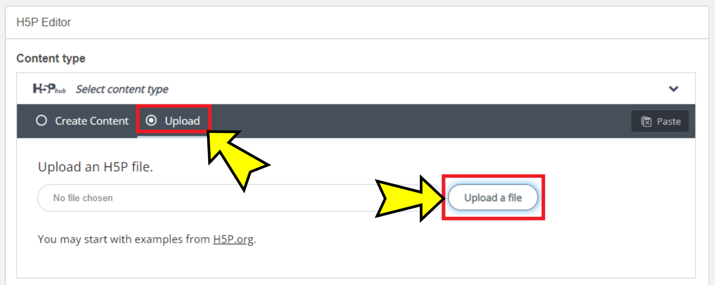

Once the .h5p file is uploaded, click the "Use" button (highlighted in a red box in the screenshot below) to customize the H5P content.

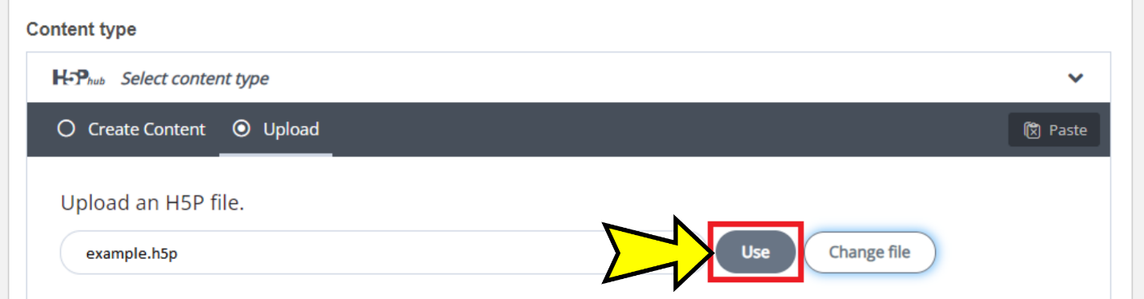

It is a good idea to save the uploaded H5P content before customization. Provide a descriptive title and select a subject before clicking the "Save" button (highlighted in a red box in the screenshot below) to save your progress.

The original series content was classified as "Reference" in eCampusOntario H5P Studio.

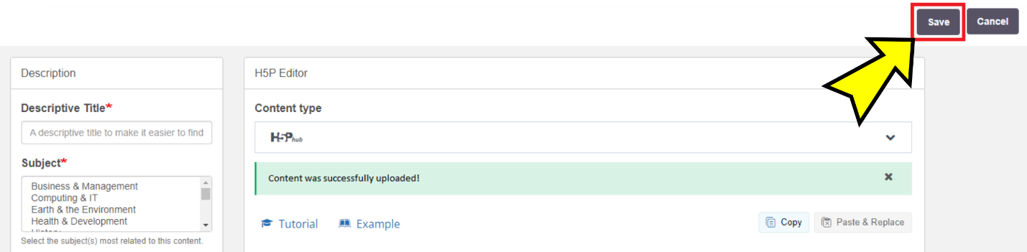

Step 3: Customize the H5P Content

Locate the H5P content you wish to customize in your dashboard (highlighted in a red box in the screenshot below).

Click the content title, then click the "Edit" button near the top-right corner (highlighted in a red box in the screenshot below).

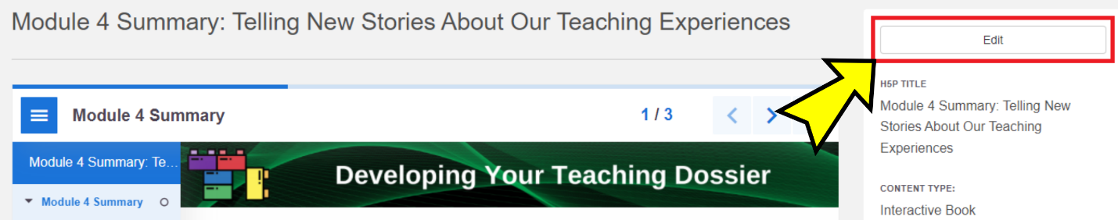

You can customize each element in the H5P Editor. Remember to click the "Save" button (highlighted in a red box in the screenshot below) to save your changes.

Note: H5P interactive book can take a while to save, depending on how much content is in the book.

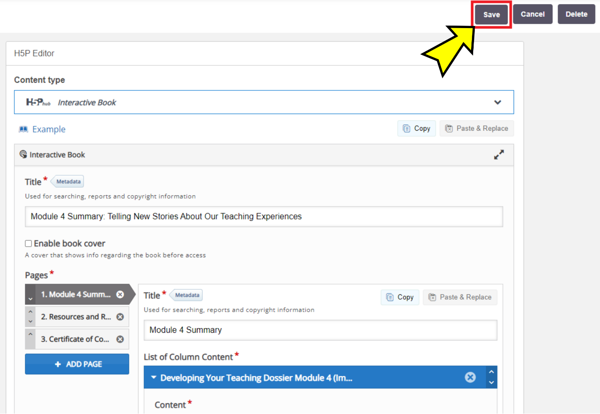

Visit the H5P.org website for examples and downloads, guides and FAQs, and forums. Have fun customizing!

Appendix A: "Developing Your Teaching Dossier" Series Embed Codes

Note: Some versions of the Blackboard Learn LMS may require a modified embed code. We have provided alternate embed codes below. The alternate embed codes have a set height of 2750 pixels. If the interactive book page length is shorter, institutions can adjust both instances of height=" 2750px" to minimize white space below the interactive book.

[Common Element] Getting Started: Welcome to Teaching Dossier Training!

Module Section | Getting Started: Welcome to Teaching Dossier Training!
H5P Embed Code (most LMSs) | <p style="max-width: 100%; height: 100vh;"><iframe src="https://h5pstudio.ecampusontario.ca/h5p/27474/embed" width="100%" height="100%" allowfullscreen="allowfullscreen"></iframe></p>
Alternate H5P Embed Code (with height of 2750 px) | <p style="max-width: 100%; height: 2750px;"><iframe src="https://h5pstudio.ecampusontario.ca/h5p/27474/embed" width="100%" height="2750px" allowfullscreen="allowfullscreen"></iframe></p>
H5P URL | https://h5pstudio.ecampusontario.ca/content/27474

Module 1: Reflecting on Your Teaching Experience: An Introduction to Teaching Dossiers

Module Section | Module 1 Section 1: What Is a Teaching Dossier?
H5P Embed Code (most LMSs) | <p style="max-width: 100%; height: 100vh;"><iframe src="https://h5pstudio.ecampusontario.ca/h5p/34576/embed" width="100%" height="100%" allowfullscreen="allowfullscreen"></iframe></p>
Alternate H5P Embed Code (with height of 2750 px) | <p style="max-width: 100%; height: 2750px;"><iframe src="https://h5pstudio.ecampusontario.ca/h5p/34576/embed" width="100%" height="2750px" allowfullscreen="allowfullscreen"></iframe></p>
H5P URL | https://h5pstudio.ecampusontario.ca/content/34576

Module Section | Module 1 Section 2: Characteristics and Components of a Teaching Dossier
H5P Embed Code (most LMSs) | <p style="max-width: 100%; height: 100vh;"><iframe src="https://h5pstudio.ecampusontario.ca/h5p/34577/embed" width="100%" height="100%" allowfullscreen="allowfullscreen"></iframe></p>
Alternate H5P Embed Code (with height of 2750 px) | <p style="max-width: 100%; height: 2750px;"><iframe src="https://h5pstudio.ecampusontario.ca/h5p/34577/embed" width="100%" height="2750px" allowfullscreen="allowfullscreen"></iframe></p>
H5P URL | https://h5pstudio.ecampusontario.ca/content/34577

Module Section | Module 1 Section 3: Five-Step Plan for Creating Your Teaching Dossier
H5P Embed Code (most LMSs) | <p style="max-width: 100%; height: 100vh;"><iframe src="https://h5pstudio.ecampusontario.ca/h5p/34580/embed" width="100%" height="100%" allowfullscreen="allowfullscreen"></iframe></p>
Alternate H5P Embed Code (with height of 2750 px) | <p style="max-width: 100%; height: 2750px;"><iframe src="https://h5pstudio.ecampusontario.ca/h5p/34580/embed" width="100%" height="2750px" allowfullscreen="allowfullscreen"></iframe></p>
H5P URL | https://h5pstudio.ecampusontario.ca/content/34580

Module Section | Module 1 Summary: Introduction to Teaching Dossiers
H5P Embed Code (most LMSs) | <p style="max-width: 100%; height: 100vh;"><iframe src="https://h5pstudio.ecampusontario.ca/h5p/34581/embed" width="100%" height="100%" allowfullscreen="allowfullscreen"></iframe></p>
Alternate H5P Embed Code (with height of 2750 px) | <p style="max-width: 100%; height: 2750px;"><iframe src="https://h5pstudio.ecampusontario.ca/h5p/34581/embed" width="100%" height="2750px" allowfullscreen="allowfullscreen"></iframe></p>
H5P URL | https://h5pstudio.ecampusontario.ca/content/34581

Module 2: Articulating Your Teaching Values and Practices: Developing Your Statement of Teaching Philosophy

Module Section | Module 2 Section 1: What is a Statement of Teaching Philosophy (STP)?
H5P Embed Code (most LMSs) | <p style="max-width: 100%; height: 100vh;"><iframe src="https://h5pstudio.ecampusontario.ca/h5p/27304/embed" width="100%" height="100%" allowfullscreen="allowfullscreen"></iframe></p>
Alternate H5P Embed Code (with height of 2750 px) | <p style="max-width: 100%; height: 2750px;"><iframe src="https://h5pstudio.ecampusontario.ca/h5p/27304/embed" width="100%" height="2750px" allowfullscreen="allowfullscreen"></iframe></p>
H5P URL | https://h5pstudio.ecampusontario.ca/content/27304

Module Section | Module 2 Section 2: Values, Practices, and Evidence
H5P Embed Code (most LMSs) | <p style="max-width: 100%; height: 100vh;"><iframe src="https://h5pstudio.ecampusontario.ca/h5p/27412/embed" width="100%" height="100%" allowfullscreen="allowfullscreen"></iframe></p>
Alternate H5P Embed Code (with height of 2750 px) | <p style="max-width: 100%; height: 2750px;"><iframe src="https://h5pstudio.ecampusontario.ca/h5p/27412/embed" width="100%" height="2750px" allowfullscreen="allowfullscreen"></iframe></p>
H5P URL | https://h5pstudio.ecampusontario.ca/content/27412

Module Section | Module 2 Section 3: Completing Your Statement of Teaching Philosophy (STP)
H5P Embed Code (most LMSs) | <p style="max-width: 100%; height: 100vh;"><iframe src="https://h5pstudio.ecampusontario.ca/h5p/27435/embed" width="100%" height="100%" allowfullscreen="allowfullscreen"></iframe></p>
Alternate H5P Embed Code (with height of 2750 px) | <p style="max-width: 100%; height: 2750px;"><iframe src="https://h5pstudio.ecampusontario.ca/h5p/27435/embed" width="100%" height="2750px" allowfullscreen="allowfullscreen"></iframe></p>
H5P URL | https://h5pstudio.ecampusontario.ca/content/27435

Module Section | Module 2 Summary: Developing Your Statement of Teaching Philosophy (STP)
H5P Embed Code (most LMSs) | <p style="max-width: 100%; height: 100vh;"><iframe src="https://h5pstudio.ecampusontario.ca/h5p/27470/embed" width="100%" height="100%" allowfullscreen="allowfullscreen"></iframe></p>
Alternate H5P Embed Code (with height of 2750 px) | <p style="max-width: 100%; height: 2750px;"><iframe src="https://h5pstudio.ecampusontario.ca/h5p/27470/embed" width="100%" height="2750px" allowfullscreen="allowfullscreen"></iframe></p>
H5P URL | https://h5pstudio.ecampusontario.ca/content/27470

Module 3: Connecting Narratives and Evidence: Developing Components of Your Teaching Dossier

Module Section | Module 3 Section 1: Teaching Dossier Components and Alignment
H5P Embed Code (most LMSs) | <p style="max-width: 100%; height: 100vh;"><iframe src="https://h5pstudio.ecampusontario.ca/h5p/34582/embed" width="100%" height="100%" allowfullscreen="allowfullscreen"></iframe></p>
Alternate H5P Embed Code (with height of 2750 px) | <p style="max-width: 100%; height: 2750px;"><iframe src="https://h5pstudio.ecampusontario.ca/h5p/34582/embed" width="100%" height="2750px" allowfullscreen="allowfullscreen"></iframe></p>
H5P URL | https://h5pstudio.ecampusontario.ca/content/34582

Module Section | Module 3 Section 2: Drafting the Dossier Components
H5P Embed Code (most LMSs) | <p style="max-width: 100%; height: 100vh;"><iframe src="https://h5pstudio.ecampusontario.ca/h5p/34583/embed" width="100%" height="100%" allowfullscreen="allowfullscreen"></iframe></p>
Alternate H5P Embed Code (with height of 2750 px) | <p style="max-width: 100%; height: 2750px;"><iframe src="https://h5pstudio.ecampusontario.ca/h5p/34583/embed" width="100%" height="2750px" allowfullscreen="allowfullscreen"></iframe></p>
H5P URL | https://h5pstudio.ecampusontario.ca/content/34583

Module Section | Module 3 Section 3: Best Practices for Writing Your Dossier
H5P Embed Code (most LMSs) | <p style="max-width: 100%; height: 100vh;"><iframe src="https://h5pstudio.ecampusontario.ca/h5p/34584/embed" width="100%" height="100%" allowfullscreen="allowfullscreen"></iframe></p>
Alternate H5P Embed Code (with height of 2750 px) | <p style="max-width: 100%; height: 2750px;"><iframe src="https://h5pstudio.ecampusontario.ca/h5p/34584/embed" width="100%" height="2750px" allowfullscreen="allowfullscreen"></iframe></p>
H5P URL | https://h5pstudio.ecampusontario.ca/content/34584

Module Section | Module 3 Summary: Developing Components of your Teaching Dossier
H5P Embed Code (most LMSs) | <p style="max-width: 100%; height: 100vh;"><iframe src="https://h5pstudio.ecampusontario.ca/h5p/34585/embed" width="100%" height="100%" allowfullscreen="allowfullscreen"></iframe></p>
Alternate H5P Embed Code (with height of 2750 px) | <p style="max-width: 100%; height: 2750px;"><iframe src="https://h5pstudio.ecampusontario.ca/h5p/34585/embed" width="100%" height="2750px" allowfullscreen="allowfullscreen"></iframe></p>
H5P URL | https://h5pstudio.ecampusontario.ca/content/34585

Module 4: Looking Ahead: Telling New Stories About Our Teaching Experiences

Module Section | Module 4 Section 1: Identifying Transferable Teaching Skills
H5P Embed Code (most LMSs) | <p style="max-width: 100%; height: 100vh;"><iframe src="https://h5pstudio.ecampusontario.ca/h5p/29435/embed" width="100%" height="100%" allowfullscreen="allowfullscreen"></iframe></p>
Alternate H5P Embed Code (with height of 2750 px) | <p style="max-width: 100%; height: 2750px;"><iframe src="https://h5pstudio.ecampusontario.ca/h5p/29435/embed" width="100%" height="2750px" allowfullscreen="allowfullscreen"></iframe></p>
H5P URL | https://h5pstudio.ecampusontario.ca/content/29435

Module Section | Module 4 Section 2: Aligning Your Teaching and Professional Personas
H5P Embed Code (most LMSs) | <p style="max-width: 100%; height: 100vh;"><iframe src="https://h5pstudio.ecampusontario.ca/h5p/29436/embed" width="100%" height="100%" allowfullscreen="allowfullscreen"></iframe></p>
Alternate H5P Embed Code (with height of 2750 px) | <p style="max-width: 100%; height: 2750px;"><iframe src="https://h5pstudio.ecampusontario.ca/h5p/29436/embed" width="100%" height="2750px" allowfullscreen="allowfullscreen"></iframe></p>
H5P URL | https://h5pstudio.ecampusontario.ca/content/29436

Module Section | Module 4 Section 3: Communicating Your Transferable Teaching Skills
H5P Embed Code (most LMSs) | <p style="max-width: 100%; height: 100vh;"><iframe src="https://h5pstudio.ecampusontario.ca/h5p/29437/embed" width="100%" height="100%" allowfullscreen="allowfullscreen"></iframe></p>
Alternate H5P Embed Code (with height of 2750 px) | <p style="max-width: 100%; height: 2750px;"><iframe src="https://h5pstudio.ecampusontario.ca/h5p/29437/embed" width="100%" height="2750px" allowfullscreen="allowfullscreen"></iframe></p>
H5P URL | https://h5pstudio.ecampusontario.ca/content/29437

Module Section | Module 4 Summary: Telling New Stories About Our Teaching Experiences
H5P Embed Code (most LMSs) | <p style="max-width: 100%; height: 100vh;"><iframe src="https://h5pstudio.ecampusontario.ca/h5p/29438/embed" width="100%" height="100%" allowfullscreen="allowfullscreen"></iframe></p>
Alternate H5P Embed Code (with height of 2750 px) | <p style="max-width: 100%; height: 2750px;"><iframe src="https://h5pstudio.ecampusontario.ca/h5p/29438/embed" width="100%" height="2750px" allowfullscreen="allowfullscreen"></iframe></p>
H5P URL | https://h5pstudio.ecampusontario.ca/content/29438

Appendix B: "Developing Your Teaching Dossier" Series Hyperlinked Resources

The "Developing Your Teaching Dossier" series institutional guide (the current document) is available in two formats, PDF and DOCX, via the URLs listed below.

Guide | URL
Institutional Guide PDF | https://ecampusontario.pressbooks.pub/app/uploads/sites/2131/2022/01/VLS-TD_InstitutionalGuide.pdf
Institutional Guide DOCX | https://ecampusontario.pressbooks.pub/app/uploads/sites/2131/2022/01/VLS-TD_InstitutionalGuide.docx

[Common Element] Getting Started: Welcome to Teaching Dossier Training!

The recap documents are hyperlinked on each Module Summary interactive book's "Resources and References" page.

Recap | URL
Getting Started PDF | https://ecampusontario.pressbooks.pub/app/uploads/sites/2131/2022/01/VLS-TD_Recap-GettingStarted.pdf
Getting Started DOCX | https://ecampusontario.pressbooks.pub/app/uploads/sites/2131/2022/02/VLS-TD_Recap-GettingStarted.docx

Resource | URL
Series Glossary PDF | https://ecampusontario.pressbooks.pub/app/uploads/sites/2131/2021/11/VLS-TD_Glossary.pdf
Series Glossary DOCX | https://ecampusontario.pressbooks.pub/app/uploads/sites/2131/2022/02/VLS-TD_Glossary.docx

Transcript | URL
Welcome PDF | https://ecampusontario.pressbooks.pub/app/uploads/sites/2131/2021/11/VLS-TD_Transcript_Welcome.pdf
Welcome DOCX | https://ecampusontario.pressbooks.pub/app/uploads/sites/2131/2022/02/VLS-TD_Transcript-Welcome.docx
Navigation PDF | https://ecampusontario.pressbooks.pub/app/uploads/sites/2131/2021/11/VLS-TD_Transcript_Navigation.pdf
Navigation DOCX | https://ecampusontario.pressbooks.pub/app/uploads/sites/2131/2022/02/VLS-TD_Transcript-Navigation.docx

Module 1: Reflecting on Your Teaching Experience: An Introduction to Teaching Dossiers

Recap | URL
Module 1 Section 1 PDF | https://ecampusontario.pressbooks.pub/app/uploads/sites/2131/2022/01/VLS-M1_Recap-Section1.pdf
Module 1 Section 1 DOCX | https://ecampusontario.pressbooks.pub/app/uploads/sites/2131/2022/02/VLS-M1_Recap-Section1.docx
Module 1 Section 2 PDF | https://ecampusontario.pressbooks.pub/app/uploads/sites/2131/2022/01/VLS-M1_Recap-Section2.pdf
Module 1 Section 2 DOCX | https://ecampusontario.pressbooks.pub/app/uploads/sites/2131/2022/02/VLS-M1_Recap-Section2.docx
Module 1 Section 3 PDF | https://ecampusontario.pressbooks.pub/app/uploads/sites/2131/2022/01/VLS-M1_Recap-Section3.pdf
Module 1 Section 3 DOCX | https://ecampusontario.pressbooks.pub/app/uploads/sites/2131/2022/02/VLS-M1_Recap-Section3.docx
Module 1 Summary PDF | https://ecampusontario.pressbooks.pub/app/uploads/sites/2131/2022/01/VLS-M1_Recap-Summary.pdf
Module 1 Summary DOCX | https://ecampusontario.pressbooks.pub/app/uploads/sites/2131/2022/02/VLS-M1_Recap-Summary.docx

Resource | URL
Module 1 Certificate of Completion PDF | https://ecampusontario.pressbooks.pub/app/uploads/sites/2131/2021/11/VLS-M1_CertificateCompletion.pdf

Sample | URL
Sample Table of Contents 1 PDF | https://ecampusontario.pressbooks.pub/app/uploads/sites/2131/2022/01/VLS-M1_SampleToC-1.pdf
Sample Table of Contents 1 DOCX | https://ecampusontario.pressbooks.pub/app/uploads/sites/2131/2022/02/VLS-M1_SampleToC-1.docx
Sample Table of Contents 2 PDF | https://ecampusontario.pressbooks.pub/app/uploads/sites/2131/2022/01/VLS-M1_SampleToC-2.pdf
Sample Table of Contents 2 DOCX | https://ecampusontario.pressbooks.pub/app/uploads/sites/2131/2022/02/VLS-M1_SampleToC-2.docx
Sample Table of Contents 3 PDF | https://ecampusontario.pressbooks.pub/app/uploads/sites/2131/2022/01/VLS-M1_SampleToC-3.pdf
Sample Table of Contents 3 DOCX | https://ecampusontario.pressbooks.pub/app/uploads/sites/2131/2022/02/VLS-M1_SampleToC-3.docx
Sample Table of Contents 4 PDF | https://ecampusontario.pressbooks.pub/app/uploads/sites/2131/2022/01/VLS-M1_SampleToC-4.pdf
Sample Table of Contents 4 DOCX | https://ecampusontario.pressbooks.pub/app/uploads/sites/2131/2022/02/VLS-M1_SampleToC-4.docx
Sample Table of Contents 5 PDF | https://ecampusontario.pressbooks.pub/app/uploads/sites/2131/2022/01/VLS-M1_SampleToC-5.pdf
Sample Table of Contents 5 DOCX | https://ecampusontario.pressbooks.pub/app/uploads/sites/2131/2022/02/VLS-M1_SampleToC-5.docx

Transcript | URL
Module 1 Introduction PDF | https://ecampusontario.pressbooks.pub/app/uploads/sites/2131/2021/11/VLS-M1_Transcript-Intro.pdf
Module 1 Introduction DOCX | https://ecampusontario.pressbooks.pub/app/uploads/sites/2131/2022/02/VLS-M1_Transcript-Intro.docx
How I Developed My Teaching Dossier PDF | https://ecampusontario.pressbooks.pub/app/uploads/sites/2131/2021/11/VLS-M1_Transcript-HowIDeveloped.pdf
How I Developed My Teaching Dossier DOCX | https://ecampusontario.pressbooks.pub/app/uploads/sites/2131/2022/02/VLS-M1_Transcript-HowIDeveloped.docx
Module 1 Summary PDF | https://ecampusontario.pressbooks.pub/app/uploads/sites/2131/2021/11/VLS-M1_Transcript-Summary.pdf
Module 1 Summary DOCX | https://ecampusontario.pressbooks.pub/app/uploads/sites/2131/2022/02/VLS-M1_Transcript-Summary.docx

Module 2: Articulating Your Teaching Values and Practices: Developing Your Statement of Teaching Philosophy

Recap | URL
Module 2 Section 1 PDF | https://ecampusontario.pressbooks.pub/app/uploads/sites/2131/2022/01/VLS-M2_Recap-Section1.pdf
Module 2 Section 1 DOCX | https://ecampusontario.pressbooks.pub/app/uploads/sites/2131/2022/02/VLS-M2_Recap-Section1.docx
Module 2 Section 2 PDF | https://ecampusontario.pressbooks.pub/app/uploads/sites/2131/2022/01/VLS-M2_Recap-Section2.pdf
Module 2 Section 2 DOCX | https://ecampusontario.pressbooks.pub/app/uploads/sites/2131/2022/02/VLS-M2_Recap-Section2.docx
Module 2 Section 3 PDF | https://ecampusontario.pressbooks.pub/app/uploads/sites/2131/2022/01/VLS-M2_Recap-Section3.pdf
Module 2 Section 3 DOCX | https://ecampusontario.pressbooks.pub/app/uploads/sites/2131/2022/02/VLS-M2_Recap-Section3.docx
Module 2 Summary PDF | https://ecampusontario.pressbooks.pub/app/uploads/sites/2131/2022/01/VLS-M2_Recap-Summary.pdf
Module 2 Summary DOCX | https://ecampusontario.pressbooks.pub/app/uploads/sites/2131/2022/02/VLS-M2_Recap-Summary.docx

Resource | URL
Strategies and Tools to Cultivate a Reflective Practice Workbook PDF | https://ecampusontario.pressbooks.pub/app/uploads/sites/2131/2021/11/VLS-M2_BonusReflectivePratice.pdf
Strategies and Tools to Cultivate a Reflective Practice Workbook DOCX | https://ecampusontario.pressbooks.pub/app/uploads/sites/2131/2022/02/VLS-M2_BonusReflectivePratice.docx
Module 2 Certificate of Completion PDF | https://ecampusontario.pressbooks.pub/app/uploads/sites/2131/2021/11/VLS-M2_CertificateCompletion.pdf

Sample | URL
Sample STP Computer Science PDF | https://ecampusontario.pressbooks.pub/app/uploads/sites/2131/2021/11/VLS-M2_SampleSTP-ComputerScience.pdf
Sample STP Computer Science DOCX | https://ecampusontario.pressbooks.pub/app/uploads/sites/2131/2022/02/VLS-M2_SampleSTP-ComputerScience.docx
Sample STP Engineering PDF | https://ecampusontario.pressbooks.pub/app/uploads/sites/2131/2021/11/VLS-M2_SampleSTP-Engineering.pdf
Sample STP Engineering DOCX | https://ecampusontario.pressbooks.pub/app/uploads/sites/2131/2022/02/VLS-M2_SampleSTP-Engineering.docx
Sample STP English PDF | https://ecampusontario.pressbooks.pub/app/uploads/sites/2131/2021/11/VLS-M2_SampleSTP-English.pdf
Sample STP English DOCX | https://ecampusontario.pressbooks.pub/app/uploads/sites/2131/2022/02/VLS-M2_SampleSTP-English.docx
Sample STP Health Science PDF | https://ecampusontario.pressbooks.pub/app/uploads/sites/2131/2021/11/VLS-M2_SampleSTP-HealthScience.pdf
Sample STP Health Science DOCX | https://ecampusontario.pressbooks.pub/app/uploads/sites/2131/2022/02/VLS-M2_SampleSTP-HealthScience.docx
Sample STP History PDF | https://ecampusontario.pressbooks.pub/app/uploads/sites/2131/2021/11/VLS-M2_SampleSTP-History.pdf
Sample STP History DOCX | https://ecampusontario.pressbooks.pub/app/uploads/sites/2131/2022/02/VLS-M2_SampleSTP-History.docx
Sample STP Physical Science PDF | https://ecampusontario.pressbooks.pub/app/uploads/sites/2131/2021/11/VLS-M2_SampleSTP-PhysicalScience.pdf
Sample STP Physical Science DOCX | https://ecampusontario.pressbooks.pub/app/uploads/sites/2131/2022/02/VLS-M2_SampleSTP-PhysicalScience.docx
Sample STP Social Science PDF | https://ecampusontario.pressbooks.pub/app/uploads/sites/2131/2021/11/VLS-M2_SampleSTP-SocialScience.pdf
Sample STP Social Science DOCX | https://ecampusontario.pressbooks.pub/app/uploads/sites/2131/2022/02/VLS-M2_SampleSTP-SocialScience.docx

Transcript | URL
Module 2 Introduction PDF | https://ecampusontario.pressbooks.pub/app/uploads/sites/2131/2021/11/VLS-M2_Transcript-Intro.pdf
Module 2 Introduction DOCX | https://ecampusontario.pressbooks.pub/app/uploads/sites/2131/2022/02/VLS-M2_Transcript-Intro.docx
Introduction to Reflective Writing PDF | https://ecampusontario.pressbooks.pub/app/uploads/sites/2131/2021/11/VLS-M2_Transcript-ReflectiveWriting.pdf
Introduction to Reflective Writing DOCX | https://ecampusontario.pressbooks.pub/app/uploads/sites/2131/2022/02/VLS-M2_Transcript-ReflectiveWriting.docx
Teaching Values PDF | https://ecampusontario.pressbooks.pub/app/uploads/sites/2131/2021/11/VLS-M2_Transcript-TeachingValues.pdf
Teaching Values DOCX | https://ecampusontario.pressbooks.pub/app/uploads/sites/2131/2022/02/VLS-M2_Transcript-TeachingValues.docx
Module 2 Summary PDF | https://ecampusontario.pressbooks.pub/app/uploads/sites/2131/2021/11/VLS-M2_Transcript-Summary.pdf
Module 2 Summary DOCX | https://ecampusontario.pressbooks.pub/app/uploads/sites/2131/2022/02/VLS-M2_Transcript-Summary.docx

Module 3: Connecting Narratives and Evidence: Developing Components of Your Teaching Dossier

Recap | URL
Module 3 Section 1 PDF | https://ecampusontario.pressbooks.pub/app/uploads/sites/2131/2022/01/VLS-M3_Recap-Section1.pdf
Module 3 Section 1 DOCX | https://ecampusontario.pressbooks.pub/app/uploads/sites/2131/2022/02/VLS-M3_Recap-Section1.docx
Module 3 Section 2 PDF | https://ecampusontario.pressbooks.pub/app/uploads/sites/2131/2022/01/VLS-M3_Recap-Section2.pdf
Module 3 Section 2 DOCX | https://ecampusontario.pressbooks.pub/app/uploads/sites/2131/2022/02/VLS-M3_Recap-Section2.docx
Module 3 Section 3 PDF | https://ecampusontario.pressbooks.pub/app/uploads/sites/2131/2022/01/VLS-M3_Recap-Section3.pdf
Module 3 Section 3 DOCX | https://ecampusontario.pressbooks.pub/app/uploads/sites/2131/2022/02/VLS-M3_Recap-Section3.docx
Module 3 Summary PDF | https://ecampusontario.pressbooks.pub/app/uploads/sites/2131/2022/01/VLS-M3_Recap-Summary.pdf
Module 3 Summary DOCX | https://ecampusontario.pressbooks.pub/app/uploads/sites/2131/2022/02/VLS-M3_Recap-Summary.docx

Resource | URL
Aligning Your Teaching Dossier PDF | https://ecampusontario.pressbooks.pub/app/uploads/sites/2131/2021/11/VLS-M3_Resource-AlignTable.pdf
Aligning Your Teaching Dossier DOCX | https://ecampusontario.pressbooks.pub/app/uploads/sites/2131/2022/02/VLS-M3_Resource-AlignTable.docx
Teaching Effectiveness Through Teaching Evaluations PDF | https://ecampusontario.pressbooks.pub/app/uploads/sites/2131/2022/01/VLS-M3_Bonus-TeachingEffectiveness.pdf
Teaching Effectiveness Through Teaching Evaluations DOCX | https://ecampusontario.pressbooks.pub/app/uploads/sites/2131/2022/02/VLS-M3_Bonus-TeachingEffectiveness.docx
Teaching Dossier Self Review Questions PDF | https://ecampusontario.pressbooks.pub/app/uploads/sites/2131/2021/11/VLS-M3_Resource-SelfReview.pdf
Teaching Dossier Self Review Questions DOCX | https://ecampusontario.pressbooks.pub/app/uploads/sites/2131/2022/02/VLS-M3_Resource-SelfReview.docx
Teaching Dossier Peer Review Form PDF | https://ecampusontario.pressbooks.pub/app/uploads/sites/2131/2021/11/VLS-M3_Resource-PeerReview.pdf
Teaching Dossier Peer Review Form DOCX | https://ecampusontario.pressbooks.pub/app/uploads/sites/2131/2022/02/VLS-M3_Resource-PeerReview.docx
Module 3 Certificate of Completion PDF | https://ecampusontario.pressbooks.pub/app/uploads/sites/2131/2021/11/VLS-M3_CertificateCompletion.pdf

Transcript | URL
Introduction Toben PDF | https://ecampusontario.pressbooks.pub/app/uploads/sites/2131/2021/11/VLS-M3_Transcript-Intro-Toben.pdf
Introduction Toben DOCX | https://ecampusontario.pressbooks.pub/app/uploads/sites/2131/2022/02/VLS-M3_Transcript-Intro-Toben.docx
Introduction Kirsten PDF | https://ecampusontario.pressbooks.pub/app/uploads/sites/2131/2021/11/VLS-M3_Transcript-Intro-Kirsten.pdf
Introduction Kirsten DOCX | https://ecampusontario.pressbooks.pub/app/uploads/sites/2131/2022/02/VLS-M3_Transcript-Intro-Kirsten.docx
Introduction Ellen PDF | https://ecampusontario.pressbooks.pub/app/uploads/sites/2131/2021/11/VLS-M3_Transcript-Intro-Ellen.pdf
Introduction Ellen DOCX | https://ecampusontario.pressbooks.pub/app/uploads/sites/2131/2022/02/VLS-M3_Transcript-Intro-Ellen.docx
Introduction Geith PDF | https://ecampusontario.pressbooks.pub/app/uploads/sites/2131/2021/11/VLS-M3_Transcript-Intro-Geith.pdf
Introduction Geith DOCX | https://ecampusontario.pressbooks.pub/app/uploads/sites/2131/2022/02/VLS-M3_Transcript-Intro-Geith.docx
STP Toben PDF | https://ecampusontario.pressbooks.pub/app/uploads/sites/2131/2021/11/VLS-M3_Transcript-STP-Toben.pdf
STP Toben DOCX | https://ecampusontario.pressbooks.pub/app/uploads/sites/2131/2022/02/VLS-M3_Transcript-STP-Toben.docx
Teaching Experience Toben PDF | https://ecampusontario.pressbooks.pub/app/uploads/sites/2131/2021/11/VLS-M3_Transcript-Experience-Toben.pdf
Teaching Experience Toben DOCX | https://ecampusontario.pressbooks.pub/app/uploads/sites/2131/2022/02/VLS-M3_Transcript-Experience-Toben.docx
Teaching Experience Kirsten PDF | https://ecampusontario.pressbooks.pub/app/uploads/sites/2131/2021/11/VLS-M3_Transcript-Experience-Kirsten.pdf
Teaching Experience Kirsten DOCX | https://ecampusontario.pressbooks.pub/app/uploads/sites/2131/2022/02/VLS-M3_Transcript-Experience-Kirsten.docx
Teaching Experience Ellen PDF | https://ecampusontario.pressbooks.pub/app/uploads/sites/2131/2021/11/VLS-M3_Transcript-Experience-Ellen.pdf
Teaching Experience Ellen DOCX | https://ecampusontario.pressbooks.pub/app/uploads/sites/2131/2022/02/VLS-M3_Transcript-Experience-Ellen.docx
Teaching Experience Geith PDF | https://ecampusontario.pressbooks.pub/app/uploads/sites/2131/2021/11/VLS-M3_Transcript-Experience-Geith.pdf
Teaching Experience Geith DOCX | https://ecampusontario.pressbooks.pub/app/uploads/sites/2131/2022/02/VLS-M3_Transcript-Experience-Geith.docx
Teaching Strategies Toben PDF | https://ecampusontario.pressbooks.pub/app/uploads/sites/2131/2021/11/VLS-M3_Transcript-Strategies-Toben.pdf
Teaching Strategies Toben DOCX | https://ecampusontario.pressbooks.pub/app/uploads/sites/2131/2022/02/VLS-M3_Transcript-Strategies-Toben.docx
Teaching Strategies Kirsten PDF | https://ecampusontario.pressbooks.pub/app/uploads/sites/2131/2021/11/VLS-M3_Transcript-Strategies-Kirsten.pdf
Teaching Strategies Kirsten DOCX | https://ecampusontario.pressbooks.pub/app/uploads/sites/2131/2022/02/VLS-M3_Transcript-Strategies-Kirsten.docx
Teaching Strategies Ellen PDF | https://ecampusontario.pressbooks.pub/app/uploads/sites/2131/2021/11/VLS-M3_Transcript-Strategies-Ellen.pdf
Teaching Strategies Ellen DOCX | https://ecampusontario.pressbooks.pub/app/uploads/sites/2131/2022/02/VLS-M3_Transcript-Strategies-Ellen.docx
Teaching Strategies Geith PDF | https://ecampusontario.pressbooks.pub/app/uploads/sites/2131/2021/11/VLS-M3_Transcript-Strategies-Geith.pdf
Teaching Strategies Geith DOCX | https://ecampusontario.pressbooks.pub/app/uploads/sites/2131/2022/02/VLS-M3_Transcript-Strategies-Geith.docx
Evaluation of Teaching Toben PDF | https://ecampusontario.pressbooks.pub/app/uploads/sites/2131/2021/11/VLS-M3_Transcript-Evaluation-Toben.pdf
Evaluation of Teaching Toben DOCX | https://ecampusontario.pressbooks.pub/app/uploads/sites/2131/2022/02/VLS-M3_Transcript-Evaluation-Toben.docx
Evaluation of Teaching Kirsten PDF | https://ecampusontario.pressbooks.pub/app/uploads/sites/2131/2021/11/VLS-M3_Transcript-Evaluation-Kirsten.pdf
Evaluation of Teaching Kirsten DOCX | https://ecampusontario.pressbooks.pub/app/uploads/sites/2131/2022/02/VLS-M3_Transcript-Evaluation-Kirsten.docx
Evaluation of Teaching Ellen PDF | https://ecampusontario.pressbooks.pub/app/uploads/sites/2131/2021/11/VLS-M3_Transcript-Evaluation-Ellen.pdf
Evaluation of Teaching Ellen DOCX | https://ecampusontario.pressbooks.pub/app/uploads/sites/2131/2022/02/VLS-M3_Transcript-Evaluation-Ellen.docx
Evaluation of Teaching Geith PDF | https://ecampusontario.pressbooks.pub/app/uploads/sites/2131/2021/11/VLS-M3_Transcript-Evaluation-Geith.pdf
Evaluation of Teaching Geith DOCX | https://ecampusontario.pressbooks.pub/app/uploads/sites/2131/2022/02/VLS-M3_Transcript-Evaluation-Geith.docx
Professional Development Toben PDF | https://ecampusontario.pressbooks.pub/app/uploads/sites/2131/2021/11/VLS-M3_Transcript-Professional-Toben.pdf
Professional Development Toben DOCX | https://ecampusontario.pressbooks.pub/app/uploads/sites/2131/2022/02/VLS-M3_Transcript-Professional-Toben.docx
Professional Development Ellen PDF | https://ecampusontario.pressbooks.pub/app/uploads/sites/2131/2021/11/VLS-M3_Transcript-Professional-Ellen.pdf
Professional Development Ellen DOCX | https://ecampusontario.pressbooks.pub/app/uploads/sites/2131/2022/02/VLS-M3_Transcript-Professional-Ellen.docx
Future Goals Toben PDF | https://ecampusontario.pressbooks.pub/app/uploads/sites/2131/2021/11/VLS-M3_Transcript-Future-Toben.pdf
Future Goals Toben DOCX | https://ecampusontario.pressbooks.pub/app/uploads/sites/2131/2022/02/VLS-M3_Transcript-Future-Toben.docx
Future Goals Ellen PDF | https://ecampusontario.pressbooks.pub/app/uploads/sites/2131/2021/11/VLS-M3_Transcript-Future-Ellen.pdf
Future Goals Ellen DOCX | https://ecampusontario.pressbooks.pub/app/uploads/sites/2131/2022/02/VLS-M3_Transcript-Future-Ellen.docx
Appendices Toben PDF | https://ecampusontario.pressbooks.pub/app/uploads/sites/2131/2021/11/VLS-M3_Transcript-Appendices-Toben.pdf
Appendices Toben DOCX | https://ecampusontario.pressbooks.pub/app/uploads/sites/2131/2022/02/VLS-M3_Transcript-Appendices-Toben.docx
Appendices Kirsten PDF | https://ecampusontario.pressbooks.pub/app/uploads/sites/2131/2021/11/VLS-M3_Transcript-Appendices-Kirsten.pdf
Appendices Kirsten DOCX | https://ecampusontario.pressbooks.pub/app/uploads/sites/2131/2022/02/VLS-M3_Transcript-Appendices-Kirsten.docx
Appendices Ellen PDF | https://ecampusontario.pressbooks.pub/app/uploads/sites/2131/2021/11/VLS-M3_Transcript-Appendices-Ellen.pdf
Appendices Ellen DOCX | https://ecampusontario.pressbooks.pub/app/uploads/sites/2131/2022/02/VLS-M3_Transcript-Appendices-Ellen.docx
Appendices Geith PDF | https://ecampusontario.pressbooks.pub/app/uploads/sites/2131/2021/11/VLS-M3_Transcript-Appendices-Geith.pdf
Appendices Geith DOCX | https://ecampusontario.pressbooks.pub/app/uploads/sites/2131/2022/02/VLS-M3_Transcript-Appendices-Geith.docx
Module 3 Summary PDF | https://ecampusontario.pressbooks.pub/app/uploads/sites/2131/2022/01/VLS-M3_Transcript-Summary.pdf
Module 3 Summary DOCX | https://ecampusontario.pressbooks.pub/app/uploads/sites/2131/2022/02/VLS-M3_Transcript-Summary.docx

Module 4: Looking Ahead: Telling New Stories About Our Teaching Experiences

Recap | URL
Module 4 Section 1 PDF | https://ecampusontario.pressbooks.pub/app/uploads/sites/2131/2022/01/VLS-M4_Recap-Section1.pdf
Module 4 Section 1 DOCX | https://ecampusontario.pressbooks.pub/app/uploads/sites/2131/2022/02/VLS-M4_Recap-Section1.docx
Module 4 Section 2 PDF | https://ecampusontario.pressbooks.pub/app/uploads/sites/2131/2022/01/VLS-M4_Recap-Section2.pdf
Module 4 Section 2 DOCX | https://ecampusontario.pressbooks.pub/app/uploads/sites/2131/2022/02/VLS-M4_Recap-Section2.docx
Module 4 Section 3 PDF | https://ecampusontario.pressbooks.pub/app/uploads/sites/2131/2022/01/VLS-M4_Recap-Section3.pdf
Module 4 Section 3 DOCX | https://ecampusontario.pressbooks.pub/app/uploads/sites/2131/2022/02/VLS-M4_Recap-Section3.docx
Module 4 Summary PDF | https://ecampusontario.pressbooks.pub/app/uploads/sites/2131/2022/01/VLS-M4_Recap-Summary.pdf
Module 4 Summary DOCX | https://ecampusontario.pressbooks.pub/app/uploads/sites/2131/2022/02/VLS-M4_Recap-Summary.docx

The following four resources are under a Creative Commons Attribution-NonCommercial-NoDerivatives 4.0 International (CC BY-NC-ND 4.0) License.

Resource | URL
Creating Your Academic CV & Cover Letter Toolkit PDF | https://ecampusontario.pressbooks.pub/app/uploads/sites/2131/2022/01/VLS-M4_Bonus-AcCVLetter.pdf
Creating Your Non-Ac Resume & Cover Letter Toolkit PDF | https://ecampusontario.pressbooks.pub/app/uploads/sites/2131/2022/01/VLS-M4_Bonus-NonAcResumeLetter.pdf
Academic Interview Guide PDF | https://ecampusontario.pressbooks.pub/app/uploads/sites/2131/2022/01/VLS-M4_Bonus-AcInterview.pdf
Non-Academic Interview Guide PDF | https://ecampusontario.pressbooks.pub/app/uploads/sites/2131/2022/01/VLS-M4_Bonus-NonAcInterview.pdf

Resource | URL
Identifying Transferable Teaching Skills PDF | https://ecampusontario.pressbooks.pub/app/uploads/sites/2131/2022/02/VLS-M4_Resource-TransferableSkills.pdf
Identifying Transferable Teaching Skills DOCX | https://ecampusontario.pressbooks.pub/app/uploads/sites/2131/2021/11/VLS-M4_Resource-TransferableSkills.docx
Communicating Alignment in Your Cover Letter PDF | https://ecampusontario.pressbooks.pub/app/uploads/sites/2131/2021/11/VLS-M4_Bonus-CoverLetter.pdf
Communicating Alignment in Your Cover Letter DOCX | https://ecampusontario.pressbooks.pub/app/uploads/sites/2131/2022/02/VLS-M4_Bonus-CoverLetter.docx
Communicating Alignment in Your EDI Statement PDF | https://ecampusontario.pressbooks.pub/app/uploads/sites/2131/2021/11/VLS-M4_Bonus-EDIStatement.pdf
Communicating Alignment in Your EDI Statement DOCX | https://ecampusontario.pressbooks.pub/app/uploads/sites/2131/2022/02/VLS-M4_Bonus-EDIStatement.docx
Addressing Gaps in Your Teaching Dossier PDF | https://ecampusontario.pressbooks.pub/app/uploads/sites/2131/2021/11/VLS-M4_Bonus-AddressingGaps.pdf
Addressing Gaps in Your Teaching Dossier DOCX | https://ecampusontario.pressbooks.pub/app/uploads/sites/2131/2022/02/VLS-M4_Bonus-AddressingGaps.docx
Module 4 Certificate of Completion PDF | https://ecampusontario.pressbooks.pub/app/uploads/sites/2131/2021/11/VLS-M4_CertificateCompletion.pdf

Transcript | URL
Module 4 Introduction PDF | https://ecampusontario.pressbooks.pub/app/uploads/sites/2131/2021/11/VLS-M4_Transcript-Intro.pdf
Module 4 Introduction DOCX | https://ecampusontario.pressbooks.pub/app/uploads/sites/2131/2022/02/VLS-M4_Transcript-Intro.docx
Identifying Transferable Teaching Skills PDF | https://ecampusontario.pressbooks.pub/app/uploads/sites/2131/2021/11/VLS-M4_Transcript-TransferableSkills.pdf
Identifying Transferable Teaching Skills DOCX | https://ecampusontario.pressbooks.pub/app/uploads/sites/2131/2022/02/VLS-M4_Transcript-TransferableSkills.docx
Culturally Relevant Pedagogy PDF | https://ecampusontario.pressbooks.pub/app/uploads/sites/2131/2021/11/VLS-M4_Transcript-EDI-CRP.pdf
Culturally Relevant Pedagogy DOCX | https://ecampusontario.pressbooks.pub/app/uploads/sites/2131/2022/02/VLS-M4_Transcript-EDI-CRP.docx
Universal Design for Learning PDF | https://ecampusontario.pressbooks.pub/app/uploads/sites/2131/2021/11/VLS-M4_Transcript-EDI-UDL.pdf
Universal Design for Learning DOCX | https://ecampusontario.pressbooks.pub/app/uploads/sites/2131/2022/02/VLS-M4_Transcript-EDI-UDL.docx
The STAR Method PDF | https://ecampusontario.pressbooks.pub/app/uploads/sites/2131/2021/11/VLS-M4_Transcript-STARMethod.pdf
The STAR Method DOCX | https://ecampusontario.pressbooks.pub/app/uploads/sites/2131/2022/02/VLS-M4_Transcript-STARMethod.docx
Module 4 Summary PDF | https://ecampusontario.pressbooks.pub/app/uploads/sites/2131/2021/11/VLS-M4_Transcript-Summary.pdf
Module 4 Summary DOCX | https://ecampusontario.pressbooks.pub/app/uploads/sites/2131/2022/02/VLS-M4_Transcript-Summary.docx

Appendix C: "Developing Your Teaching Dossier" Series Embedded Videos

All 41 videos from the "Developing Your Teaching Dossier" series are listed in a YouTube playlist at https://www.youtube.com/playlist?list=PLm9zcxSvwTwqi7YWv7dYilknvfNVAOx3C

[Common Element] Getting Started: Welcome to Teaching Dossier Training!

Video | URL
Welcome to the Developing Your Teaching Dossier Series! | https://youtu.be/bBwvYt2b7_c
How do I navigate through the module? | https://youtu.be/7nqUD9FxAmE

Module 1: Reflecting on Your Teaching Experience: An Introduction to Teaching Dossiers

Video | URL
Introduction to Teaching Dossiers | https://youtu.be/tTrl3dth9nY
How I Developed My Teaching Dossier | https://youtu.be/3dOQOEuYBmw
Summary of Introduction to Teaching Dossiers | https://youtu.be/GZYCEOlz_Gg

Module 2: Articulating Your Teaching Values and Practices: Developing Your Statement of Teaching Philosophy

Video | URL
Introduction to Developing Your STP | https://youtu.be/TqPUWp1OT08
What is reflective writing? | https://youtu.be/tuzUawDySpA
Defining Our Teaching Values | https://youtu.be/Dd9E40jNXMk
Summary of Developing Your STP | https://youtu.be/aqGSoGsDkPo

Module 3: Connecting Narratives and Evidence: Developing Components of Your Teaching Dossier

Module 3 videos are grouped in YouTube playlists organized by topics. The tables below provide both playlist and standalone video URLs. The H5P interactive books embedded videos use the playlist URLs.

Meet Toben / Kirsten / Ellen / Geith Playlist Video URLs
https://www.youtube.com/watch?v=AVwtl73r7mc&list=PLm9zcxSvwTwpD30VXtXHq9pO8A5cctbl7&index=1
https://www.youtube.com/watch?v=n9cSWvTaGmw&list=PLm9zcxSvwTwpD30VXtXHq9pO8A5cctbl7&index=2
https://www.youtube.com/watch?v=zYXpjeMLEJ8&list=PLm9zcxSvwTwpD30VXtXHq9pO8A5cctbl7&index=3
https://www.youtube.com/watch?v=4zDneLoJk5I&list=PLm9zcxSvwTwpD30VXtXHq9pO8A5cctbl7&index=4

Video | URL
Meet Toben | https://youtu.be/AVwtl73r7mc
Meet Kirsten | https://youtu.be/n9cSWvTaGmw
Meet Ellen | https://youtu.be/zYXpjeMLEJ8
Meet Geith | https://youtu.be/4zDneLoJk5I

Video | URL
The STP with Toben | https://youtu.be/Su2VWZtE04Y

Teaching Experience with Toben / Kirsten / Ellen / Geith Playlist Video URLs
https://www.youtube.com/watch?v=6qNqd6DMCZY&list=PLm9zcxSvwTwrKyVVNS9A_ohHVUEmWTxKH&index=1
https://www.youtube.com/watch?v=SAtYqBKFOIw&list=PLm9zcxSvwTwrKyVVNS9A_ohHVUEmWTxKH&index=2
https://www.youtube.com/watch?v=Pb-vlmhLcCw&list=PLm9zcxSvwTwrKyVVNS9A_ohHVUEmWTxKH&index=3
https://www.youtube.com/watch?v=bHnppFHbVRI&list=PLm9zcxSvwTwrKyVVNS9A_ohHVUEmWTxKH&index=4

Video | URL
Teaching Experience with Toben | https://youtu.be/6qNqd6DMCZY
Teaching Experience with Kirsten | https://youtu.be/SAtYqBKFOIw
Teaching Experience with Ellen | https://youtu.be/Pb-vlmhLcCw
Teaching Experience with Geith | https://youtu.be/bHnppFHbVRI

Teaching Strategies with Toben / Kirsten / Ellen / Geith Playlist Video URLs
https://www.youtube.com/watch?v=yPayFrR2Kho&list=PLm9zcxSvwTwp5s1YXF7TbkgHj3Z3CT_Yu&index=1
https://www.youtube.com/watch?v=o8TPI2wEa7s&list=PLm9zcxSvwTwp5s1YXF7TbkgHj3Z3CT_Yu&index=2
https://www.youtube.com/watch?v=z4VWPVveyBs&list=PLm9zcxSvwTwp5s1YXF7TbkgHj3Z3CT_Yu&index=3
https://www.youtube.com/watch?v=w2FKstZC2Ic&list=PLm9zcxSvwTwp5s1YXF7TbkgHj3Z3CT_Yu&index=4

Video | URL
Teaching Strategies with Toben | https://youtu.be/yPayFrR2Kho
Teaching Strategies with Kirsten | https://youtu.be/o8TPI2wEa7s
Teaching Strategies with Ellen | https://youtu.be/z4VWPVveyBs
Teaching Strategies with Geith | https://youtu.be/w2FKstZC2Ic

Evaluation of Teaching with Toben / Kirsten / Ellen / Geith Playlist Video URLs
https://www.youtube.com/watch?v=qwfZ_iyMfHE&list=PLm9zcxSvwTwrjSdZ_Gy1aFzmfwi_DCFOw&index=1
https://www.youtube.com/watch?v=mWKjVE1ycgo&list=PLm9zcxSvwTwrjSdZ_Gy1aFzmfwi_DCFOw&index=2
https://www.youtube.com/watch?v=qRe9LKzTyQs&list=PLm9zcxSvwTwrjSdZ_Gy1aFzmfwi_DCFOw&index=3
https://www.youtube.com/watch?v=A6nq7W6XTxw&list=PLm9zcxSvwTwrjSdZ_Gy1aFzmfwi_DCFOw&index=4

Video | URL
Evaluation of Teaching with Toben | https://youtu.be/qwfZ_iyMfHE
Evaluation of Teaching with Kirsten | https://youtu.be/mWKjVE1ycgo
Evaluation of Teaching with Ellen | https://youtu.be/qRe9LKzTyQs
Evaluation of Teaching with Geith | https://youtu.be/A6nq7W6XTxw

Professional Development with Toben / Ellen Playlist Video URLs
https://www.youtube.com/watch?v=brO9ZayW-iM&list=PLm9zcxSvwTwpnI7mFgY4DNrYu44VteOt9&index=1
https://www.youtube.com/watch?v=T79DM_IrvIY&list=PLm9zcxSvwTwpnI7mFgY4DNrYu44VteOt9&index=2

Video | URL
Professional Development with Toben | https://youtu.be/brO9ZayW-iM
Professional Development with Ellen | https://youtu.be/T79DM_IrvIY

Future Goals with Toben / Ellen Playlist Video URLs
https://www.youtube.com/watch?v=rhTtYW0r1TU&list=PLm9zcxSvwTwov-OV7RjbDfKuU9lep8D1x&index=1
https://www.youtube.com/watch?v=XFbgftULLqw&list=PLm9zcxSvwTwov-OV7RjbDfKuU9lep8D1x&index=2

Video | URL
Future Goals with Toben | https://youtu.be/rhTtYW0r1TU
Future Goals with Ellen | https://youtu.be/XFbgftULLqw

Appendices with Toben / Kirsten / Ellen / Geith Playlist Video URLs
https://www.youtube.com/watch?v=82V0OpwtI40&list=PLm9zcxSvwTwoBFk4T8MX_JcR9i7QLd418&index=1
https://www.youtube.com/watch?v=6xwgoZSHyNI&list=PLm9zcxSvwTwoBFk4T8MX_JcR9i7QLd418&index=2
https://www.youtube.com/watch?v=V3NzSJtW3fo&list=PLm9zcxSvwTwoBFk4T8MX_JcR9i7QLd418&index=3
https://www.youtube.com/watch?v=O3jJOFC6t78&list=PLm9zcxSvwTwoBFk4T8MX_JcR9i7QLd418&index=4

Video | URL
Appendices with Toben | https://youtu.be/82V0OpwtI40
Appendices with Kirsten | https://youtu.be/6xwgoZSHyNI
Appendices with Ellen | https://youtu.be/V3NzSJtW3fo
Appendices with Geith | https://youtu.be/O3jJOFC6t78

Video | URL
Summary of Developing Components | https://youtu.be/OnAtkSBi62c

Module 4: Looking Ahead: Telling New Stories About Our Teaching Experiences

Video | URL
Introduction to Telling New Stories | https://youtu.be/jmPL2HgUoBc
Identifying Your Transferable Skills Activity | https://youtu.be/GsmrbAZI_So
What is the STAR method? | https://youtu.be/tTKc3cmLqAE
Summary of Telling New Stories | https://youtu.be/yp33WZ--Dgc

EDI in Teaching Playlist Video URLs
https://www.youtube.com/watch?v=lcsh2cEtQyA&list=PLm9zcxSvwTwp4thgSfd5Npu-aIPOLEDIj&index=1
https://www.youtube.com/watch?v=OsMmiTvvFq8&list=PLm9zcxSvwTwp4thgSfd5Npu-aIPOLEDIj&index=2

Video | URL
Culturally Relevant Pedagogy | https://youtu.be/lcsh2cEtQyA
Universal Design for Learning | https://youtu.be/OsMmiTvvFq8

Appendix D: Sample Series Customization Demonstration: Certification of Completion

Removing the Certificate of Completion

The "Developing Your Teaching Dossier" series provides a self-serve Certificate of Completion at the end of each of the four modules. Because the module has no tracking and reporting capabilities, institutions may want to use their own system for managing training progress and completion.

As a sample customization demonstration, the following section provides step-by-step instructions on removing the self-serve Certification of Completion (highlighted in a red box in the screenshot below) from the module. Refer to the H5P.org website for further guidance on reusing H5P content.

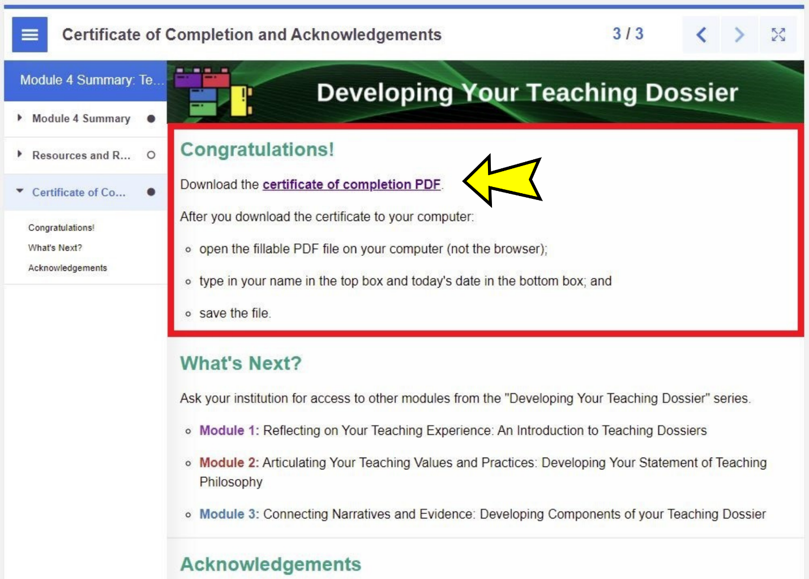

Step 1: Download the H5P File

Scroll to the bottom-left of the interactive book you want to remove the certificate and click the "Reuse" button (highlighted in a red box in the screenshot below).

Download the interactive book as an .h5p file (screenshot below).

Step 2: Upload the H5P File

Log in to your H5P account and click the "Create" button near the top-right corner (highlighted in a red box in the screenshot below).

Click the "Upload" button (highlighted in a red box in the screenshot below) and click the "Upload a file" button (highlighted in a red box in the screenshot below) to upload the .h5p file from Step 1.

Once the .h5p file is uploaded, click the "Use" button (highlighted in a red box in the screenshot below) to customize the H5P content.

It is a good idea to save the uploaded H5P content before customization. Provide a descriptive title and select a subject before clicking the "Save" button (highlighted in a red box in the screenshot below) to save your progress.

The original series content was classified as "Reference" in eCampusOntario H5P Studio.

Step 3: Customize the H5P Content

Locate the H5P content you wish to customize in your dashboard (highlighted in a red box in the screenshot below).

Click the content title, then click the "Edit" button near the top-right corner (highlighted in a red box in the screenshot below).

Locate and select the "Certificate of Completion and Acknowledgements page (highlighted in a red box in the screenshot below). Update the page title and metadata to the new name you wish to use.

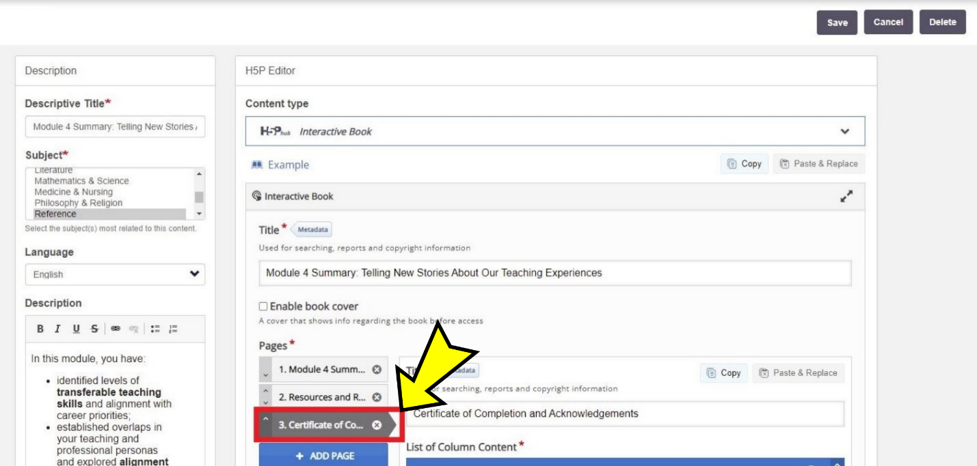

Scroll down to locate the "Congratulations! (Text)" section, where the certificate is presented. Click the "X" (highlighted in a red box in the screenshot below) to remove the certificate section.

Alternatively, you can provide new instructions in the space and use the up and down arrows (highlighted in a red box in the screenshot below) to move the section up and down the page.

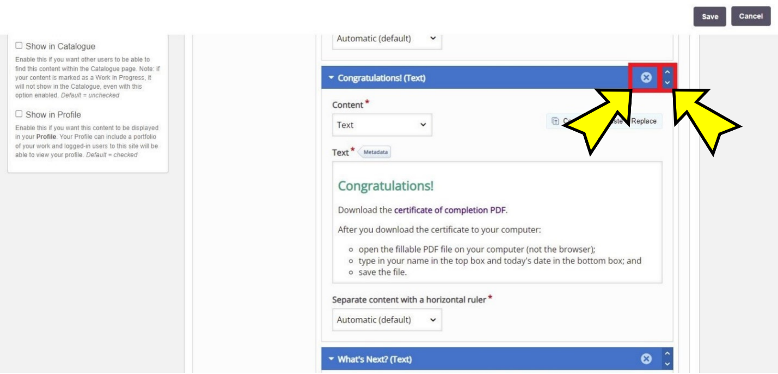

After completing your changes, click the "Save" button near the top-right corner (highlighted in a red box in the screenshot below) to save your work.

Note: H5P interactive book can take a while to save, depending on how much content is in the book.

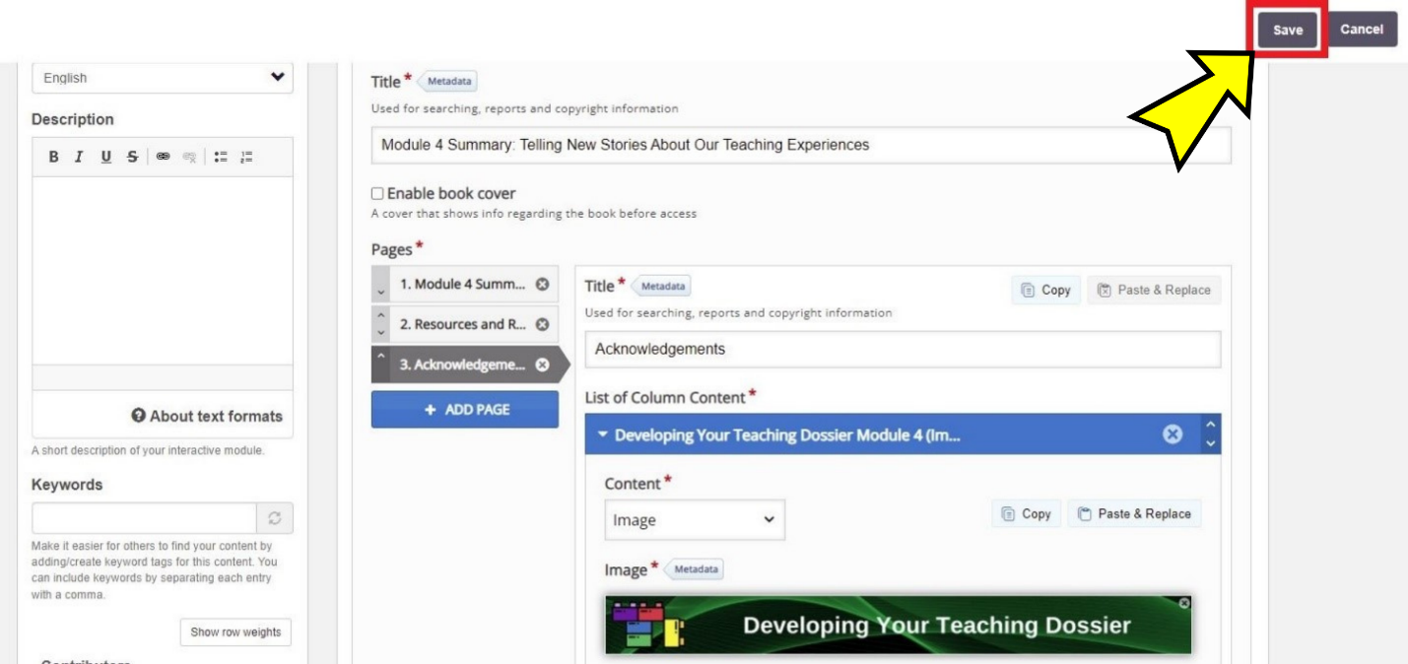

The Certificate of Completion has been successfully removed and the new page title is "Acknowledgements." Note the difference with the initial demonstration screenshot on page 75.

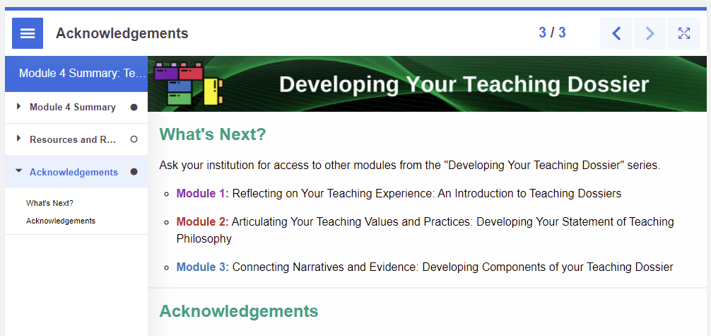

© 2022, VLS Developing Your Teaching Dossier. Except where otherwise noted, this work is made available under a Creative Commons Attribution-NonCommercial-ShareAlike 4.0 International (CC BY-NC-SA 4.0) License: https://creativecommons.org/licenses/by-nc-sa/4.0/.

