Introduction to Fundamentals

Using NI Multisim and the NI myDAQ
Measuring DC Voltage and Current

Learning Objectives
- Use NI Multisim to simulate measurements of voltage and current.
- Use the NI myDAQ to measure the voltage and current in simple circuits.

What You Need
myDaq
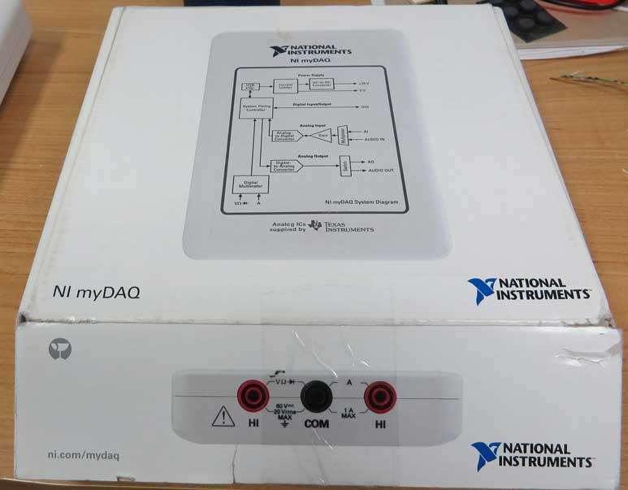

Breadboard
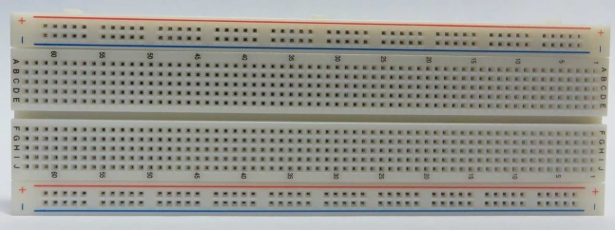

Resistor
560 Ω

Red Light Emitting Diode

1: Using NI Multisim to Simulate DC Voltage and Current Measurements

Purpose

In this exercise you will simulate a simple circuit and measure the voltage across a virtual lamp and the current flowing through the circuit.

- In Multisim open a new NI myDAQ design
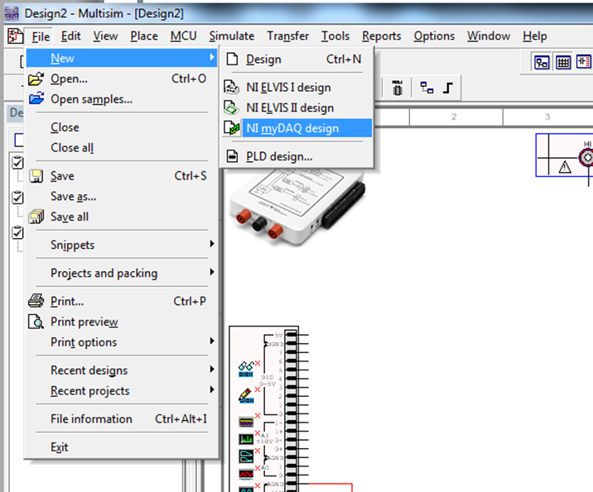

Use the guidelines below to create the following simple circuit:
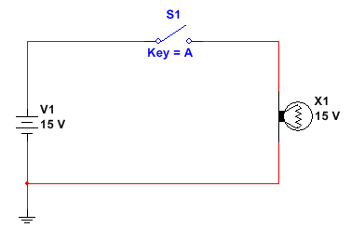

Click the Place Source icon in the top left corner and place the DC_POWER and GROUND parts in your workspace.

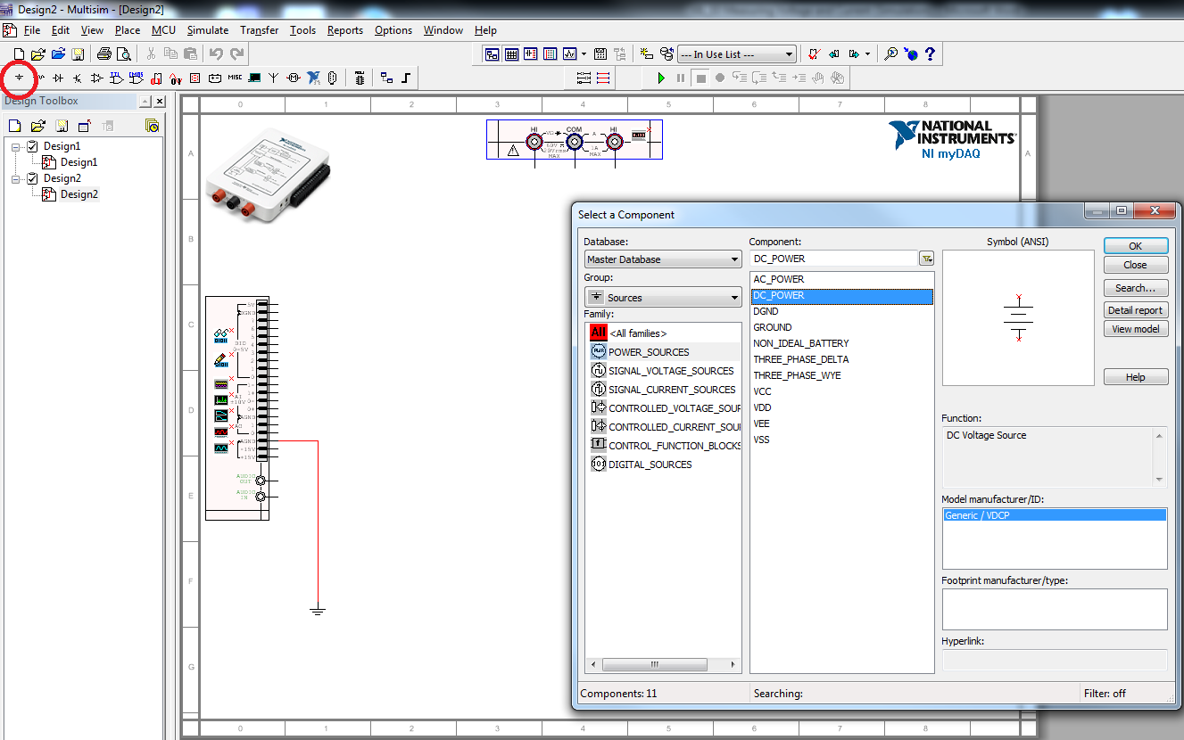

The properties menu for the part can be opened by double clicking on the DC_POWER part. Here you can change the voltage to 15V.

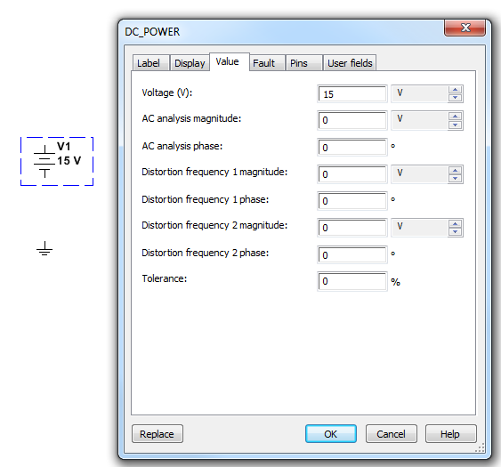

Click on the Place Basic icon, select and place the SPST (Single Pole Single Throw) switch part on the worksheet.

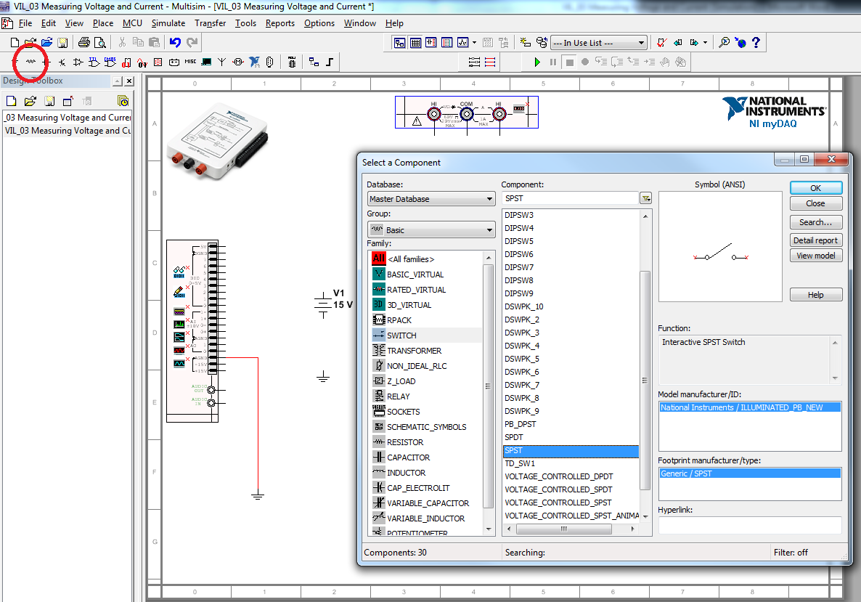

Another way to find parts is to select the Place menu and then select Component…

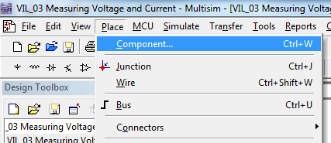

Under Group select ALL <All groups> and under Component: start typing the part you are interested in (in this case a lamp). Select and place the Virtual Lamp on your worksheet.

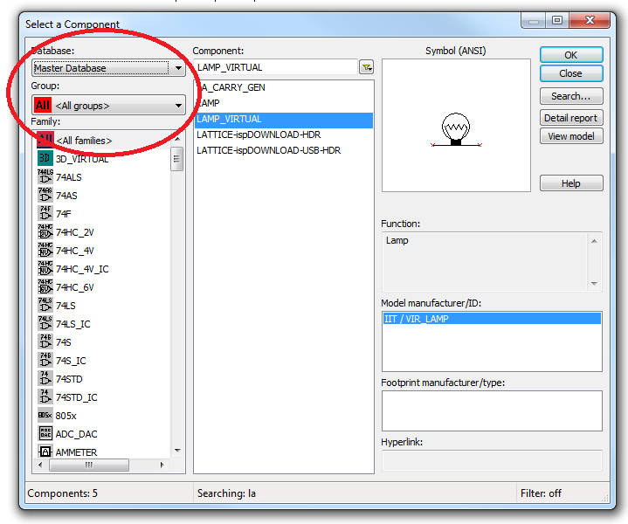

By right clicking on the part, you bring up a menu which will allow you to rotate the part.

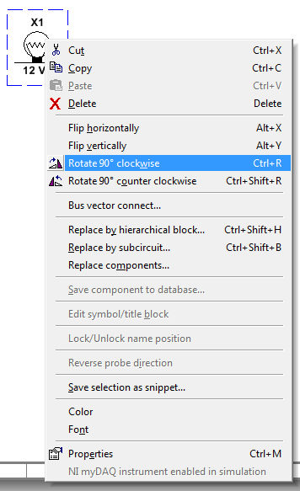

Double click on the lamp and change its voltage to 15V.

Wire all the components together by clicking on the terminals of each part and joining them together.

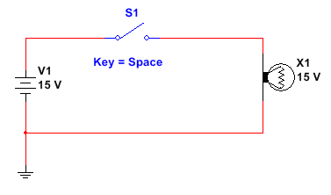

Run the simulation and note that the lamp should light up when the switch is closed, and turn off when the current is stopped by opening the switch.
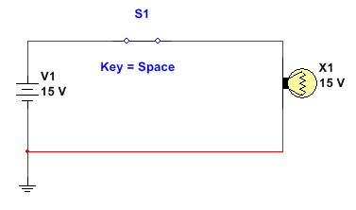

Connect the myDAQ in your simulation to measure the voltage across the lamp. (Remember when measuring voltage we measure across the device).
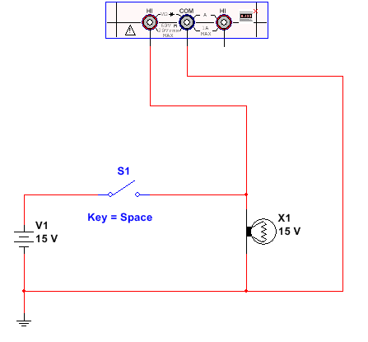

Double click on the myDAQ DMM to activate it

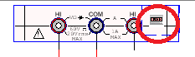

Run the simulation and measure the voltage across the lamp with the switch open and closed. You should get results similar to below:

Switch Open
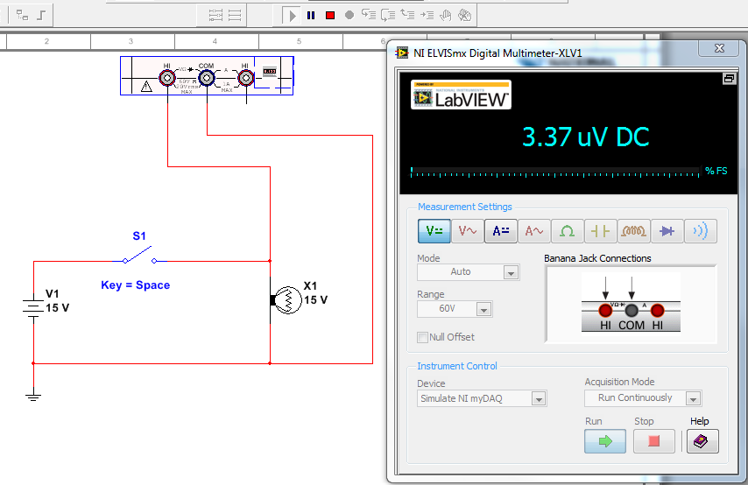

Switch Closed
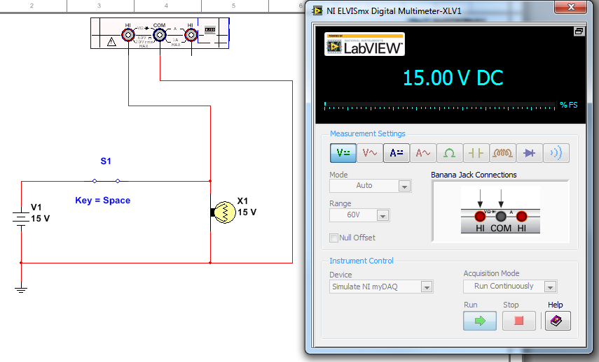
Connect the myDAQ to measure the current flowing through the lamp. Remember in order to measure the current through the circuit, the meter must be inserted into the circuit. (Break open the circuit and connect the meter).

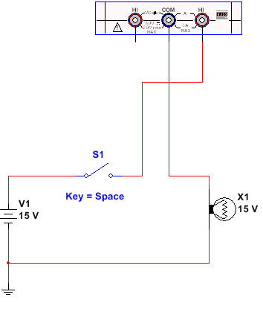

Set the DMM to measure DC current. Run the simulation and record the current with the switch open and closed.

Switch Open
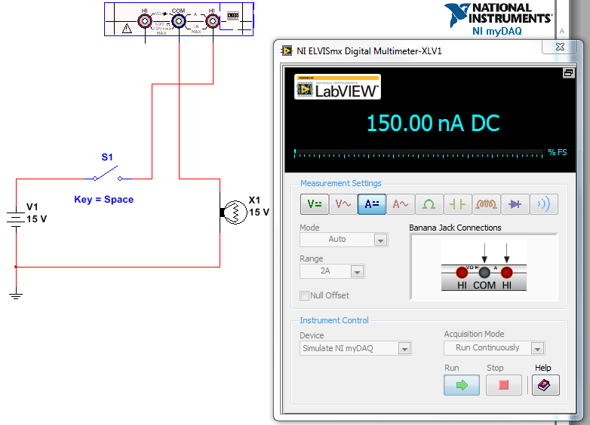

Switch Closed
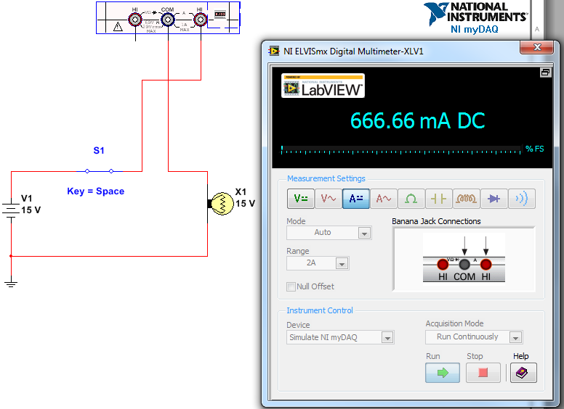

Delete the V1 15V source and connect the circuit to the +15V source and AGND (analog ground) on the myDAQ. Run the simulation and verify that the voltage and current are the same.

Note: This won’t work in reality. The myDAQ is current limited at approximately 30mA.
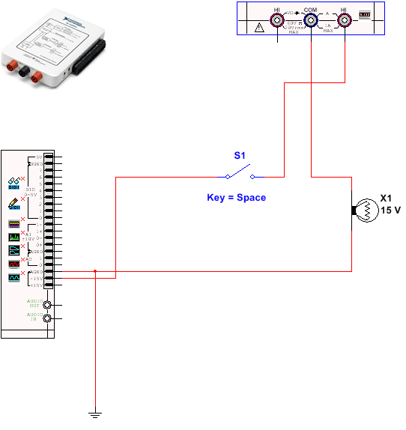

2: Using the NI myDAQ to measure DC Voltage and Current

Purpose
In this exercise you will measure the voltage and current through a real circuit using the myDAQ and compare those measurements to a simulation.

Warning: In this lab the resistor will dissipate about 300mW. Your resistors are designed for 500mW. They are going to get hot! Don’t run the circuit for long periods of time and give the resistor a chance to cool before touching it.

Parts Required:
1 - 560Ω resistor
1 – Red LED

- In Multisim open a new NI myDAQ design

- Create the following circuit using the myDAQ +15V source as the supply voltage:

Schematic Diagram
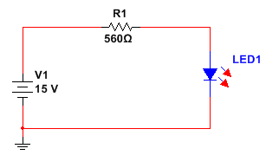

Multisim Layout
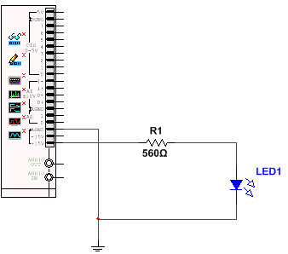
- You will take the following measurements:

Simulated Results
 | Across Source  (from +15V to AGND) | Across R1 | Across LED1
Voltage

Current in Circuit

- Connect the myDAQ DMM (in simulation mode) across each component in turn and measure/record the voltage across each device listed in the table. Then insert the DMM into the circuit and measure the current through the circuit (record your result).

Note: Screenshots of the measurements are shown at the conclusion of the lab if you run into difficulty taking your measurements.

Your results should be similar to the following:

Simulated Results
 | Across Source  (from +15V to AGND) | Across R1 | Across LED1
Voltage | 15.00 V | 13.17 V | 1.83V

Current in Circuit | 23.51 mA

- Try reversing the lead connection to the DMM. You’ll notice that all your measurements will now appear as negative. This is why it is important for a schematic to provide a proper reference system so that you know how all the measurements should be referenced.

Most of our examples are fairly simple with the HI lead on the myDAQ connected to the most positive point and the COM lead to the most negative (or closest to common) being measured.

- Construct the circuit on your breadboard and connect the +15V and AGND connections to the real myDAQ. (This circuit is built exactly the same as the circuit from last week with a different resistor and LED).

Typically the short lead of the LED is the cathode lead and should be connected towards the most negative potential (In this case connect it directly to AGND).

The +15V connection should be made to the side of the resistor not connected to the LED (just like in our schematic and simulation).

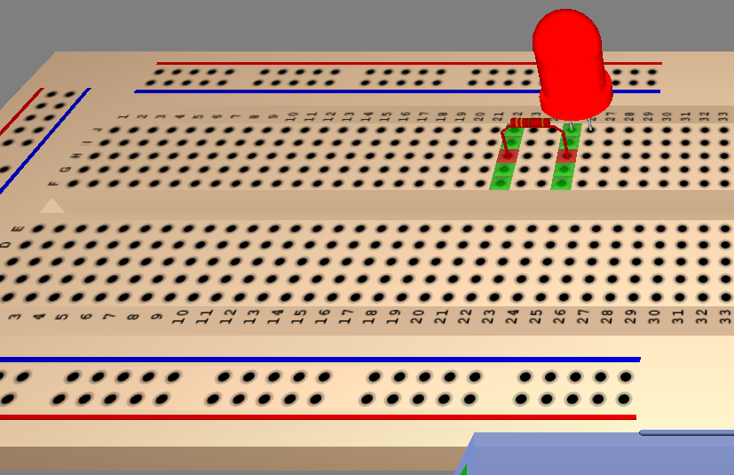
Connect your myDAQ to the computer via the USB cable and then select myDAQ1 (NI myDAQ) under Device in the Instrument Control of the myDAQ multimeter.

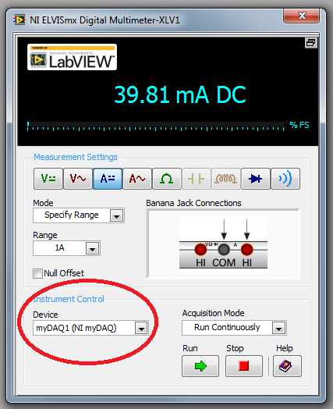

- You will take the following measurements:

Measured Values of circuit with myDAQ
 | Across Source  (from +15V to AGND) | Across R1 | Across LED1
Voltage

Current in Circuit

- Select Run on the myDAQ multimeter and measure/record all the values in the table above (measuring the values in the real circuit).

- Compare your results to the simulated values. As a result of the myDAQ’s low current capacity, the myDAQ’s output voltage may “sag”, resulting in a source voltage closer to 14V.

If the LED does not light, it is possible that you have inserted it backwards. Try reversing it.

Suggestions on taking your measurements:

Voltage Across Source
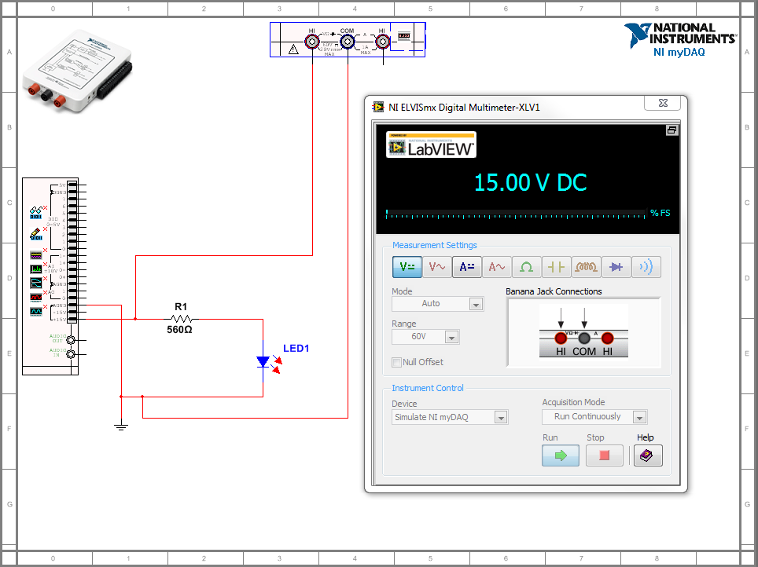

Voltage Across R1
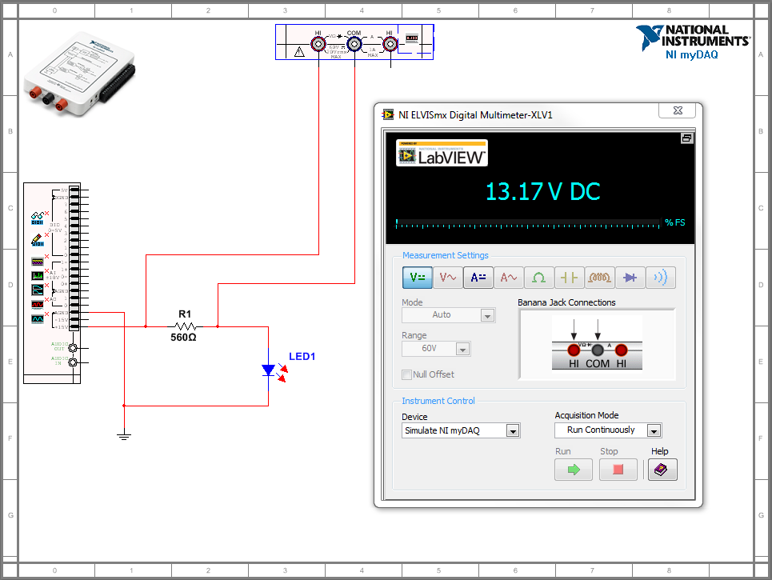

Voltage Across LED
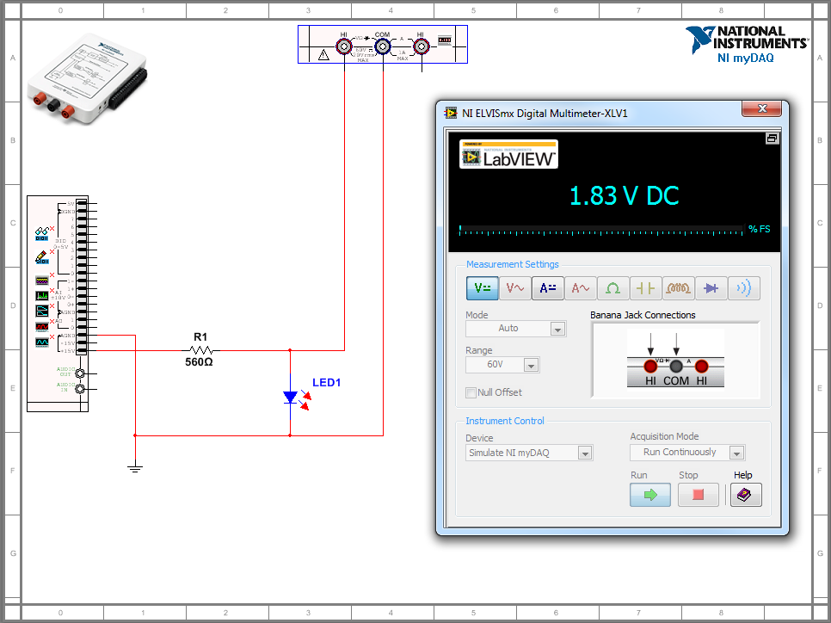

Current Through Circuit
(Note: Since there is only one path for current flow, the current can be measured at any point in the circuit)
