Introduction to Fundamentals

Using NI Multisim and the NI myDAQ
Measuring Resistance

Learning Objectives
- Measure resistance through an electrical simulation and experimentally using the NI myDAQ

What You Need
myDaq
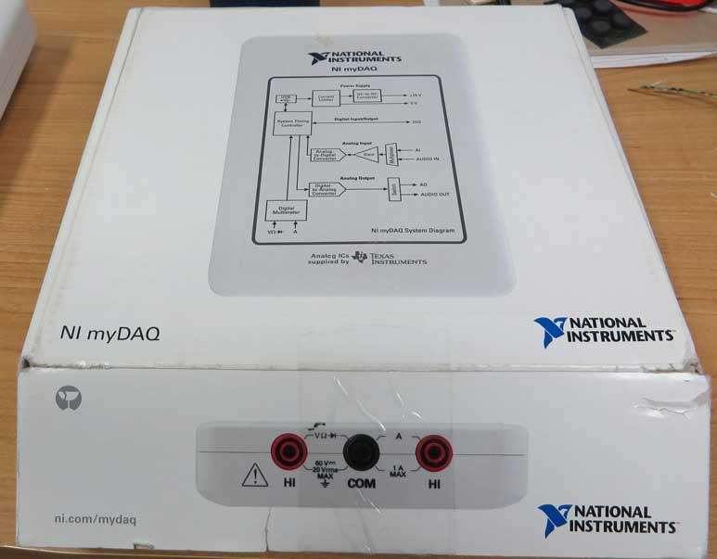

Breadboard
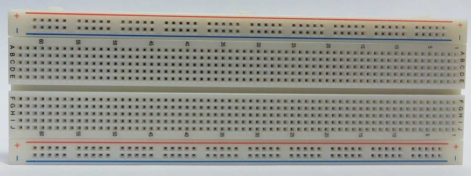

Resistors
10 Ω
82 Ω
330 Ω
1 kΩ
2.2 MΩ

The resistor colour code chart can be found here:
Digikey Resistor Code Chart

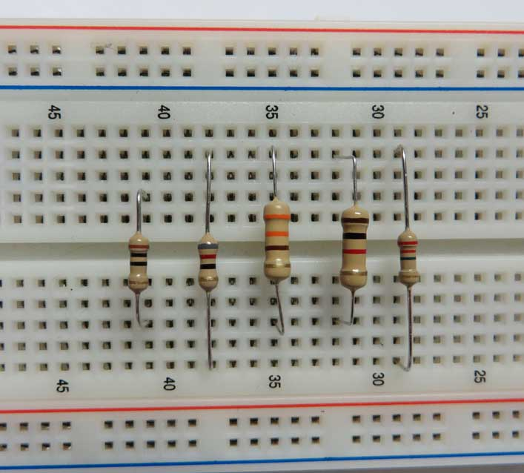

1: measurment of resistance using a simulator

Purpose

In this lab you will simulate the measurement of resistance using NI Multisim and calculate tolerances.

Only NI Multisim is required for this part of the exercise.

Calculated Values
Refer to the resistor values shown in the table below.

Using the procedure for standard four band resistors, determine the corresponding colour code for each.

List the colours in Table 1. (Correct answers located at end of this section)

Table 1 Colour Codes
Resistance  & Tolerance | Colour Codes  First Digit Second Digit Multiplier Tolerance
10 Ω ± 5%
82 Ω ± 2%
330 Ω ± 1%
1 kΩ ± 0.5%
4.7 kΩ ± 0.25%
2.2 MΩ ± 5%

The tolerance of a resistor is a specification which indicates a range of possible values.

For example, for a 10 kΩ resistor with a 5% tolerance:

Tolerance = (5%)(10 kΩ) = 0.5 kΩ = 500 Ω

Therefore the actual value of the resistor is between 9.5 kΩ and 10.5 kΩ.

Calculate the expected minimum and maximum values for the resistors in Table 2, and record the results in your log book.

Table 2 Resistor Tolerance
Resistance  & Tolerance | Resistance Range  Minimum Maximum
10 Ω ± 5%
82 Ω ± 2%
330 Ω ± 1%
1 kΩ ± 0.5%
4.7 kΩ ± 0.25%
2.2 MΩ ± 5%

Use NI Multisim to measure virtual resistors

Open NI Multisim, and select the PLACE BASIC icon which appears as a resistor schematic symbol (shown below). This will open the Select a Component menu with the Basic group of parts open menu allowing you to select and place basic components. Select RESISTOR

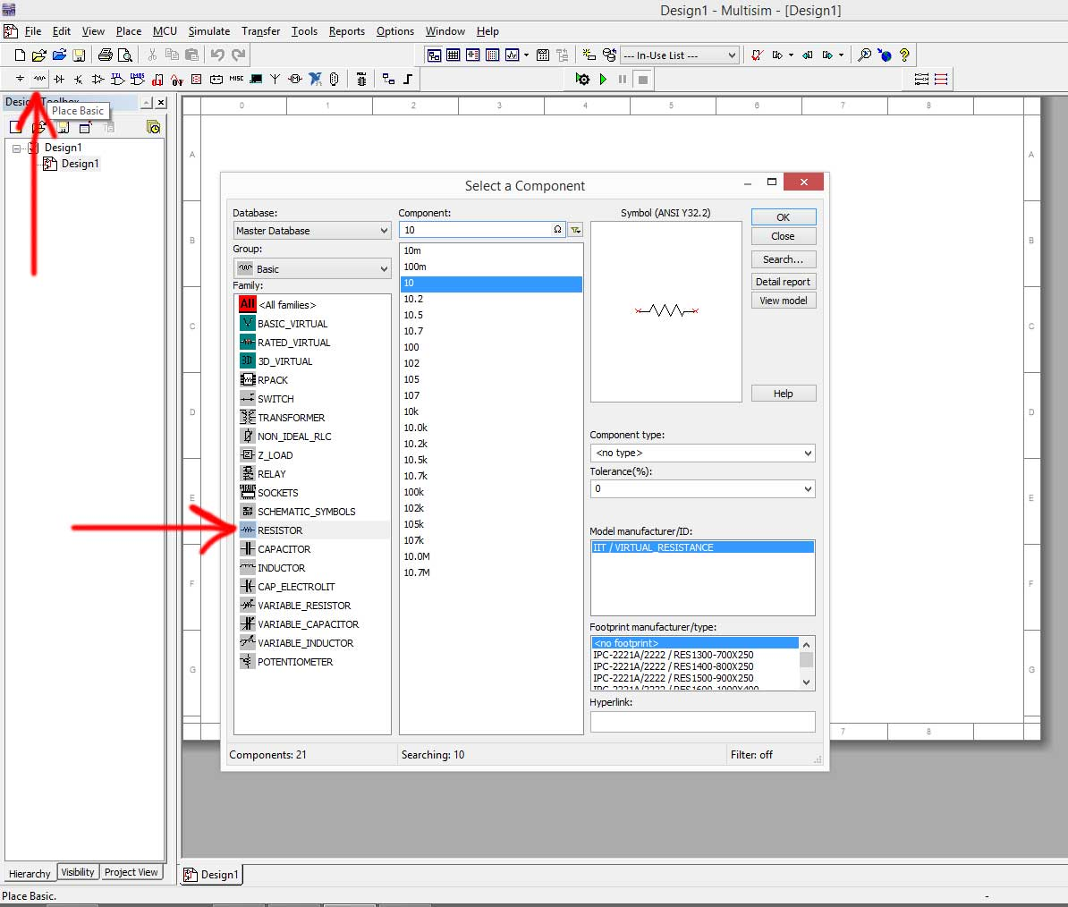

You can type the value of resistor in the text box labelled Component or you can select it from the list.

Set the tolerance of the resistor by clicking on the Tolerance (%) drop down box located in the middle left of the window.

Place the following resistors with these tolerances. Note that although 0.25% isn’t an option, you can still type it in.
10 Ω ± 5%
82 Ω ± 2%
330 Ω ± 1%
1 kΩ ± 0.5%
4.7 kΩ ± 0.25%
2.2 MΩ ± 5%

Your workspace should look similar to the following:

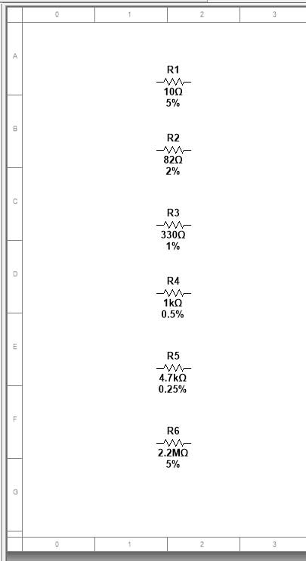

Go to the SIMULATE menu and make sure that USE TOLERANCES is selected.

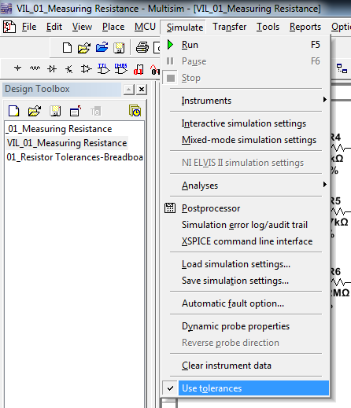

Place two multimeters in the workspace

Instruments can be found as icons along the right hand side of the main window. Instruments can also be found by navigating the Simulate/Instruments menu. You want to place two different multimeters in the workspace. Place the NI Multisim default multimeter, and a simulation of a real Agilent multimeter as shown:

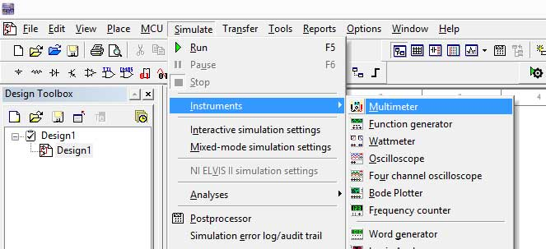

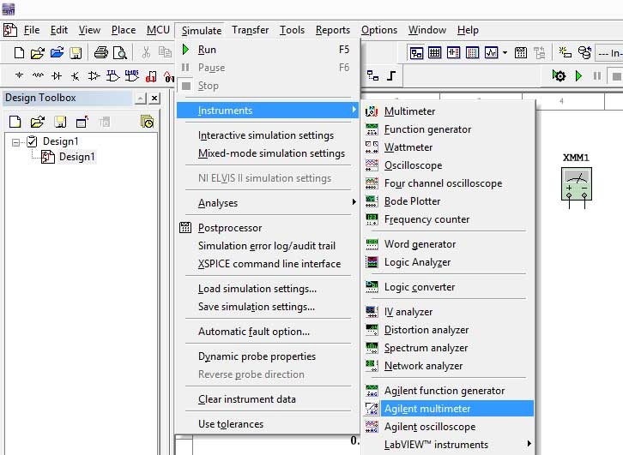

XMM1 is the NI Multisim generic multimeter. XMM2 is a simulation of an Agilent 6½ digit multimeter. The meters will open if double clicked as shown:

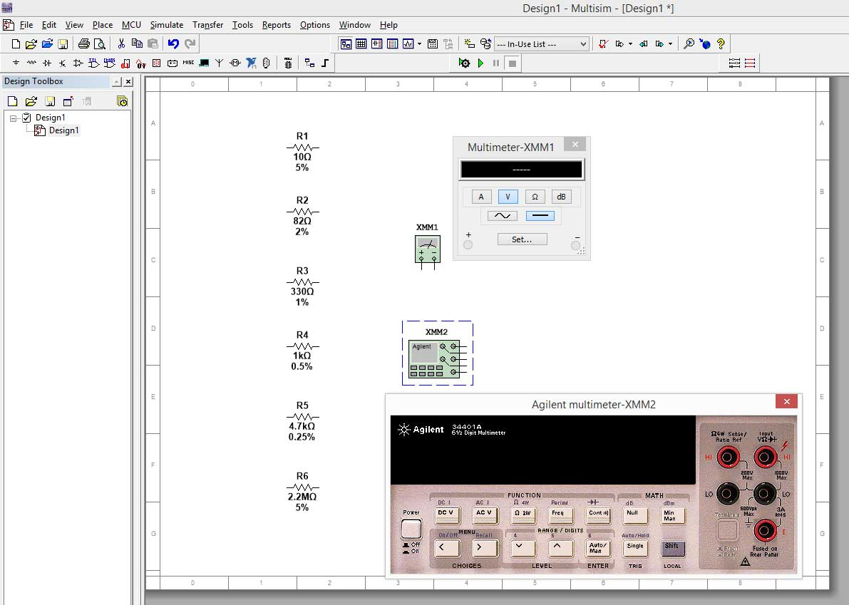

Add a GROUND symbol to the workspace (Multisim requires this to run the simulation, it is not required in real life). You can find it by clicking on the Place Source icon and selecting POWER_SOURCES

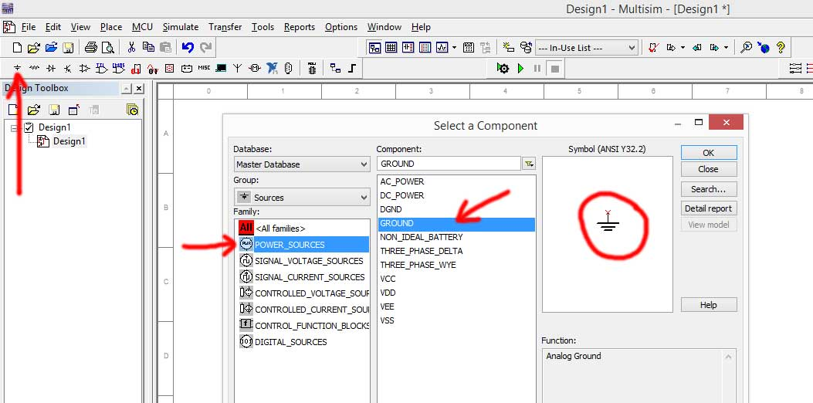

Create the following tables in Excel (or your logbook):

Table 3 Measurements with XMM1
Nominal Resistance | Measured Resistance | % Error
10 Ω
82 Ω
330 Ω
1 k Ω
4.7 k Ω
2.2 M Ω

Table 4 Measurements with XMM2
Nominal Resistance | Measured Resistance | % Error
10 Ω
82 Ω
330 Ω
1 k Ω
4.7 k Ω
2.2 M Ω

Wire up XMM1 to the first resistor as shown. You wire by clicking on a terminal which creates a “wire”. You can place a wire by dragging the wire behind your cursor and clicking again. You terminate the wire by clicking on another lead (for a component or instrument) or by right clicking.

The wiring option (and related options such as creating a junction of wires) can also be found in the Place menu.

Right clicking on a wire will open an options window allowing you to change its properties (such as colour) or delete it.
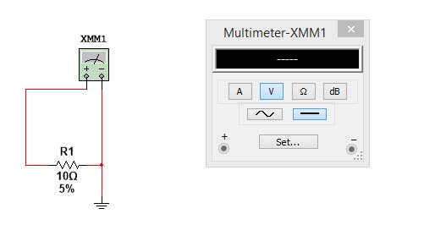
Click on the Ω symbol on XMM1. This will cause the multimeter to measure resistance.

When you begin the simulation by clicking the START SIMULATION icon, NI Multisim will vary the values of the resistors by the tokerance you indicated (failures can also be simulated). Note that once you click the stop simulation button and then restart the simulation the resistor values will change (within the tolerance).

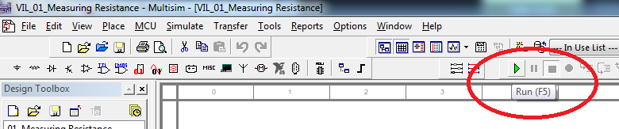

Start the simulation and measure the resistance. You should see something similar to the following (within the tolerance indicated):

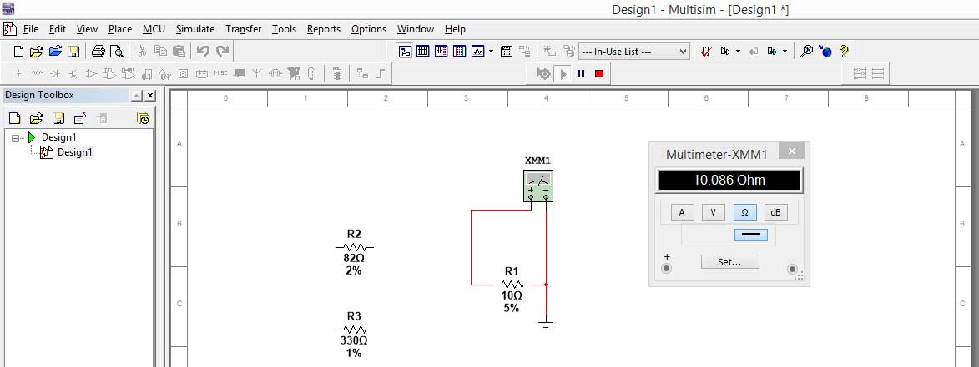

Record the value in the table, calculate the actual % error from the nominal value and repeat this process with the remaining resistors.

Note: Do not try to measure one resistor with both XMM1 and XMM2 at the same time as this will cause an error in the simulation and provide you with a totally incorrect result on XMM1.

Repeat this process by now connecting the resistors to XMM2.

You must actually press the power button on the simulated instrument for it to work. Then click on the button with the Ω 2W symbol (this means 2 wire resistance measurement).

Note: XX2 provides increased precision when compared to XMM1.
The resistors values measured by XMM1 and XMM2 may be quite different because the simulation has been stopped and restarted causing the resistor values to be reset.
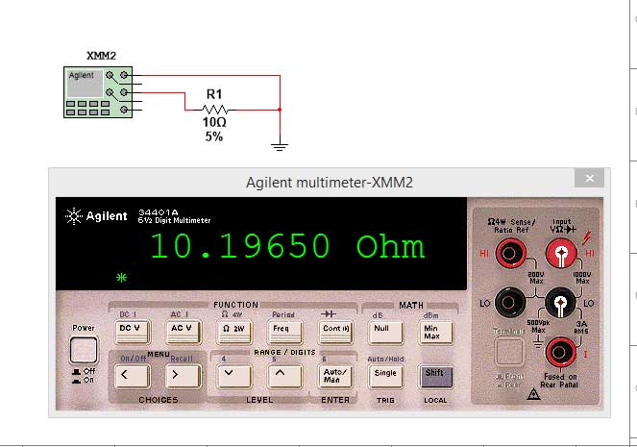
Measure each resistor again using the XMM2 meter and enter you values in the table. Calculate the % error of the resistance from the nominal value.
All of the %error values should be within the tolerance set for the resistor.

Answers
Table 1 Colour Codes
Resistance  & Tolerance | Colour Codes  First Digit Second Digit Multiplier Tolerance
10 Ω ± 5% | Brown | Black | Black | Gold
82 Ω ± 2% | Grey | Red | Black | Red
330 Ω ± 1% | Orange | Orange | Brown | Brown
1 kΩ ± 0.5% | Brown | Black | Red | Green
4.7 kΩ ± 0.25% | Yellow | Violet | Red | Blue
2.2 MΩ ± 5% | Red | Red | Green | Gold

Table 2 Resistor Tolerance
Resistance  & Tolerance | Resistance Range  Minimum Maximum
10 Ω ± 5% | 9.5Ω | 10.5Ω
82 Ω ± 2% | 80.36Ω | 83.64Ω
330 Ω ± 1% | 326.7Ω | 333.3Ω
1 kΩ ± 0.5% | 995Ω | 1005Ω
4.7 kΩ ± 0.25% | 4.69kΩ | 4.71kΩ
2.2 MΩ ± 5% | 2.09MΩ | 2.31MΩ

2: Measuring resistance with the mydaq

Plug the myDAQ USB cable into your computer. When the NI ELVISmx Instrument Launcher appears select the DMM (Digital Multimeter) (In some cases, you may have to manual launch the Instrument Launcher from the program menu)

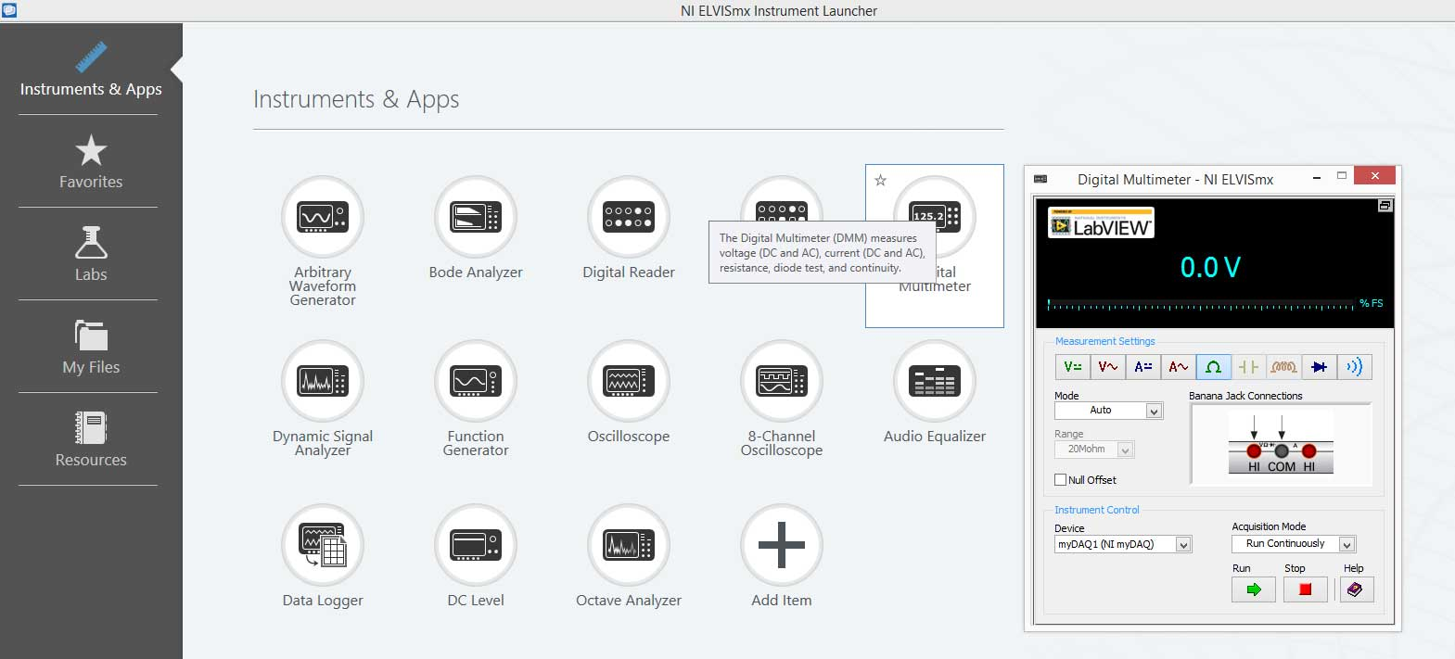

Click run in the DMM panel and then click Ω to measure resistance. You’ll notice that by mousing over the various icons the Context Help window will change its content to explain each one. Set the Mode to Auto. This will cause the meter to “Auto Range” which means that it will select the lowest range possible to measure the resistance (and provide you with the most precise result).

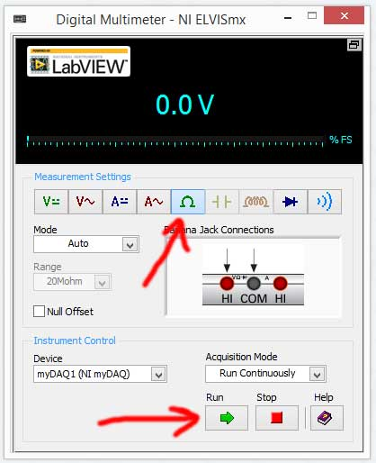

Insert the meter leads into the myDAQ. You’ll notice that the virtual instrument on the computer shows you where the correct connections are.

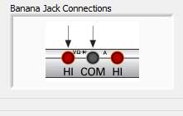

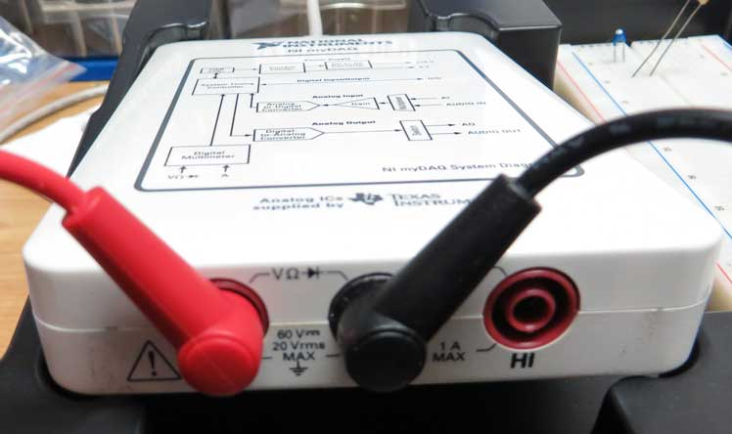

Place one of the resistors in the breadboard and measure as shown (1kΩ resistor shown).

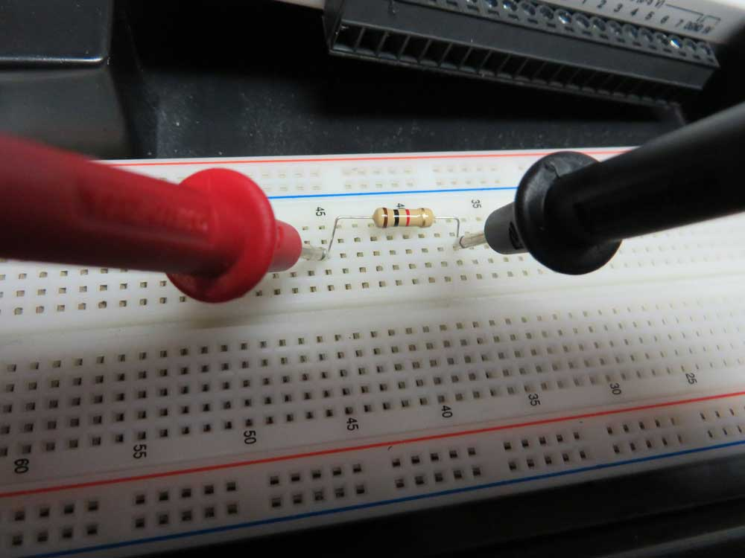
You should read something similar to this on the myDAQ

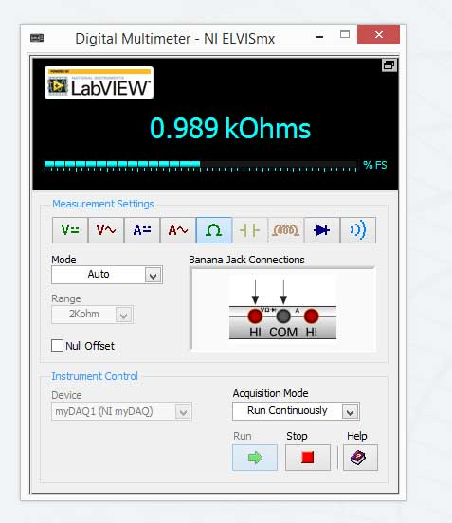

Change the Mode to Specify Range and then try changing the range from the 200Ω range to the 20MΩ range. These are the maximum resistances that can be measured using that range. If using the 1kΩ resistor it should read +Over on the 200Ω range (1k is too high to measure, or 0.00MΩ on the 20MΩ range because it’s too small to measure.

Always remember to use the lowest range possible. (If the meter doesn’t Auto Range).

Measure the resistance for each of the resistors (record the value as displayed on the meter), and then calculate the percentage error (which should be within 5%).

Measured Resistance Values using NI myDAQ
Nominal Resistor Value | Measured Value | % Error
10 Ω
82 Ω
330 Ω
1 kΩ
2.2 MΩ

$$Percentage Error= \frac{\left| Nominal Value-Measured Value \right|}{| Measured Value |} x 100\%$$

