Introduction to Fundamentals

Using NI Multisim and the NI myDAQ
Connecting your first Circuit

Learning Objectives
- Build a simple circuit on a solderless breadboard and familiarize yourself with basic electrical measurements using the NI myDAQ
Skills
- Build a simple circuit on a solderless breadboard using a resistor and Light Emitting Diode (LED) which is powered using the myDAQ

What You Need
myDaq
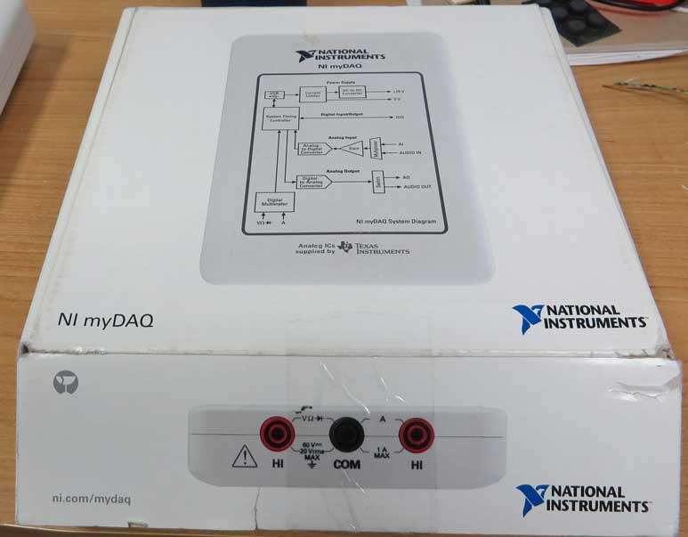

Breadboard
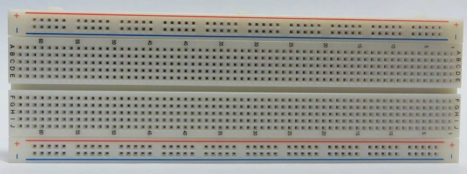

Wire
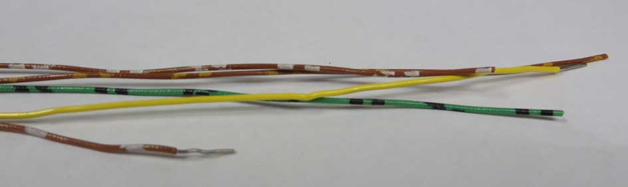

1 kΩ Resistor (Brown, Black, Red, Gold Bands)
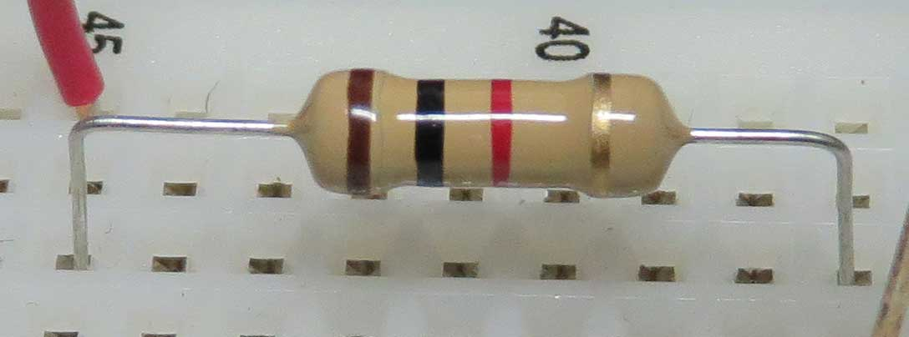

Light Emitting Diode
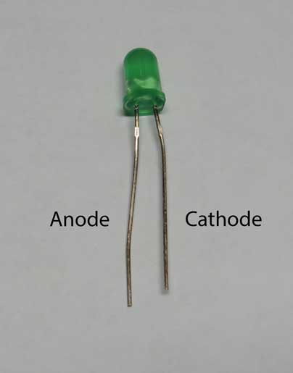

1: Setting up the Solderless Breadboard

The breadboard allows you to easily connect electrical and electronic components together when building relatively simple circuits. Inside the breadboard are electrical connections allowing you to connect the parts without wires.

Top View of Breadboard
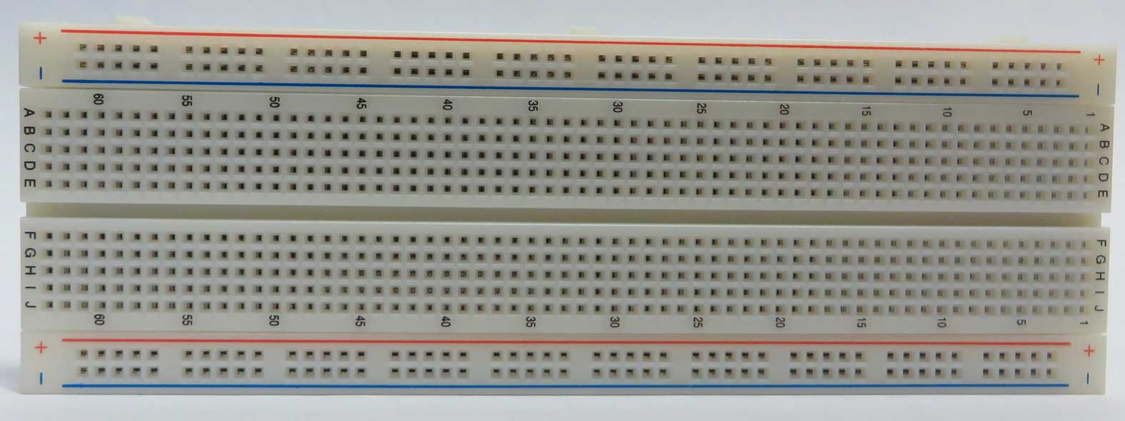

Bottom View of Breadboard with Adhesive Back Removed
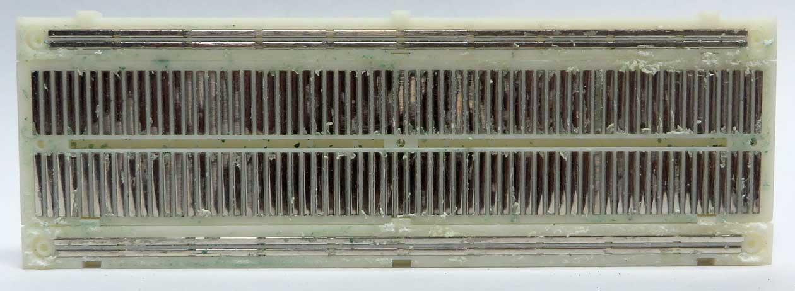

Note the two top and two bottom rows form conductive bars that run the entire length of the breadboard. Any wires or leads placed in holes connected by that bar will allow current to flow between them. Although many people use these “bus bars” as connecting points for power (note the + and – new to the rows) you should avoid using them unless you have a large number of power connections to make. The long conductor of the bus bar acts like an antenna and can cause your circuit to become electrically “noisy”.

The vertical bars connect points A,B,C,D, and E together creating 63 separate columns. Anything in column 1 points A-E are connected together. Columns 1 and 2 are not.

Vertical bars also connect points F,G,H,I, and J together in each column. The ditch separating the E and F rows isolates points A-E from F-J for each column. We’ll use this feature quite a bit when we start using electronic “chips”. For now, just remember that the top and bottom are separated.

Remove the myDAQ and tray from the box and place your breadboard in the tray. (You don’t need to use the tray, but it generally makes life easier I find.

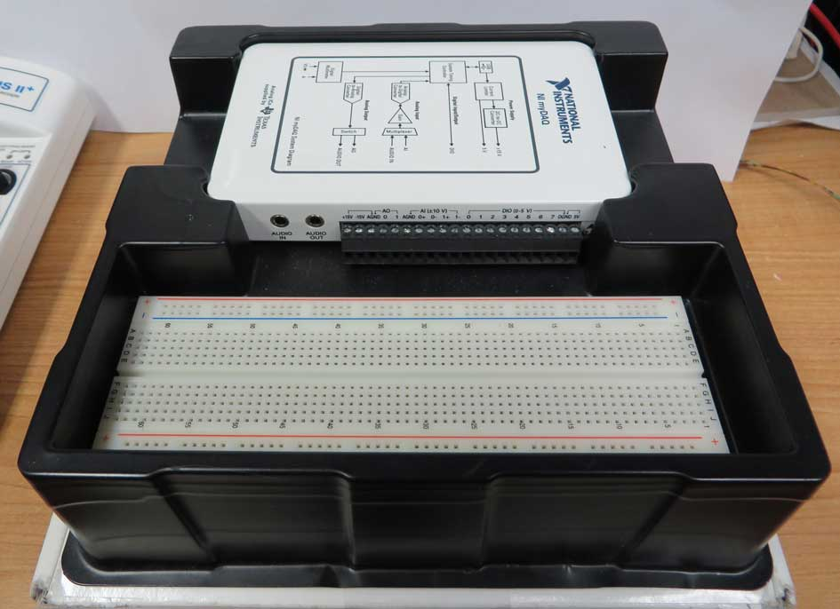

2: Light emitting diode

The LED Pin Connections

The LED has two leads: the Anode and the Cathode. If the Anode is more positive than the Cathode, and the voltage is high enough the LED will light up. If you hook it up backwards nothing happens.
Note:
You usually need a resistor in series with the LED, or it could fail. An LED of this type, can not limit its current to a safe level.

The longer lead (unless someone cut it on you…) should be the “Anode” and the shorter lead the “Cathode”. You’ll notice that on many LEDs there is a flat spot on the package which is typically the cathode side.

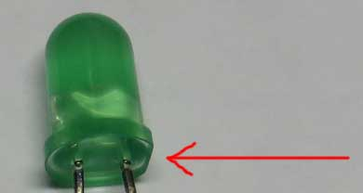

You should always check the data sheet for the part, just in case!

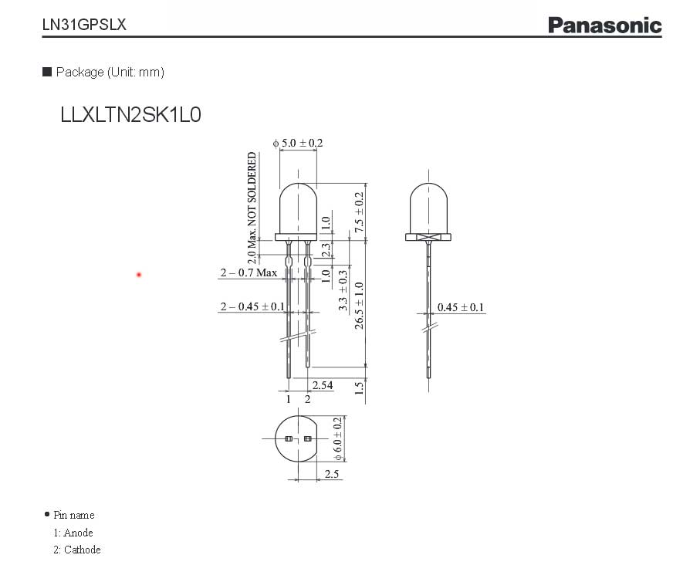http://www.semicon.panasonic.co.jp/ds4/LN31GPSLX_E.pdf

3: Wiring Up the LED

Connect the resistor and LED together as shown in the images. (Don’t worry about the wires yet). Notice that one lead of the resistor and one lead of the LED share the same column. This connects them together. Current will flow through the resistor into the breadboard and then into the LED.

Note: Make sure the Anode (longer lead) is the one sharing the same column as the resistor.

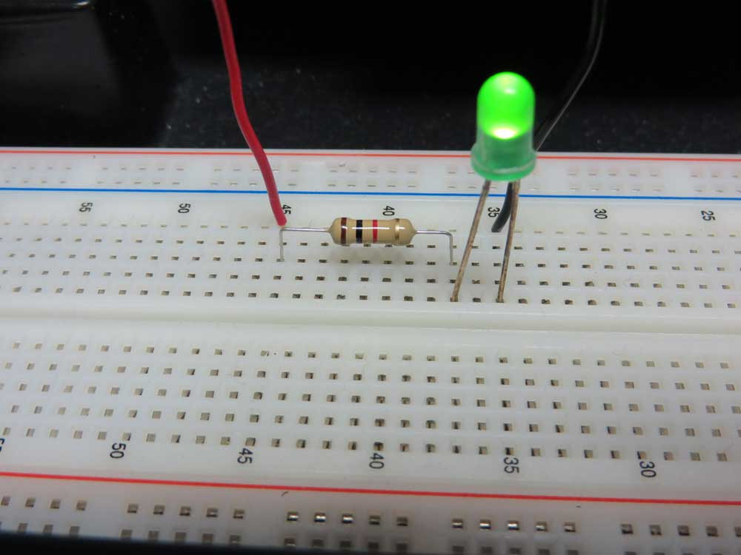

You can form (bend) the leads of the resistor using your needle nose pliers. You should cut the ends of the leads off that were covered in paper. The glue on the leads can get stuck in the breadboard and create bad connections that will be hard to track down later.

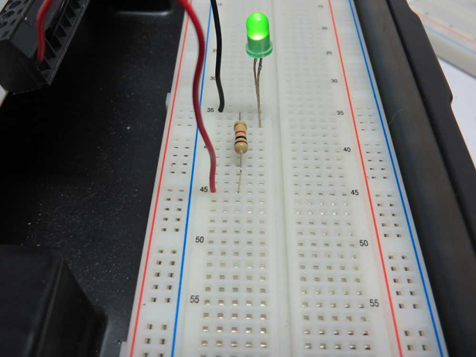

Wire it up

Use your pliers and wire strippers to cut two wires long enough to travel from the breadboard to the myDAQ terminal strip. Preferably use red and black ( for “+” and “-“ ) to make it easy to identify.

Connect the red wire ( the “positive” wire ) to the myDAQ as shown to the +15V terminal.
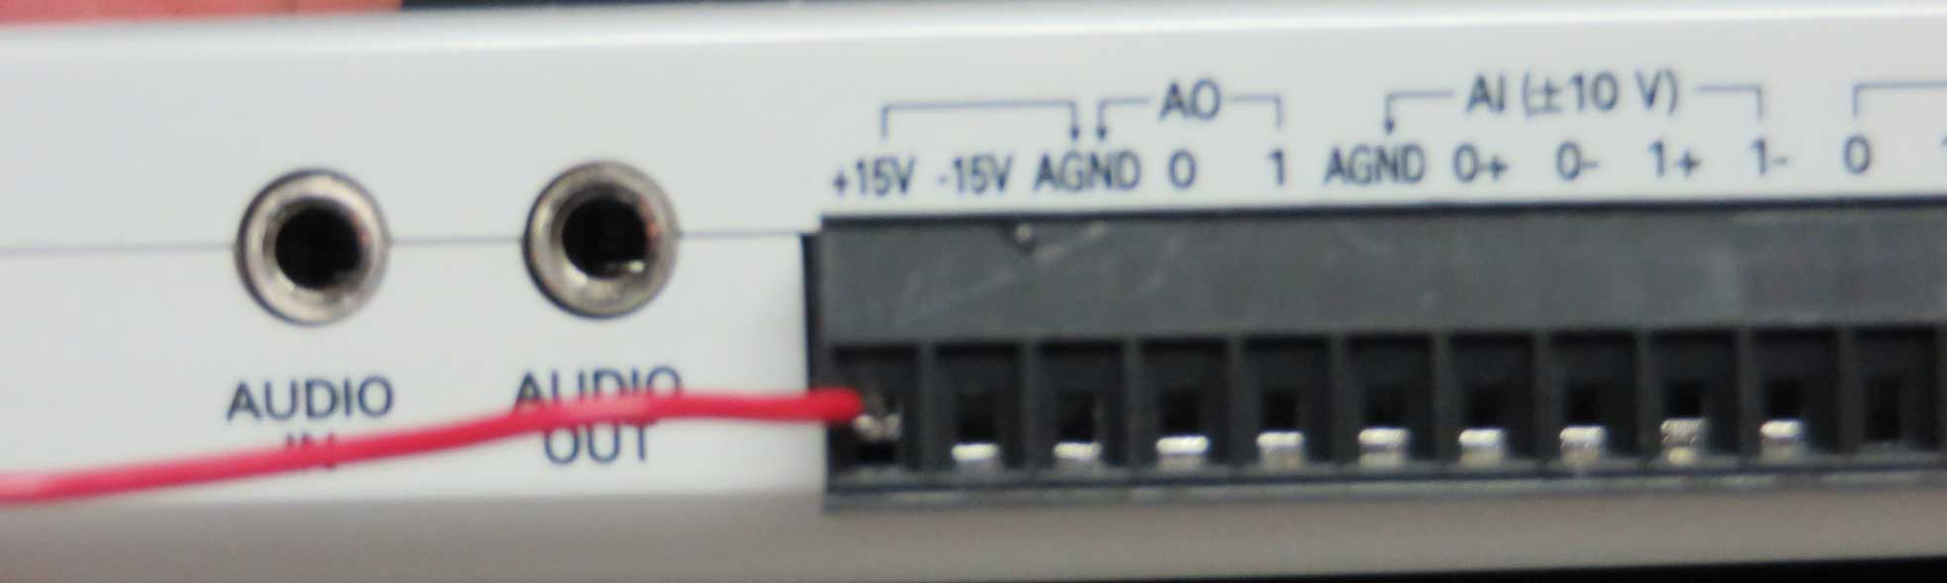

Use the screwdriver that came with the myDAQ to tighten the connector. When you turn the screw clockwise (right) it will close the terminal jaws. When you turn the screw counterclockwise (left) the jaws open. Make sure you can see that the wire is being pinched at the top of the connector. Pinching it at the bottom creates a bad connection that will easily pull out.

Connect the black wire (the “negative“ wire ) to the AGND terminal as shown.
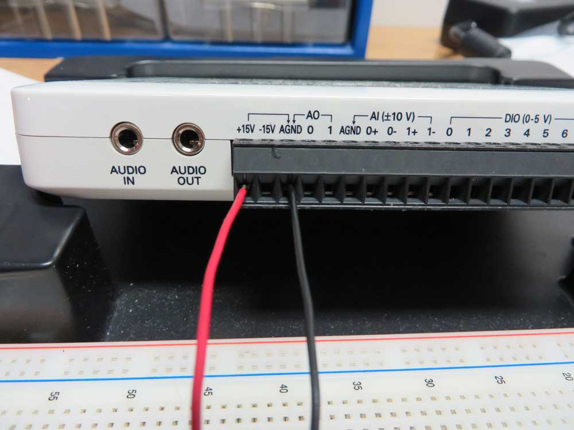

Connect the wires to your circuit as shown. Notice that the positive lead (+15V) is connected to a hole in the same column as the resistor and the negative lead (AGND) is connected to a hole in the same column as the Cathode of the LED.
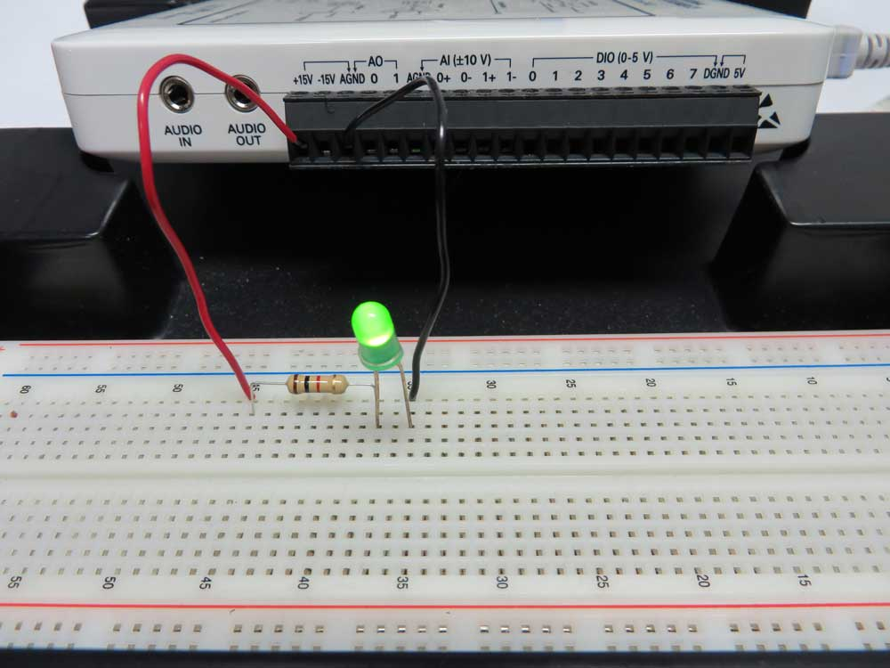

(Assuming Conventional Current Flow) Current will flow from the positive terminal through the resistor, into the LED, and then from the LED into the negative terminal.

Worried you’re going to burn something up? The myDAQ can only produce a maximum of 32mA from the +15V terminal (always check the specification sheet). The LED maximum operating current is 30mA. The LED won’t be thanking you if you short something out, but it’s unlikely that you’ll damage it.

Power It Up!
Plug the myDAQ USB cable into a computer. The blue LED on the side of the myDAQ should light up indicating that the myDAQ is powered. Within a few seconds your LED should light up!

myDAQ Specifications: http://www.ni.com/pdf/manuals/373060e.pdf pg. 43
LED Datasheet: http://www.semicon.panasonic.co.jp/ds4/LN31GPSLX_E.pdf

Not Working?
- Make sure the blue light is on (on the myDAQ)
- Try flipping the LED around (in case you put it in backward)
- The most common problem is that the connections are not made correctly. Remember if two leads are to be connected, they must be in the same column of the breadboard.
- Double check the connection to the myDAQ (give them a light tug)

Still can’t get it to work? Ask a friend or your professor for help. Sometimes a fresh pair of eyes will see something that you missed.

