Examples from Textbooks
The following examples have been taken from textbooks. Examine each example and the attached statements. Pick the statement that you think BEST describes the example. Then, brainstorm ways the material could be made more inclusive.

Example #1
In a unit on marriage in a sociology textbook, the following images are included:
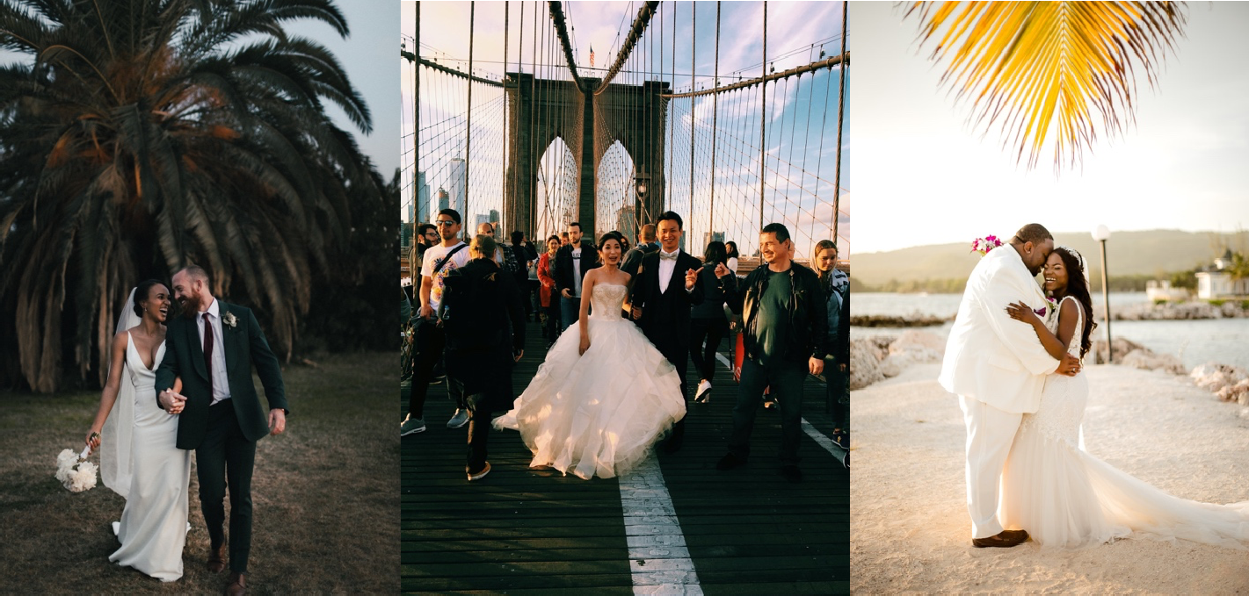

Pick the statement that you think BEST describes these images:

1 These images include a wide variety of perspectives, worldviews, and experiences.
1 These images exclude a variety of perspectives, worldviews, and experiences.

Brainstorm some ways that this material could be made more inclusive.

Example #2
The following passage is found at the beginning of an introductory textbook on math and science:

“There are many well-known scientists who have contributed to advancements in their field. From as far back as Archimedes in Ancient Greece, through to Charles Darwin, Thomas Edison, Albert Einstein, and Stephen Hawking, man has been searching for answers about the nature of the universe. In this book we will examine the contributions of these individuals to shaping the fields of math and science.”

Pick the statement that you think BEST describes this passage:

1 This passage includes a wide variety of perspectives and worldviews.
1 This passage excludes a variety of perspectives and worldviews.

Brainstorm some ways that this material could be made more inclusive.

The following passage is from a textbook for teachers-in-training:

“An essential part of classroom management is the teacher’s positioning in the room. While learners are working, try not to stay in one place. Instead, walk around the room and bend down to speak to students.”

Pick the statement that you think BEST describes this passage:

1 This passage is inclusive of various abilities.
1 This passage is not inclusive of various abilities.

Brainstorm some ways that this material could be made more inclusive.

Example #4

The following passage is taken from a textbook on the skilled trades:

“A technician is only as accurate as the measurement equipment they are using. If the equipment is used incorrectly or is faulty, then the measurements will be inaccurate. If the measurements are inaccurate, then the technician will draw the wrong conclusions.” (Source)

Pick the statement that you think BEST describes this passage:

1 This passage uses inclusive and non-discriminatory language.
1 This passage does not use inclusive and non-discriminatory language.

Brainstorm some ways that this material could be made more inclusive.

Answer Key

Example #1:
These images include some depiction of racial diversity. However, they all represent heterosexual relationships and Western wedding traditions. They could be made more inclusive by depicting different family structures and a broader spectrum of wedding traditions.

Are there other ways you can think of to make this material more inclusive?

Example #2:
This passage focuses only on a Western-centric history of math and science. It only references male thinkers in the field. It could be made more inclusive by including different perspectives and worldviews as well as thinkers of other genders.

Are there other ways you can think of to make this passage more inclusive?

Example #3:
This passage assumes that an instructor can physically walk around a classroom and bend down to speak to learners. It could be made more inclusive by suggesting other ways an instructor can monitor student work and engage in classroom management.

Are there other ways you can think of to make this passage more inclusive?

Example #4:
This passage uses the pronoun "they" to describe the technician. This is inclusive as it avoids gendering the technician.

Are there other ways you can think of to make this passage more inclusive?

