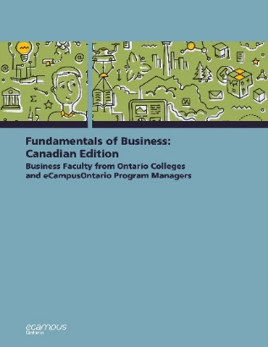
The following passage is the introductory paragraph to a unit on the Canadian Economic System. Read the passage and answer the questions that follow. Words likely to be unknown by your ELLs have been substituted with the word "huh"
Like most countries, Canada features a mixed market system much like its neighbor to the south; though the Canadian and U.S. economic systems are primarily free market systems, the federal government controls some basic services, such as the huh service and air traffic control. The Canadian economy also has some characteristics of a huh system, such as providing social security retirement benefits to retired workers or free health care to its population.
The free market system was huh by Adam Smith in his book The Wealth of Nations. huh in 1776. According to Smith, competition alone would ensure that consumers received the best products at the best prices. In the kind of competition he assumed, a huh who tries to charge more for his product than other huh would not be able to find any buyers. A job-huh who asks more than the going wage will not be hired. Because the “huh hand” of competition will make the market work effectively, there will not be a need to regulate prices or wages. Almost immediately, however, a tension developed among free market huh between the principle of huh-huh - leaving things alone - and government intervention. Today, it is common for the Canadian government to huh in the operation of the economic system. For example, government huh influence on the food and industries through Canada’s Food and Drug Act and Regulations which protect consumers by preventing huh or huh products from reaching the market.
Questions:
- Are you confident that you summarize the main points of the paragraph?
- Approximately how long did it take you to read this passage?
- If you had to look up the "huh" out words in a dictionary, approximately how long would it take you to read this passage?
Now read the passage with all the words visible.
Like most countries, Canada features a mixed market system much like its neighbor to the south; though the Canadian and U.S. economic systems are primarily free market systems, the federal government controls some basic services, such as the postal service and air traffic control. The Canadian economy also has some characteristics of a socialist system, such as providing social security retirement benefits to retired workers or free health care to its population.
The free market system was espoused by Adam Smith in his book The Wealth of Nations. published in 1776. According to Smith, competition alone would ensure that consumers received the best products at the best prices. In the kind of competition he assumed, a seller who tries to charge more for his product than other sellers would not be able to find any buyers. A job-seeker who asks more than the going wage will not be hired. Because the “invisible hand” of competition will make the market work effectively, there will not be a need to regulate prices or wages. Almost immediately, however, a tension developed among free market theorists between the principle of laissez faire - leaving things alone - and government intervention. Today, it is common for the Canadian government to intervene in the operation of the economic system. For example, government exerts influence on the food and industries through Canada’s Food and Drug Act and Regulations which protect consumers by preventing mislabeled or mislabeled products from reaching the market.

Word Coverage

Percentages of words in each category for the passage you just read:
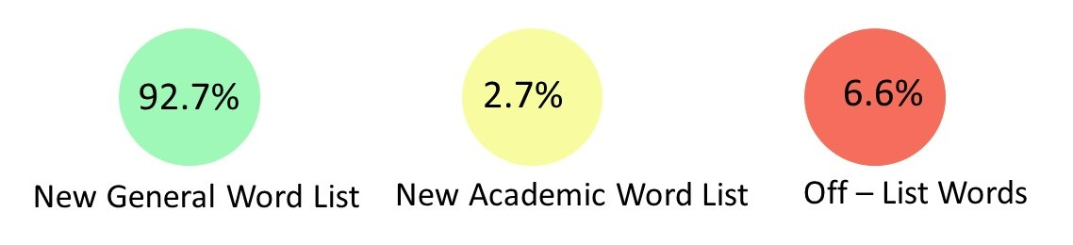
Much of the text belongs to the New General Service List which represents the 2800 core English words.

Some of the words are in the New Academic Word List which represents 963 words and their forms that are common in academic texts across disciplines.
intervene, published, theorists

Some of the words do not appear on either list. Many of these words are subject specific jargon that are important to understand the subject content.
espoused, exerts, invisible, laissez faire, mislabeled, postal, seeker, seller, socialist
Most ELLs will know most of the common text found on the General Service List and some of the vocabulary from the New Academic Word List if they have studied those words or encountered them previously. They may be familiar with some of the off-list text also depending on their prior learning and their first language which may have some similar words (cognates) or similar root words. In order to read with good comprehension, readers should know 98% of the vocabulary in the text (Schmitt et al., 2011).

Task A
The following passage is from the same unit on Economics and Business. Highlight the words that you think would not be on the new general word list or the new academic word list in this passage from the section “Monopoly”
One purpose of an economy is to provide people with goods and services – cars, computers, video games, houses, rock concerts, fast food, amusement parks. One way in which economists measure the performance of an economy is by looking at a widely used measure of total output called the gross domestic product (GDP). The GDP is defined as the market value of all goods and services produced by the economy in a given year. The GDP includes only those goods and services produced domestically; goods produced outside the country are excluded. The GDP also includes only those goods and services that are produced for the final user intermediate products are excluded. For example the silicon chip that goes into a computer (an intermediate product) would not count directly because it is included when the finished computer is counted. By itself, the GDP does not necessarily tell us much about the direction of the economy. But change in the GDP does. If the GDP (after adjusting for inflation, which will be discussed later) goes up, the economy is growing. If it goes down, the economy is contracting. There is some debate amongst economists that GDP provides the most accurate measure of an economy’s performance. Many economists believe that GDP per capita, which is the measure of total production of goods and services divided by the number of households, is a better indicator of an economy’s performance. For example, according to the World Bank, as of 2017 India’s GDP ranked 7th in the world at $2.439 trillion (USD) while Canada’s GDP ranked 10th at $1.640 trillion (USD). However, as of 2017, Canada GDP per capita ranks 18th at $44,773 per household, compared to India’s GDP per capita which ranked 142nd in the world at $1,852 per household.

Task B
Look at the words you highlighted. Some of the words are frequently used in many contexts and appear on the New Academic Word List so students should learn them. Others are used specifically for this context. For those words, students should be given a reference glossary. Determine if the words should be “learned” or put in a glossary.

Online tools such as the NAWL Highlighter can analyze text to identify words that are on the New Academic Word List, New General Service Word List or are Off-List. The online tool Rewordify identifies difficult vocabulary and provides simplifed wording. Teachers can use this tool to quickly identify words that may be difficult for ELLs. Based on the suggestions, text can easily be modified. The simplified wording can be used to quickly generate vocabulary tasks and glossaries. Students can use this tool to support their reading comprehension.
The following is text output from Rewordify. The text in brackets is the simplified text.

Like most countries, Canada features a mixed market system much like its neighbor to the south; though the Canadian and U.S. economic [money-based] systems are primarily [mostly] free market systems, the federal government controls some basic services, such as the postal service and air traffic control. The Canadian economy [process of people making, selling, and buying things] also has some characteristics [features/ qualities/ traits] of a socialist system, such as providing social security retirement benefits to retired workers or free health care to its population.
The free market system was espoused [supported] by Adam Smith in his book The Wealth of Nations. published in 1776. According to Smith, competition alone would ensure [secure/make sure of] that consumers [people (who use a product or service)] received the best products at the best prices. In the kind of competition he assumed, a seller who tries to charge more for his product than other sellers would not be able to find any buyers. A job-seeker [searcher (for something)] who asks more than the going wage will not be hired. Because the "invisible hand" of competition will make the market work effectively, there will not be a need to regulate [control] prices or wages. Almost immediately, however, a tension developed among free market theorists [people (who try to come up with explanations for things)] between the principle [way of thinking/basic truth/rule] of laissez faire - leaving things alone - and government intervention [action that helps a bad situation]. Today, it is common for the Canadian government to intervene in [get involved and help in] the operation of the economic [money-based] system. For example, government exerts [uses/puts into action] influence on the food and industries [businesses] through Canada's Food and Drug Act and Regulations [Rules] which protect consumers [people (who use a product or service)] by preventing mislabeled or mislabeled products from reaching the market.

Tips
What can you do to support ELLs with assigned readings for your course?
- Be selective in quantity and general accessibility
  - Select the minimum number of accessible readings that are essential for your course. Additional readings can be assigned as additional readings but all assignments and testing should be based on the essential readings.
  - Assign specific sections of a chapter to read rather than the whole chapter. Chose sections that align with your specific learning objectives. Give students a specific purpose for completing the reading so they know what they are supposed to learn from the reading.
- Provide definitions of key subject specific vocabulary
  - Identify key terminology with simply written definitions from an ELL dictionary (https://www.oxfordlearnersdictionaries.com/us/) for your subject. Alternatively, create a class collaborative dictionary. Ask students which words are unfamiliar in the readings to develop an understanding of the challenges for your typical learners.
- Highlight text features
  - Early in your course, take some time to highlight how to navigate your course textbook. Awareness of the usefulness of features such as the table of contents, glossary, index (important words often appear both in the glossary and the index) and appendices is beneficial for ELLs. Taking a “chapter walk” with your students illustrates helpful features of a text such as chapter objectives (to help identify key concepts), headings and subheadings, text (colour, italics and bold used to indicate important words), side notes, illustrations, graphics, captions, review questions, quizzes and further readings. Focus on how these features organize the text and highlight important information.
- Scaffold Learning
  - Provide questions based on the text that focus on key language and concepts to help ELLs understand what you want them to learn from the reading. An advance reading organizer helps ELLS prioritize important vs unimportant details and also indicates when they have missed important pieces of information. For example, if the organizer asks them to list the four identifying features of a specific item and they can only list three, then they know that they need to re-read the passage or seek clarification from you.
- Choose e-resources when possible
  - E-resources support the use of multiple tools that may help ELLs Use the web app remodify.com to indicate vocabulary in a reading passage that might be challenging to comprehend, and to view accessible wording for ELLs. Encourage students to use the site to generate reading passages with the difficult words replaced or defined [insert link to highlighted passage] with more accessible language. Settings can be changed to view the original side by side with the same passage that has had the difficult words replaced by simplified language.
  - comprehend the text. Encourage your students to install Read Write Gold, a free toolbar. Its features include a phonetic spell checker, picture dictionary, text-to-speech, speech-to-text, translator, screen shot reader, vocabulary list builder, concept mapping, word prediction, PDF aloud, word banks, voice notation, and highlighting. With this tool, your ELLs can hear the text read aloud, find meanings of words easily and highlight key concepts.

Put in Action
- Pick a selection from your course readings and highlight the subject specific vocabulary that may be unknown by ELLs in your courses.
- If there is a text glossary – check to see if these words have been defined.
- For any words not already defined, write a simple definition. Use a learner dictionary to find definitions that are accessible for ELLs (https://www.oxfordlearnersdictionaries.com/us/) or use rewordify.com to provide simplified wording.

Answers Task A/B
The following words are on the NAWL and off-list.
Learn: amongst, amusement, duplicate, economist, goods, gross, indicator, inefficient, inhibit, intermediate, monopoly, utility
Glossary: adhere, per capita, domestically, geographical, silicon, spectrum

