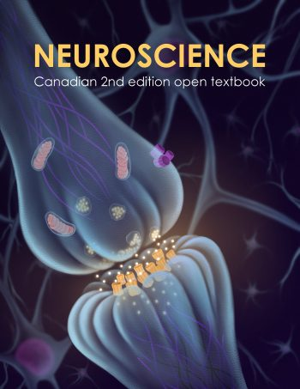

Neuroscience Text

The following passage is the introductory paragraph to a unit on the circulatory system. Read the passage and answer the questions that follow. Words that are likely unfamiliar to ELLs have been replaced by “huh”.
Most animals are complex huh huh that require a mechanism for transporting huh throughout their bodies and removing waste products. The huh system has evolved over time from simple huh through cells in the early evolution of animals to a complex network of blood vessels that reach all parts of the human body. This extensive network supplies the cells, tissues, and huh with huh and huh and removes carbon huh and waste, which are huh of huh.
At the core of the human huh system is the heart. The size of a huh huh, the human heart is protected beneath the huh huh. Made of specialized and unique huh muscle, it pumps blood throughout the body and to the heart itself. Heart huh are driven by huh huh huh that the brain and huh huh help to regulate. Understanding the heart basic huh and function is important to understanding the body huh and huh systems.
Gas exchange is one essential function of the huh system. A huh system is not needed in huh with no specialized huh organs because huh and carbon huh huh directly between their body tissues and the external environment. However, in organisms that possess huh and huh, huh must be transported from these specialized huh to the body tissues via a huh system. Therefore, huh systems have had to evolve to huh the great diversity of body sizes and body types present among animals

Questions:
- Are you confident that you summarize the main points of the paragraph?
- Approximately how long did it take you to read this passage?
- If you had to look up most of the blacked out words in a dictionary, approximately how long would it take you to read this passage?

Now read the passage with all the words visible.

Most animals are complex multicellular organisms that require a mechanism for transporting nutrients throughout their bodies and removing waste products. The circulatory system has evolved over time from simple diffusion through cells in the early evolution of animals to a complex network of blood vessels that reach all parts of the human body. This extensive network supplies the cells, tissues, and organs with oxygen and nutrients, and removes carbon dioxide and waste which are byproducts of respiration..
At the core of the human circulatory system is the heart. The size of a clenched fist, the human heart is protected beneath the rib cage. Made of specialized and unique cardiac muscle, it pumps blood throughout the body and to the heart itself. Heart contractions are driven by intrinsic electrical impulses that the brain and endocrine hormones help to regulate. Understanding the heart basic anatomy and function is important to understanding the body circulatory and respiratory systems.
Gas exchange is one essential function of the circulatory system. A circulatory system is not needed in organisms with no specialized respiratory organs because oxygen and carbon dioxide diffuse directly between their body tissues and the external environment. However, in organisms that possess lungs and gills, oxygen must be transported from these specialized respiratory organs to the body tissues via a circulatory system. Therefore, circulatory systems have had to evolve to accommodate the great diversity of body sizes and body types present among animals.
The text not listed belongs to the New General Service List which represents the 2800 core English words. The words listed under NAWL are found in the New Academic Word List which represents 963 words and their forms that are common in academic texts across disciplines. The off-list words are words that do not appear on either list. Many of these words are subject specific jargon that are important to understand the subject content.
Most ELLs will know most of the General Service List text and some of the NAWL text if they have studied those words or encountered them previously. They may be familiar with some of the off-list text also depending on their prior learning and their first language which may have some similar words (cognates) or similar root words. In order to read with good comprehension, readers should know 98% of the vocabulary in the text (Schmitt et al., 2011).

Word Coverage
Percentages of words in each category for the passage you just read:
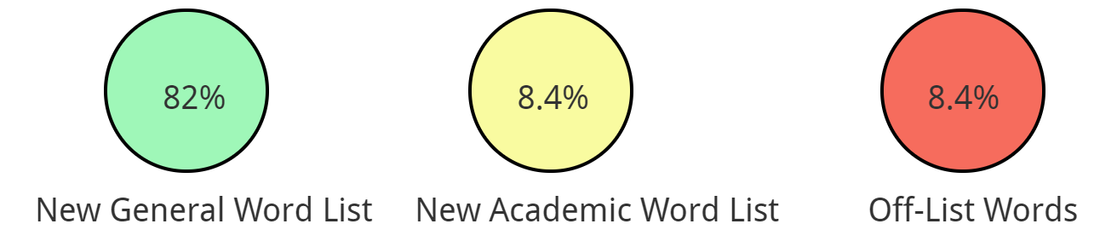
Much of the text belongs to the New General Service List which represents the 2800 core English words.

Some of the words are in the New Academic Word List which represents 963 words and their forms that are common in academic texts across disciplines.
diffuse, diffusion, dioxide, hormones, impulses, lungs, nutrients, organisms, organs, oxygen, respiratory

Some of the words do not appear on either list. Many of these words are subject specific jargon that are important to understand the subject content.
accommodate, anatomy, byproducts, cardiac, circulatory, clenched, contractions, dioxide, electrical, endocrin,
fist, gills, intrinsic, multicellular, respiration, rib cage
Most ELLs will know most of the common text found on the General Service List and some of the vocabulary from the New Academic Word List if they have studied those words or encountered them previously. They may be familiar with some of the off-list text also depending on their prior learning and their first language which may have some similar words (cognates) or similar root words. In order to read with good comprehension, readers should know 98% of the vocabulary in the text (Schmitt et al., 2011).

Task A
The following passage is from the same unit on the circulatory system. Click on words that you think would not be on the new general word list or the new academic word list in this passage from the section “Components of the Blood."

Hemoglobin is responsible for distributing oxygen, and to a lesser extent, carbon dioxide, throughout the circulatory systems of humans, vertebrates, and many invertebrates. The blood is more than the proteins, though. Blood is actually a term used to describe the liquid that moves through the vessels and includes plasma (the liquid portion, which contains water, proteins, salts, lipids, and glucose) and the cells (red and white cells) and cell fragments called platelets. Blood plasma is actually the dominant component of blood and contains the water, proteins, electrolytes, lipids, and glucose. The cells are responsible for carrying the gases (red cells) and immune the response (white). The platelets are responsible for blood clotting. Interstitial fluid that surrounds cells is separate from the blood, but in hemolymph, they are combined. In humans, cellular components make up approximately 45 percent of the blood and the liquid plasma 55 percent. Blood is 20 percent of a person’s extracellular fluid and eight percent of weight.
Task B
Some of the words you highlighted are frequently used in many contexts and appear on the New Academic Word List so students should learn them. Others are used specifically for this context. For those words, students should be given a reference glossary. Put the highlighted words into the categories “learn” and “glossary.”

Simplifying Text
Online tools such as the NAWL Highlighter can analyze text to identify words that are on the New Academic Word List, New General Service Word List or are Off-List. The online tool Rewordify identifies difficult vocabulary and provides simplified wording. Teachers can use this tool to quickly identify words that may be difficult for ELLs. Based on the suggestions, text can easily be modified. The simplified wording can be used to quickly generate vocabulary tasks and glossaries. Students can use this tool to support their reading comprehension.
The following is text output from Rewordify. The text in brackets is the simplified text.

Most animals are complex multicellular [having more than one cell] organisms [living things] that require a mechanism for [a way for] transporting [moving] nutrients [things that act as foods] throughout their bodies and removing waste products. The circulatory system has evolved [has changed (and gotten better)] over time from simple diffusion through cells in the early evolution [change for the better, over time] of animals to a complex network of blood vessels [tubes (in the body)] that reach all parts of the human body. This extensive [long/big] network supplies the cells, tissues, and organs with oxygen and nutrients [things that act as foods], and removes carbon dioxide and waste, which are byproducts [things produced along with something else] of respiration [breathing].
At the core of the human circulatory system is the heart. The size of a clenched [squeezed tightly] fist, the human heart is protected beneath the rib cage. Made of specialized [made to do one thing very well] and unique [like nothing else in the world] cardiac [heart-related] muscle, it pumps blood throughout the body and to the heart itself. Heart contractions are driven by intrinsic [built-in] electrical impulse [sudden (unplanned) desire]s that the brain and endocrine hormones [chemicals produced by the body] help to regulate [control]. Understanding the heart's basic anatomy [body structure] and function is important to understanding the body's circulatory and respiratory [breathing and lung related] systems.
Tips:

In addition to supporting ELLs, these tips increase accessibility for all learners in your class.

What can you do to support ELLs with assigned readings for your course?
- Be selective in quantity and general accessibility
  - Select the minimum number of accessible readings that are essential for your course. Additional readings can be assigned as additional readings but all assignments and testing should be based on the essential readings.
  - Assign specific sections of a chapter to read rather than the whole chapter. Chose sections that align with your specific learning objectives. Give students a specific purpose for completing the reading so they know what they are supposed to learn from the reading.
- Provide definitions of key subject specific vocabulary
  - Identify key terminology with simply written definitions from an ELL dictionary (https://www.oxfordlearnersdictionaries.com/us/) for your subject. Alternatively, create a class collaborative dictionary. Ask students which words are unfamiliar in the readings to develop an understanding of the challenges for your typical learners.
- Highlight text features
  - Early in your course, take some time to highlight how to navigate your course textbook. Awareness of the usefulness of features such as the table of contents, glossary, index (important words often appear both in the glossary and the index) and appendices is beneficial for ELLs. Taking a “chapter walk” with your students illustrates helpful features of a text such as chapter objectives (to help identify key concepts), headings and subheadings, text (colour, italics and bold used to indicate important words), side notes, illustrations, graphics, captions, review questions, quizzes and further readings. Focus on how these features organize the text and highlight important information.
- Scaffold Learning
  - Provide questions based on the text that focus on key language and concepts to help ELLs understand what you want them to learn from the reading. An advance reading organizer helps ELLS prioritize important vs unimportant details and also indicates when they have missed important pieces of information. For example, if the organizer asks them to list the four identifying features of a specific item and they can only list three, then they know that they need to re-read the passage or seek clarification from you.
- Choose e-resources when possible
  - E-resources support the use of multiple tools that may help ELLs comprehend the text. Encourage your students to install Read Write Gold, a free toolbar. Its features include a phonetic spell checker, picture dictionary, text-to-speech, speech-to-text, translator, screen shot reader, vocabulary list builder, concept mapping, word prediction, PDF aloud, word banks, voice notation, and highlighting. With this tool, your ELLs can hear the text read aloud, find meanings of words easily and highlight key concepts.
  - Use the web app remodify.com to indicate vocabulary in a reading passage that might be challenging to comprehend, and to view accessible wording for ELLs. Encourage students to use the site to generate reading passages with the difficult words replaced or defined [insert link to highlighted passage] with more accessible language. Settings can be changed to view the original side by side with the same passage that has had the difficult words replaced by simplified language.

Put it in Action
- Pick a selection from your course readings and highlight the subject specific vocabulary that may be unknown by ELLs in your courses.
- If there is a text glossary – check to see if these words have been defined.
- For any words not already defined, write a simple definition. Use a learner dictionary to find definitions that are accessible for ELLs (https://www.oxfordlearnersdictionaries.com/us/) or use rewordify.com to provide simplified wording.

Task A/B Answers
The following words are the words in the passage that are not on the New General Service word list. Some of the words are frequently used in many contexts and appear on the New Academic Word List so it is helpful for students to learn them. Others are used specifically for this context. For those words, a glossary is sufficient. Drag the words into the categories “learn” and “glossary”
cellular, circulatory, clotting, dioxide, dominant, electrolytes, extracellular, fluid, glucose, hemoglobin, hemolymph, immune, interstitial, invertebrates, lipids, oxygen, plasma, platelets, vertebrates
Learn: dioxide, dominant, fluid, immune, oxygen,
Glossary: cellular, circulatory, clotting, electrolytes, extracellular, glucose, hemoglobin, hemolymph, interstitial, invertebrates, lipids, plasma, platelets, vertebrates

