Activity 2: Success

Part A: Vocabulary
Read the collocations for “success” in the online Oxford Collocations Dictionary.
Complete the mind map by filling in the empty spaces (either print the map or use bullets in the textbox) below with appropriate adjectives, verbs and expressions related to Success from the dictionary.
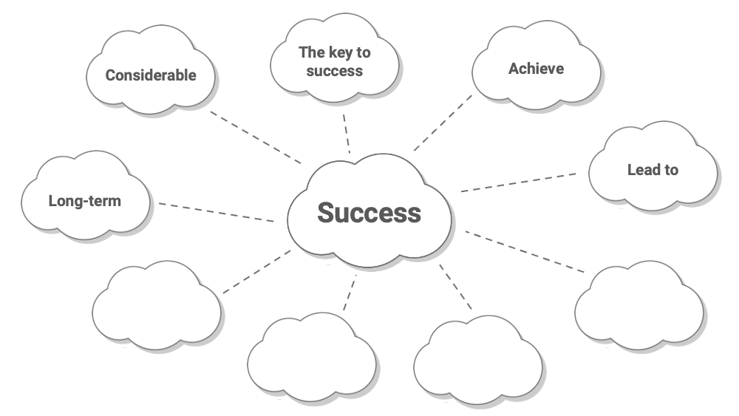

1. Use the space below to complete the map with comma separated terms (add more than 4 if needed):
Answer
2. Write down at least three of your own example sentences.
Sentence 1 | Sentence 2 | Sentence 3

