Activity 3: Problem Solving

Part A: Group Discussion
Work in groups and discuss your answers to the following questions.
1. What are the traits of a good problem-solver in your opinion?
Answer
2. What steps could go into finding a solution to a problem?
Answer
3. Can creativity be applied to problem-solving? How?
Answer

Part B: Read the Article
Skim the article How to become a creative problem solver by Louise Cunnah and find the benefits of using creativity in problem solving.
Answer

Part C: Definitions
Fill in the terms into the correct cells to match them to the definitions below:
Term | Definition
 | following the usual practices of the past
 | to indicate
 | fully developed in all aspects
 | to start thinking about other matters
 | a puzzling or mysterious question
 | to hit
 | remember
 | invent a word or expression
 | to feel a strong emotion
Options
recall, conventional, burst, wander, signify, strike, riddle, rounded, coin

Part D: Read for Details
Read the article from Part B again and answer the following questions in your group.
Each question has a sample answer that will be revealed when you click/tap on the Check button and then Show Solution.
1. What assumption underlies the CPS model?
Answer
2. According to the CPS model, what are the differences between the clarifying and ideating steps?
Answer
3. At which step in the CPS model are ideas put into action? What do you know about this step?
Answer
4. What are the benefits of using the mind mapping technique?
Answer
5. What do the different colors in the Six Different Hats technique imply?
Answer

6. Is there anything that needs to be done before one starts mind wandering?
Answer
7. According to the text, what technique can help an individual go beyond the typical brainstorming methods?
Answer
8. How does one ensure that they continue to generate creative ideas without burning out?
Answer

Part E: Critical Thinking
Think about a challenge you have faced in your language learning courses (e.g., a challenging test, paper, essay, or presentation).
To brainstorm solutions, use the following techniques:
Step 1- Divergent Thinking | Step 2- Convergent Thinking
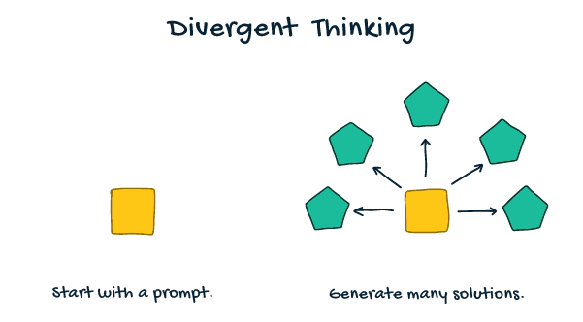  When producing ideas:  - Strive for quantity (i.e., generate as many ideas as possible)  - Defer judgement (do not evaluate their effectiveness at this point)  - Build off others’ ideas  - Freewheel (at this stage, it is okay to produce wild ideas!) | 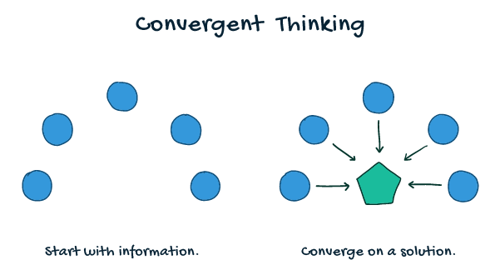  Evaluating the effectiveness of your ideas:  - Rate your ideas  - Cluster your ideas (i.e., put them into different categories)  - Tag your favourites

In your groups, discuss the following questions using the Divergent and Convergent Thinking methods.
1. What problem-solving strategies did you use to achieve the best outcomes?
Answer
2. If you were to face the challenge again, what would you do differently? What creative problem-solving strategies would you use?
Answer

