Activity 1: Creativity

Part A: Reflection

Reflection
The field of creativity studies has a standard definition for creativity:
“Creativity consists of both originality and effectiveness. Originality is a necessary condition but is not sufficient. Original ideas must also be useful and appropriate” (Runco & Jaeger, 2012).
1. What do you think about the above definition?
Answer
“Creativity is not a capacity of special people, but a special capacity of all people” (Carter, 2004, p. 13).
2. To what extent do you agree or disagree with this statement?
Answer
3. Is creativity an innate talent, or is it a mindset that can be learned in the environment?
Answer

Part B: Critical Thinking

What is creativity? Read the creativity definitions in the poster below and discuss which definitions resonate with you. How important is it to be “a creative language learner”? Why?
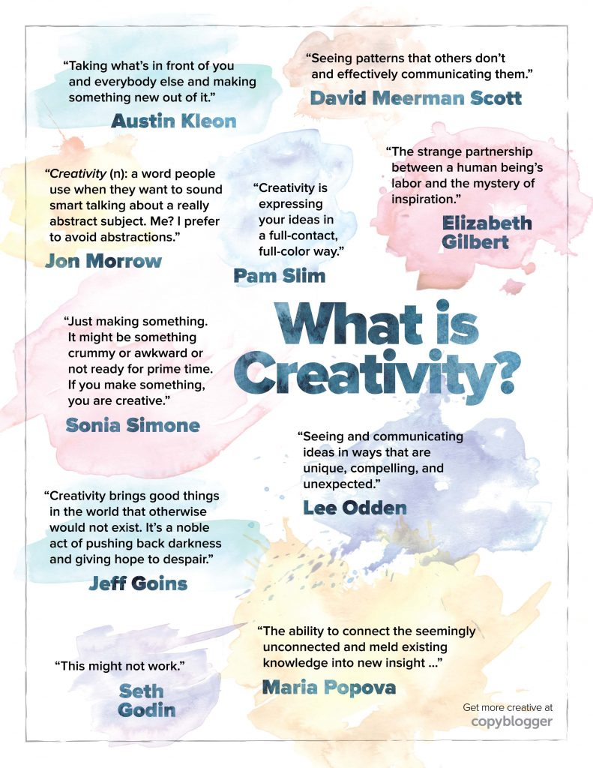
Source: copyblogger.com

Answer

