Activity 1: Resilience and Hope in Storytelling

Part A: Reflection

Reflection
1. Do you consider yourself a good storyteller?
Storytelling is the act of telling or presenting a story in various ways, ranging from a conversation to creating social media posts, websites, or media for different audiences.
Answer
2. Do you enjoy listening to others’ stories?
Consider places where you hear stories. These can be friends and family but also reading, listening to audiobooks, watching movies and similar activities. Detail if you enjoy listening to stories (or not), and why?
Answer
3. In your opinion, what elements make stories powerful?
Powerful stories are ones that capture your attention and leave a strong impression with the audience. What makes stories powerful? What are some of the things you like seeing in stories?
Answer

Part B: Brainstorm
Based on the definitions above, can you think of any personal stories that contain elements of resilience, hope or both?

Brainstorm
Definitions:
- Resilience is defined as the ability to cope with stressors and bounce back from difficulties in life (Windle, 2011). Resilient individuals thrive as a result of their challenging experiences.
- Hope is defined as goal-directed thinking in the wake of positive emotions, motivation and optimism (Snyder, 2005).
Based on the definitions above (resilience and hope), can you think of any personal stories that contain elements of resilience, hope or both?
Share your ideas with your group.
Notes

Here are some examples:
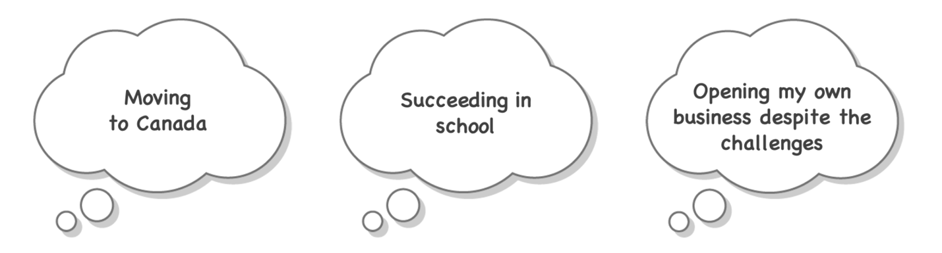

Part C: Share Your Stories

Share
In your groups, take 5 mins each to share your stories.
- Were there any particular stories that resonated with you? Do you think your story was personally meaningful?
- Why or why not?
Notes

