E-book project instructions and template: CIVE 230 Engineering and Sustainable Development

Sustainability Contribution
(Total marks: 20)
(due on various Fridays at 11:59pm EST on LEARN Dropbox)

The sustainability contribution is a brief project worth 5% of your final course grade, to give you an opportunity to contribute a sustainability idea. Every student will get a chance to contribute content, which means you will co-create content for the course by submitting a PowerPoint slide with audio narration. This activity is to encourage you to explore sustainable cities, infrastructure, solutions and technologies globally to generate an enriched learning experience and create an opportunity for peer-to-peer learning. This could go beyond course content. If in doubt about the choice of topic for your contribution, feel free to ask on Piazza or by email.

Slides will be compiled together to form an e-book by the class for online publishing. The topic is assigned based on the last digit of your student number, as follows:

Last digit of student ID | Topic | Module Week and Due date
0 | Global atmospheric change including climate change | Week 3: due May 29
1 | Air pollution and models of air quality | Week 4: due June 5
2 | Water resources and water scarcity issues | Week 5: due June 12
3 | Water pollution and methods to improve water quality | Week 6: due June 19
4 | Energy – fossil fuels and renewables | Week 7: due June 26
5 | Solid waste management | Week 8: due July 3
6 | Sustainable buildings | Week 9: due July 10
7 | Sustainable transportation | Week 10: due July 17
8 | Sustainable energy | Week 11: due July 24
9 | Sustainable water use and urban forests | Week 12: due July 31

Slide presentation
A slide template is provided in widescreen format (16:9) for you to use. References for images and content is to be placed in the notes section of the slide, not on the slide.
An example of an image reference:
Harmoni Central Busway Transjakarta 1 by Gunawan Kartapranata is licensed under CC BY-SA 4.0
https://commons.wikimedia.org/wiki/File:Harmoni_Central_Busway_Transjakarta_1.JPG
An example of content reference (as usual):
UNDP, 2015. Bus Rapid Transport Development in Greater Jakarta (Jabodetabek): Finance-Ready Proposal.
https://www.undp.org/content/dam/LECB/docs/pubs-namas/undp-lecb-Indonesia-Bus-Rapid-Transport-Report-201512.pdf

Adding audio
Add a 2-3-minute audio to your slide by inserting an audio recording onto the slide. This is a straightforward process in MS PowerPoint (Insert > Audio > Record Audio...). Once recorded, you’ll see an audio icon on your slide, which you can place in the title banner in the bottom right corner as shown.
Audio recording icon insertion
Representative image on half the slide (make sure the image is labeled for reuse)
City, Country
Title is the sustainable infrastructure or technology of interest

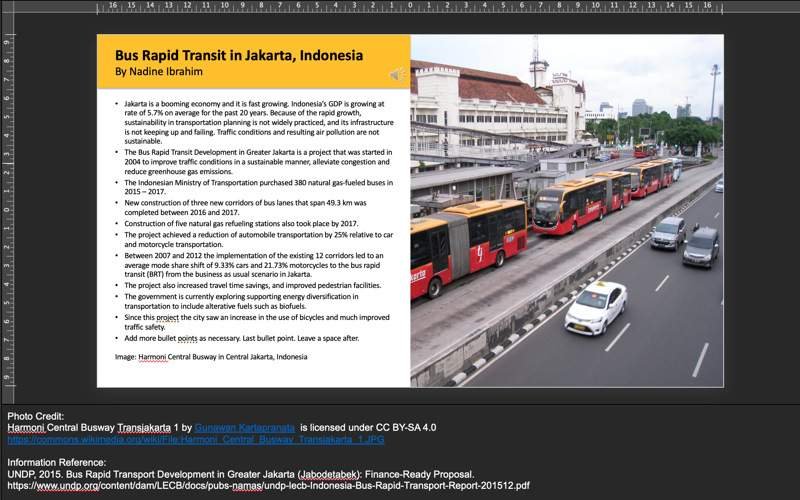
A few bullet points describing the challenge first, and then the sustainable infrastructure or technology, strategy of interest.
Your name
The colour of the title banner is your choice
Image title
Photo Reference (where attribution is required)
Notes on fonts:
Title: Calibri 22 bold
Author: Calibri 22
Bullets and References: Calibri 12

Reference for the information/ data presented

