Commerce [Course Code] – Tutorial Assignment #2
Due: [Date and time] on MS Teams

Learning to Learn – Time Management

As university students, 24 hours in a day often doesn’t feel like enough time. Managing multiple courses, deliverables in these courses, extracurricular activities, family, friends, sleep, and our personal interests can often get overwhelming. The best solution to this common dilemma is to make the most effective use of our limited time, this is where time management comes into play. Time management is a critical skill to have, there are many different ways to manage your time, but this week’s focus is scheduling. Creating schedules allows you to allocate time to specific tasks and responsibilities, prioritize, and make the most effective use of your time. Before you create your schedule, there are a few things you need to consider, and preparatory steps you need to take.

While we will go over a few different strategies in our tutorial, you have complete liberty to choose how to present your schedule. Some examples can be found on the following pages:
- Word document
- Excel Spreadsheet
- Photo of Google Calendar/iCalendar
- Photo of Planner
Submit to: MS TEAMS: General > Assignments > Assignment #2 – Tutorial 3

Tips/Tricks:
Step 1: Make note of all of the deliverables (quizzes, tests, assignments) and their due dates – will be assisted in class!
Step 2: Evaluate the personal, non-academic related, things you would like to accomplish
- Example:
- Virtual events you would like to attend
- Workouts you want to complete
- Activities you want to do
- Extracurriculars you want to get involved in
Step 3: Identify your priorities and your non-negotiables
Step 4: Create your schedule! - more tips to be discussed in class, feel free to bring yours to share!

ASSIGNMENT INSTRUCTIONS:

- Create your personal weekly schedule
  - Includes: course times, study time, rest, exercise, social time etc.
  - Make sure this is realistic for your sleep schedule
- Create a semester long schedule for your course deliverables in each course
- In a few sentences, explain how this schedule will help you throughout the school year
For any questions contact your TA [Email]
Examples/Inspiration:

iCal/Google Calendar
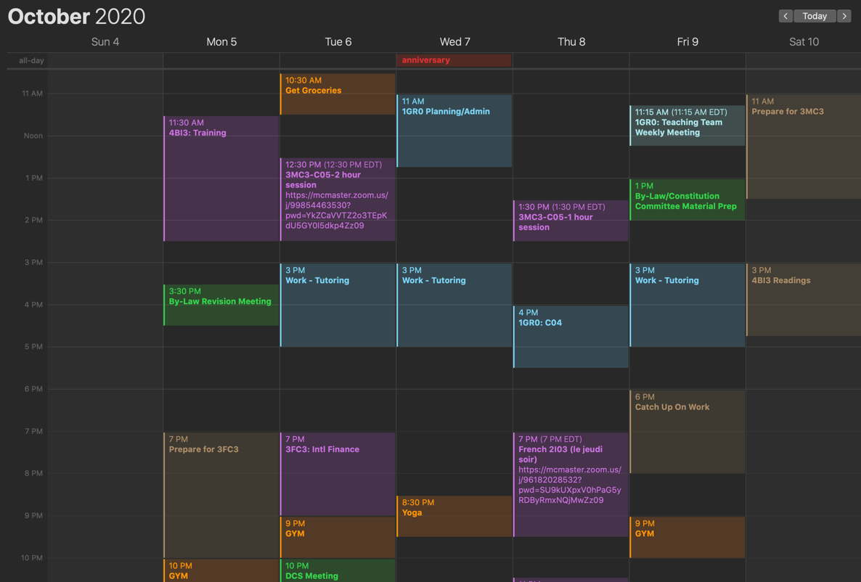
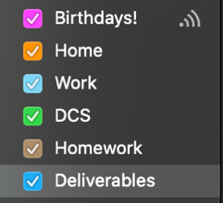

Excel Doc
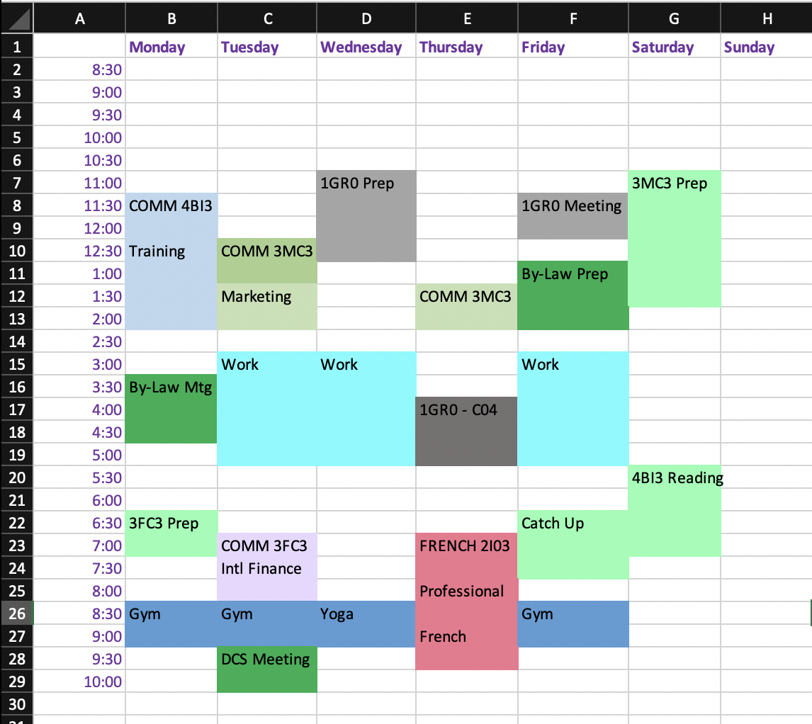

Written Planner

Planner/Agenda
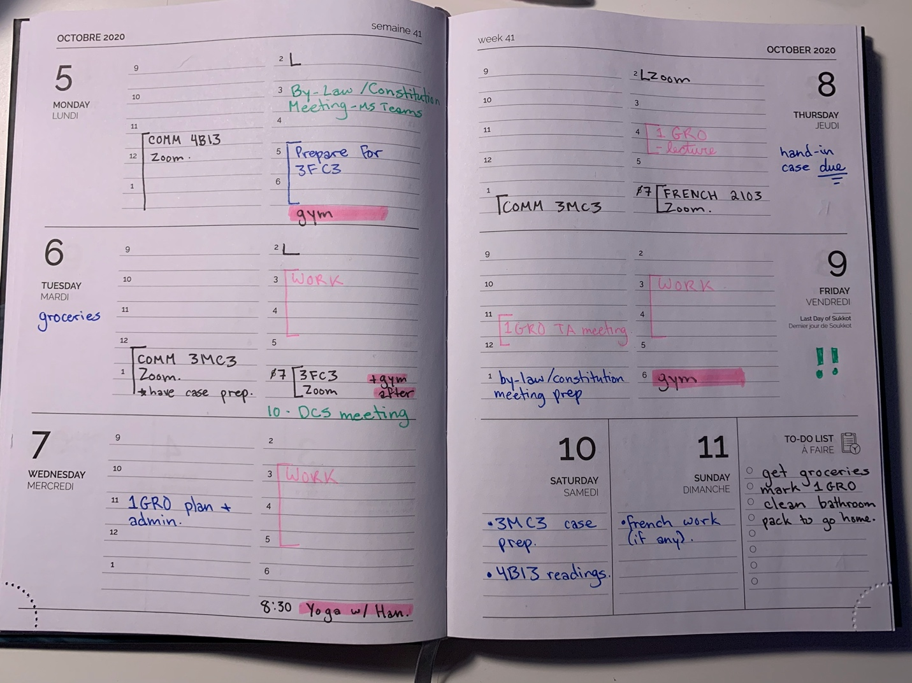

3 Month Schedule:

