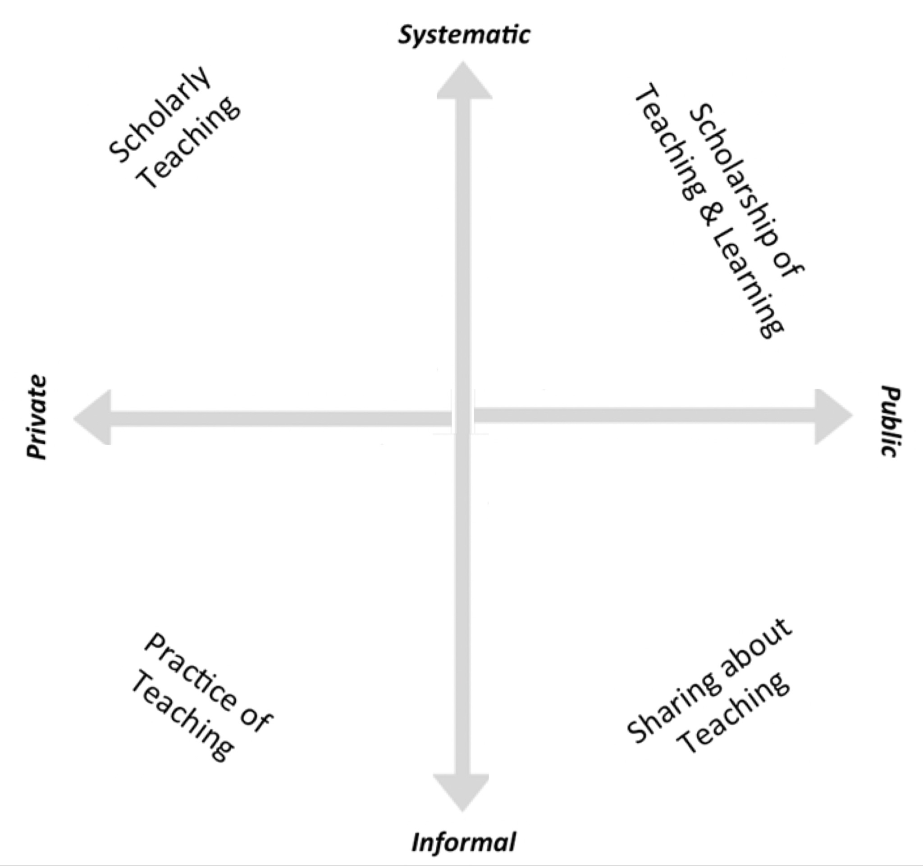

Dimensions of Activities Related to Teaching (DART). Image by Kern et al (2015) in The role of SoTL in the academy: Upon the 25th anniversary of Boyer’s Scholarship Reconsidered. Journal of the Scholarship of Teaching and Learning, 15(3), 1-14. CC BY 4.0
[Alt text: A diagram with two intersecting axes. The vertical line is labelled “systematic” at the top and “informal” at the bottom. The horizontal line is labelled “private” on the left and “public” on the right. The axes create four quadrants, labelled (starting from the top right, clockwise): scholarship of teaching and learning, sharing about teaching, practice of teaching, and scholarly teaching.]

- Within which quadrants are your current HyFlex teaching-related activities located?

- Where are the activities located on the Public - Private dimension? Informal - Systematic dimension?

Plan for Further Development of HyFlex Teaching-Related Activities
 | Goal 1:  [type goal here] | Goal 2:  [type goal here] | Goal 3:  [type goal here]
Quadrant (Practice of Teaching; Sharing about Teaching; Scholarly Teaching; Scholarship of Teaching and Learning)
Timeline

Steps to Achieve Goals

Resources Needed
Benefits
Potential Barriers to Development
Assessment of Progress

