Application to ADDIE Framework

Complete the first part of this activity by identifying how you will obtain formative feedback throughout the course design process (feedback can be from students, peers, or self), using the ADDIE framework. Consult the Course Design Program Guide for a full description of each phase. Though this framework was not a focus of this module, it is important to acknowledge that course design does not have to happen in isolation and that evaluation strategies such as obtaining formative feedback can be applied in different ways.
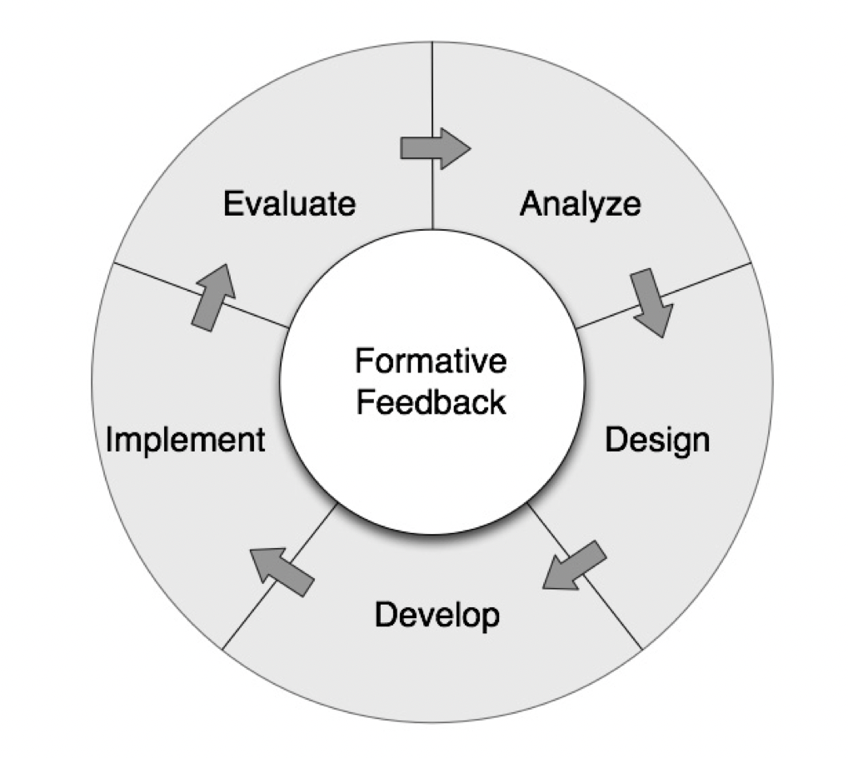
ADDIE model of instructional design. Image from the Course Design Program Guide (CC BY-NC-SA 4.0) at the University of Calgary’s Taylor Institute for Teaching and Learning.
[Alt Text: A circle diagram labeled “Formative Feedback” in the center. The outer ring of the circle is divided into five sections with arrows pointing from labels: Analyze, Design, Develop, Implement, Evaluate (and then back to Analyze).]

Feedback to be collected during the Analyze Phase

Feedback to be collected during the Design Phase

Feedback to be collected during the Development Phase

Feedback to be collected during the Implementation Phase

Feedback to be collected during the Evaluation Phase

Course Design Rubric
Simonson, S. R., Earl, B., & Frary, M. (2021). Establishing a framework for assessing teaching effectiveness. College Teaching, 1-18. https://doi.org/10.1080/87567555.2021.1909528 (CC BY NC 4.0)

Course Design: Designs course materials in alignment with course learning outcomes
Exemplary teachers will design their courses around appropriate learning outcomes, design a variety of summative and formative assessments, which effectively measure student achievement of those outcomes, and create course activities which support students in reaching the course learning outcomes.
Possible Sources of Evidence | Category | Exemplary | Proficient | Developing | Missing
- Syllabus  - Course assignments  - Student work samples  - Other course materials  - Course design table | 1.1. Course learning outcomes guide course design process | Well-developed course learning outcomes are present for all courses and guide the course design process | Course learning outcomes are present for all courses and guide the course design process. | Course learning outcomes are present, are not well-developed, and/or do not guide course design process. | Course learning outcomes are absent.
 | 1.2. Alignment of assessments | Assessments obviously align with course learning outcomes | Most assessments align with course learning outcomes. | Assessments are present and do not appear to match the course learning outcomes. | Without course learning outcomes, alignment of assessments cannot be determined.
 | 1.3. Alignments of course activities | Course activities are consistently aligned with, and thus support students in working toward, course learning outcomes and assessments; alignment is explicitly established and communicated. | Course activities are somewhat aligned with, and thus support students in working toward, course learning outcomes and assessments; alignment not explicitly established or communicated | Course activities are not clearly aligned with course learning outcomes and assessments | Without course learning outcomes, alignments of activities cannot be determined.
 | 1.4. Course design and learning outcomes encourage discipline-specific ways of thinking | Course activities teach students to think about and use the subject like a practitioner in the discipline, consistent with the students’ background and level. | Some development of discipline-specific ways of thinking is evident, but it is not clear that this is successful or that it is consistent with the students’ background or level. | Few course activities appear to support discipline-specific ways of thinking or this process is not demonstrated in a meaningful way. | Activities do not appear to help students develop discipline-specific ways of thinking.
 | 1.5. Student achievement of course learning outcomes | Ensures that students are achieving course learning outcomes by reflecting on student work. Student work samples demonstrate substantial achievement of course learning outcomes. | Monitors student achievement of course learning outcomes. Student work samples demonstrate achievement of course learning outcomes. | Student work samples present a tenuous link to course learning outcomes. | Student work samples do not appropriately demonstrate student success OR student work samples are absent.

