Nonverbal Communication – Hand Gestures
In the space under each image, write what you understand to be the meaning of these gestures. What do they mean in your culture? If they are not commonly used, or you are not familiar with them, what do you think they mean?
Images extracted from this video: https://www.youtube.com/watch?v=JCwyRn40fvk
What do these gestures mean to you?
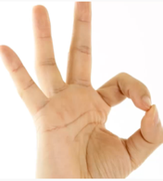 | 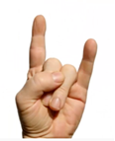 |  | 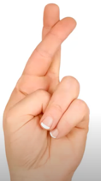 | 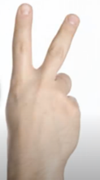
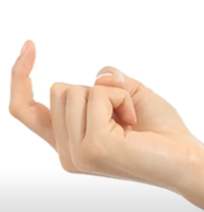 | 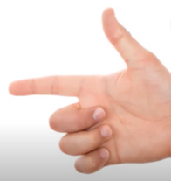 |  |  | 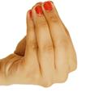
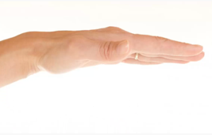 | 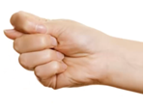 |  |  | 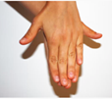
ZoneA. (2017). The Definitions Of Hand Gestures Around The World. Youtube. https://youtu.be/JCwyRn40fvk licensed under CC BY 3.0.

