How I understand myself based on cultural orientations

Mark with an X or a dot where you see yourself in relation to these orientations. In the space under the line, write one or two examples of influences you think helped you move towards that orientation. For example, your background, family, education, type of work, organization, life experience, and so on.

Individualism | How do you see yourself in relation to others?  ____________________|____________________ | Communitarianism
Value personal freedom, achievement, independence, self-reliant, standing out  Created by Griffin Mullins  from The Noun Project |  | Value consensus, group needs before individual needs, safety in the group, working as a team  Created by Griffin Mullins  from The Noun Project
Universalism | How do you define what is fair?  ____________________|____________________ | Particularism
Value rules, obligations, fair means following rules  rules before relationships  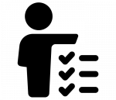  Created by Adrien Coquet  from The Noun Project |  | Value relationships and these often dictate how rules are applied relationships before rules  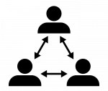  Created by Davo Sime  from The Noun Project
Task (specific) | How do you get things done? How far do you get involved?  ____________________|____________________ | Relationship (diffuse)
Value separating work and personal life, work together even if not best friends, focus on the destination  Created by Tresnatiq  from The Noun Project |  | Value an overlap between work and personal life, relationships vital for achieving goals, focus on the journey 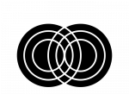  Created by Tresnaqit  from The Noun Project
Achievement (egalitarian) | How do you view status and hierarchy? Is it obtained or given?  ____________________|____________________ | Ascription (hierarchy)
Value on people’s performance, not status, no matter who you are, you are what you have achieved  Created by Kevin Markle  from The Noun Project |  | Value status and place importance on power, title and a recognized position, roles define behaviour  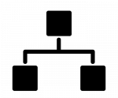  Created by Neha Tyagi  from The Noun Project
Affective | How do you express and manage emotions?  ____________________|____________________ | Neutral
Value free, spontaneous display of emotions in public and private, hiding emotions considered dishonest  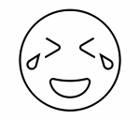  Created by Vectoriconset10  from The Noun Project |  | Value controlled reactions, avoid revealing emotions too quickly, being neutral shows professionalism  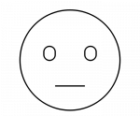  Created by Vectoriconset10  from The Noun Project
Sequential time (monochronic) | How do you define and approach time?  ____________________|____________________ | Synchronous time (polychronic)
Value punctuality, sticking to the plan, one thing or part of a project at a time, focus on the big picture  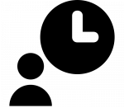  Created by Razmik Badalyan  from The Noun Project |  | Value relationships, plans and commitments are flexible, working on many parts of a project at a time 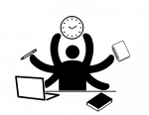  Created by ProSymbols  from The Noun Project
Internal direction | How do you relate to your environment?  ____________________|____________________ | External direction
Value being able to control nature or the environment to reach goals, focus on self, own group, “I master”  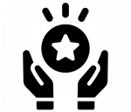  Created by Adrien Coquet  from The Noun Project |  | Value and accept what one cannot control in nature or environment, “I accept what can't be changed”  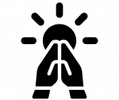  Created by Adrien Coquet  from The Noun Project
Low context | How much do you rely on the context for communication?  ____________________|____________________ | High context
Value on explicit messages, clear descriptions, “say what you mean and say it clearly”  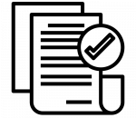  Created by Nareerat Jaikaew  from The Noun Project |  | Value implicit aspects of communication, nonverbal cues, silences, “read between the lines”  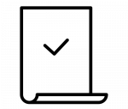  Created by Verry Obito  from The Noun Project

